**Learning Plan**

**Unit 4 Natural Disasters**

**Period 4 Reading For Writing导学案**

**Part 1.Previewing.**

**Exercise1.**

1).what is tsunami?

A tsunami is a series of waves in the _____（海里）. It is often caused by an e__________. It is very d_______ and can cause great _______（损失）.

2).What is the kind of **text type** is? _________________________

3). Match the sentence with the **feature** it shows:

It was released the day after the tsunami . B. Concise language(语言简洁)

Tsunami Hits Asia Over 6500 Dead A. Timeliness（及时）

killing more than 6500 people C. Accurate numbers （精确的数字）

4).Find out the **structure** of the text by matching the following parts with the right number.

1 Headline(tells what the story is about)主标题

2 Lead (date , place,event and cause)

3 Body(details)

4 End(effect/following events)影响或后续事情

5 Byline(shows the reporter and date)副标题

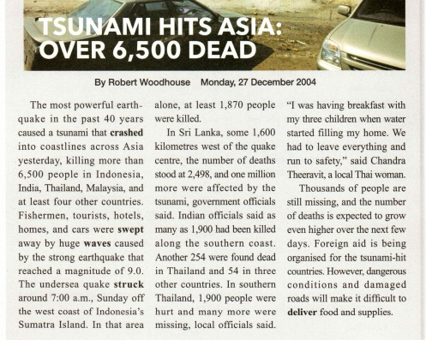

**Exercise2. Answer the questions on p54.**

1). When did the tsunami happen?

A. On 27 December, 2004. B.On 26 December, 2004.

2).Why would it be difficult to deliver food and supplies?

A. Because of dangerous conditions. B. Because of damaged roads. C. Both A and B.

**Exercise3 .Read the summary and find out where do the main points come from .**

On 26 December 2004, a tsunami killed more than 6,500 tourists, fishermen and other locals in Southeast Asia.(要点1) Thousands of people are missing and the number of deaths is expected to grow. (要点2)The damage caused by the tsunami is making it difficult for rescue workers to help the survivors.

要点1- ________________________________________________

要点2- ________________________________________________

要点3- ________________________________________________

**Part 2.Summary writing**

Follow the steps below to write a summary for the first text called “the night the earth didn’t sleep.

1. Review the structure and main points of the text.

2.Rewrite the main points of each paragraph (in your own words as possible as you can).

**Para1.**

Strange things happened in the countryside before the earthquake An earthquake hit Tangshan China on 28 July 1976.

———————————————————————————————————————

**Para2.**The number of people who were killed or badly injured in the quake was more than 400,000.

———————————————————————————————————————

**Para3**.Nearly everything in the city was destroyed.

———————————————————————————————————————

**Para4**.Soldiers and medical workers came and began rescuing and rebuilding the city soon after the quakes.

_______________________________________________________________________________

**Para5.**With strong support from the government and the tireless efforts of the city's people, a new Tangshan was built upon the earthquake ruins.

_______________________________________________________________________________

**Part 3.Summary**

_______________________________________________________________________________

_______________________________________________________________________________

**Part 4.Homework**

**France Locked Down Again法国再次封城**

France will enter a new nationwide lockdown starting Friday and lasting at least the whole of November in order to control the spread of the novel coronavirus, French President Emmanuel Macron announced on Wednesday evening.

The new measures echo the eight-week lockdown that France enforced in the spring, when hospitalizations and deaths caused by the COVID-19 pandemic reached a peak. The lockdown was effective at containing the pandemic, but the virus started spreading again after relaxing rules starting May 11.

The new measures Macron announced – which will last until December 1 – will mean people have to stay in their homes except to buy essential goods, seek medical attention, or use their daily one-hour allocation of exercise.

Anyone leaving their home will have to carry a special document justifying being outside, which can be checked by police, he said. Restaurants, cafes and shops not selling essential goods will have to close down for at least the next two weeks.