**教学目标**

After this class, the students will be able to

1. Introduce student clubs, along with related vocabulary.

2. use proper expressions to show they are interested and listening in a conversation.

3. develop confidence of showing themselves and keep interested in learning English.

**教学重难点**

Practice predicting and listening for gist through natural conversations in English about clubs and club activities..

**教学过程**

**Leading-in**

**Students’Activities**

1.  Watch and answer**—***What clubs are there? Can you briefly describe the activities in these clubs?*

2.  Match and talk— *Which club do you like? Answer the question with the help of the different expressions. Read the pictures and do the match. Then describe the four pictures briefly.*

**Aims**

To introduce the topic, use some expressions and enlarge students’knowledge of student clubs.

**Listening**

**Students’ Activities**

**1. Task 1**: Listen for the gist.

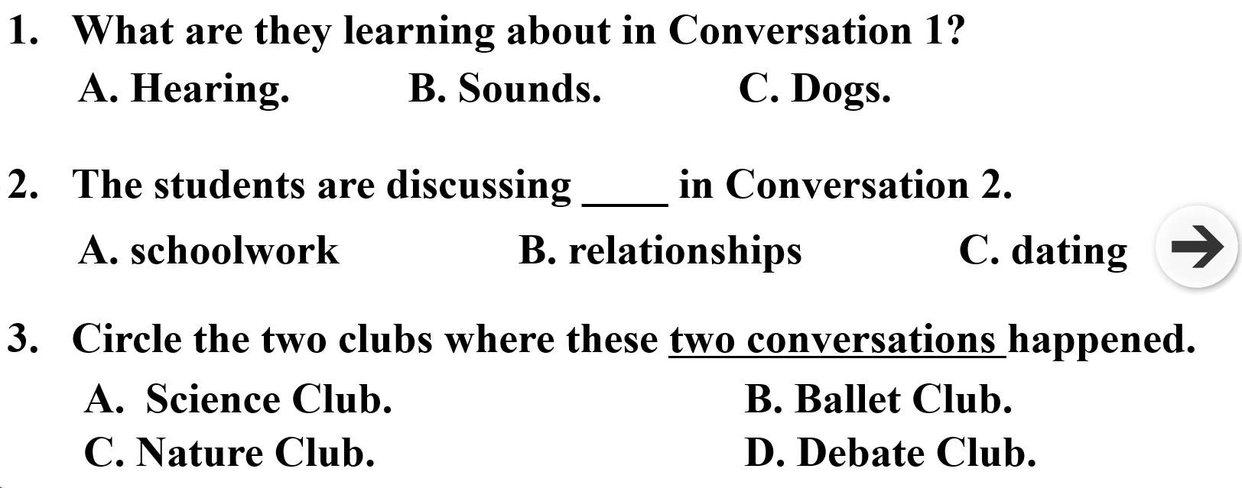

Read the questions and try to predict the answers together with students. Introduce the three sources we can guesses the answers from: the evidence available, personal experience, and one’s reasoning ability. Replay the conversation. More time is needed to be spent on conversation 1. Students may feel confused for the first time As more evidence available with the practice of blank filling, the predictions are refined and students can get the answer happily.

Don’t listen for a single word but for the whole sentence.

**Aims**

To predict the answers with the present choices.

**2. Task 2**: Listen for details

*— Listen and tick.*

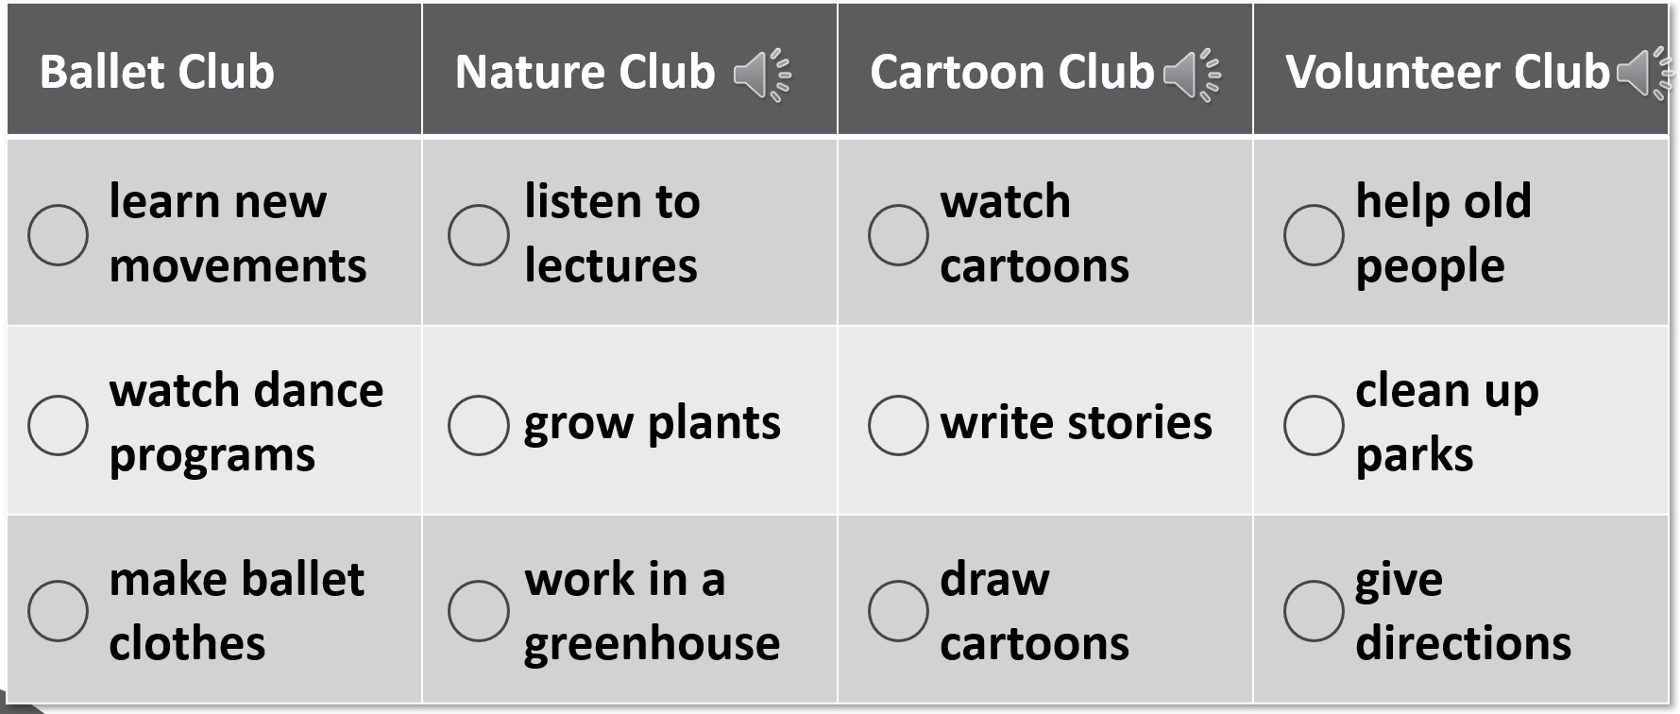

It is important to carefully go over the questions and the answer choices before listening. And listening for these information helps to draw a conclusion.

**Aims**

To practice listening for the detailed information and get a conclusion.

**Talking**

**Students’ Activities**

**Work in groups and choose one of the clubs from below, or create a new club you think others would be interested in joining.**

Discuss the following information: club name, slogan, aim, activities, meeting time and place.

Prepare an introduction for your club.

Make a poster if necessary. (share some for example)

Show their work!

**Aims**

To practise what students have learnt by having a conversation and encourage them to talk whatever they like.