**Effective Beginning and Ending in Practical Writing**

**Teaching Objectives:**

1. Students will be able to identify the communicative functions of beginnings and endings in practical writing.

2. Students will be able to apply appropriate communicative strategies in their own writing.

3. Students will be able to evaluate the effectiveness of beginnings and endings in practical writing.

**Teaching Key Points:**

1. Understanding the communicative functions of beginnings and endings in different writing genres.

2. Identifying appropriate communicative strategies for beginnings and endings.

3. Applying and practicing communicative strategies in writing.

**Teaching Difficult Points:**

1. Analyzing the effectiveness of beginnings and endings in practical writing.

2. Integrating communicative strategies into students' own writing.

**Teaching Process:**

1.Lead-in

- Introduce the communicative functions of beginnings and endings in practical writing.

- Explain that writing is a form of communication and that beginnings and endings are important for setting the tone and achieving the writing purpose.



2. Examples and Analysis

- Present examples of beginnings and endings in different writing genres (informal/formal, email/letter/poster).

- Analyze the effectiveness of each example in achieving its communicative purpose.

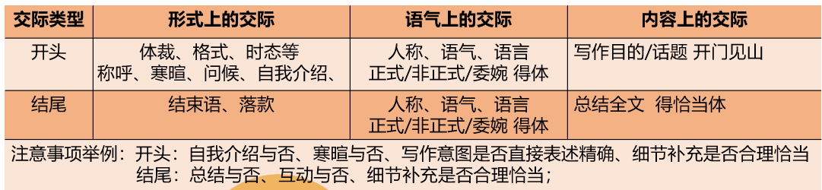

3. Group Discussion

- Divide students into groups to discuss the communicative strategies used in the examples.

- Have each group share their findings and discuss the effectiveness of the strategies.

4. Writing Practice

- Provide students with a writing prompt and ask them to write a beginning and ending on their own.

- Have students share their writing and receive peer feedback on the effectiveness of their beginnings and endings.

5. Summarization and Reflection

- Summarize the key points about the communicative functions of beginnings and endings.

- Reflect on the importance of these strategies for effective writing.

6. Homework Assignment

- Assign students to write a complete practical writing piece, focusing on the effectiveness of their beginnings and endings.

7. Conclusion

This teaching plan provides a structured approach to help students understand and apply the communicative functions of beginnings and endings in practical writing. It includes examples, discussion, writing practice, and reflection to promote learning and skill development.