**The World**（**1216-1231**）材料分析和教学目标：

本次选用的材料：①*Forbes*的*The Power Era (Taylor’s Version)*（泰勒·斯威夫特）、②*New Scientist*的*Great Wall of China is protected by a coat of lichen and moss*（地衣和苔藓护长城）、③*The Guardian*的*New Covid variant on rise, with prevalence greater for under-45s*（新冠病毒变体呈上升趋势，45岁以下人群患病率更高）、④*The Wall Street Journal*的*Is it true that shopping carts are full of germs?*（冰岛火山喷发会带来什么）和⑤BBC的新闻报道。通过语法填空、阅读理解、分析长难句、翻译句子、听力填空和词汇拓展等方式，让学生从多角度提升学习兴趣，提高分析句子、运用词块和听力能力。外媒英语新闻可以让学生体验真实语境下的语言运用，拓展学生的国际视野，了解时事，逐步提升跨文化沟通能力，形成正确的世界观、人生观和价值观。

**教学思路：**

**Part 1: News Report 1 *Forbes* (December 2023/January 2024 Pages 20-21 )**

**The Power Era (Taylor’s Version) 泰勒·斯威夫特**

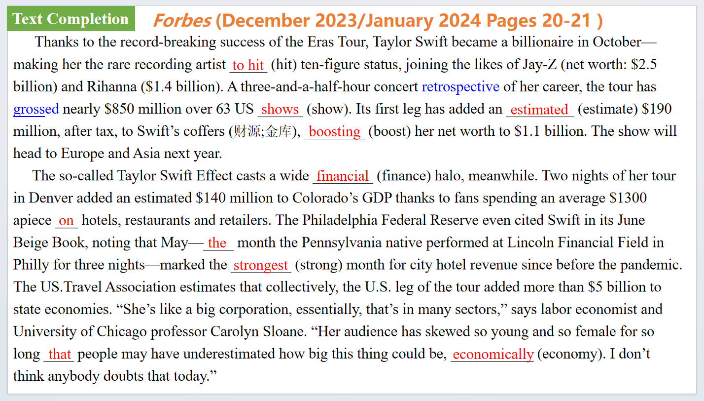

【设计意图】通过语篇填空的形式帮助学生理解新闻的主要内容，同时训练语言语法的运用能力：在语篇的视角下如何正确使用所给词汇，根据语法规则确定词汇的正确形式，使得文章通顺，激活学生的思维和语言。该新闻主题语境是关于“人与社会”中“社会热点问题”这一子主题，通过学习让学生了解泰勒·斯威夫特最近大热的现象。

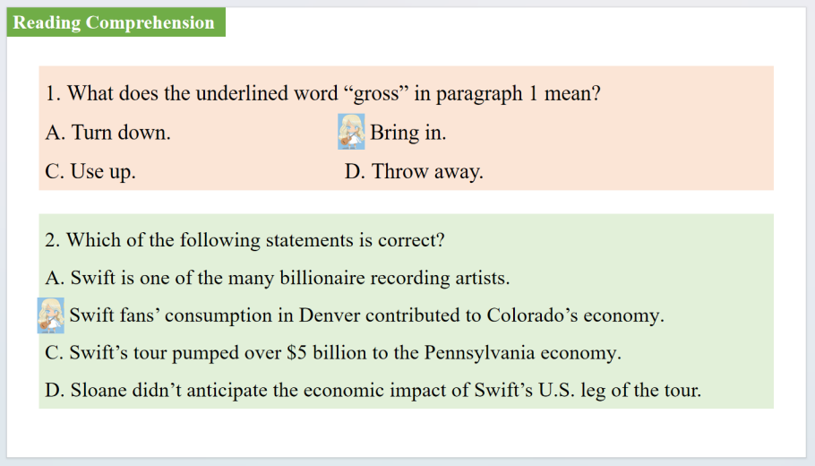

【设计意图】通过阅读理解的形式帮助学生理解新闻的主要内容。

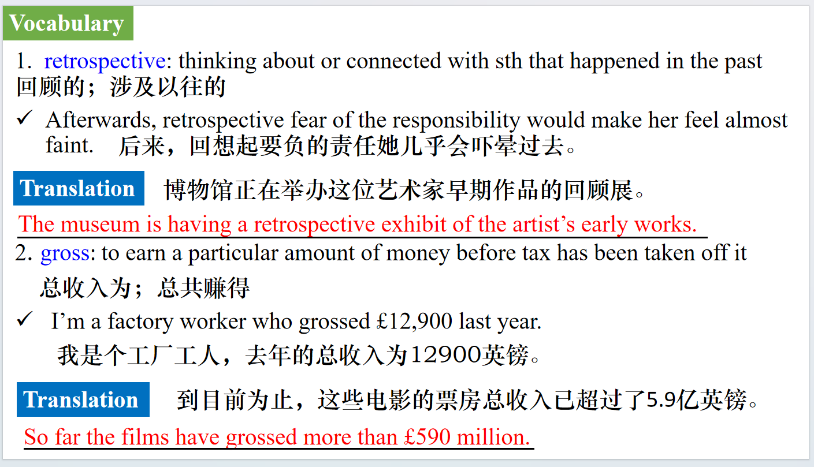

【设计意图】对文本中的词汇进行解读，并通过翻译句子对其进行巩固。

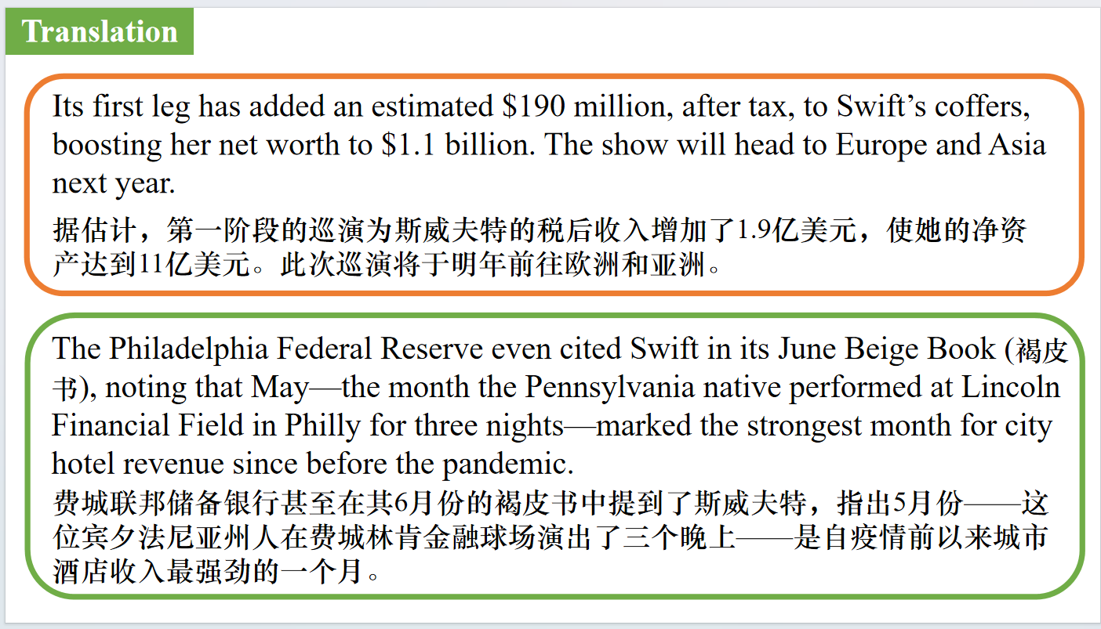

【设计意图】对文中的两个句子进行翻译练习，对其中单词、词组、句法进行巩固并关注句子结构。

**Part 2: News Report 2 *New Scientist* (16th December 2023 Page 11)**

**Great Wall of China is protected by a coat of lichen and moss**

**地衣和苔藓护长城**

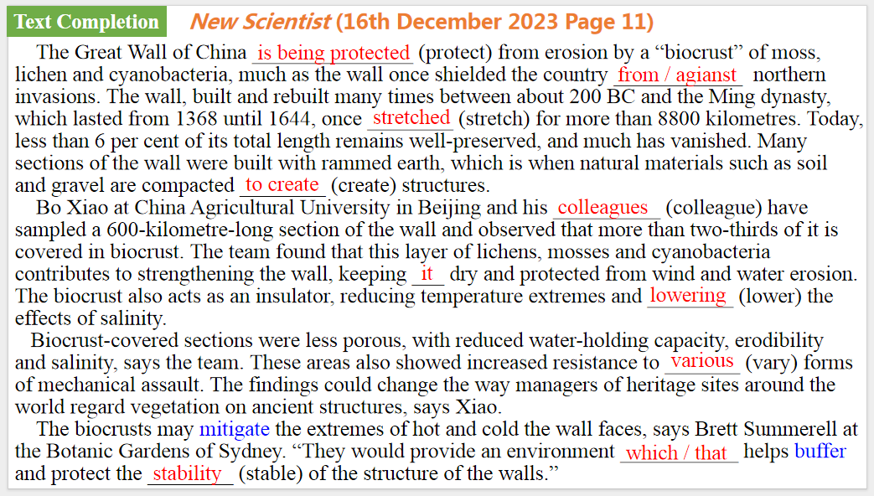

【设计意图】通过语篇填空的形式帮助学生理解新闻的主要内容，同时训练语言语法的运用能力：在语篇的视角下如何正确使用所给词汇，根据语法规则确定词汇的正确形式，使得文章通顺，激活学生的思维和语言。该新闻主题语境是关于“人与社会”中“物质与非物质文化遗产”这一子主题，通过学习让学生了解地衣和苔藓对长城的保护作用。

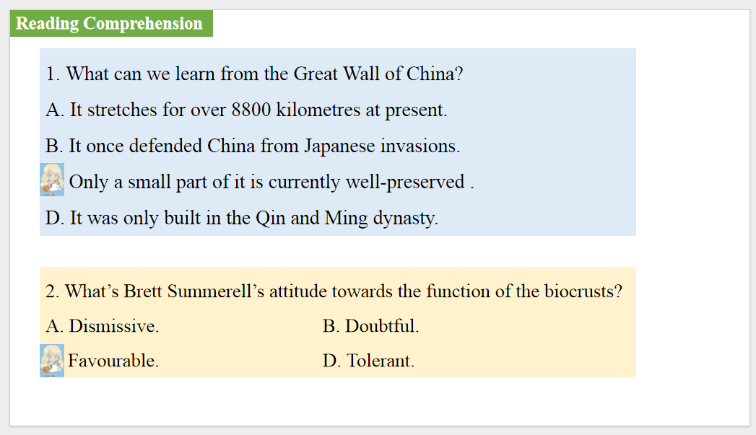

【设计意图】通过阅读理解的形式帮助学生理解新闻的主要内容。

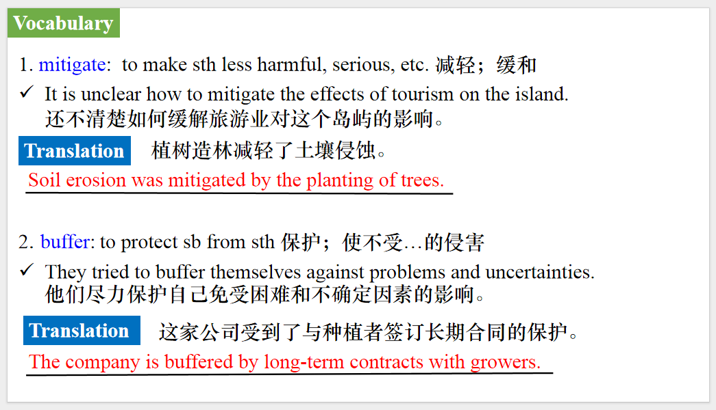

【设计意图】对文本中的词汇进行解读，并通过翻译句子对其进行巩固。

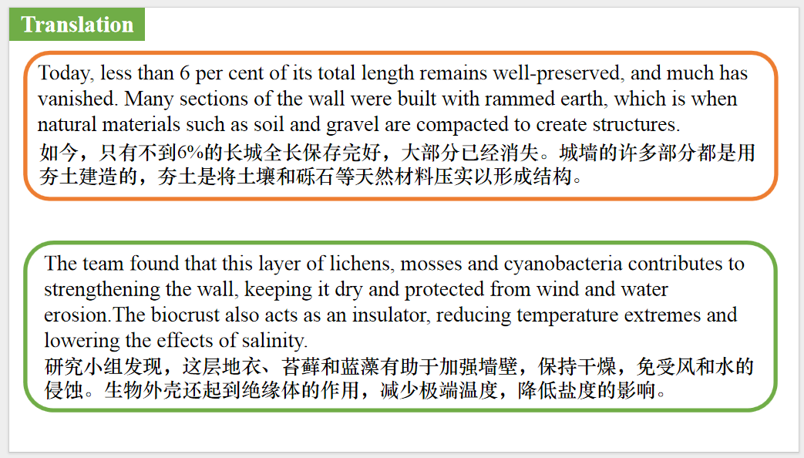

【设计意图】对文中的两个句子进行翻译练习，对其中单词、词组、句法进行巩固并关注句子结构。

**Part 3: News Report 3 *The Guardian (22nd December 2023 Page 11)***

**New Covid variant on rise, with prevalence greater for under-45s**

**新冠病毒变体呈上升趋势，45岁以下人群患病率高**

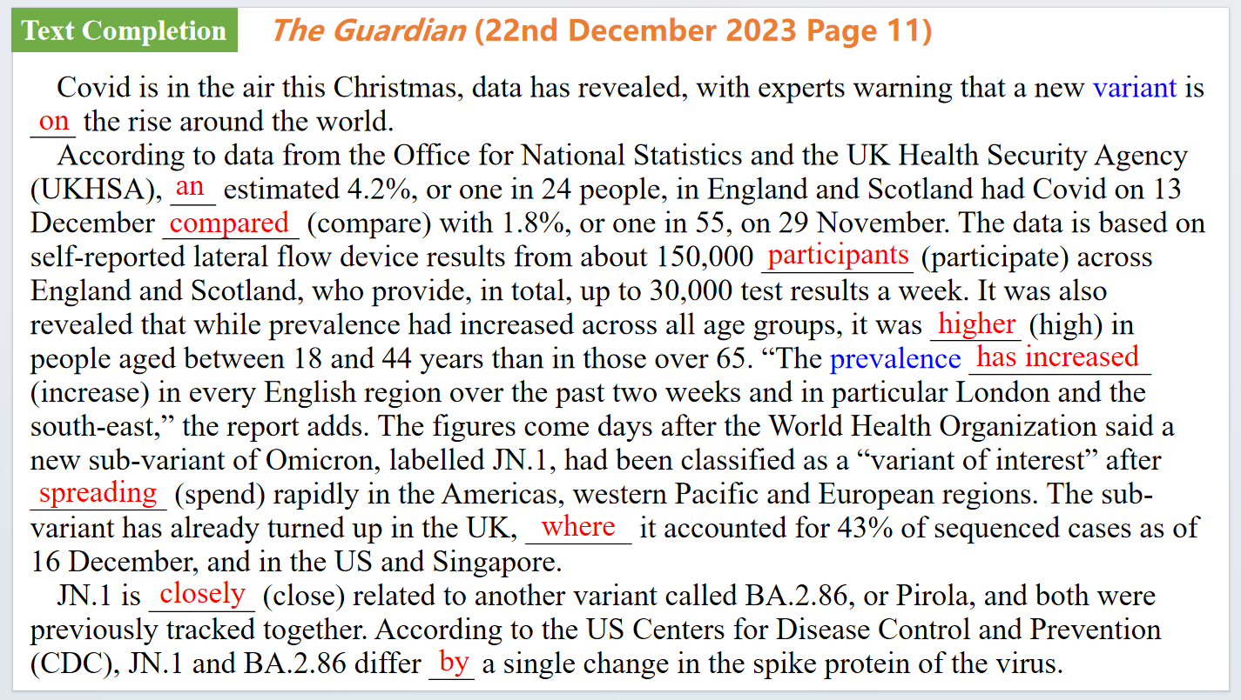

【设计意图】通过语篇填空的形式帮助学生理解新闻的主要内容，同时训练语言语法的运用能力：在语篇的视角下如何正确使用所给词汇，根据语法规则确定词汇的正确形式，使得文章通顺，激活学生的思维和语言。该新闻主题语境是关于“人与社会”中“社会热点问题”这一子主题，通过学习让学生了解新冠病毒变体呈上升趋势，45岁以下人群患病率高的社会现象。



【设计意图】对文本中的词汇进行解读，并通过翻译句子对其进行巩固。



【设计意图】对文中的两个句子进行翻译练习，对其中单词、词组、句法进行巩固并关注句子结构。

**Part 4: News Report 1 *The Wall Street Journal* ( (21st December 2023 A14 )**

**Scientists unsure about scope of impact as Iceland volcano spews toxic gas 冰岛火山喷发会带来什么**

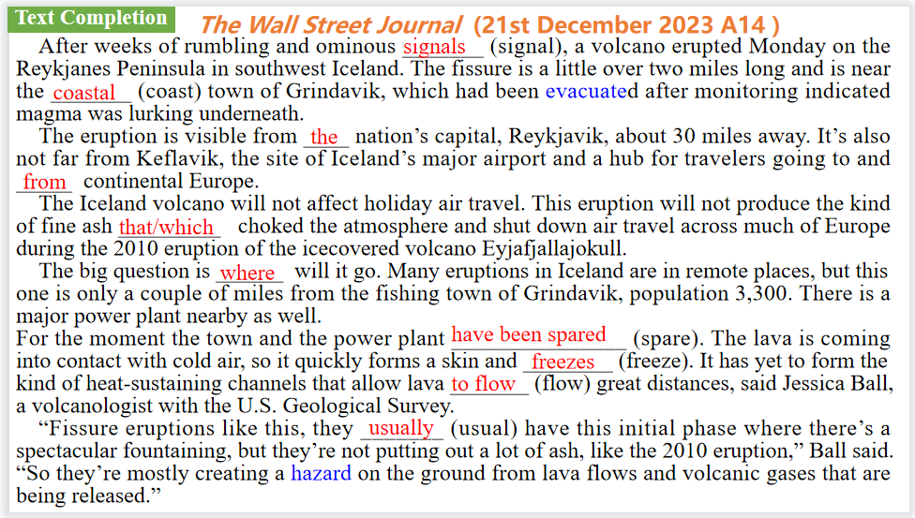

【设计意图】通过语篇填空的形式帮助学生理解新闻的主要内容，同时训练语言语法的运用能力：在语篇的视角下如何正确使用所给词汇，根据语法规则确定词汇的正确形式，使得文章通顺，激活学生的思维和语言。该新闻主题语境是关于“人与自然”中“自然灾害与防范，安全常识与自我保护”这一子主题，通过学习让学生了解冰岛火山喷发影响。

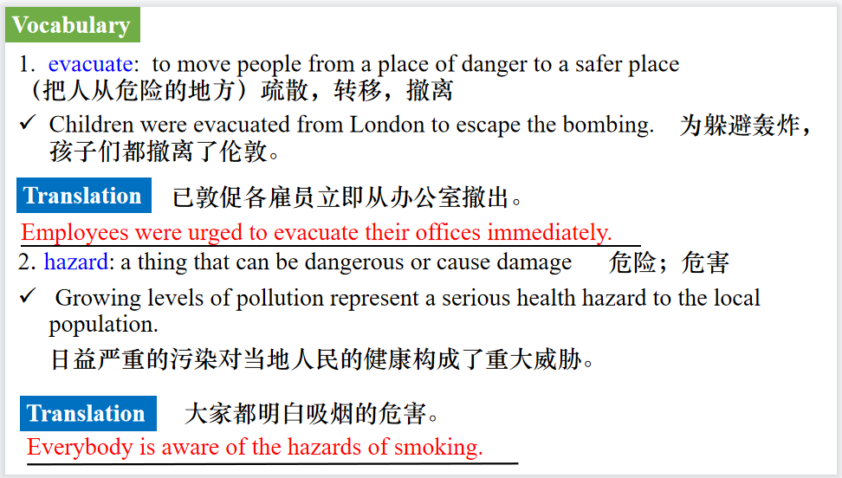

【设计意图】对文本中的词汇进行解读，并通过翻译句子对其进行巩固。

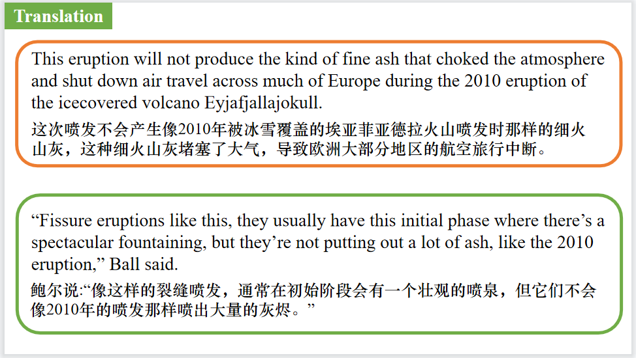

【设计意图】对文中的两个句子进行翻译练习，对其中单词、词组、句法进行巩固并关注句子结构。

**Part 5: BBC News 12/21/2023**

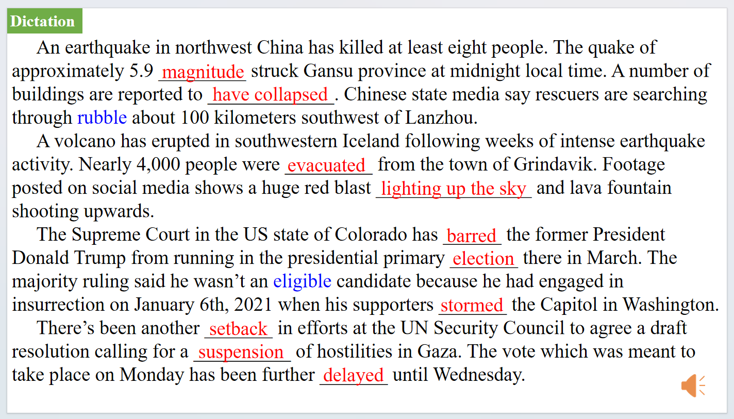

【设计意图】听一则材料，通过听力填空的方式理解文本，考察听力辨识词汇的能力。



【设计意图】对文本中的词汇进行解读，并通过翻译句子对其进行巩固。

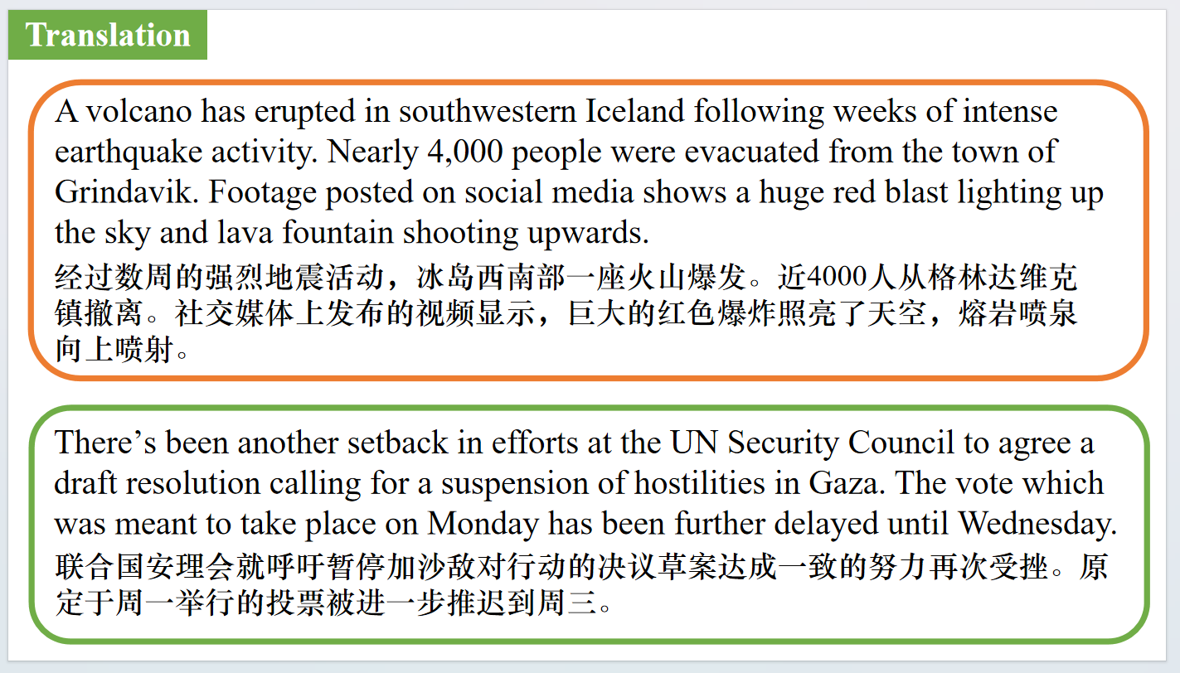

【设计意图】对文中的两个句子进行翻译练习，对其中单词、词组、句法进行巩固并关注句子结构。

附：外刊原文

**Part 1: News Report 1 *Forbes* (December 2023/January 2024 Pages 20-21 )**

**The Power Era (Taylor’s Version) 泰勒·斯威夫特**

“You are making me feel phenomenal,” Taylor Swift likes to tell the sold-out stadium of fans at each stop on her Eras Tour, right before she performs her feminist anthem “The Man”. Basking in the applause, the 34-year-old pop star then flexes her biceps and kisses the muscle, all of which whips the audience into a bigger frenzy. “You’re making me feel,” she says, as a smile spreads across her face, “*powerful*”.

Its brilliant theatrics, but Swiftie Nation knows that she is, and has always been, the true source of her own power—and 17 years into her remarkable career, Swift has never had more economic, cultural and political clout. All this has caused her to soar up the ranks of *Forbes*’ World’s 100 Most Powerful Women, from No. 79 in 2022 to No.5 this year.

Thanks to the record-breaking success of the Eras Tour, Swift became a billionaire in October—making her the rare recording artist to hit ten-figure status, joining the likes of Jay-Z (net worth: $2.5 billion) and Rihanna ($1.4 billion). A three-and-a-half-hour concert retrospective of her career, the tour has grossed nearly $850 million over 63 US shows. Its first leg has added an estimated $190 million, after tax, to Swift’s coffers, boosting her net worth to $1.1 billion. The show will head to Europe and Asia next year.

The so-called Taylor Swift Effect casts a wide financial halo, meanwhile. Two nights of her tour in Denver added an estimated $140 million to Colorado’s GDP thanks to fans spending an average $1300 apiece on hotels, restaurants and retailers. The Philadelphia Federal Reserve even cited Swift in its June Beige Book, noting that May—the month the Pennsylvania native performed at Lincoln Financial Field in Philly for three nights—marked the strongest month for city hotel revenue since before the pandemic. The US.Travel Association estimates that collectively, the U.S. leg of the tour added more than $5 billion to state economies.

“She’s like a big corporation, essentially, that’s in many sectors,” says labor economist and University of Chicago professor Carolyn Sloane. “Her audience has skewed so young and so female for so long that people may have underestimated how big this thing could be, economically. I don’t think anybody doubts that today.”

That predominantly young, female audience also followed Swift to the box office this year. Here again, she flexed her entrepreneurial muscle bypassing Hollywood studios to release The *Eras Tour* movie directly with AMC in October despite the fact that she had no traditional marketing apparatus at her back. No matter: Swift herself is the ultimate marketing machine. Stacy Jones, founder of marketing agency Hollywood Branded, estimates that over the last two years the singer has amassed more than $130 billion in “earned media”—a bit of a voodoo number that attempts to estimate the value of free publicity. Word of mouth and a few well-timed appearances at Kansas City Chiefs football games were more than enough visibility to get fans in the seats. The movie notched a $93 million opening weekend in the US.and has grossed more than $200 million worldwide.

As with the Eras Tour and film, much of Swift’s power stems from her direct control over her business. More impressive (and more lucrative) is the way in which she reclaimed ownership of her song catalog by rerecording albums that were part of a $300 million sale she alleges was done behind her back. She has so far rerecorded and released four of the six albums that were part of that sale. The most recent of these, 1989 (Taylor’s Version) set a Spotify record for most-streamed artist in a single day when it was released in late October. She now holds the No.1 spot on the platform, with 109 million monthly listeners.

*Forbes* estimates Swift’s catalog is worth $500 million: when you consider that Katy Perry and Justin Bieber sold the rights to their respective music catalogs in 2023 for more than $200 million the decision to make *Taylor’s Versions* looks even more masterful. As formidable as Swift is, she is not however the most powerful woman in the world. That title goes to European Commission President Ursula von der Leyen, whose policy and budgetary decisions affect Europe’s 450 million people. That number soon might soar past 500 million: In her annual state of the union speech in September, von der Leyen reaffirmed her intent to make Ukraine and countries in the Western Balkans EU members.

No.2 this year is Christine Lagarde, the European Central Bank president who is shaping Europe’s monetary policy at a moment of high inflation. Also coming in ahead of Swift is U.S. Vice President Kamala Harris (No.3) and Italian prime minister Giorgia Meloni (No.4) Both are the first women to hold their respective positions, and Meloni is asserting her influence by proposing reforms to Italy’s constitution that would allow for the direct election of the prime minister. “All those with hard power are truly powerful women” says Jones, the branding expert, “but they are not going to be able to change the world in the way that Taylor Swift is.”

**Part 2: News Report 2 *New Scientist* (16th December 2023 Page 11)**

**Great Wall of China is protected by a coat of lichen and moss**

**地衣和苔藓护长城**

The Great Wall of China is being protected from erosion by a “biocrust” of moss, lichen and cyanobacteria, much as the wall once shielded the country from northern invasions.

The wall, built and rebuilt many times between about 200 BC and the Ming dynasty, which lasted from 1368 until 1644, once stretched for more than 8800 kilometres.Today, less than 6 per cent of its total length remains well-preserved, and much has vanished.

Many sections of the wall were built with rammed earth,which is when natural materials such as soil and gravel are compacted to create structures.

Bo Xiao at China Agricultural University in Beijing and his colleagues have sampled a

600-kilometre-long section of the wall and observed that more than two-thirds of it is covered in biocrust. The team found that this layer of lichens, mosses and cyanobacteria contributes to strengthening the wall,keeping it dry and protected from wind and water erosion.The biocrust also acts as an insulator, reducing temperature extremes and lowering the effects of salinity.

Biocrust-covered sections were less porous, with reduced water-holding capacity, erodibility and salinity,says the team. These areas also showed increased resistance to various forms of mechanical assault.

The findings could change the way managers of heritage sites around the world regard vegetation on ancient structures, says Xiao.

The biocrusts may mitigate the extremes of hot and cold the wall faces, says Brett Summerell at the Botanic Gardens of Sydney. “They would provide an environment that helps buffer and protect the stability of the structure of the walls.”

**Part 3: News Report 3 *The Guardian* (22nd December 2023 Page 11)**

**New Covid variant on rise, with prevalence greater for under-45s**

**新冠病毒变体呈上升趋势，45岁以下人群患病率更高**

Covid is in the air this Christmas, data has revealed, with experts warning that a new variant is on the rise around the world.

According to data from the Office for National Statistics and the UK Health Security Agency (UKHSA), an estimated 4.2%, or one in 24 people, in England and Scotland had Covid on 13 December compared with 1.8%, or one in 55, on 29 November.

The data is based on self-reported lateral flow device results from about 150,000 participants across England and Scotland, who provide, in total, up to 30,000 test results a week. It was also revealed that while prevalence had increased across all age groups, it was higher in people aged between 18 and 44 years than in those over 65.

“The prevalence has increased in every English region over the past two weeks and in particular London and the south-east,” the report adds.

The figures come days after the World Health Organization said a new sub-variant of Omicron, labelled JN.1, had been classified as a “variant of interest” after spreading rapidly in the Americas, western Pacific and European regions. The sub-variant has already turned up in the UK, where it accounted for 43% of sequenced cases as of 16 December, and in the US and Singapore.

JN.1 is closely related to another variant called BA.2.86 , or Pirola, and both were previously tracked together. According to the US Centers for Disease Control and Prevention (CDC), JN.1 and BA.2.86 diff er by a single change in the spike protein of the virus.

**Part 4: News Report 1 *The Wall Street Journal* ( (21st December 2023 A14 )**

**Scientists unsure about scope of impact as Iceland volcano spews toxic gas 冰岛火山喷发会带来什么**

BY JOEL ACHENBACH

After weeks of rumbling and ominous signals, a volcano erupted Monday on the Reykjanes Peninsula in southwest Iceland. The fissure is a little over two miles long and is near the coastal town of Grindavik, which had been evacuated after monitoring indicated magma was lurking underneath.

The eruption is visible from the nation’s capital, Reykjavik, about 30 miles away. It’s also not far from Keflavik, the site of Iceland’s major airport and a hub for travelers going to and from continental Europe.

Will the Iceland volcano affect holiday air travel?

No. The airport remains open. This eruption will not produce the kind of fine ash that choked the atmosphere and shut down air travel across much of Europe during the 2010 eruption of the icecovered volcano Eyjafjallajokull.

That explosive eruption vividly demonstrated what happens when hot lava meets cold frozen water. Known as a phreatomagmatic eruption, the molten rock — magma — made contact with ice and meltwater and flashed to steam.

“That’s an explosive process that breaks the lava into very fine pieces that are able to move higher into the atmosphere,” said Diana Roman, a volcanologist at the Carnegie Institution for Science in Washington.

By contrast, the volcanic system on the Reykjanes Peninsula is dusted with December snow but is far from the glaciers of Iceland.

The lava, Roman said, “is coming out as liquid chunks that are cooling in the air and are falling down to create what we call cinder, or spatter, or bombs.”

Iceland’s foreign minister, Bjarni Benediktsson, announced on X, formerly known as Twitter, “there are no disruptions to flights to and from Iceland and international flight corridors remain open.”

How dangerous is this eruption of searing hot lava?

This is not a tourist-friendly eruption. It is emitting toxic gas. And this is searing hot lava, even by lava standards, at roughly 2000 degrees F.

“It’s on the hot end of the spectrum of lavas,” Roman said.

The big question is where will it go. Many eruptions in Iceland are in remote places, but this one is only a couple of miles from the fishing town of Grindavik, population 3,300. There is a major power plant nearby as well.

For the moment the town and the power plant have been spared. The lava is coming into contact with cold air, so it quickly forms a skin and freezes. It has yet to form the kind of heat-sustaining channels that allow lava to flow great distances, said Jessica Ball, a volcanologist with the U.S. Geological Survey.

“Fissure eruptions like this, they usually have this initial phase where there’s a spectacular fountaining, but they’re not putting out a lot of ash, like the 2010 eruption,” Ball said. “So they’re mostly creating a hazard on the ground from lava flows and volcanic gases that are being released.”

The eruption is also losing much of its initial intensity, according to the Icelandic Meteorological Office.

“The lava flow is estimated to be about one-quarter of what it was at the beginning of the eruption on 18 December, and a third of the original fissure is active. The lava fountains are also lower than at the start of the eruption, reaching about 30 meters at their highest,” the office reported Tuesday on its website.

But the situation, like the molten rock, is fluid.

“We have no idea how large this fissure will grow,” said Suzan van der Lee, a Northwestern University seismologist who visited that region of Iceland this summer. “There’s a lot of magma down there, and it’s hard to know how much of it will come out. If all of it comes out at once, that’s pretty disastrous.”

Did scientists know the volcano would erupt?

Unlike big earthquakes, many volcanoes telegraph their activity well in advance, typically with increasing tremors. Volcano researchers in Iceland had been anticipating an eruption this fall due to enhanced seismic activity, and a swarm of earthquakes Sunday signaled that the event was imminent.

But that kind of advance warning depends on routine monitoring. An obvious outlier is the Tonga eruption in January 2022, in which a submerged volcano set off an unexpectedly explosive event, triggering a tsunami and sending a giant column of ash into the stratosphere.

Why does Iceland have so many volcanoes?

The nation sits squarely on the Mid-Atlantic Ridge, a mountain chain where two major tectonic plates are spreading apart. That process, a key element of plate tectonics, is slowly widening the Atlantic Ocean. Almost all of the ridge is submerged. The new eruption is happening on a peninsula that marks where the ridge meets the southwest shore of Iceland.

“That whole peninsula is like a volcano. And the whole Mid-Atlantic Ridge is a line of volcanoes,” van der Lee said.