**Good Listening Habits**

**Good habits** formed at youth make all the difference

------Aristotle 亚里士多德

**教学设计：**

**☆Teaching objectives：**

*To grasp the basic good habits of listening

**☆Teaching important points and difficult points：**

*5 important habits: **Habit 1: Take deep breaths to change your state to be focused**

**Habit 2:READ IN ADVANCE AND AS FAST AS POSSIBLE**

**Habit3: make use of the information in the questions and choices to predict**

**Habit 4: Circle the words and read the questions and focus on what you are listening for.**

**Habit5: 1.Read the text of your wrong questions.2. Understand new words and expressions**

**☆Teaching methods：**

Group discussion, live presentation, pair work and individual task

**☆Teaching aids：**

handout learning material, PPT and the other normal teaching tools

**☆Teaching procedures：**

Step 1： Lead in(before-listening)

一、Ask students several questions and let them tick their answers

1.Did you feel noisy just now?

1. Yes B. No

2.Are you feeling focused now?

1. Yes B. A little C. Not at all

3.What do you think is the best state(状态) of doing listening exercise?

1. Focused and calm B. Not focused and distracted
2. Does the breathing practice help a little when you are trying to be focused ?
3. Yes B. No

If the answer is yes, make it a habit when doing listening exercises. If not, try more!

二、Learn to make a conclusion: what should we do before listening?

**Habit 1: Take deep breaths to change your state to be focused**

三、Listen to a short dialogue and do Listening exercise 1 without giving them enough time to read in advance

1．What will the woman do this afternoon?（17年全国2卷）

A．Do some exercise.

B．Go shopping.

C．Wash her clothes.

2．Why does the woman call the man?

A ．To cancel a flight.

B． To make an apology.

C． To put off a meeting.

3．How much more does David need for the car?

A．$ 5,000. B．$20,000. C．$25,000.

四、Learn to make a conclusion: what should we do after we have the listening materials?

**Habit 2:READ IN ADVANCE AND AS FAST AS POSSIBLE**

Step 2：listen to long dialogues and finish Listening exercise 2（while listening)

**三．Listening exercise 2: long dialogues**

听下面一段较长对话，回答以下小题。(23年全国乙卷)

6. Which of the following does the woman dislike?

A. The bedroom.  B. The sitting room.  C. The kitchen.

7. What does the woman suggest they do next?

1. Go to another agency.
2. See some other flats.

C. Visit the neighbours.

听下面一段独白，回答以下小题。(23年全国乙卷)

17. Where was Open Tchaikovsky Competition held in 1986?

A. In Moscow.  B. In Chelyabinsk.  C. In Berlin.

18. What does Maxim say about the competition he attended at 10?

A. It inspired many young musicians.

B. It was the music event of his dreams.

C. It was a life-changing experience.

19. Which kind of music are the young players required to play?

A. Rock music.  B. Pop music.  C. Classical music.

20. What does Maxim value most in young players’ performance?

A. Expressiveness.  B. Smoothness.  C. Completeness.

五、Learn to make a conclusion:After reading in advance, what should we do at first?

**Habit3: make use of the information in the questions and choices to predict**

六、listen to short dialogues and finish Listening exercise 3

**四．Listening exercise 3: short dialogues**

1．What will the woman do this afternoon?（17年全国2卷）

A．Do some exercise.　　 B．Go shopping.  C Wash her clothes.

2．Why does the woman call the man?

A ．To cancel a flight.  B． To make an apology.   C．  To put off a meeting.

3．How much more does David need for the car?

A．$ 5,000.          B．$20,000.        C．$25,000.

4．What is Jane doing?

A．Planning a tour.    B．Calling her father.  C．Asking for leave.

5 ．How does the man feel?

1. Tired.          B．Dizzy.          C．Thirsty.

**Ask: What do we read for?**

1. __________
2. __________

(How to understand meanings?)

①Circle the key words in the choices

②Use some Chinese to reduce your memory pressure

③Read the questions and focus on what you are listening for.

七、Learn to make a conclusion: when reading, focus on what you are listening for. If possible, you can write some Chinese to reduce your memory pressure

**Habit 4: Circle the words and read the questions and focus on what you are listening for.**

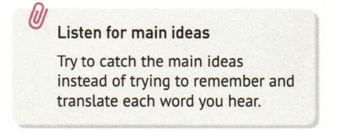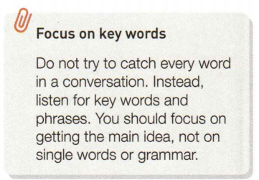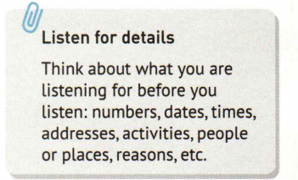

Step 3: After listening, how to deal with the wrong choices?（After listening)

**Habit5: 1.Read the text of your wrong questions.2. Understand new words and expressions**

**Self-assessment(自我评估)**

1. Have you mastered how to change to the best state for listening？□
2. Have you kept it in mind to read the questions in advance and as fast as possible?□
3. Can you do the prediction ?□
4. Have you learned to read the questions and choices for pronunciations and meanings?□
5. Can you remember to check the texts to learn new words and read?□

**Listening Materials:**

**Text 1**

M: Let’s go for a nice walk into the country this afternoon.

W: I certainly could enjoy the exercise, but I’ve agreed to go with Alice to buy some clothes.

**Text 2**

W: Hello, Mr. Smith. I’m afraid Dr. Brown won’t be able to see you today. He’s still waiting for a flight out of New York. He said he would meet you tomorrow afternoon. Is it OK?

M: Sounds good. Thank you for calling.

**Text 3**

W: David, have you saved enough for the car?

M: I have$20, 000 now. And the car costs 25, 000. My parents said they would like to help, but I don’t want to use their money.

**Text 4**

W: Dr. Block, I need to take a few days off, because my father is coming over to visit. And I need to show him around the city.

M: OK, Jane. But be sure to come back to work next week.

**Text 5**

M: Amy, my head is spinning. It must be a touch of the sun.

W: You’d better lie back still for a while. Take it easy for the rest of the day, and stay in the shade. It’s too hot today.

**Text 6（66词）挑选公寓**

W: What do you think, Terry?

M: Well, it has one more bedroom than the last flat and the sitting room is big.

W: But there is not enough cupboard space in the kitchen.

M: It’s cheaper than the last one we saw and it is in a good neighborhood.

W: Well, maybe we’ll have to see if the agent has anything else to show us.

【词汇】agent n. （房产）中介

**Text 10（190词）音乐比赛裁判讲演**

M: Hello, I’m Maxim Vengerov, and I’m very happy to share with you my connection with open Tchaikovsky competition. It was June 1986 when I came to Moscow to participate in open Tchaikovsky competition at the age of 10 from Chelyabinsk. This was actually the turning point of my life. Then I attended a world music festival in Berlin. And it was interesting to say that a kid made his breakthrough already at the age of ten. And that was me. Now as a judge of the competition, I can see clearly the huge challenges facing the musicians in the competition. Where else can you see young players playing within ten days classical works and Russian traditional music before coming to the final stage? As a musician, it’s important to give maximum attention and time to your own reflections of your own feelings. So, what I’m really looking for in the competition is to meet someone who can touch me musically. I want to see the seed, at least the seed of the great tree that can grow. I would go for this violinist. I would go for this musician.

【词汇与句子】

open Tchaikovsky competition 柴可夫斯基公开赛 Chelyabinsk （俄罗斯）车里雅宾斯克

breakthrough 突破 go for 选择；偏好