**The World**（**1001-1015**）材料分析和教学目标：

本次选用的材料：①《纽约时报》的*In France, the World Cup Takes the Spotlight*（法国橄榄球世界杯激情开赛）、②《*BBC*野生生物》的*Highest ever ocean temperatures recorded*（有史以来最高的海洋温度）、③《泰晤士报》的*Nobel for literature goes to Norwegian minimalist* （诺贝尔文学奖授予挪威极简主义者）④《国家地理》的*Solar Power from Space*（来自太空的太阳能）和⑤VOA的视频新闻报道。通过语法填空、阅读理解、分析长难句、翻译句子、听力填空和词汇拓展等方式，让学生从多角度提升学习兴趣，提高分析句子、运用词块和听力能力。外媒英语新闻可以让学生体验真实语境下的语言运用，拓展学生的国际视野，了解时事，逐步提升跨文化沟通能力，形成正确的世界观、人生观和价值观。

**教学思路：**

**Part 1: News Report 1《纽约时报》2023年10月2日 44页**

**In France, the World Cup Takes the Spotlight**

**法国橄榄球世界杯激情开赛**

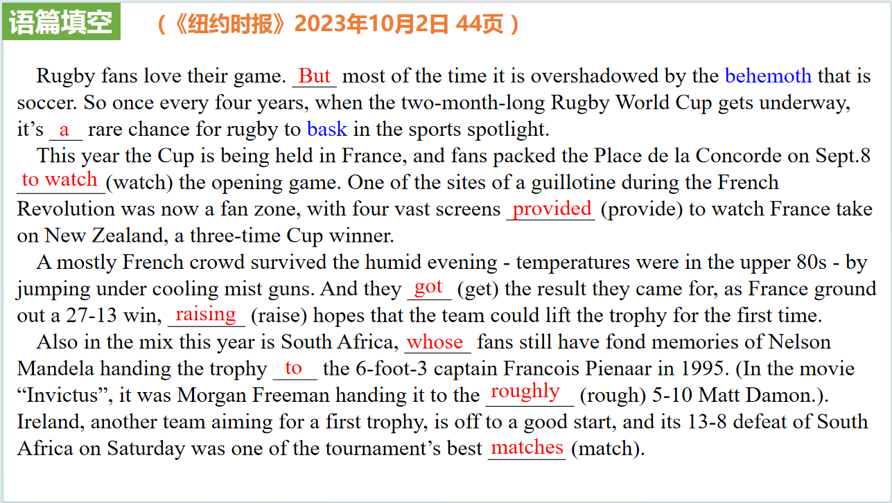

【设计意图】通过语篇填空的形式帮助学生理解新闻的主要内容，同时训练语言语法的运用能力：在语篇的视角下如何正确使用所给词汇，根据语法规则确定词汇的正确形式，使得文章通顺，激活学生的思维和语言。该新闻主题语境是关于“人与社会”中“大型体育赛事”这一子主题，通过学习让学生了解今年法国橄榄球世界杯的概况。

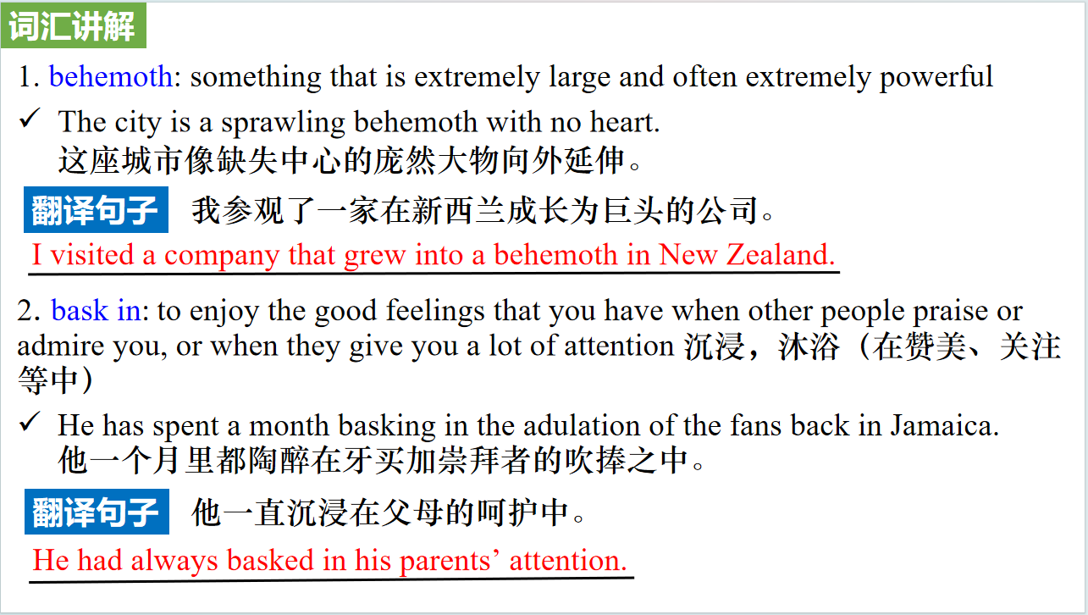

【设计意图】对文本中的词汇进行解读，并通过翻译句子对其进行巩固。

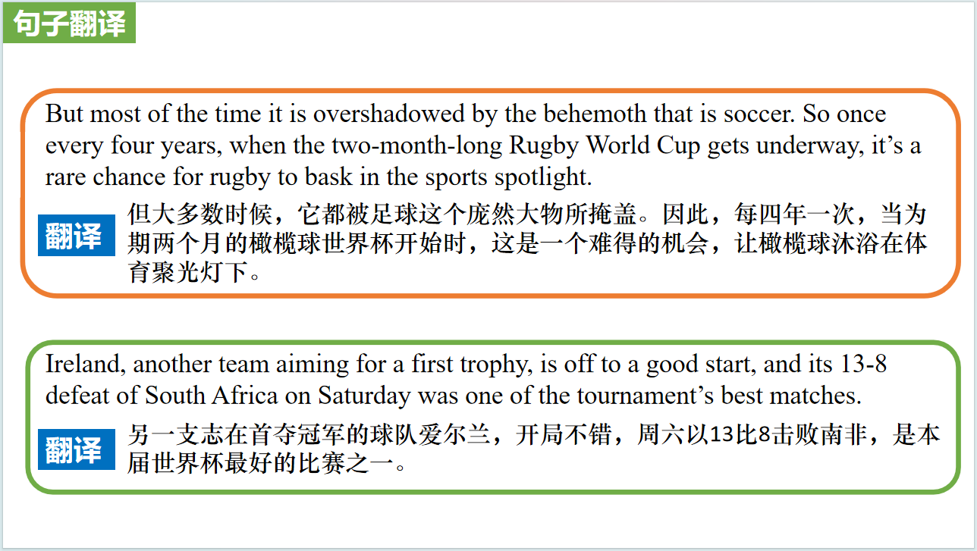

【设计意图】对文中的两个句子进行翻译练习，对其中单词、词组、句法进行巩固并关注句子结构。

**Part 2: News Report 2《BBC野生生物》2023年10月刊 13页**

**Highest ever ocean temperatures recorded**

**有史以来最高的海洋温度**

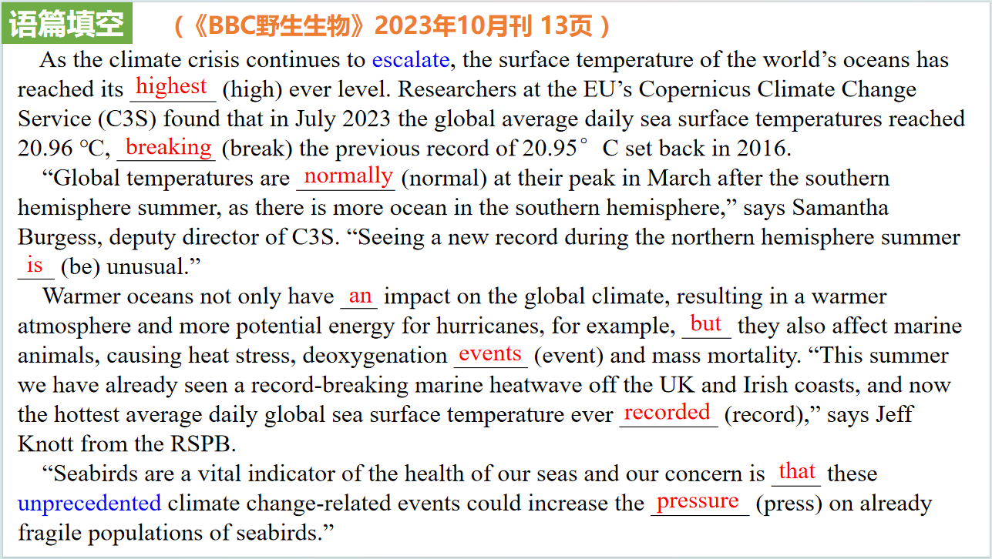

【设计意图】通过语篇填空的形式帮助学生理解新闻的主要内容，同时训练语言语法的运用能力：在语篇的视角下如何正确使用所给词汇，根据语法规则确定词汇的正确形式，使得文章通顺，激活学生的思维和语言。该新闻主题语境是关于“人与自然”中“自然环境保护”这一子主题，通过学习让学生了解到海洋变暖不仅会对全球气候产生影响，还会影响海洋动物。

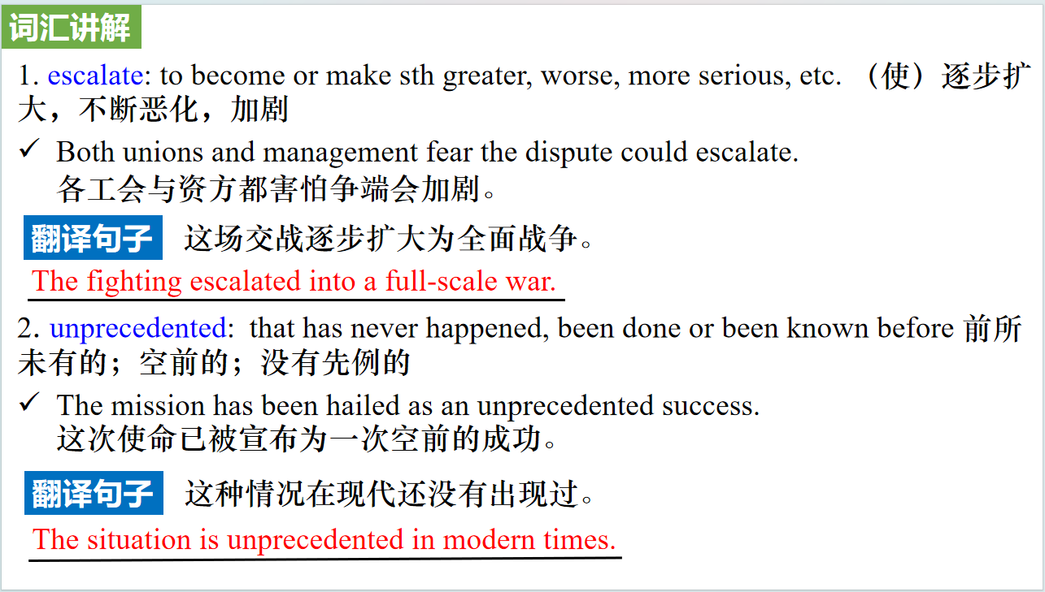

【设计意图】对文本中的词汇进行解读，并通过翻译句子对其进行巩固。

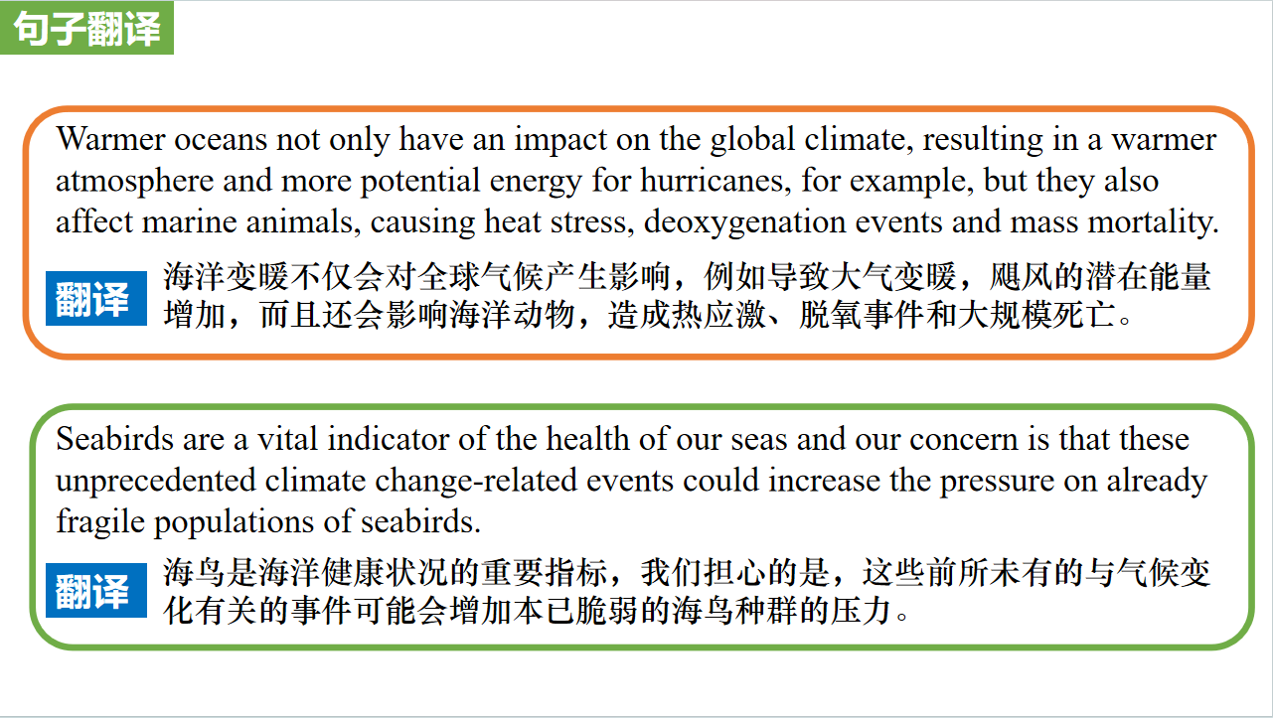

【设计意图】对文中的两个句子进行翻译练习，对其中单词、词组、句法进行巩固并关注句子结构。

**Part 3: News Report 3《泰晤士报》2023年10月6日 13页**

**Nobel for literature goes to Norwegian minimalist**

**诺贝尔文学奖授予挪威极简主义者**

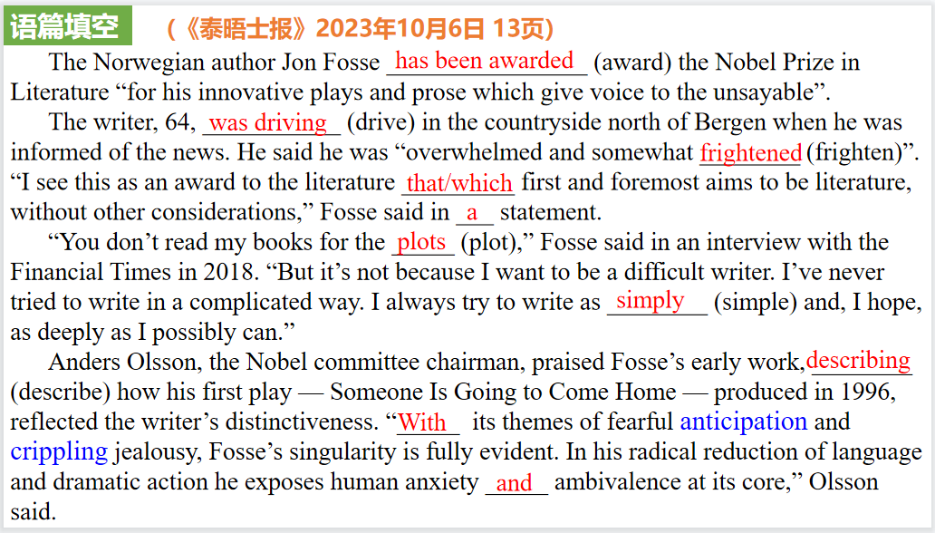

【设计意图】通过语篇填空的形式帮助学生理解新闻的主要内容，同时训练语言语法的运用能力：在语篇的视角下如何正确使用所给词汇，根据语法规则确定词汇的正确形式，使得文章通顺，激活学生的思维和语言。该新闻主题语境是关于“人与社会”中“社会热点问题”这一子主题，通过学习让学生了解瑞典文学院宣布将2023年诺贝尔文学奖授予挪威剧作家约恩·福瑟（Jon Fosse），授奖词为：“创新的戏剧和散文，为不可言说的事情发声”。

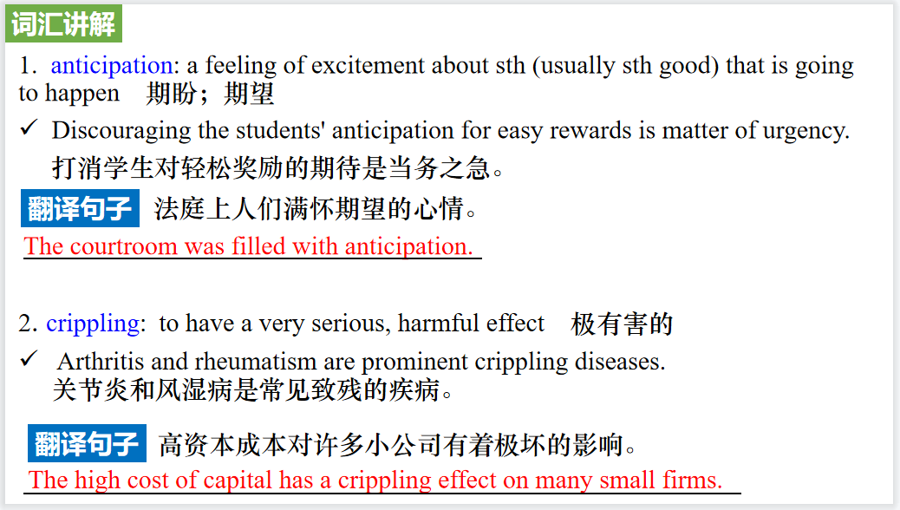

【设计意图】对文本中的词汇进行解读，并通过翻译句子对其进行巩固。

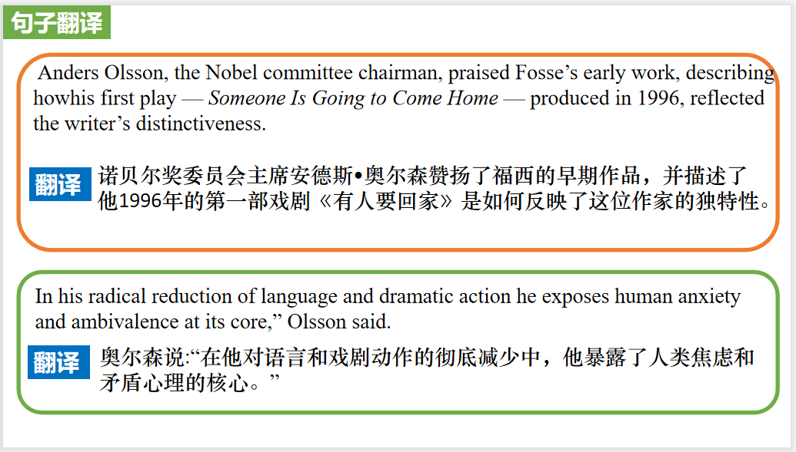

【设计意图】对文中的两个句子进行翻译练习，对其中单词、词组、句法进行巩固并关注句子结构。

**Part 4: News Report 4《国家地理》2023年10月刊 EXPLORE版面**

**Solar Power from Space 来自太空的太阳能**

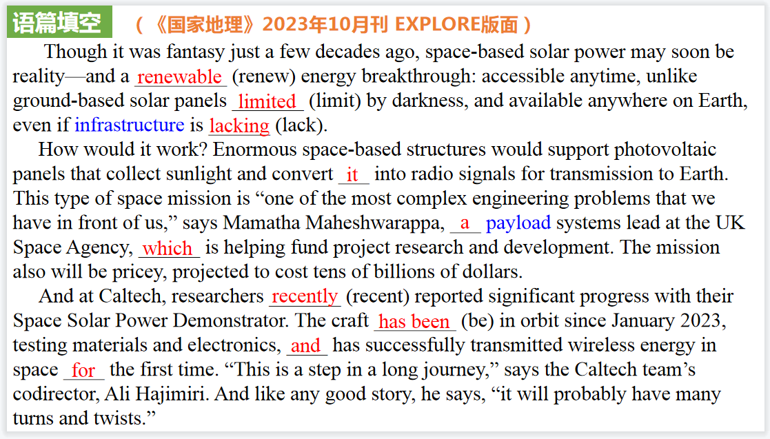

【设计意图】通过语篇填空的形式帮助学生理解新闻的主要内容，同时训练语言语法的运用能力：在语篇的视角下如何正确使用所给词汇，根据语法规则确定词汇的正确形式，使得文章通顺，激活学生的思维和语言。该新闻主题语境是关于“人与自然”中“自然科学研究成果”这一子主题，通过学习让学生了解一种利用太空太阳能的技术。

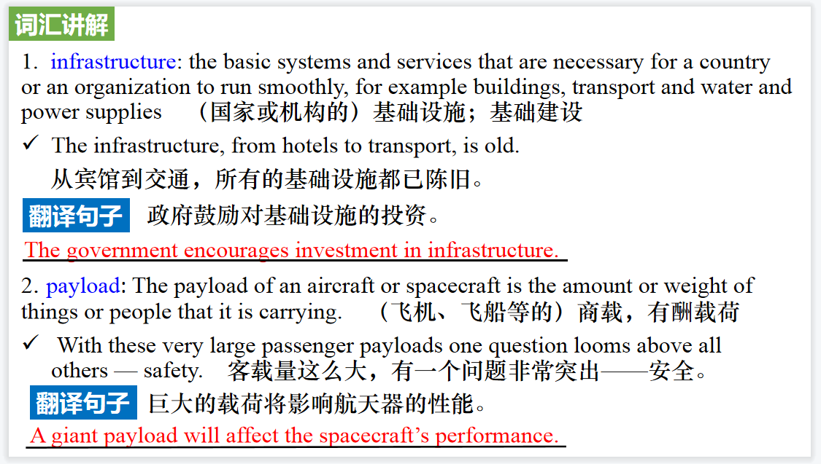

【设计意图】对文本中的词汇进行解读，并通过翻译句子对其进行巩固。

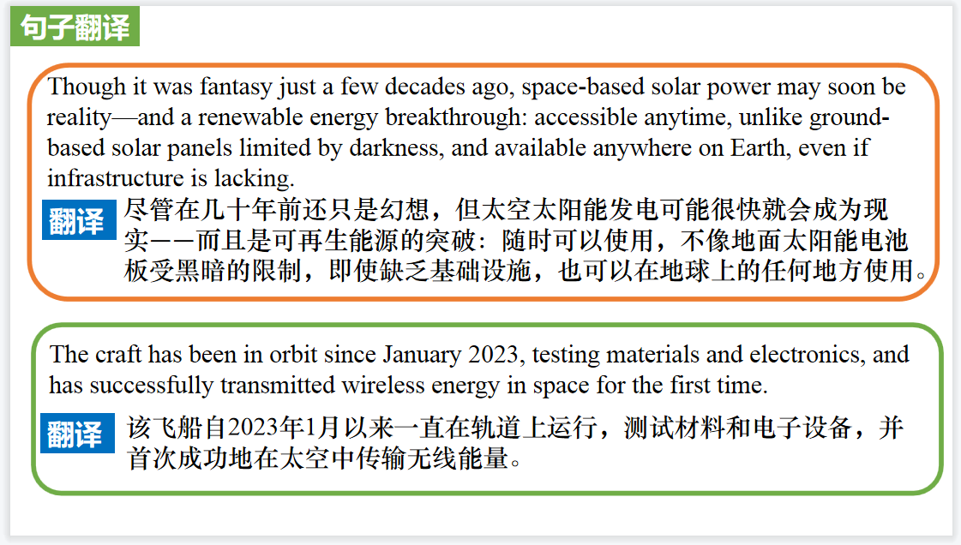

【设计意图】对文中的两个句子进行翻译练习，对其中单词、词组、句法进行巩固并关注句子结构。

**Part 5: VOA 10/03/2023**

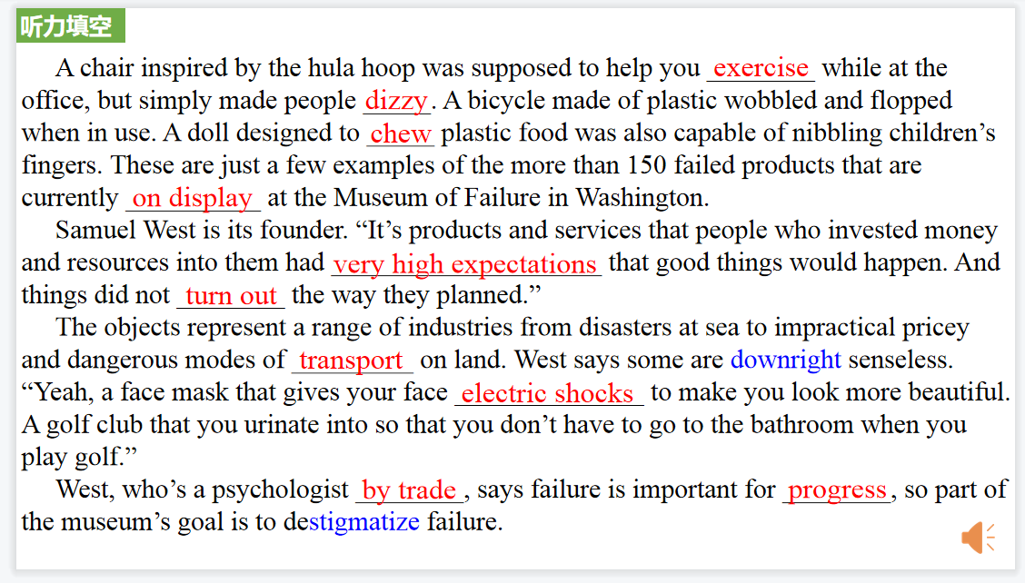

【设计意图】听一则材料，通过听力填空的方式理解文本，考察听力辨识词汇的能力。

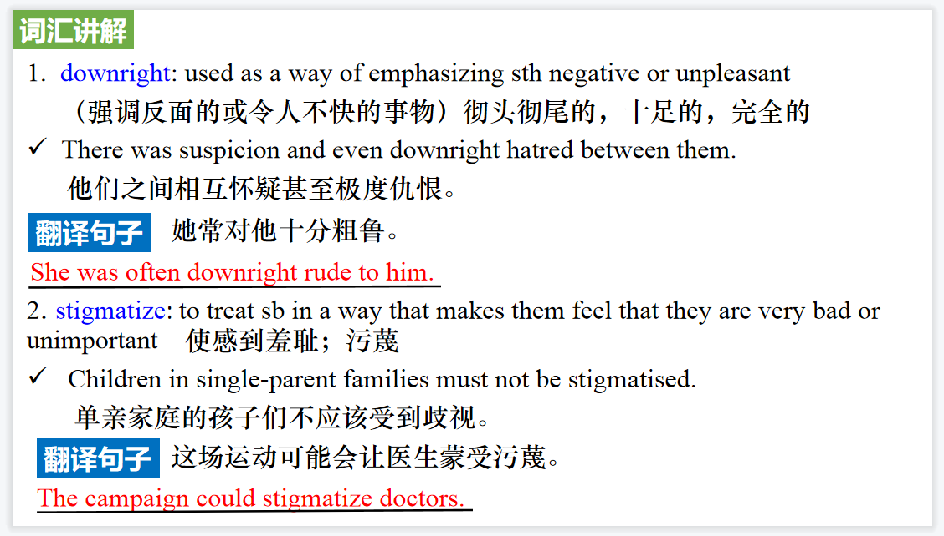

【设计意图】对文本中的词汇进行解读，并通过翻译句子对其进行巩固。

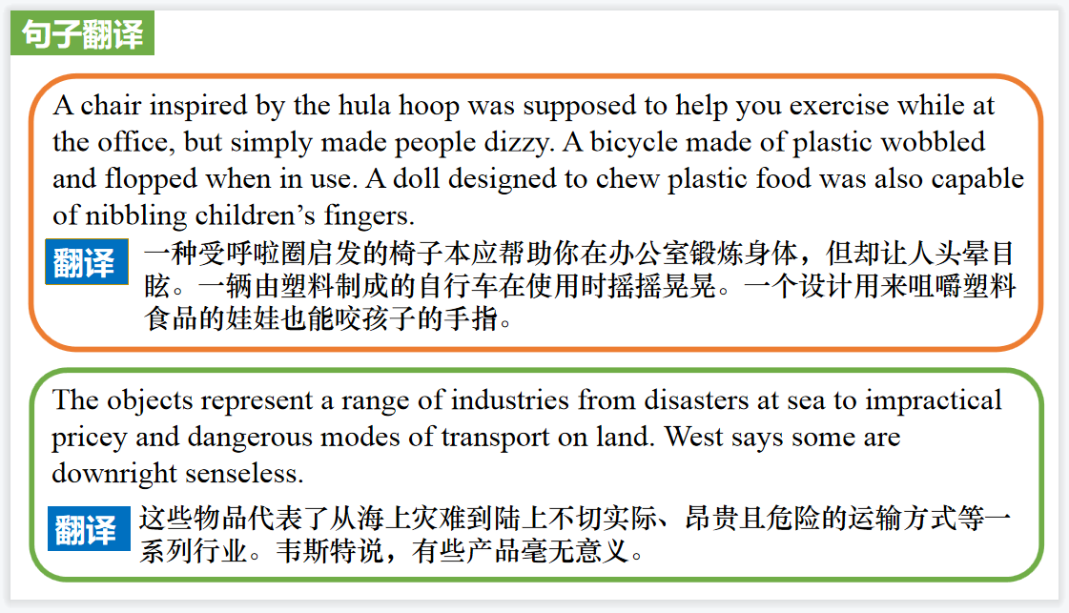

【设计意图】对文中的两个句子进行翻译练习，对其中单词、词组、句法进行巩固并关注句子结构。

附：外刊原文

**Part 1: News Report 1《纽约时报》2023年10月2日 44页**

**In France, the World Cup Takes the Spotlight**

**法国橄榄球世界杯激情开赛**

Rugby fans love their game. But most of the time it is overshadowed by the behemoth that is soccer. So once every four years, when the two-month-long Rugby World Cup gets underway, it’s a rare chance for rugby to bask in the sports spotlight.

This year the Cup is being held in France, and fans packed the Place de la Concorde on Sept.8 to watch the opening game. One of the sites of a guillotine during the French Revolution was now a fan zone, with four vast screens provided to watch France take on mighty New Zealand, a three-time Cup winner。

A mostly French crowd survived the humid evening - temperatures were in the upper 80s - by jumping under cooling mist guns. And they got the result they came for, as France ground out a 27-13 win, raising hopes that the team could lift the trophy for the first time.

Also in the mix this year is South Africa, whose fans still have fond memories of Nelson Mandela handing the trophy to the 6-foot-3 captain Francois Pienaar in 1995. (In the movie “Invictus,” it was Morgan Freeman handing it to the roughly 5-10 Matt Damon.)

Ireland, another team aiming for a first trophy, is off to a good start, and its 13-8 defeat of South Africa on Saturday was one of the tournament’s best matches.

But the World Cup is also a showcase for the sport’s minnows, teams like Namibia, Georgia and Tonga, who don’t normally get to play the big boys in competitive matches. The Cup has historically had its share of blowouts, and there have been a few this year: But Fiji dented the hopes of Australia with an instantly famous 22-15 victory, its first over that rival since 1954.

Despite making eight of the nine previous Cups, the United States is not in the 20-team field, having been eliminated last fall by Portugal.

Even those playing a level or three below the World Cup find this the best part of the quadrennial period. “It’s an honor to have the World Cup, and it puts rugby in France plainly in front of everyone, because normally the team is always hidden by the country’s interest in the football team,” said Youssouf Yatera, who plays second row for Suresnes rugby club, a professional team in the third tier in France.

**Part 2: News Report 2《BBC野生生物》2023年10月刊 13页**

**Highest ever ocean temperatures recorded**

**有史以来最高的海洋温度**

As the climate crisis continues to escalate, the surface temperature of the world’s oceans has reached its highest ever level. Researchers at the EU’s Copernicus Climate Change Service(C3S) found that in July 2023 the global average daily sea surface temperatures reached 20.96°℃, breaking the previous record of 20.95°C set back in 2016.

“Global temperatures are normally at their peak in March after the southern hemisphere summer, as there is more ocean in the southern hemisphere,” says Samantha Burgess, deputy director of CʒS. “Seeing a new record during the northern hemisphere summer is unusual.”

Warmer oceans not only have an impact on the global climate, resulting in a warmer atmosphere and more potential energy for hurricanes, for example, but they also affect marine animals, causing heat stress, deoxygenation events and mass mortality. “This summer we have already seen a record-breaking marine heatwave off the UK and Irish coasts, and now the hottest average daily global sea surface temperature ever recorded,” says Jeff Knott from the RSPB.

“Seabirds are a vital indicator of the health of our seas and our concern is that these unprecedented climate change-related events could increase the pressure on already fragile populations of seabirds.”

**Part 3: News Report 3《泰晤士报》2023年10月6日 13页**

**Nobel for literature goes to Norwegian minimalist**

**诺贝尔文学奖授予挪威极简主义者**

**The Norwegian author Jon Fosse has been awarded the Nobel Prize in Literature “for his innovative plays and prose which give voice to the unsayable”.**

**The writer, 64, was driving in the countryside north of Bergen when he was informed of the news. He said he was “overwhelmed and somewhat frightened”. “I see this as an award to the literature that first and foremost aims to be literature, without other considerations,” Fosse said in a statement.**

**Born in 1959 on the Norwegian west coast, he has written numerous novels, plays, essays, children’s books and translations. He is lauded for his stripped-back style, which has come to be known as “Fosse minimalism.”**

**A serious accident he had aged seven would influence his writing as an adult. His first novel, Raudt, svart (Red, Black), was published in 1983 but his breakthrough came with the 1989 novel**

**Naustet (Boathouse). Fosse was praised for blending “a rootedness in the language and nature of his Norwegian background”.**

**His magnum opus consists of seven works in a single volume, Septology. Spanning some 800 pages rarely interrupted by punctuation, it tracks the story of an ageing painter who lives alone as he reckons with the divine.**

**Though his work has been translated into more than 40 languages, it was largely unknown to English-speaking readers until Fitzcarraldo — the London-based independent publisher which now has five Nobel winners in its stable — published Septology.**

**“You don’t read my books for the plots,” Fosse said in an interview with the Financial Times in 2018. “But it’s not because I want to be a difficult writer. I’ve never tried to write in a complicated way. I always try to write as simply and, I hope, as deeply as I possibly can.”**

**Anders Olsson, the Nobel committee chairman, praised Fosse’s early work, describing how his first play — Someone Is Going to Come Home — produced in 1996, reflected the writer’s distinctiveness. “With its themes of fearful anticipation and crippling jealousy, Fosse’s singularity is fully evident. In his radical reduction of language and dramatic action he exposes human anxiety and ambivalence at its core,” Olsson said.**

**Fosse joins a list of laureates including Bob Dylan, Kazuo Ishiguro and Ernest Hemingway. Last year’s winner was the French writer Annie Ernaux, best known for her personal memoir Les Années(The Years).**

**Part 4: News Report 4《国家地理》2023年10月刊 EXPLORE版面**

**Solar Power from Space 来自太空的太阳能**

**Though it was fantasy just a few decades ago, space-based solar power may soon be reality—and a renewable energy breakthrough: accessible anytime, unlike ground-based solar panels limited by darkness, and available anywhere on Earth, even if infrastructure is lacking.**

**How would it work? Enormous space-based structures would support photovoltaic panels that collect sunlight and convert it into radio signals for transmission to Earth. This type of space mission is “one of the most complex engineering problems that we have in front of us,” says Mamatha Maheshwarappa, a payload systems lead at the UK Space Agency, which is helping fund project research and development. The mission also will be pricey, projected to cost tens of billions of dollars.**

**And at Caltech, researchers recently reported significant progress with their Space Solar Power Demonstrator. The craft has been in orbit since January 2023, testing materials and electronics, and has successfully transmitted wireless energy in space for the first time. “This is a step in a long journey,” says the Caltech team’s codirector, Ali Hajimiri. And like any good story, he says, “it will probably have many turns and twists.”**