**Unit 3 Book 2 学案**

1. **blog [blɒɡ]n. _______,____________vi.________**

**blog post________,____________**

**blogger[ˈblɒɡə(r)]n.___________;________**

1. **go through ______;_______;_______;_______**

易混形近词：

**though [ðəʊ]adv. _______;_______conj. _______;_______**

**through [θruː]prep. _______;_______;________**

**thorough ['θʌrə]adj. ________;________;________**

**thought [θɔːt]n. ________;________;________**

1. **tough [tʌf] adj. _______,_______;_______,_______;_______**

**形近助记：though去掉h(house) 助记：______没有_______，________他仍不觉得_______。**

1. **province ['prɒvɪns] n. _____;_________**

**词根词缀：pro-(向前)+-vinc-(征服)+e：向前征服的领域——_______**

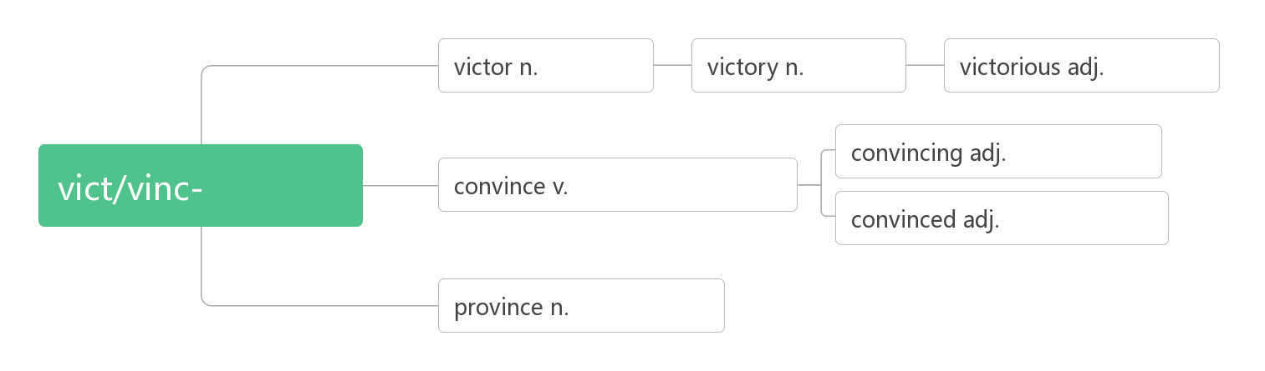

1. **conference ['kɒnf(ə)r(ə)ns]n. _______;________;________**

**词根词缀：con-(一起)+fer-(拿来)+-ence：拿到一起来______——_______;_______**



1. **resident ['rezɪdənt] n.______;__________adj. ________;_________**

**词根词缀：re-(强调)+sid-(坐)+-ent(名词或形容词后缀)：坐在某处不走的人——_______;________**

**residence ['rezɪdəns] n. 住宅，住处；居住**

1. **plus [plʌs]n. ______,_______;_______adj. ______;________prep. _____,_______**
2. **function ['fʌŋkʃən] n. ______;_______vi. 运行；行使职责**

**词根词缀：func-(做)+-tion(名词后缀)：“做”的行为——实施“_____”；行使“______”**

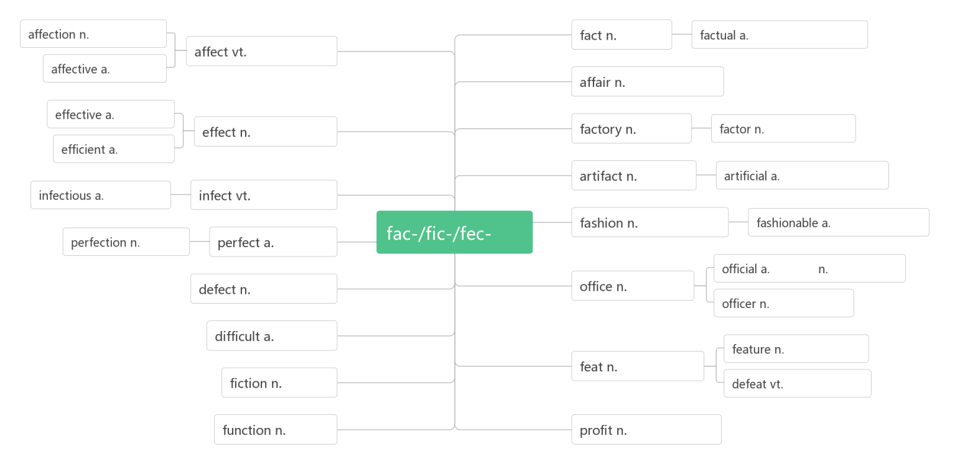

1. **battery ['bæt(ə)rɪ]n.______,________**

**词根词缀：batt-(beat打)+e(电子)+ry(名词后缀)：打出电子的东西——______**

1. **confirm [kən'fɜ:m]vt. _______;_______;_______**

**词根词缀：con-(强调)+firm(坚定的，牢固的)：使某事变的确定无疑——_______;_______**

1. **press [pres]n. vt. &vi.________;_______n._______;______;________**

**press conference ____________**

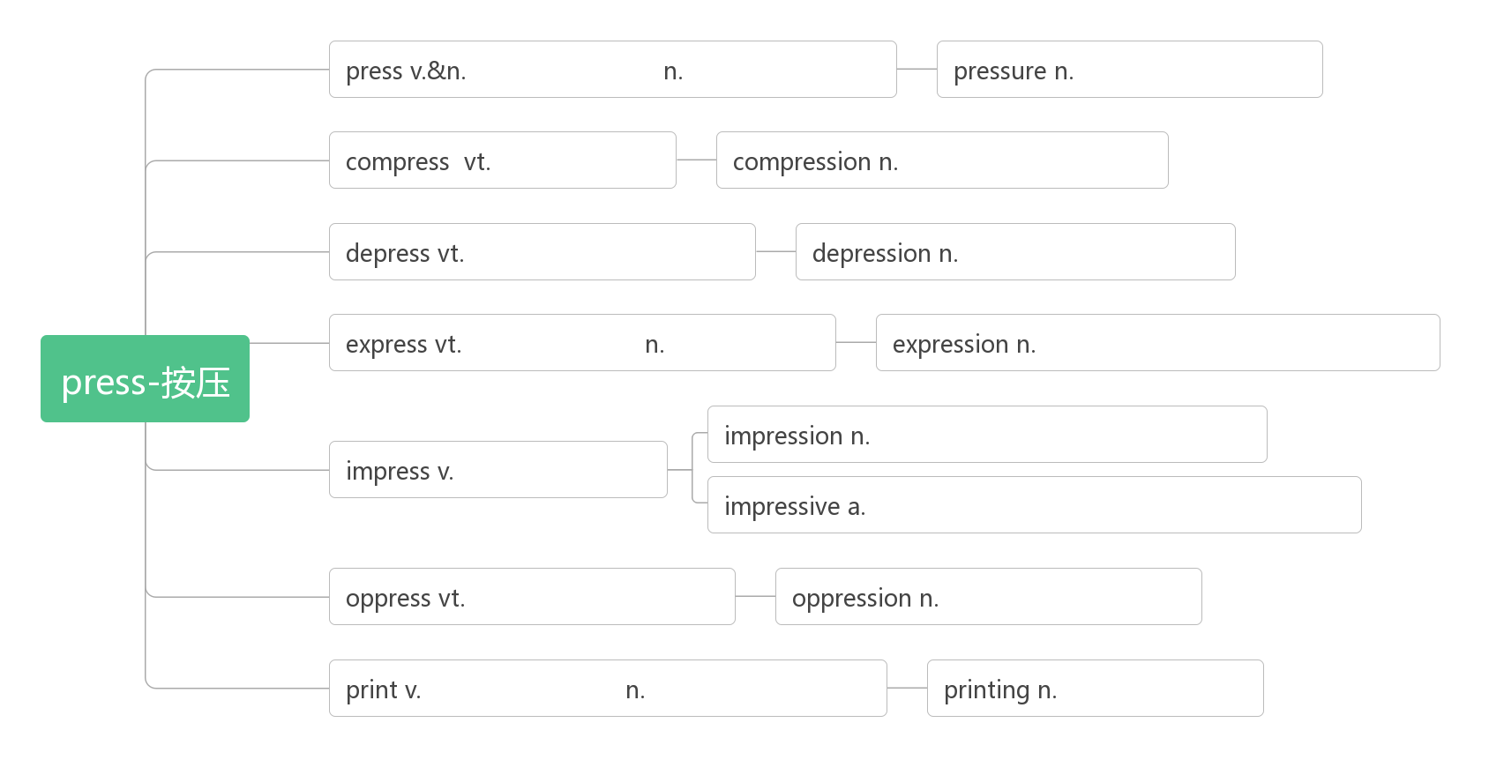

1. **button ['bʌt(ə)n]n. _______;_______vt. _______;_______**

**破拆法：butt(屁股)+on(上)：裤子上的_______要_______，要不屁股就会露出来。**

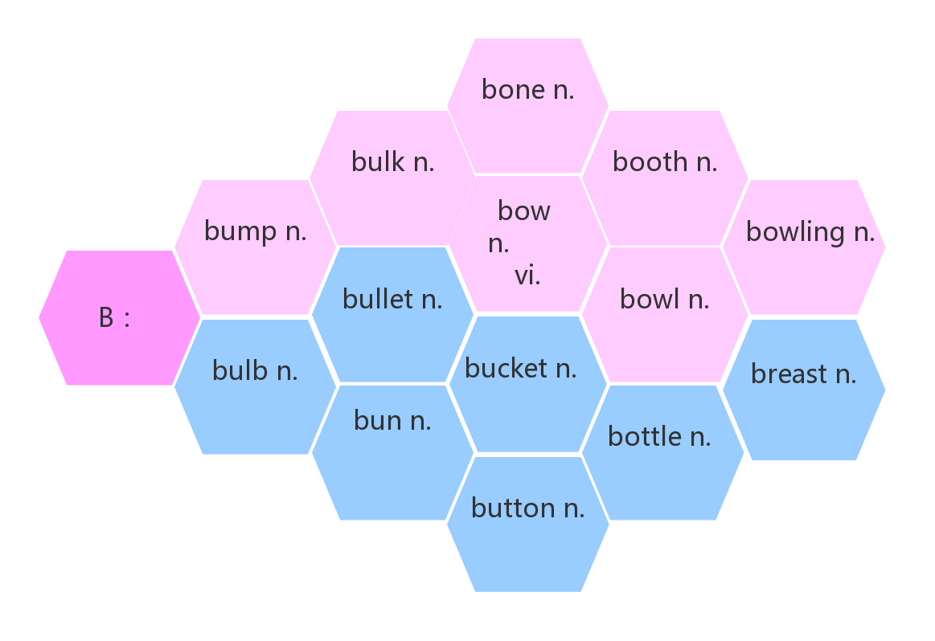

1. **file [faɪl]n. _______;_______;__________**

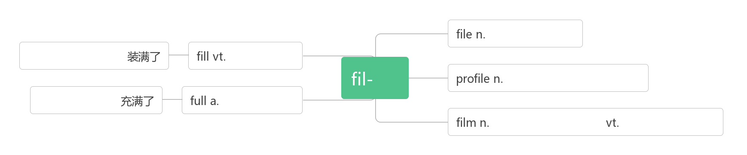

1. **shape [ʃeɪp]n. ______;______;_______vt.&vi._______;________**

**_____________状况良好, 身材好**

1. **track [træk] n. _______;_______;_______;_______vt.& vi. _______;_______**

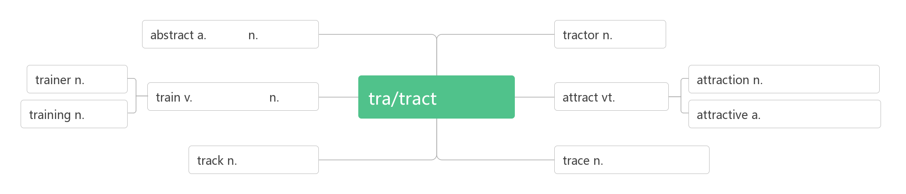

**__________________记录，了解……的动态**

**__________________田径**

1. **discount ['dɪskaʊnt] n. ______vi.& vt. ________**

**词根词缀：dis(否定:不)+count(数,计算)：不计算在内的价格——_______**

_______________以折扣价

1. **account [ə'kaʊnt]n.______;______;_______ vi.______;______;______**

**account for_______, ______;______;_______**

**on account of _______;_______**

**take ...into account ________________**

**on no account _______**

**of account _______**

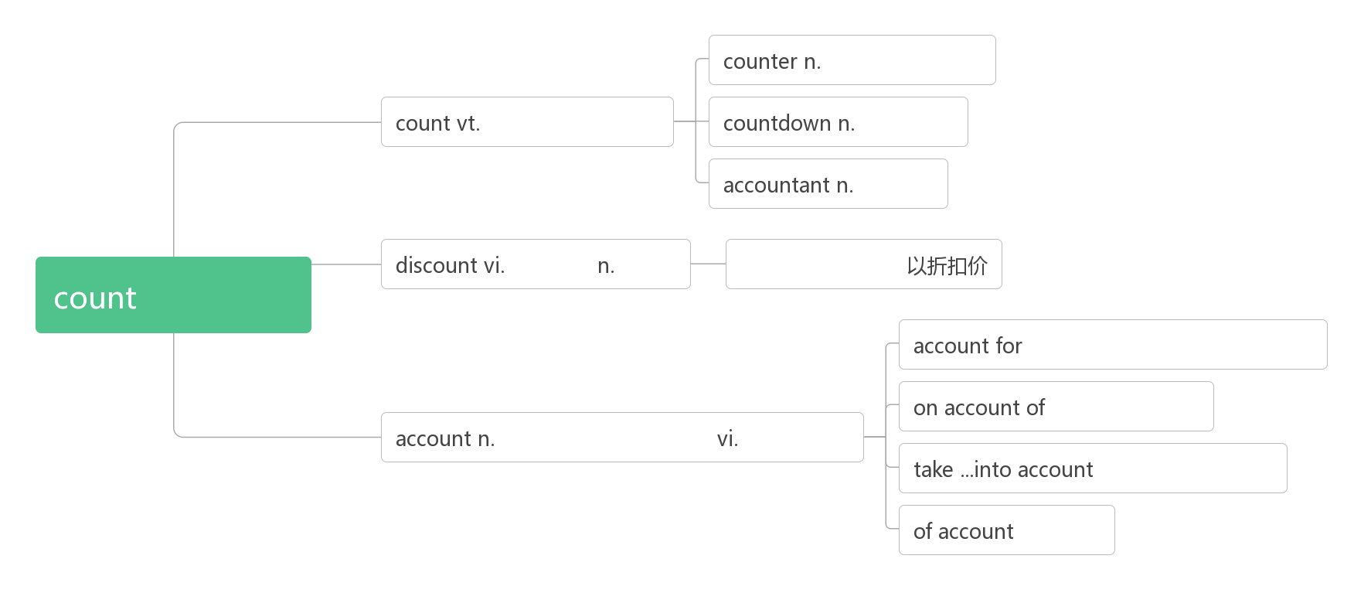

1. **click [klik] n. vt. & vi._______**
2. **privacy ['praɪvəsi]n. ______;_______;_______;________**

**词根词缀：priv-(私人)+-acy (名词后缀)：私人的空间：_______;_______**

**___________ ['praɪvət]adj. 私人的；私有的；私下的n. 列兵**

**privilege ['prɪvɪlɪdʒ] n._______;_______**

It's such a privilege to be a part of these kids’ lives, even just for a few hours, getting to know them and hearing their stories. (2019北京) 能成为这些孩子生活的一部分，哪怕只是几个小时，去了解他们，听他们的故事，是一种特权

Her responsibility, her privilege, would be to rescue it. (2019江苏) 她的责任，她的特权，将是拯救它。

They tell us to ignore privilege, power, and deep pockets.(2013江苏) 他们告诉我们要忽略特权、权力和金钱。

1. **theft [θeft]n. ______;______**

**破拆法：the(特指)+-ft(left) 助记：the left, (贼)留下的东西——______——______**

**_______[θiːf]n. 小偷，贼**

1. **rude [ruːd]adj. ________;________**

**_____________对……粗鲁**

1. **target ['tɑːgɪt]n. ______;_______vt. ______;__________**

**破拆法：tar-(它)+get(获得) 助记：获得它就是我的_______**

1. **troll[trəʊl]n.(北欧神话)_______；__________**

**破拆法：t-(它)+roll(滚动) 助记：不管是______还是______，统统让它滚。**

1. **cyberbully [ˈsaɪbərbʊli] n.______vt. & vi.__________**

**破拆法：cyber(网络的)+bully(欺凌;恶霸)：______;_________**

1. **false [fɔːls] adj._______;_______;_______**

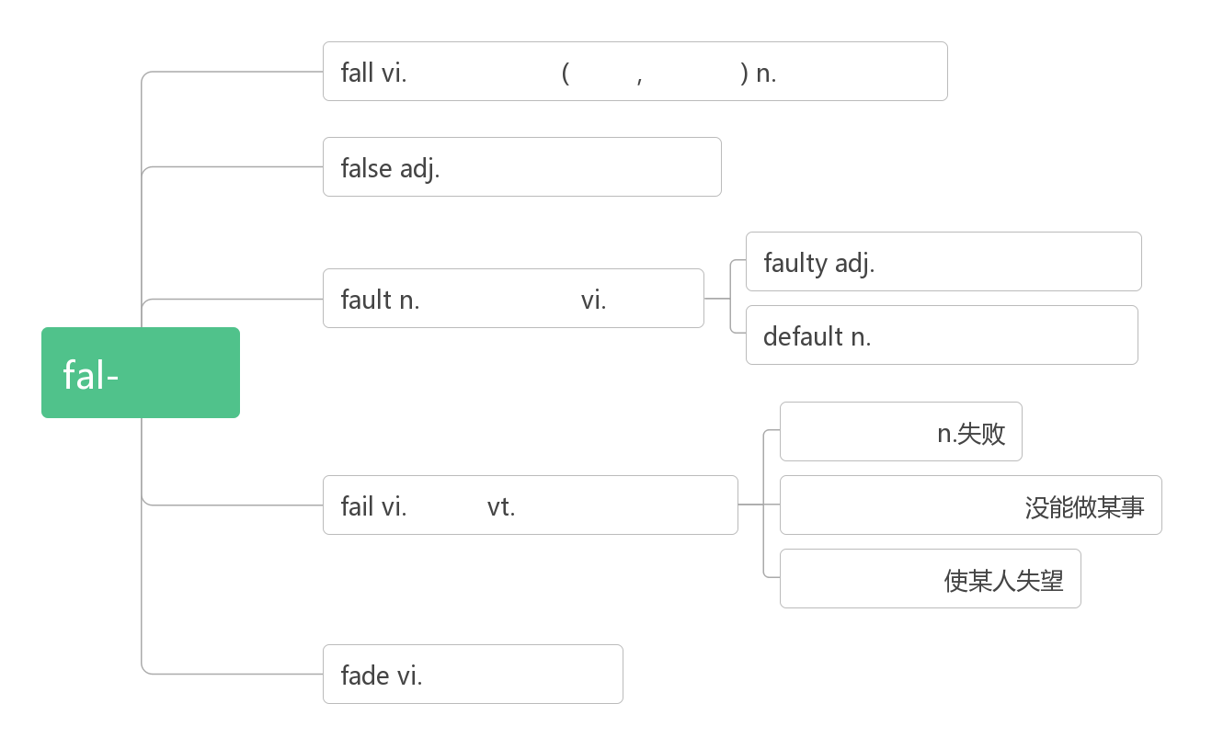

1. **particular [pəˈtɪkjələ(r)]  adj. ______;______;______;______n. __________;________**

**词根词缀：part(部分)+-ic(形容词后缀)+(-ular属性)：有自己特定属性的——_______;_______**

**______________________ 对……讲究，对……挑剔**

An intelligent person be particular about trifle(小事).  聪明的人是不会与人斤斤计较的.

**_____________ [pəˈtɪkjələli] adv. 尤其；特别；异乎寻常地**

1. **embarrass [ɪmˈbærəs] v. (尤指在社交场合) _________,_________**

**词根词缀：em-(=in进入)+barr-(栅栏)+-ass(动词后缀)：把人放入栅栏与栅栏之间，使进退两难——________**

**________________ [ɪmˈbærəsmənt]  n.尴尬；窘迫； 难堪**

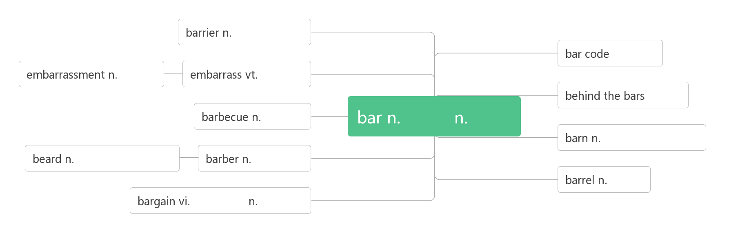

1. **make fun of________,________**

**have fun (with) (与……一起)__________**

1. **upset [ʌpˈset]****vt._______;_______;________(_______, _______) adj. _______;_______;_______ n._______;_______**

**词根词缀：up(向上)+-set (sit坐)：底朝天——_______;______;_________**

**____________________对……感到难过/沮丧**

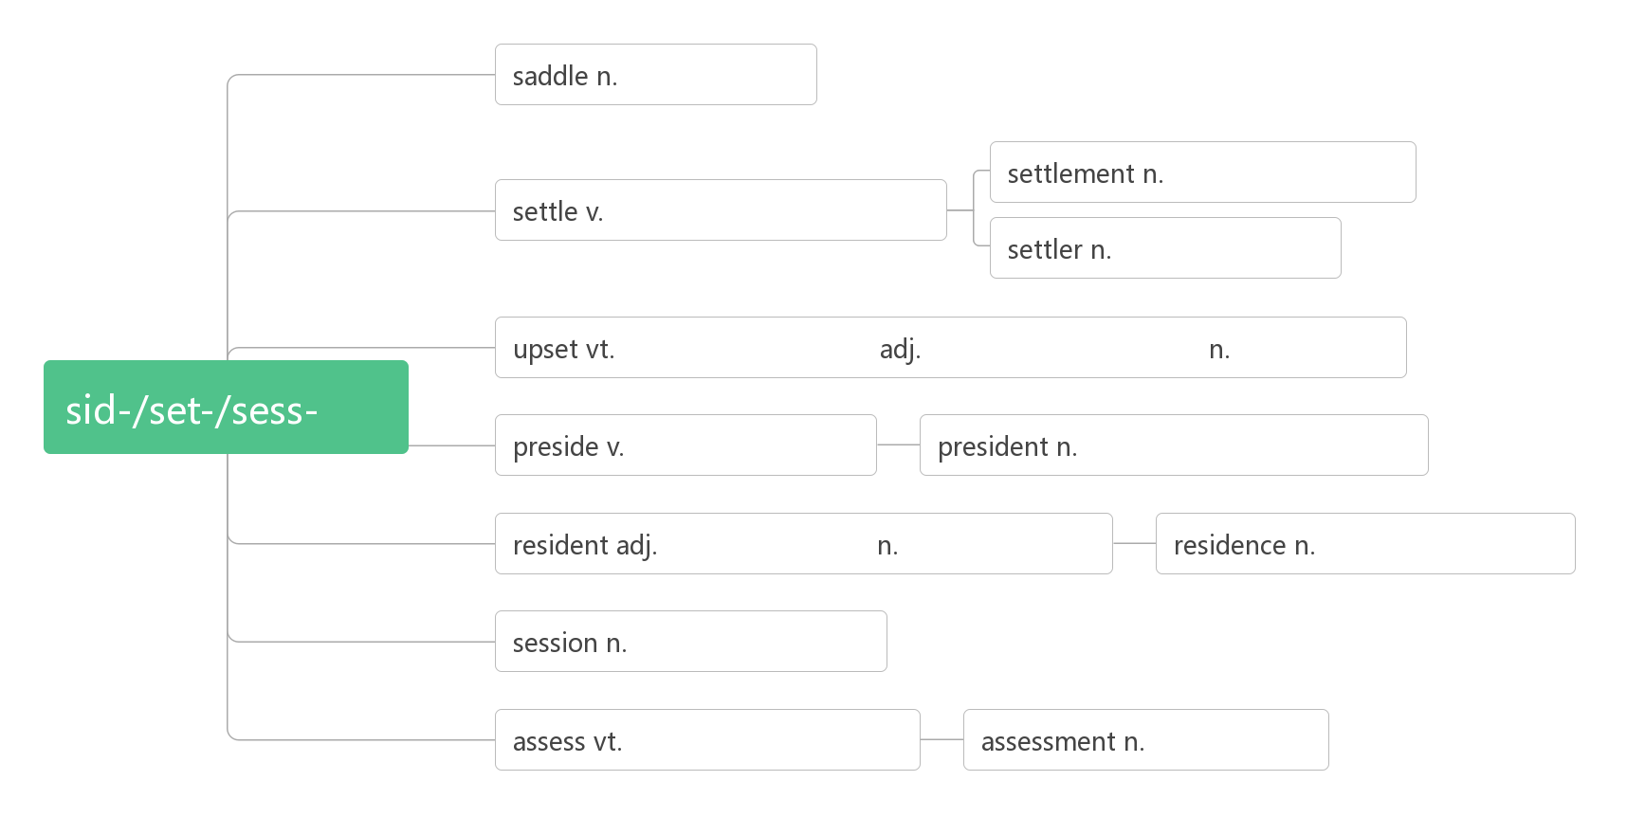

1. **guide [ɡaɪd] n._______;_______;_______ vt. _______;________**

**guideline [ˈɡaɪdlaɪn] n. _______;__________**

1. **author [ˈɔːθə(r)]n. _______;_______;_________**

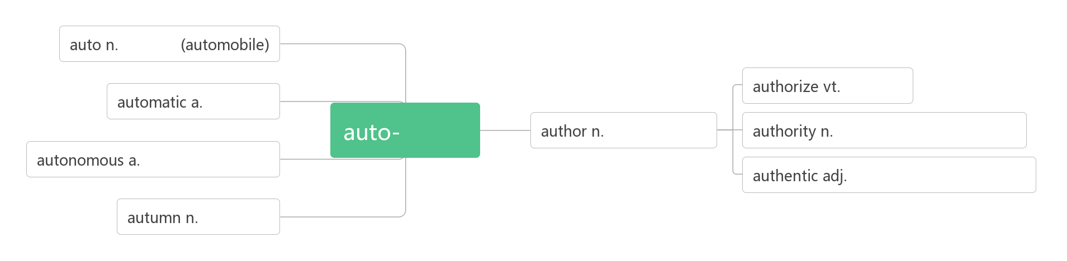

1. **tip [tɪp]  n. ______;______;_______;_______v.______;_______;________**

**助记：要听他在刀___上表演_______的______和______，必须给_______。**

1. **familiar [fəˈmɪliə(r)] adj. _______;________;________n. _______;_______**

**___________________对……熟悉**

**___________________ 为……所熟悉**

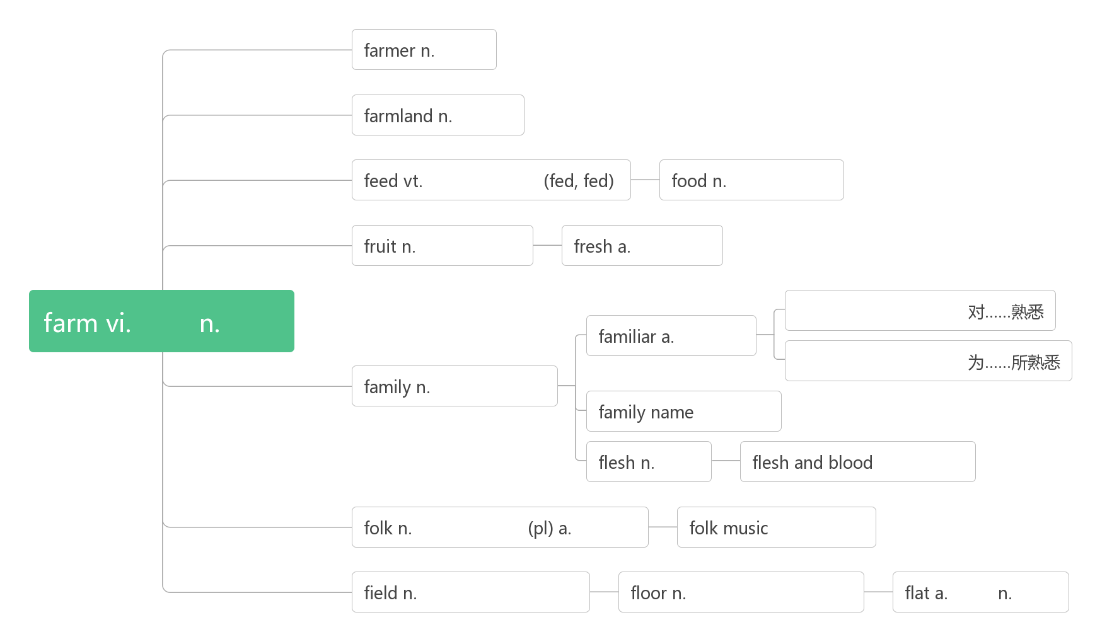

1. **______________________ 记住，牢记**
2. **define [dɪˈfaɪn]vt. _______;________;__________**

**词根词缀：de-(强调)+fine(限定)：对……的内涵加以限定——________;_______**

**_____________ [ˌdefɪˈnɪʃn]  n.定义**

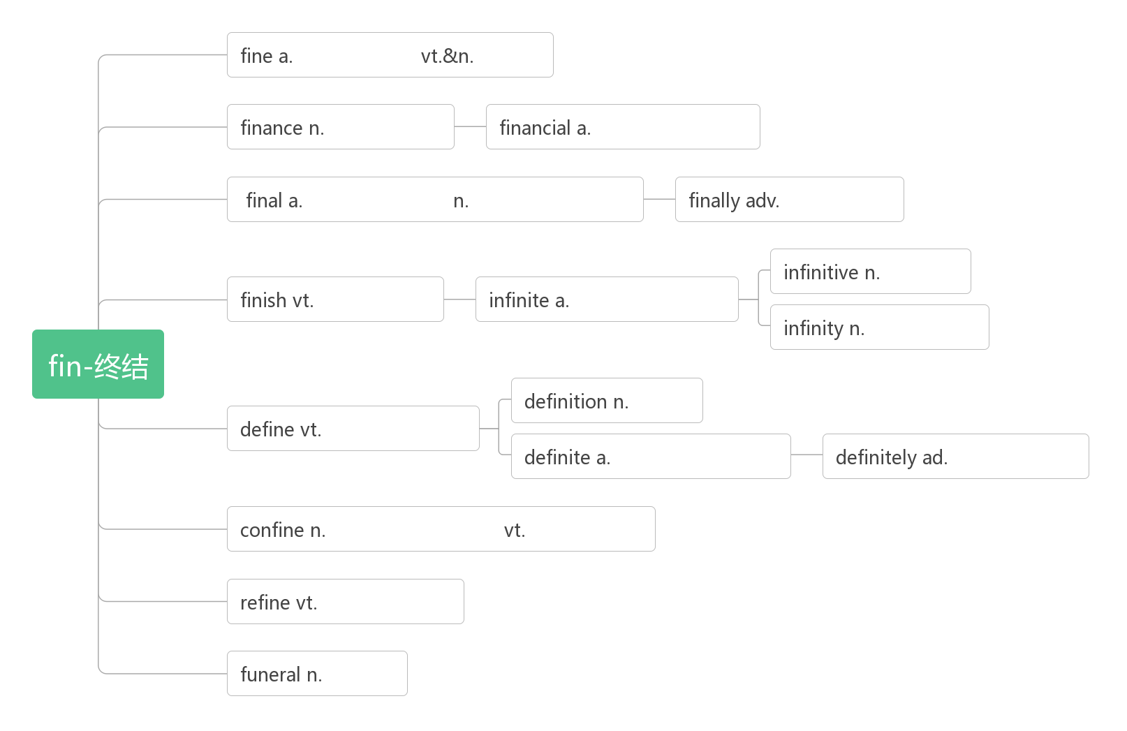

1. **case[kei]n._____;_____;_______;_______**

**in case (of/that) ___________,___________**

**in no case________**

**in this/that case____________________**

1. **the World Wide Web (abbr. www) _________**