选择性必修二Unit 1 Reading and thinking Science and scientists

文本简述
本单元围绕科学和科学家为主题展开，讲述了几位中外科学家的生平、经历、研究过程和重要贡献，旨在激发青少年对科学研究的兴趣和好奇心，引导他们思考科学研究的方法，探索科学家的必备品质和科学精神的基本要素。本文通过引导学生分析John Snow探究霍乱病源、切断感染源、并最终阻止霍乱流行的过程与方法，促使他们思考和梳理科学研究的基本步骤和常见方法，理解质疑精神在科学研究中的作用。
教学目标
By the end of this class, students will
- get information about how John Snow defeated cholera;
- summarize the stages of scientific research;
- talk about the significance and contribution of John’s work

教学设计
Step 1: Lead-in
Show students some pictures and talk about what happened during the Covid-19.
Question 1: Are you familiar with these situations?
Question 2: Besides coronavirus, what other kinds of epidemics(流行病) do you know?
Introduce something about Cholera to students.
Cholera: It begins in the stomach and a severe case can lead to death without immediate treatment. It features loss of liquid (缺水), severe vomiting (呕吐), and diarrhea (腹泻).

Step 2: Pre-reading
Read the title and make predictions.
John Snow Defeats “King Cholera”

Who ? How ? What ?
Questions: 1. Who was John Snow?
2. What is King Cholera?
3. How did John Snow defeat King Cholera?
Step 3: While-reading
Activity 1 Read for the main idea and check your predictions
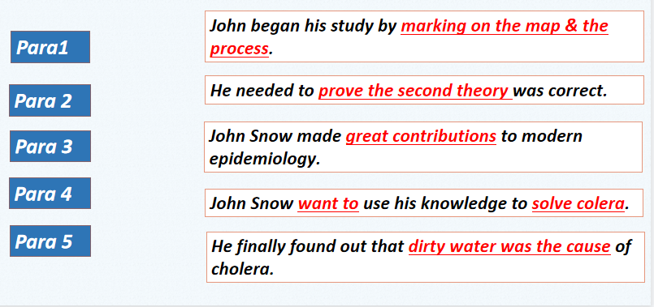
Activity 2 Read for stages
- In order to carry out the scientific research, can you put the seven research stages in order?
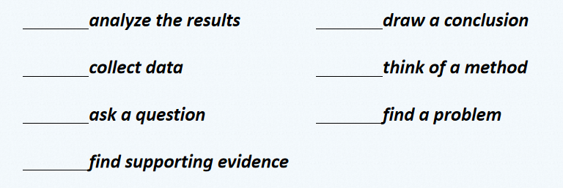
- Find the seven scientific research stages in Para.2 & 3. Underline the key words or sentences. Pay attention to some verbs or adjectives.

Activity 3 Read for detailed information
- Read Para.1 carefully and finish the mind map of Colera.
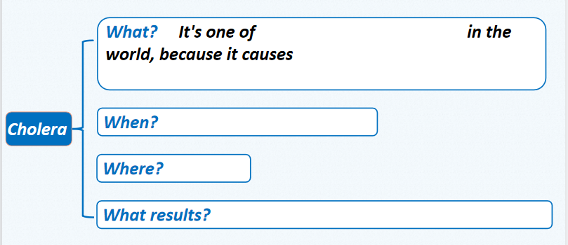
- Read Para.2 & 3 carefully. Answer the following questions about the map. Then according to the map, complete the chart below about steps in the research.
- What kind of map is it?
- What does “-” mean?
- What does “PH” mean?
- Where is the pump?
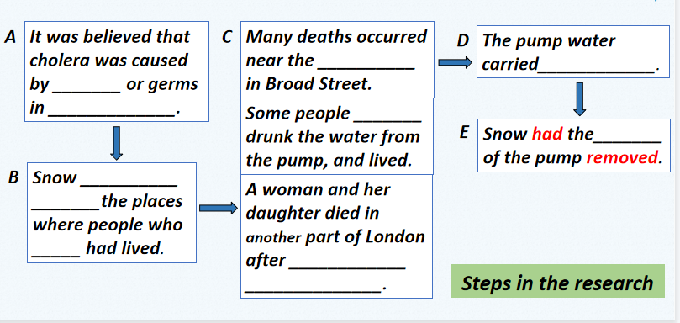
- Read Para.4 & 5 carefully and answer the questions.
- What caused the outbreak of cholera in London?
A. Bad air B. Water infected by raw waste
C. Polluted air D. Water polluted by the air
- Why was John Snow called the father of modern epidemiology?

Step 4: Group discussion
Question: What qualities and scientific spirits do they have in common? Find your supporting evidence in the text.

Step 5: Homework
Ask students to write a short story about a scientist.
补充材料：The story of colera 观看霍乱的故事，增进学生对霍乱的理解，加深学生对课文的理解。

