**B3U1**

**Period 1 Listening and Speaking**

**Teaching Objectives：**

By the end of the class, students will be able to

1. master some phrases that describe the festivals:

2. learn how to identify the relationships between speakers while listening and know some basic features

3. introduce other Chinese festivals to classmates by giving information like time, place, origin, purpose and celebrations

**Teaching Important and Difficult Points：**

How to make students work out the listening tip of guessing the relationships between the speakers.

How to make students describe a Chinese festival in a short speech.

**Teaching Procedures:**

**hundred**

**thousand**

**million**

**____________关于**

**Step 1: Preparation**

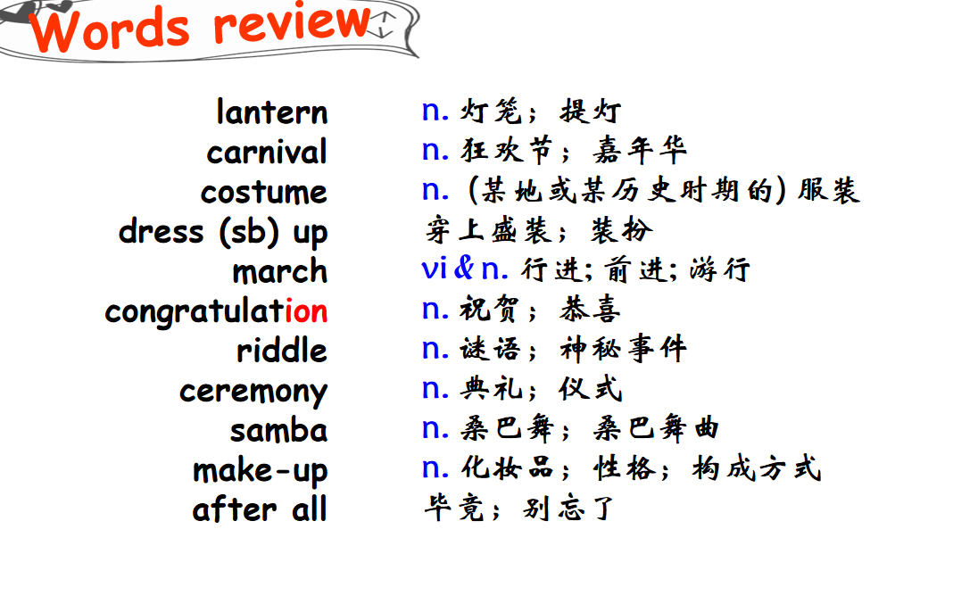

**Step 2: Lead-in**

**Task 1: Guess a festival**

Students will be asked to look at some clues to guess a festival:

Clue1：It takes place on the fifteenth day of the lunar year.

Clue2：People will march along the streets on this day.

Clue3：Some places will hold the Lion Dance Show.

Clue4: People can guess riddles.

T: Which festival is it?/ What will people do to celebrate the Chinese Lantern Festival?

(此环节目的在于通过猜节日激发他们的学习兴趣。追问学生元宵节的一些活动，激活他们的背景知识并处理本课时的一些关于活动的词组，为后续听力做准备。）

**Task 2: Know more festivals**

Student will be asked to look at two pictures and guess some information of the two festivals:

1. Can you guess what the two festivals are? Where will them be held? How do you know?
2. What are the purposes of these two festivals?
3. What will they do to celebrate the two festivals?

(此环节目的在于训练学生通过图片获取信息的能力，通过图片我们可以知道两个节日所属国家、部分活动以及节日目的等。让学生知道了解一个节日可以通过该节日所属国家、举办时间、节日目的以及节日活动等方面去了解，为输出活动向外介绍一个中国节日做铺垫。）

**Step 3: Listening**

**Task1: listen and match**

Students will be asked to listen and match the order of the conversations with the festivals and the relationships between the speakers:

1. How can we guess the the relationships between the speakers?

**Listening tip:**

pay attention to how people talk to each other

specific questions

tone(语气）

1. Listen and match the order of the conversations with the festivals and the relationships between the speakers, while listening, take notes that tell you the relationships.

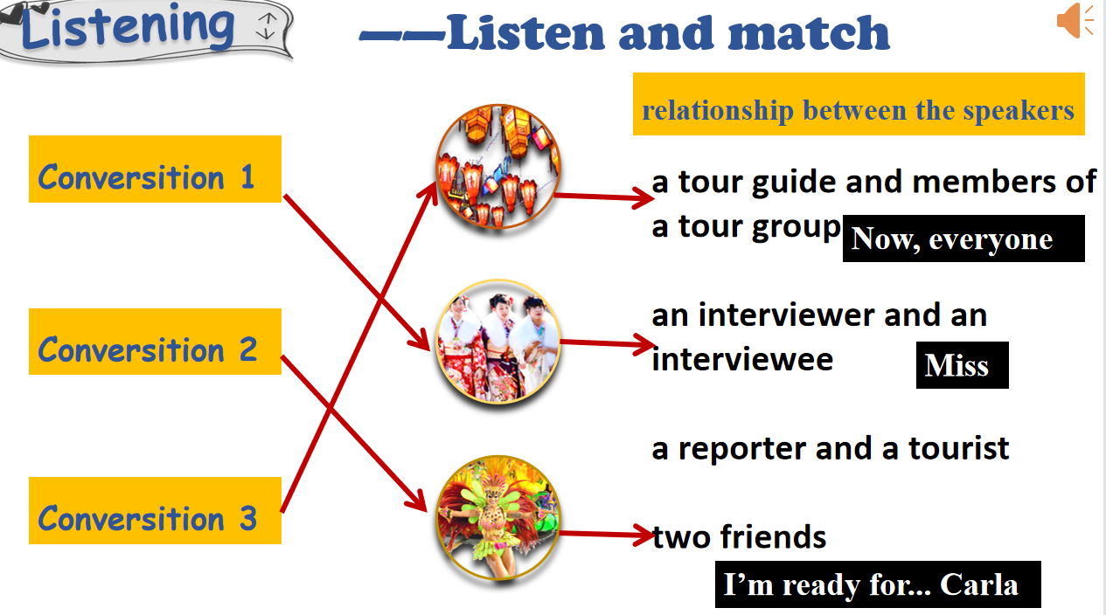

**Task2: listen for details**

1. Students will be asked to listen and fill in blanks

**Conversation 1:**

It’s ___________on becoming an adult. The girl is wearing ______ colors. It took her a long time to do her ___ and _______, and to get ______ . She is going to meet her _____ soon. “Being an adult” means being ____________, and responsible for ______ and __________.

**Conversation 2:**

Carla advises Limei to change her ______ and ______ . This is because the weather is _____ and they will ____ _____ __ _______ and _____for a long time.

**Conversation 3:**

It’s a ____ for eyes. People can guess______ on the paper to get gifts, watch the ______ and ____dances, as well as eat yuanxiao, a kind of _______ _____________.

**Step 4: Perception of the conversations**

Students will be asked to read the conversations by themselves to feel the differences among the conversations and try to work out the feature of each type of conversation.

**Conversation1:**

**Language feature of an interview**

**Interviewer:**

**Interviewee:**

**Beginning:Excuse me! Can I ask you some questoins?**

**positive comments + brief questions**

**The answers to the questions are specific and rich**

**Conversation2:**

**statements, informal, intimate**

Conversation between friends:

**Language feature**

**A guide usually introduce the place on his own. Sometimes, there is the interaction between the guide and tourists.**

**Sometimes, there will be sentences like “On your left/right you will see...”, “Turn the corner here, you will...”, “If you look up, you will...”, “Take a look at...”**

**Conversation3:**

**Step 5: Speaking**

Students will be asked if they have an opportunity to be a guide to introduce Chinese festivals to some foreigners, Which one will they choose to introduce? And how?

**Time, Place, Origin, Purpose, Celebrations**

Sample

It’s my great honour to share with you the festival—the Mid-autumn Festival. The Mid-autumn Festival, an ancient festival with a long history in China, is usually celebrated on the fifteenth day in August of the lunar year. It begins with a very interesting story. Long ago... From then on, Chinese people celebrate it on the day to memorize that important event. When the festival approaching, you will find yourself surrounded by various mooncakes in the streets or malls. People will gether together to enjoy the mooncakes at home, admire the moon, visit the lantern fair, fire the firework...