Unit5 The Chinese Writing System:

Connecting the Past and the Present

一、课标要求

1.从语篇中提取主要信息和观点，理解语篇要义；

2.理解语篇中显性或隐性的逻辑关系；

3.把握语篇中主要事件的来龙去脉：

4.抓住语篇中的关键概念和关键细节：

5.理解书面语篇中标题、小标题、插图的意义；

6.辨认关键字词和概念以迅速查找目标息；

7.根据语篇标题预测语篇的主题和内容；

8.把握语篇的结构；

二、 学习目标

1. To know about the development of the Chinese writing system and its functions

2. To learn to analyse the basic text structure

3.To realize the importance of Chinese writing system and build up the confidence in Chinese culture

三、教学重难点

1The development of the students’ reading skills.

2.The comprehension of four functions of Chinese characters to spread Chinese culture.

课前预习案

一、 词汇预习 夯实基础

1. 体系；制度；系统 2. 即使；尽管

3. 因素；要素 4. 骨头；骨质

5. 壳；壳状物 6. 雕刻

7. 王朝；朝代 8. 地方话；方言

9. 方法；途径 10. 经典作品；名著

11. 尊重；关注 12. 文字；符号；角色；品质

13. 公共事务；事件

二、拓展词汇知变形

1. N.文明，文明世界 → civilise vt. 开化；使文明
2. Vt. 以........为据点；以........ 为基础→ basis n. 基础，底部。
3. n. 象征；符号 → symbolic adj. 象征性的→ symbolise vt. 象征；代表
4. N. （指物、语言等的）变体；多样化→vary v.变化；改变；不同→various adj. 各种各样的；不同的
5. Adj. 主要的；重要的；大的 n. 主修课程；主修学生 vi. 主修；→majority n. 大多数。
6. Adj. 全球的；全世界的→globe n.地球仪；球
7. Vt. 欣赏；感激→ appreciation n. 感激
8. carve vt.

三、短语互译

1. be known for 2.古代文明

3. At the beginning 4.追溯到

5. up and down 6.非常重要

7. be connected with 8.全球事务

四、阅读课文 深度预习 完成句子：

1.中国以其古代的文明而闻名，尽管历史上有过许多兴衰，但其文明一直延续到现代。

China is wildly known for its ancient which has continued all the way through into , the many in its history.

2.它可以追溯到数千年前使用龙骨的时期，古代中国人在动物的骨头和壳上面雕刻符号。

It several thousand years the use of longgu---animal and on which were by ancient Chinese people

课中案

Activity 1: Talking about Chinese characters

Game time:

Q1: Do you know this Chinese character?

   

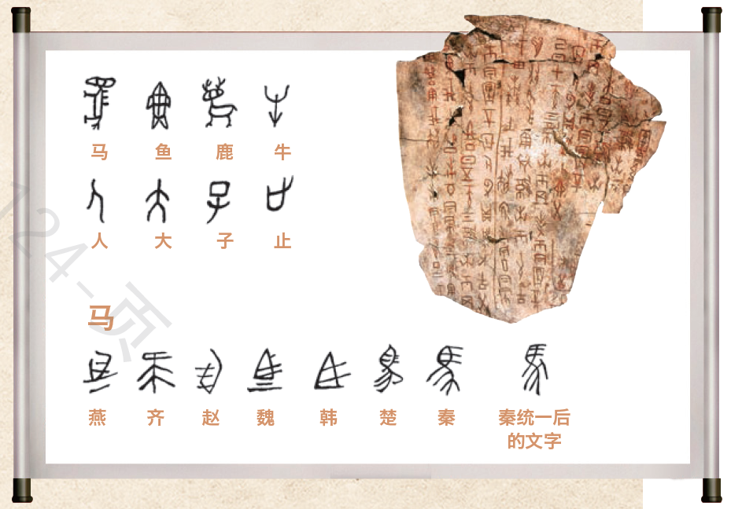

Q2: Can you recognize another “马” in the picture?

Q3: Where did people write down the symbols?

Q4: How did people write down the symbols on animal shells?

Activity 2: Predicting the content

Q1: What will be talked about?

Q2: What may be the author's intention of writing the passage?

Activity 3: Reading to get the main idea

The passage tells us the 、 and of the Chinese writing system.

Activity 4: Focusing on the development

Q1: What kind of words can show the development of the Chinese writing system clearly?

Q2: What happened to the Chinese characters at those important times?

**Activity 5: Focusing on the functions**

Q1: What are the key words of the second part of the title?

Q2: Could you find some sentences including words indicating “the past and the present”?

Q3: Besides connecting the past and the present, what other functions does the Chinese writing system have? Give the evidence.

Activity 6: Focusing on the importance

Q1: Why does the author emphasize the “connecting” function of the Chinese writing system?

Q2: Can you find some sentences showing the importance of the Chinese writing system directly?

Activity 7: Identifying the structure of the passage

Activity8: make a presentation.

Make a speech on the opening ceremony of the Festival of Chinese Characters in your school to call on students to make the Chinese writing system known to more people. Your speech should include:① a topic; ② the development, function and importance of the Chinese writing system; ③ a conclusion.

Homework write your speech out and hand it in.

课后案

**同类话题延伸阅读 （摘自人民网**Wednesday, Nov 13, 2019 **）**

‘Language abilities could propel people’s understanding of Chinese culture’: Utah senator

By Zhao Tong ([People's Daily Online](http://english.peopledaily.com.cn/))    17:34, November 12, 2019

Jacob Jake L. Anderegg is being interviewed on Nov. 8, 2019 in Beijing. (People’s Daily Online/Zhao Tong)

A Utah senator has highlighted the important role of the Chinese language in understanding China’s culture, and in communicating with Chinese people deeply.

“You actually understand China better by knowing Chinese,” Jacob Anderegg, a Utah senator, told People’s Daily Online.

He said that when people speak the same language, people can communicate effectively, including people’s ideas, concepts and visions. When people from different countries have language barriers, sometimes it's really hard to help people understand each other. Yet when people have common ties such as a common language, it makes the progress going forward so much easier.

Without knowing China’s language and culture, some Westerners have had some controversial views about the Confucius Institute’s language teaching motives. "people who have those types of criticisms by in large don't have a lot of experience working one on one with China, having friendships with Chinese, or knowing the culture of China. Teachers in the Confucius Institutes are fantastic. ”said Anderegg, who believes that language abilities could propel people’s understanding of Chinese culture.

He mentioned that China and the United States are the first and second largest economies on the planet. The two countries are going to be working together for a long time. They can work through whatever problems they have today.

“China needs the United States and the United States needs China,” said Anderegg.

Anderegg had a negotiation with officials of Confucius Institute headquarters about incorporating the HSK into the certification program for language learning in American high schools on Nov. 8, 2019 in Beijing. He said that the negotiations extended into discussions about evaluations of the test itself to make sure that it meets various levels of students that are studying Chinese.

Utah is the leading state when it comes to implementing the Chinese language immersion program. Out of 50 American states, Utah represents about one percent of the entire American population, but it represents 33 percent of all Chinese language learning, according to Anderegg.

“There are more than 14,000 students throughout the state who are speaking, learning and can communicate in Chinese at the elementary school level, which is uncommon amongst other states in the United States,” said Anderegg.

Anderegg told People’s Daily Online that they will be able to establish a good working relationship, and he hoped to figure out a pathway forward。