**Teaching Plan for *The hummingbird***

* **Teaching objectives**

After this lesson, students are expected to

1. Learn the methods of analyzing original articles, given opening sentences and then apply them to future writing practice.
2. Develop critical thinking ability, divergent thinking ability and creative thinking ability by digging out the theme of the story and discussing how the plot will develop.
3. Improve continuation writing skills by applying all-rounded synergy to writing practices.
4. Develop correct life outlook and value by analyzing the theme of the story—the harmony between animals and human beings.

* **Teaching procedure (T=teacher; Ss=students)**

**Step 1: Warming-up**

T presents 3 pictures.

1. What can you see in the pictures?
2. What’s the relationship between animals and human beings?
3. How can we maintain the harmony?

**Step 2: Leading-in**

Consolidate and classify the process and skills of continuation writing

1. what to read: Characters, Setting, Plot-theme, POV, Language
2. what to write: based on plotting—highlight the theme and personality of characters; two opening paragraphs
3. how to write: achieve all-rounded synergy (协同)

**Step 3: Reading**

find out information related to character, setting, plot-theme, POV, and language

1. characters: I, the hummingbird, an old friend (all need to be mentioned in the writing to be continued)
2. setting: on the farm, a milking house
3. plot: (detailed information—summary of two parts)—the first encounter

* pay attention to the interaction of characters and see how it develops over time (by locating the cohesive words—still; again)
* the theme is conveyed through the interaction of the characters

1. POV

|  |  |
| --- | --- |
| **Description from the 1st person limited point of view** | |
| **hearing** | * ***A noise*** at a window caught my attention. * …then let out ***a squeaking call*** … * Then someone ***said, “She must have come to say good-bye.”*** |
| **vision** | * ***She*** was covered in spider-webs (蛛网) and was barely able to move her wings. ***She*** ceased her struggle… * With ***the bird*** in my cupped hand, I ***looked around*** to see how ***she*** had gotten in. * When I opened my hand, ***the bird*** did not fly away; ***she*** sat looking at me with her bright eyes. * I stopped, and ***she*** soon took wing but did not immediately fly away. Hovering (悬停), ***she*** approached within six inches of my face. For a very long moment, ***this tiny creature*** looked into my eyes, turning her head from side to side. Then ***she*** flew quickly out of sight. * I was standing by the car when ***a hummingbird*** flew to the center of our group and began hovering. * ***She*** turned from person to person until ***she*** came to me. ***She*** again looked directly into my eyes, … |
| **touch** | * I ***removed*** the ***sticky*** spider-webs that covered ***her*** head and wings. |
| **thinking** | * ***Perhaps*** ***she*** had been struggling against the window too long and was too tired***?*** Or too thirsty***?*** |

1. Language

* “she” — pronoun— to directly narrate what “I” saw, heard, touched and thought;
  + personification (rhetorical device 修辞手法)
* “the bird, this tiny creature, a hummingbird” — use different/ varied names to avoid repetition.
* use some cohesive words—still; again… to show how interaction of characters develops over time
* use simple but descriptive words and expressions

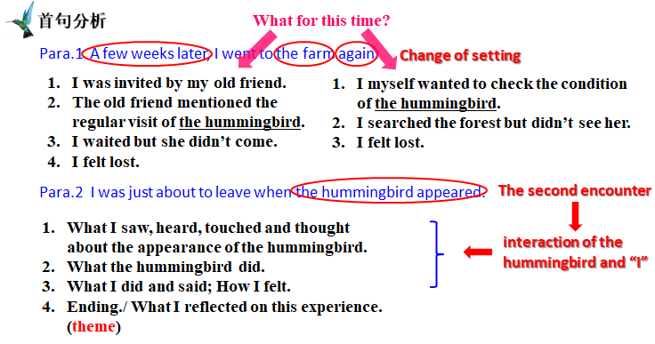**Step 4: Designing the plot**

1. by relating to the analysis of original article
2. by relating to the two opening sentences (key words)
3. by relating to the theme
4. by focusing on the logic and coherence of the plot

**Step 5: Writing practices**

1. writing by echoing
2. writing the whole passage by applying all the strategies mentioned above.