**拉波夫叙事理论指导下的高中英语读后续写**

**—2025年2月浙江省名校协作体读后续写**

**礼泉县教育局教研室 高小聪**

**Teaching goals:**

1. 理解拉波夫叙事模式的核心要素（点题、指向、进展与冲突、评议、结局、回应），并能应用于续写任务。

2. 掌握读后续写任务的结构要求，学会通过首尾呼应、主题升华等技巧构思多元结局。

3. 积累并灵活运用“善行类语块”，提升续写的语言表现力和情感感染力。

**Teaching steps:**

**Ⅰ. 拉波夫叙事模式**

**点题（Abstract）：**即叙事者对故事的简要概述，一般位于故事开头，可指向故事的主题。

**指向（Orientation）：**是叙事者对时间、地点、人物、环境的描述，为事件的展开作铺垫，但并非所有的叙事都有这四个指向。

**进展（Complication）：**是对故事发展变化的描述，按照一定的顺序推进，通过人物语言、动作、心理活动的描写来呈现故事的曲折发展。

**评议（Evaluation）：**体现叙事者或故事中的人物对于事件的观点、态度，评议可以出现在故事的各个地方，在进展与结局之间常常会有评议。通过观点、态度、评议体现人性、凸显主题。

**结局（Resolution）：**是对故事人物和事件最终结果的交代。

**回应（Coda）：**是故事与现实的链接，是故事对现实的影响或故事赋予现实生活的意义，通常表达作者的感悟和价值取向，升华故事主题。

**Ⅱ. 解析读后续写任务**

第二节(满分 25分)

阅读下面材料，根据其内容和所给段落开头语续写两段，使之构成一篇完整的短文。

Right after I had my first son, I found myself with a surplus of baby formula (奶粉) I couldn't use due to his stomach issues. Not wanting it to go to waste,I tuned to a website for giving away items for free. Shortly afterward a young woman from my small town reached out, expressing her desperate need for the formula. She explained that her husband had just passed away in an accident, leaving her in a dificult situation, Feeling a tug at my heart. I immediately promised to save all the formula for her.

However, three days passed, and I heard nothing, I tried to connect her but failed, My husband suggested it might be a cruel joke or maybe some sort of sick tricks. Unwilling to believe it, I decided to give it one last try.

This time I got through. In the telephone. I could hear the tiredness and strain in her voice as she mentioned she'd just managed to pay her phone bill and had to wait until she could find a way to get closer to town. It was clear she was struggling. Trying to keep my tone neutral，I offered to send the formula to her house. After an awkward silence，she agreed and provided her address.

Once I hung up,I felt compelled to do more than just provide the formula. We checked her address and discovered she lived in a desolate part of town. Her cottage was situated in the middle of the desert, far removed from any public transportation. Realizing how tough her situation must be, I went through my pantry (食品储藏室), fridge and freezer, gathering anything we could spare. In total, we filled three bags and a laundry hamper with food and essentials.

When we arrived at her home the next day, she welcomed us inside, her face devoid(没有) of emotion. The sight that greeted me was heartbreaking: her living space was almost empty, with only a single couch and a bare kitchen. Even when we unloaded the items, she still seemed almost numb, as if life had drained all the color from her. Without a word, she simply nodded, turned away, and mechanically began making a bottle for her son, her movements slow and detached.

注意:

(1)续写词数应为150左右;

(2)请按如下格式在答题卡的相应位置作答。

**P1.点题（Abstract）**

**Sympathy and Kindness**

I had a surplus of _______due to my baby’s stomach issues. I volunteered _______ all the formula for a young woman who got into _______ with her husband ___________ by Internet.

**P1&P2指向（Orientation）**

**Time:** Right after I _____ my first son;

**Places:** My house in the small _____;

The young woman's cottage situated in the middle of the _______, in a _________part of town;

**Characters：**

**Leading roles:** I, a _______ full of love and compassion; a young ________ in trouble whose husband had passed away;

**Supporting role:** My ________(become suspicious of the young woman’s situation);

**Settings：**The _________ of surplus formula brings to light the difficult situation of a young mother, laying the __________for subsequent conflicts and actions.

**(P1-P5）发展 development**

**进展（Complicating Action）**

I _______ information online about ___________ formula , and a young mother ____________ to us for help. Losing touch with her, my husband __________ it was a sick trick, but I____________ contacting her. Eventually, the phone was connected and we ________to deliver the formula, food and essentials to the young mother's home, ________I witnessed her extremely poor living conditions.

**冲突Conflicts**

My losing contact with the young mother's led to a __________ , highlighting the _________between her desperate living situation and the my goodwill.

**P1-P5评议（Evaluation）**

**Emotional descriptions:**

I heard the young woman’s miserable situation, feeling a _____ at my heart.

Hearing her tiredness and strain in her voice, I tried to keep my tone ________.

...I felt ____________ to do more than just provide the formula...

...she welcomed us inside, her face devoid(没有) of _________.

...she still seemed almost ________, as if life had drained all the ______from her.

**Environmental descriptions:**

The emptiness and _____________ of the desert cottage symbolized the young mother's ________.

**Depictions of actions:**

The young mother's behaviors implied her ________________with the pressure of life.

**主题（Theme）：**

The power of love, kindness and sympathy: ... ...

**结尾（Ending）：**

结局（Result or Resolution）... ...

回应（Coda）... ...

**Ⅲ. 巧妙构思多元结局**

**一、 首尾呼应, 主题升华**

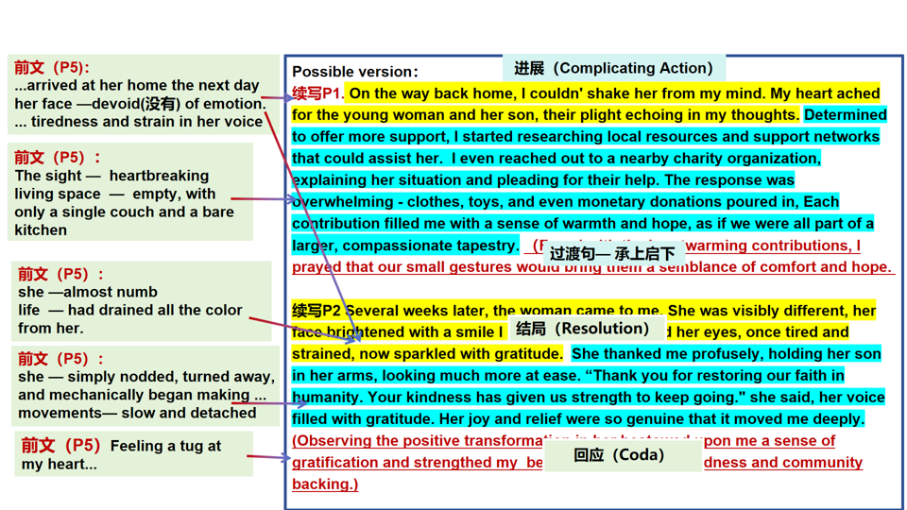

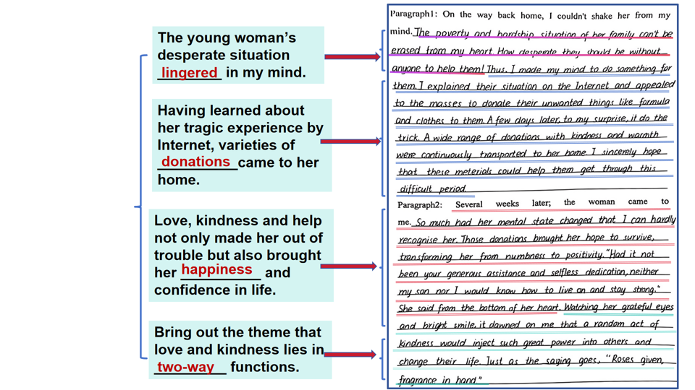**二、深刻感悟, 立德树人**

**三、自然结尾,以景结情**

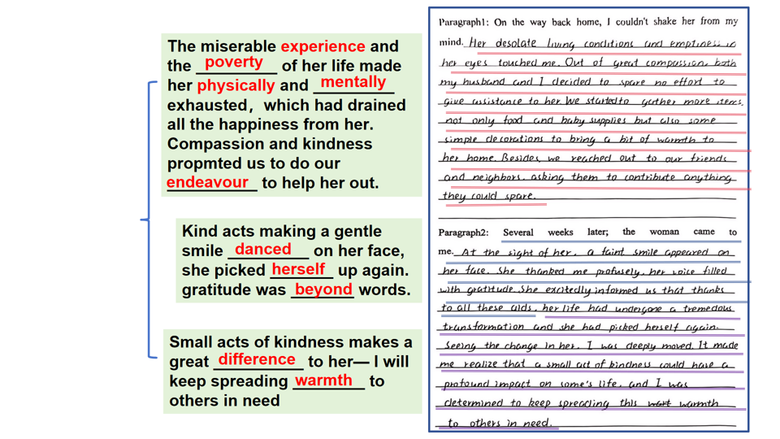

**IV. 善行类语块整理**

**绝望无助：**

1. the tiredness and strain in her voice 声音疲倦、紧张

2. her face devoid(没有) of emotion 脸上没有意思表情

3. seemed almost numb 几乎麻木了

4. life had drained all the color from her

生活滤干了她所有的色彩

5. her movements slow and detached

6. be sunk into hopelessness 陷入绝望

7. in despair 在绝望中

8. dash one’s hopes 使某人的希望破灭

9. be overwhelmed by a feeling of despair 深感绝望

10. with one’s head and shoulders hanging down 耸拉着头和肩

**尴尬窘迫：**

1. after an awkward silence 一阵尴尬的沉默
2. flush with embarrassment 尴尬得脸发红
3. lower one’s head 低下头
4. feel one’s face burning 脸上滚烫
5. feel the blood rush to one’s face 感到血液涌上脸颊
6. One’s face blushed. 某人脸红了

**悲伤难过：**

1. in low spirits 情绪低落
2. with a heavy heart 怀着沉重的心情
3. be down in spirits/be blue 情绪低落
4. with a long face 哭丧着脸
5. a burst of sadness  一阵悲伤

**温暖感动：**

1. be moved to tears  感动得流泪
2. moist/misty eyes  眼睛湿润了
3. a warm current rises in one’s heart  一股暖流涌上心头
4. feel warm 感到温暖
5. be touched/moved deeply/profoundly 深受感动
6. choke with sobs 哽咽
7. tears spring to one’s eyes 热泪盈眶
8. melt the ice in her heart 融化了她内心的冰川

**开心喜悦：**

1. One’s eyes danced with joy and sweetness. 眼里荡漾着开心与甜蜜

2. flash a bright smile 闪过灿烂的微笑

3. One’s eyes twinkled with pleasure. 眼里闪耀着快乐

4. be lighthearted 满心欢喜

5. wear a shining smile 挂着灿烂的微笑

6. a wild joy took control of sb 内心狂喜

7. One’s face lit up 满脸喜色

**意识领悟：**

1. be aware of 意识到
2. be overcome with emotion 心中百感交集
3. in/hold the belief that... 相信......
4. learn from the experience that 从这段经历中学到......
5. deeply understand 深刻地领悟
6. make Sb. realize... 使某人意识到......

**善良与同理心：**

1. By showing kindness to others, I learn that sympathy and help can make a positive impact on the world around him.
2. By putting herself in others shoes, I have learned to be more empathetic and understanding towards those around her.
3. kindness comes full circle (爱出者爱返，福往者福来).

**V. Conclusion**



**爱出者爱返，福往者福来.**

**kindness comes full circle.**

**— 汉.贾谊《新书》**