文本特征

本文属于“人与社会”主题语境下“对社会有突出贡献的人物”这一主题群。和上一单元Women of achievements 同属于一个主题语境和主题群。

文章共四段，包含袁隆平的社会角色定位（第一段）、生平经历及贡献（第二段）、名利观和兴趣（第三段）以及梦想（第四段）。这四段文字看似互不相关，其实是由What makes Yuan Longping a pioneer for all people?这一问题串联起来的，可以在解决问题的过程中去处理四段文字的内容，而不要割裂它们。

教学过程

**Step 1: warming up (3 min)**

Questions: 1.What does “pioneer” mean to you?

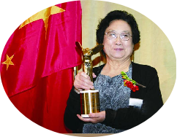

productive?

creative?

famous?

2. Who is she?

3. Do you think she is a pioneer in science?

4. Do you think she is a pioneer for all people?

设计意图：1. 解释“pioneer” 一词，激活学生图式 2. 使学生参与到关于Pioneer的评判标准的讨论中来，引入话题。

**Step 2: Fast Reading (5mins)**

* Paragraph 1 Introduction

Focus on who, what and why: 1. Who is the pioneer?

1. What did he do as a pioneer?

a devoted farmer

a famous scientist

devote his life to farmers

continually work the land in his research

1. Why is he considered a pioneer for all people?

设计意图：帮助学生提取并筛选关键信息，从而掌握本文的三个关键词：pioneer, scientist, farmer.

**Step 3: Intensive Reading (25mins)**

* Paragraph 2 Experience and achievement

Focus on the TIME ORDER Circle the time in the text and fill in the form.

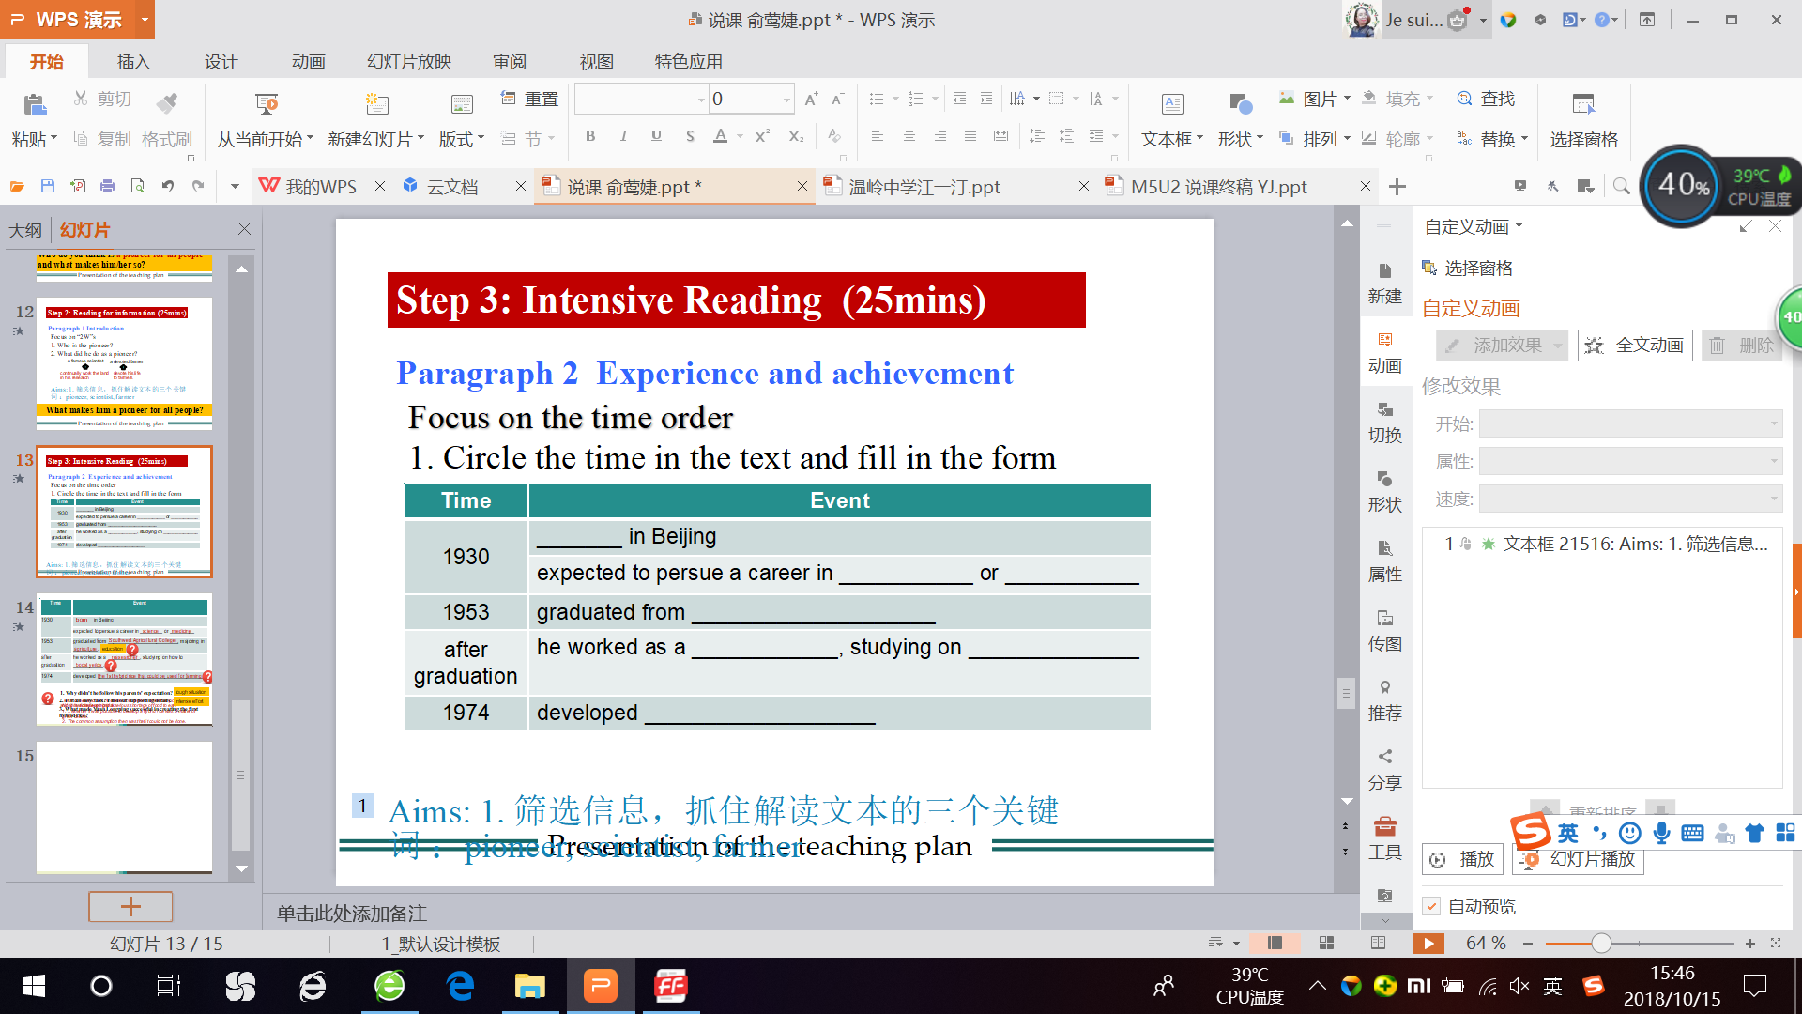

original intention

Tip1: Present sb's experience and achievement in the order of time.

1. Why did he devoted all his life to finding ways to grow more rice?

Years of hardwork

2. Is it an easy task? Find out supporting details.

3. What made Yuan Longping successful in creating the first hybrid rice?

education

Years of hardwork

original intention

设计意图：帮助学生整合信息，并总结袁隆平成功的原因：教育背景+初心+自身努力，从而对学生人身观、价值观的构建施以积极影响。

* Paragraph 3 Contributions

Focus on the DATA Tip 2: Present sb's contribution with data.

1. Circle the number in the text and tell what they mean.

2. Question: What will you do with these awards?

设计意图：帮助学生理解袁隆平的成就和贡献，进一步解释为什么袁隆平被称为“a pioneer for all people”.

* Paragraph 4 Qualities

Focus on the CONTRAST Tip3: Present sb's quality by making contrasts.

Questions: 1. What was Yuan Longping's attitude towards being famous?

2. What did Yuan Longping attitude towards his money?

3. Why he did so?

设计意图：帮助学生理解袁隆平对名利的态度，引导学生思考产生这种态度背后的原因，从而进一步解释为什么袁隆平被称为“a pioneer for all people”.

* Paragraph 5 Qualities

Focus on the KEY WORD. Tip 4: Present sb's quality via key words.

Questions: 1. What do you think is the key word in this paragraph?

1. What are Yuan Longping’s dreams?
2. According to the dreams, what qualities do Yuan Longping have?

progressive

设计意图：抓住本段中心词 “dream” 帮助学生理解袁隆平的两个梦想，以及他与时俱进，不断创新的精神品质，进一步解释为什么袁隆平被称为“a pioneer for all people”. 此外，学生从袁隆平孜孜以求的追梦经历中也能明白：梦想永无止境，而我们一直在造梦、追梦的路上。 .

**Step 4: Reflecting (6mins)**

Question: What makes YLP a pioneer for all people?

Focus on the CONTENT

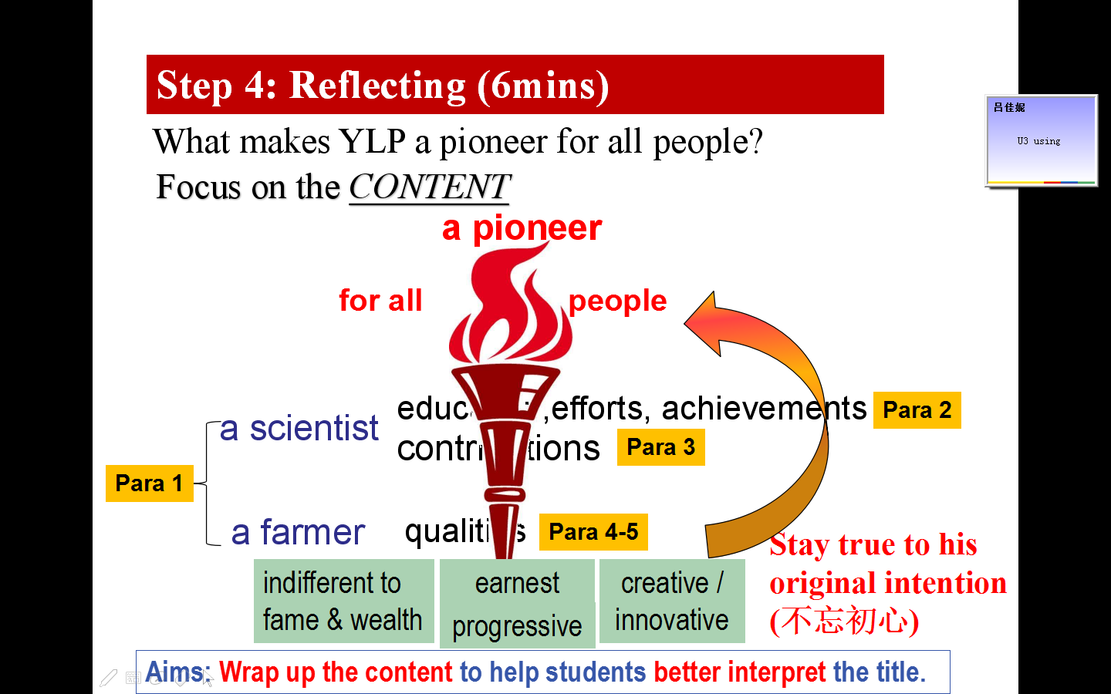

设计意图：总结文章各段要点，解读标题，让学生理解为什么袁隆平被称为人类的先驱。

Focus on the WRITING TECHNIQUES

Tip1: Present sb's experience and achievement in the order of time.

Tip2: Present sb's contribution with data.

Tip3: Present sb's quality by making contrasts.

Tip4: Present sb's quality via key words.

设计意图：总结文中用到的写作手法，为读后仿写活动做铺垫。

**Step 5: Inspiring (6mins)**

Back to the question in Lead-in, discuss it with your classmates:

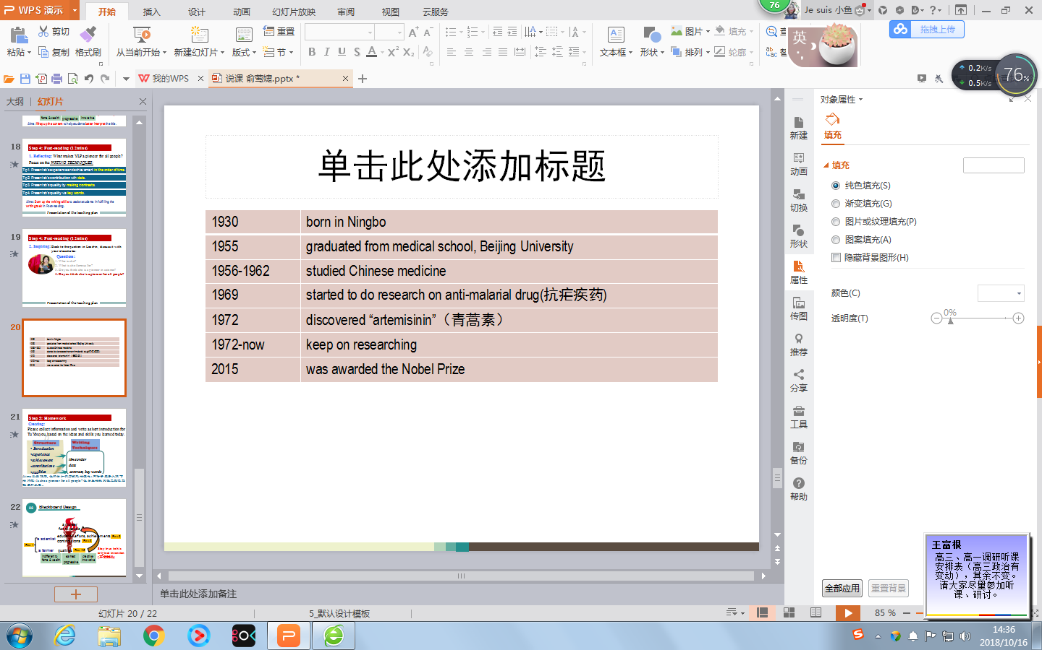

Discussion:

4. Do you think she is a pioneer for all people?

Tu's experiences

设计意图：1.照应导入部分，解答第四问：屠呦呦是不是全人类的先锋？

2. 通过浏览屠呦呦的生平经历，学生能够掌握关于屠呦呦的基本信息，并结合文中学到的写作手法进行仿写。

**Step 6: Homework**

Creating: Please collect information and write a short introduction for Tu Youyou, based on the

ideas and skills you learned today.

设计意图：以读促写，给学生一个表达创造性思维的平台，让他们在仿写过程中落实本课所学的内容。

\