Worksheet
阅读下面材料，根据其内容和所给段落开头语续写两段，使之构成一篇完整的短文。
It was a hot day in Florida. The school year had just ended and it was time for summer vacation. We had just gotten a little black dog who we named One-Eyed. We chose that name because he could only see out of one eye.
Everybody wanted to do something for the dog: feed him, teach him tricks and take long walks with him. Everybody was so happy to have this active, playful and shaggy new addition to our family. Everybody, that is, except my mom and me.
All my mom saw when she looked at the dog was someone else to clean up after. Shedding, messy, muddy, he pounced all over the house. All Mom seemed to care about was getting the house cleaned. My mom began to put Clorox (高乐氏漂白水) in the bathtub. There was no messing with Mom when she started cleaning, so I decided to move out of the way, Actually, getting out of the way is a move I'd been practicing for a long time.
Being the youngest in my family has had its advantages, of course. More than a few times I was spoiled or everyone said I was the cutest. But being the youngest also came with its fair share of troubles. "You're too young!“ "You'll mess this up!" they'd often say. I knew that my family loved me but I couldn't wait to show them I could do things by myself.
Every time I asked my brother or my sister if I could pet One-Eyed, they would shout, "No!" or tell me that I had germs and if I touched One-Eyed he would die! I really believed them. Once I even confessed to my mom that I touched the dog when no one noticed. At first, my mom seemed very confused about what I was telling her, but then she realized. My mom scolded my brother and sister, "You better stop teasing your little brother!" Little brother! That's exactly what I was. That really got my blood boiling! Secretly, I decided, "I'll show them what a little kid can do !"
Para 1: That afternoon, I took the dog and sneaked into the bathroom. _____________________
_______________________________________________________________________________________________________________________________________________________________________________________________________________________________________________________________________________________________________________________________________________________________________________________________________________________________________________________________________________________________________________________________________________________________________________________________________________________________________________________________________________________________________________________________________
Para 2: I thought my mom would punish me, but she was just standing there and laughing. _____
________________________________________________________________________________________________________________________________________________________________________________________________________________________________________________________________________________________________________________________________________________________________________________________________________________________________________________________________________________________________________________________________________________________________________________________________________________________________________________________
Task 1: Summarize the story.

Task 2: Raise questions and answer them based on the two given sentences for plotting.
Para 1: That afternoon, I took the dog and sneaked into the bathroom.

Para 2: I thought my mom would punish me, but she was just standing there and laughing.

Task 3: Underline useful expressions in the text for further use in your writing.
Original expressions | Your version

Task 4: Brainstorm useful expressions when describing dogs.

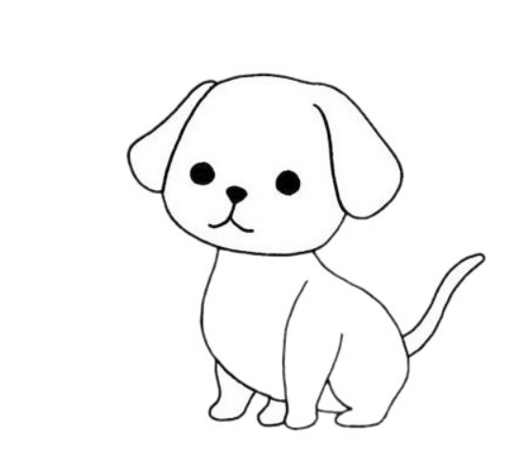

Task 5: Extended reading original material

