**The World**（**0316-0331**）材料分析和教学目标：

本次选用的材料：①*BBC Wildlife*的*Raven’s return*（渡鸦的回归）、②*New Scientist*的*Buildings could be 3D printed using ink made of waste wood*（建筑可以用废木材制成的墨水进行3D打印）、③*The Times*的*Stars do not shine for female chefs, admits Michelin boss*（米其林老板承认，女厨师不会得到青睐）、④*Time*的*Texas’ Scorched Panhandle*（德克萨斯州大火）和⑤CNN的新闻报道。通过语法填空、阅读理解、分析长难句、翻译句子、听力填空和词汇拓展等方式，让学生从多角度提升学习兴趣，提高分析句子、运用词块和听力能力。外媒英语新闻可以让学生体验真实语境下的语言运用，拓展学生的国际视野，了解时事，逐步提升跨文化沟通能力，形成正确的世界观、人生观和价值观。

**教学思路：**

**Part 1: News Report 1 *BBC Wildlife ( March 2024 Page 10)***

**Raven’s return 渡鸦的回归**

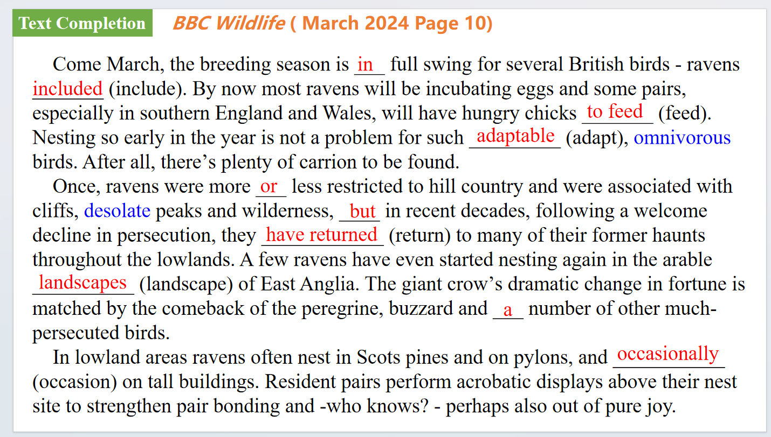

【设计意图】通过语篇填空的形式帮助学生理解新闻的主要内容，同时训练语言语法的运用能力：在语篇的视角下如何正确使用所给词汇，根据语法规则确定词汇的正确形式，使得文章通顺，激活学生的思维和语言。该新闻主题语境是关于“人与自然”中“人与动植物”这一子主题，通过学习了解渡鸦回归自然的现象。

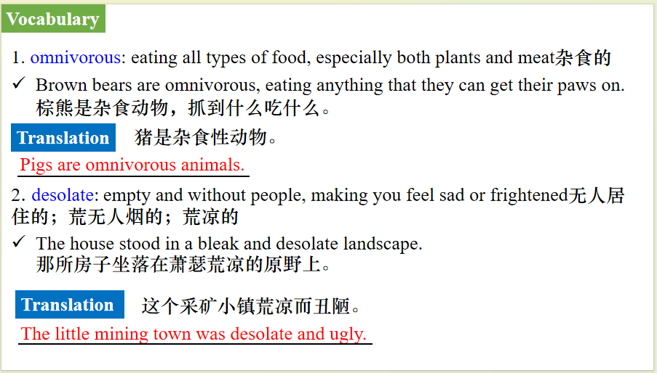

【设计意图】对文本中的词汇进行解读，并通过翻译句子对其进行巩固。

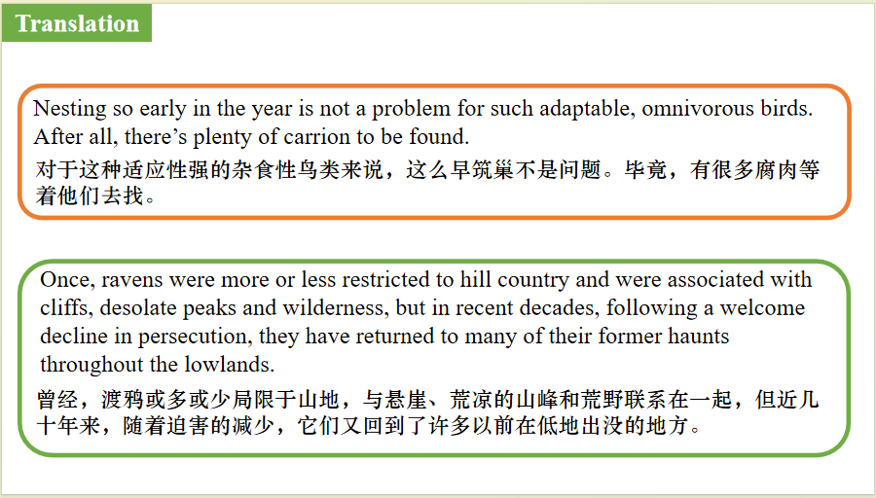

【设计意图】对文中的两个句子进行翻译练习，对其中单词、词组、句法进行巩固并关注句子结构。

**Part 2: News Report 2 *New Scientist* ( 23rd March 2024 Page 13)**

**Buildings could be 3D printed using ink made of waste wood**

**建筑可以用废木材制成的墨水进行3D打印**

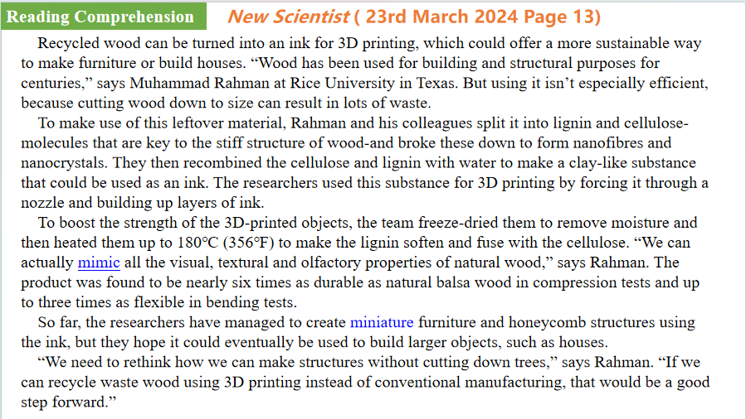

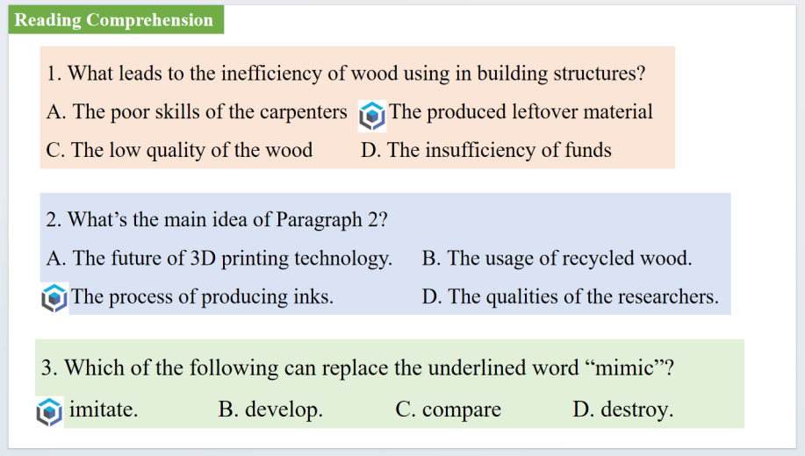

【设计意图】通过阅读理解的形式帮助学生理解新闻的主要内容。该新闻主题语境是关于“人与社会”中“科技发展与信息技术创新”这一子主题，通过学习让学生了解建筑可以用废木材制成的墨水进行3D打印的新科技。



【设计意图】对文本中的词汇进行解读，并通过翻译句子对其进行巩固。

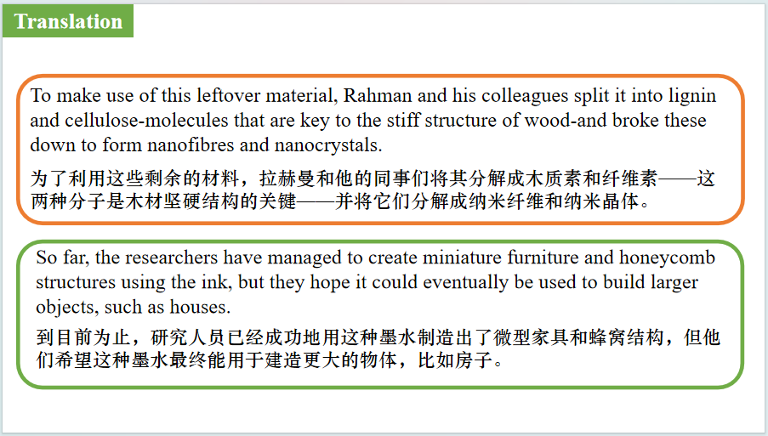

【设计意图】对文中的两个句子进行翻译练习，对其中单词、词组、句法进行巩固并关注句子结构。

**Part 3: News Report 3 *The Times* (19th March 2024 P31)**

**Stars do not shine for female chefs, admits Michelin boss**

**米其林老板承认，女厨师不会得到青睐**

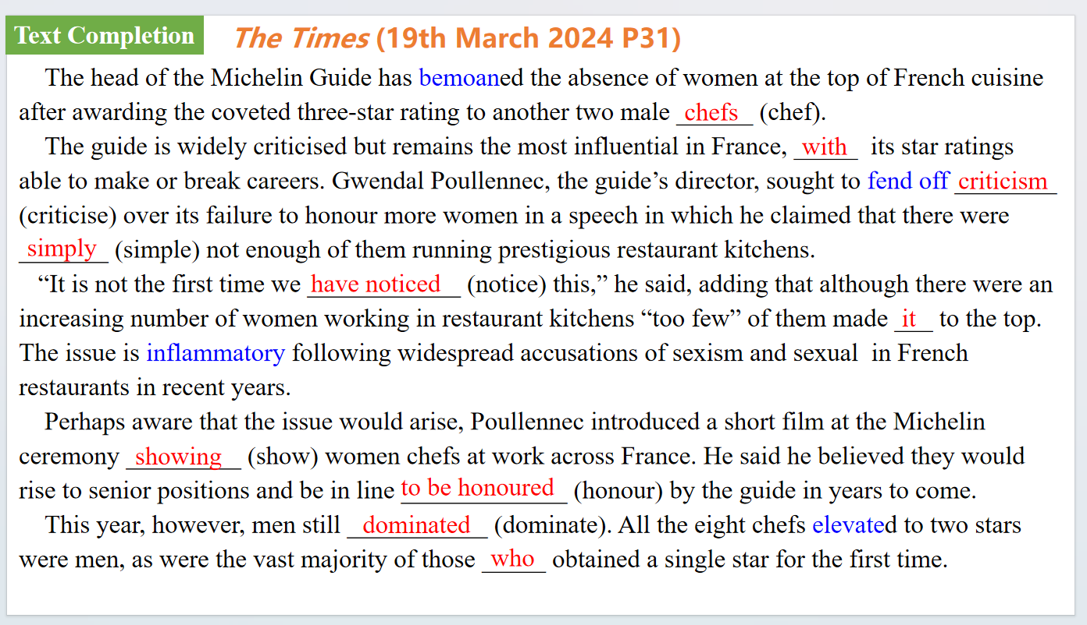

【设计意图】通过语篇填空的形式帮助学生理解新闻的主要内容，同时训练语言语法的运用能力：在语篇的视角下如何正确使用所给词汇，根据语法规则确定词汇的正确形式，使得文章通顺，激活学生的思维和语言。该新闻主题语境是关于“人与社会”中“社会热点问题”这一子主题，通过学习让学生了解法国餐馆普遍存在性别歧视，法国米其林餐厅男性占主导地位，女性很难评到星级的现象。

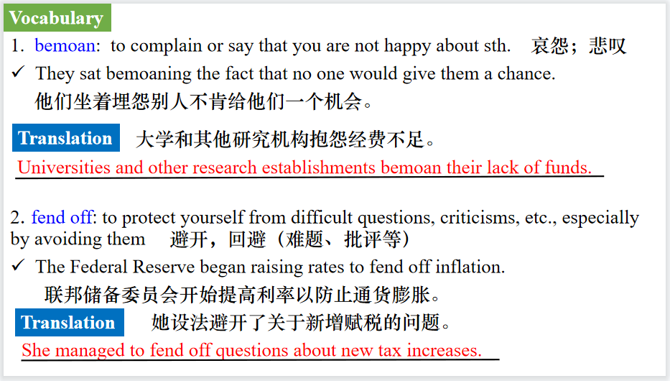

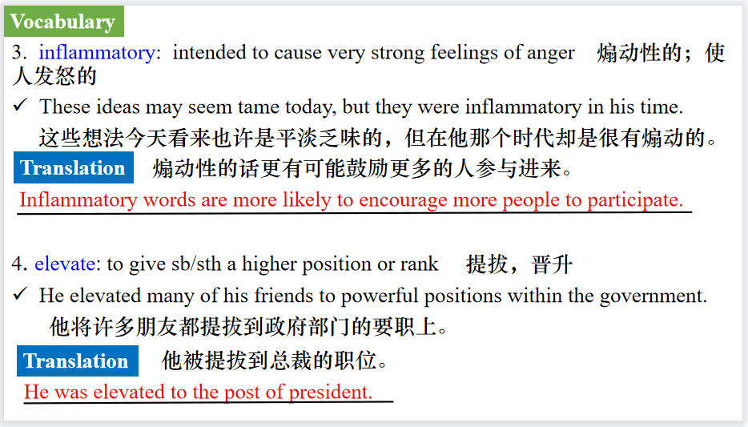

【设计意图】对文本中的词汇进行解读，并通过翻译句子对其进行巩固。

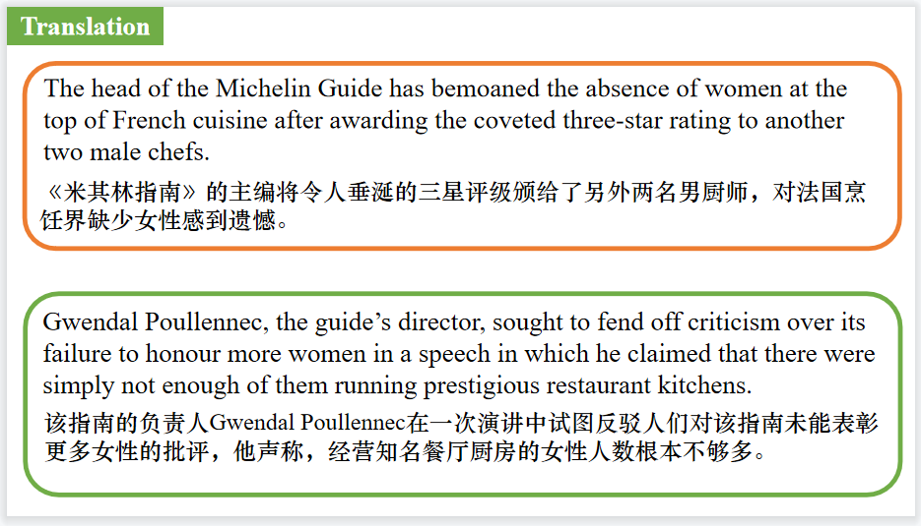

【设计意图】对文中的两个句子进行翻译练习，对其中单词、词组、句法进行巩固并关注句子结构。

**Part 4: News Report 4 *Time* (25th March 2024 P13)**

**Texas’ Scorched Panhandle 德克萨斯州大火**

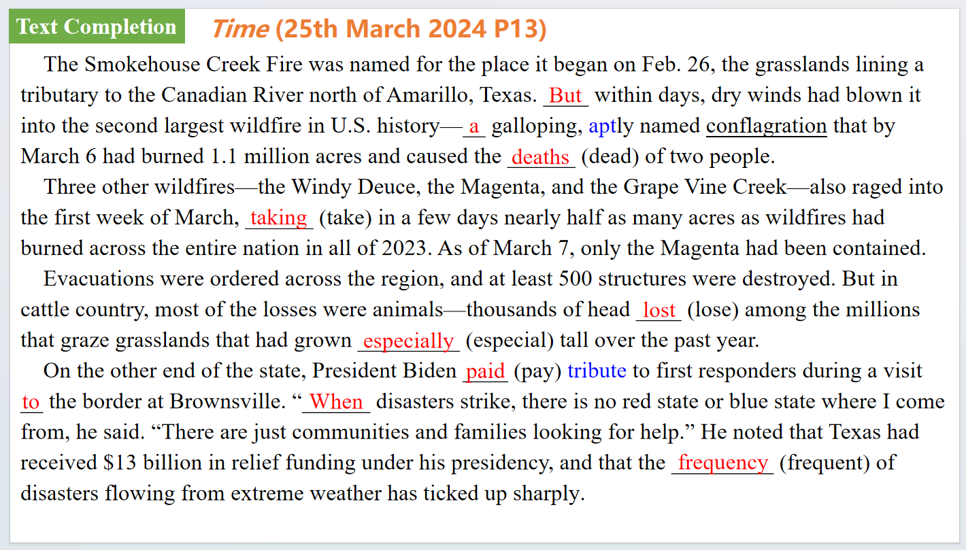

【设计意图】通过语篇填空的形式帮助学生理解新闻的主要内容，同时训练语言语法的运用能力：在语篇的视角下如何正确使用所给词汇，根据语法规则确定词汇的正确形式，使得文章通顺，激活学生的思维和语言。该新闻主题语境是关于“人与社会”中“社会热点问题”这一子主题，通过学习让学生了解美国得克萨斯州大火的事件。

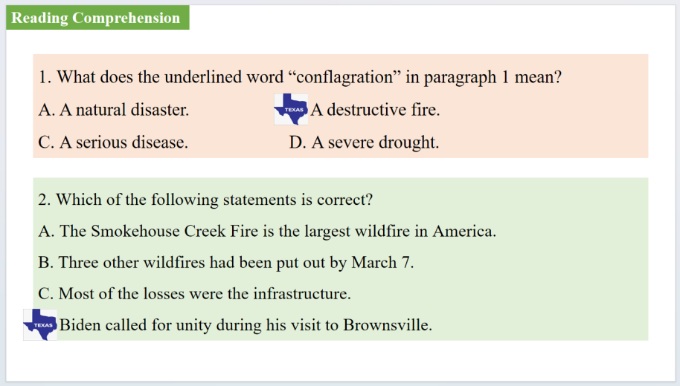

【设计意图】通过阅读理解的形式帮助学生理解新闻的主要内容。

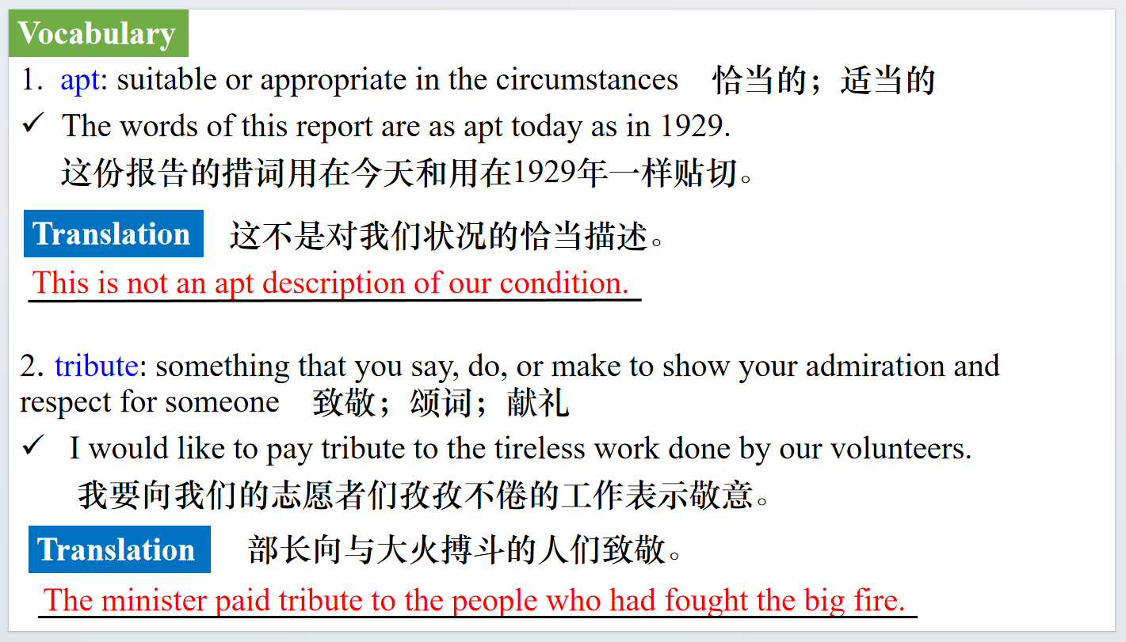

【设计意图】对文本中的词汇进行解读，并通过翻译句子对其进行巩固。

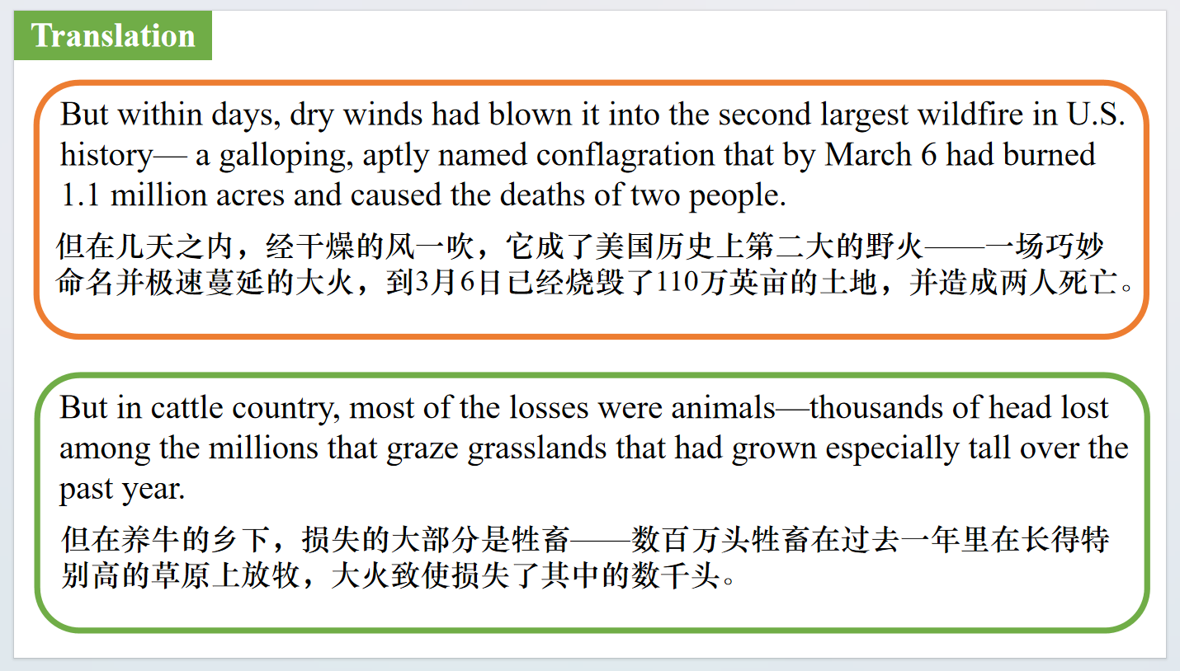

【设计意图】对文中的两个句子进行翻译练习，对其中单词、词组、句法进行巩固并关注句子结构。

**Part 5: CNN News 03/22/2024**

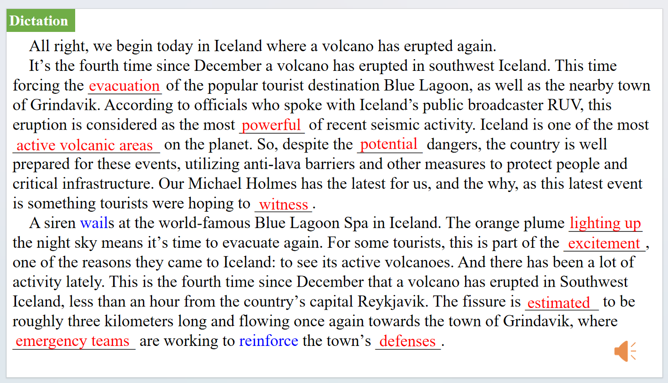

【设计意图】听一则材料，通过听力填空的方式理解文本，考察听力辨识词汇的能力。

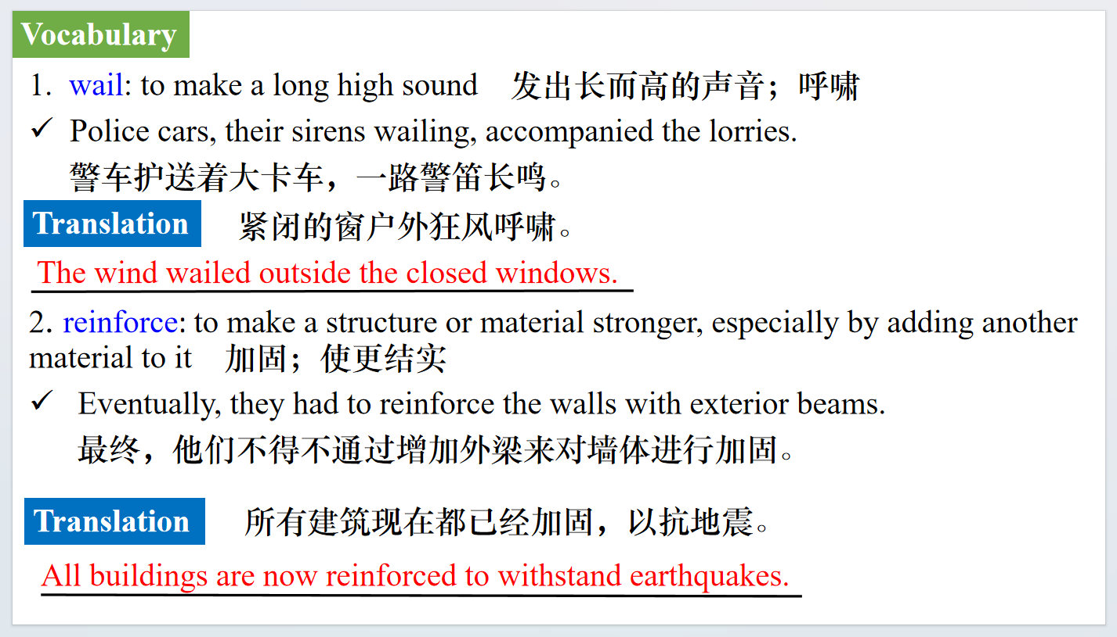

【设计意图】对文本中的词汇进行解读，并通过翻译句子对其进行巩固。

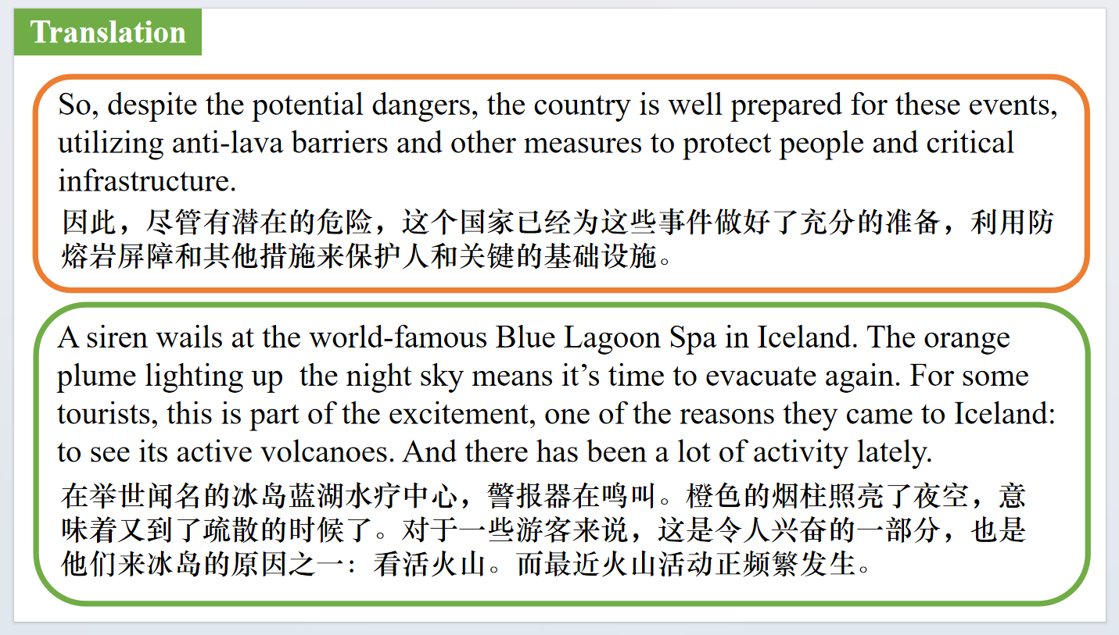

【设计意图】对文中的两个句子进行翻译练习，对其中单词、词组、句法进行巩固并关注句子结构。

附：外刊原文

**Part 1: News Report 1 *BBC Wildlife* ( March 2024 Page 10)**

**Raven’s return 乌鸦的回归**

Come march, the breeding season is in full swing for several British birds - ravens included. By now most ravens will be incubating eggs and some pairs, especially in southern England and Wales, will have hungry chicks to feed. Nesting so early in the year is not a problem for such adaptable, omnivorous birds. After all, there’s plenty of carrion to be found.

Once, ravens were more or less restricted to hill country and were associated with cliffs, desolate peaks and wilderness, but in recent decades, following a welcome decline in persecution, they have returned to many of their former haunts throughout the lowlands. A few ravens have even started nesting again in the arable landscapes of East Anglia. The giant crow’s dramatic change in fortune is matched by the comeback of the peregrine, buzzard and a number of other much-persecuted birds.

In lowland areas ravens often nest in Scots pines and on pylons, and occasionally on tall buildings. Resident pairs perform acrobatic displays above their nest site to strengthen pair bonding and -who knows? - perhaps also out of pure joy.

**Part 2: News Report 2 *New Scientist* ( 23rd March 2024 Page 13)**

**Buildings could be 3D printed using ink made of waste wood**

**建筑可以用废木材制成的墨水进行3D打印**

Recycled wood can be turned into an ink for 3D printing, which could offer a more sustainable way to make furniture or build houses. “Wood has been used for building and structural purposes for centuries,” says Muhammad Rahman at Rice University in Texas. But using it isn’t especially efficient, because cutting wood down to size can result in lots of waste.

To make use of this leftover material, Rahman and his colleagues split it into lignin and cellulose-molecules that are key to the stiff structure of wood -and broke these down to form nanofibres and nanocrystals. They then recombined the cellulose and lignin with water to make a clay-like substance that could be used as an ink. The researchers used this substance for 3D printing by forcing it through a nozzle and building up layers of ink.

To boost the strength of the 3D-printed objects, the team freeze-dried them to remove moisture and then heated them up to 180℃(356℉) to make the lignin soften and fuse with the cellulose. “We can actually mimic all the visual, textural and olfactory properties of natural wood,” says Rahman. The product was found to be nearly six times as durable as natural balsa wood in compression tests and up to three times as flexible in bending tests.

So far, the researchers have managed to create miniature furniture and honeycomb structures using the ink, but they hope it could eventually be used to build larger objects, such as houses.

“We need to rethink how we can make structures without cutting down trees,” says Rahman. “If we can recycle waste wood using 3D printing instead of conventional manufacturing, that would be a good step forward.”

**Part 3: News Report 3 *The Times* (19th March 2024 P31)**

**Stars do not shine for female chefs, admits Michelin boss**

**米其林老板承认，女厨师不会得到青睐**

The head of the Michelin Guide has bemoaned the absence of women at the top of French cuisine after awarding the coveted three-star rating to another two male chefs.

Fabien Ferré, of the restaurant La Table du Castellet in southern France, and Jérôme Banctel, who is at Le Gabriel in Paris, join 28 chefs who already had three stars, the highest rating in the Michelin system.

Only one of them, Anne-Sophie Pic, is a woman.

The guide is widely criticised but remains the most influential in France, with its star ratings able to make or break careers. Gwendal Poullennec, the guide’s director, sought to fend off criticism over its failure to honour more women in a speech in which he claimed that there were simply not enough of them running prestigious restaurant kitchens.

“It is not the first time we have noticed this,” he said, adding that although there were an increasing number of women working in restaurant kitchens “too few” of them made it to the top.

“We deplore that,” Poullennec said as the newspaper Le Figaro asked on its website:“Where are the women?”

The issue is inflammatory following widespread accusations of sexism and sexual harassment in French restaurants in recent years.

Perhaps aware that the issue would arise, Poullennec introduced a short film at the Michelin

ceremony showing women chefs at work across France. He said he believed they would rise to

senior positions and be in line to be honoured by the guide in years to come.

This year, however, men still dominated. All the eight chefs elevated to two stars were men, as were the vast majority of those who obtained a single star for the first time.

Among the handful of women to be given one Michelin star was Eugénie Béziat, 41, who has taken over the Espadon restaurant at the Ritz Hotel in Paris.

Manon Fleury, 32, a former member of the French national fencing team who put down her sword to take up cooking, also won a star for her cuisine at the Datil restaurant in Paris.

The ceremony in Tours, central France, is to French cuisine what the Oscars are to cinema.

Chefs struggled to hold back tears as they walked up to the stage to receive their stars, with music resonating around the hall and applause ringing in their ears. Ferré grabbed the headlines, becoming at the age of 35 one of the youngest chefs to obtain three stars from Michelin. Poullennec said that Ferré and Banctel, 52, had elevated cuisine into an art form.

But Stéphane Durand-Souffland, Le Figaro’s restaurant critic, was unconvinced. He said Michelin’s criteria were “opaque” and accused it of awarding stars to young chefs in order to appear modern. He said Michelin’s guide was like the company’s tyres: “Little substance and a lot of air.”

**Part 4: News Report 4 *Time* (25th March 2024 P13)**

**Texas’ Scorched Panhandle 德克萨斯州大火**

The Smokehouse Creek Fire was named for the place it began on Feb. 26, the grasslands lining a tributary to the Canadian River north of Amarillo, Texas. But within days, dry winds had blown it into the second largest wildfire in U.S. history—a galloping, aptly named conflagration that by March 6 had burned 1.1 million acres and caused the deaths of two people: an 83-year-old woman found in her burned home, and a 44-year-old woman who died after being found outside her truck that had been overtaken by smoke and flames.

Three other wildfires—the Windy Deuce, the Magenta, and the Grape Vine Creek—also raged into the first week of March, taking in a few days nearly half as many acres as wildfires had burned across the entire nation in all of 2023. As of March 7, only the Magenta had been contained. In neighboring Oklahoma, multiple fires burned more than 300,000 acres.

Evacuations were ordered across the region, and at least 500 structures were destroyed. But in cattle country, most of the losses were animals—thousands of head lost among the millions that graze grasslands that had grown especially tall over the past year. Republican Governor Greg Abbott issued a state disaster declaration in 60 Texas counties.

On the other end of the state, President Biden paid tribute to first responders during a visit to the border at Brownsville. “When disasters strike, there is no red state or blue state where I come from, he said. “There are just communities and families looking for help," He noted that Texas had received $13 billion in relief funding under his presidency, and that the frequency of disasters flowing from extreme weather has ticked up sharply: “I love some of my Neanderthal friends, who still think there's no climate change.”