**读后续写教学设计**

绍兴市上虞区城南中学 陶江英

【主题语境】人与自我——做人与做事

【语篇类型】记叙文（原文见附录）

【语篇研读】故事内容如下：一群探险爱好者穿越圣地亚哥附近的沙漠，到达Thunder Canyon Cave进行探险。进入这个洞穴，必须穿过一个冰冷的瀑布，沿着狭小的石缝侧身前行，在这个过程中，“我”被卡在石缝中，进退两难。整队人齐心协力也没能把我解救出来，最后队长Luca只好向救援队求助。本文以叙事为主，按照事情发展的先后顺序进行展开，结构清晰，动作描写细致入微，是一篇动作描写具体化的优秀文本。在分析动作描写的同时，引导学生关注动作背后的人物个性特点和人物心理的变化。本文通过描述野外探险时队员间互助合作救“我”脱险的故事揭示了时团队合作精神的重要性，属于人与自我的主题语境，引导学生在平时的集体生活中要发扬团队精神，共同进步。

【教学目标】学生在学习完本篇记叙文后，能够：

1. 借助“导读卡”梳理故事发展框架，理清主人公心理活动变化这一主线，概括故事主要内容，学会分析和推断信息的逻辑关系，培养逻辑性思维的能力；

2. 借助“导构卡”，根据续写段落开头语预测可能的情节发展和结尾，为续写选择合适的划线关键词，构建符合逻辑的续写故事框架，培养逻辑性和创新性思维的能力，根据搭建的故事框架进行书面语言的输出；

3. 根据“导改卡”，按照主题思想、情节构思、语言表达三个方面对同学的读后续写进行评价，发表自己的观点和立场，并对续写进行修改、润色，从而提升批判性思维能力，重点关注：动词的准确使用。

【教学设计】

【导入】

Free talk: Show a picture of a boy who was stuck in a crack.

Ask students: What happened to the boy? How can he go out of the crack?

**Tip1: Use specific verbs to describe a specific scene.**

【设计意图】自由讨论导入相关动词，拓展知识，激发兴趣，提出写作建议，为更好地理解文本和写作输出做好铺垫。

【导读卡】

1. The structure:

Para.1 The tiring trip→Para.2 The experienced leader→Para.3 The helpful teammates

2. 5W and 1H:

when: Sunday last year, who: the group, where: cave, what: explored and rescued, why: I was stuck in…, how: ?

3. Plot map

Plot 1: The tiring trip

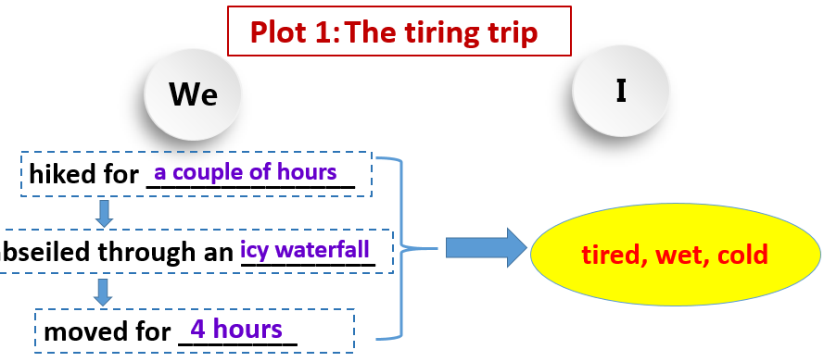

Plot 2: The experienced leader

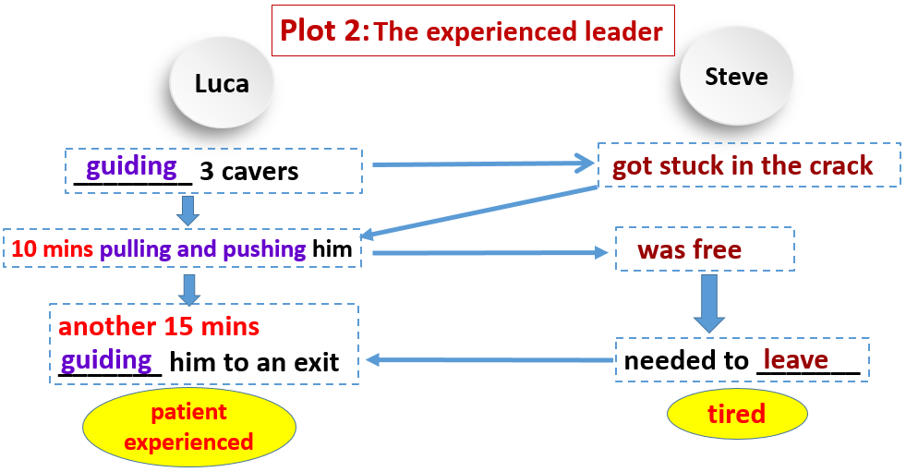

Plot 3: The helpful teammates

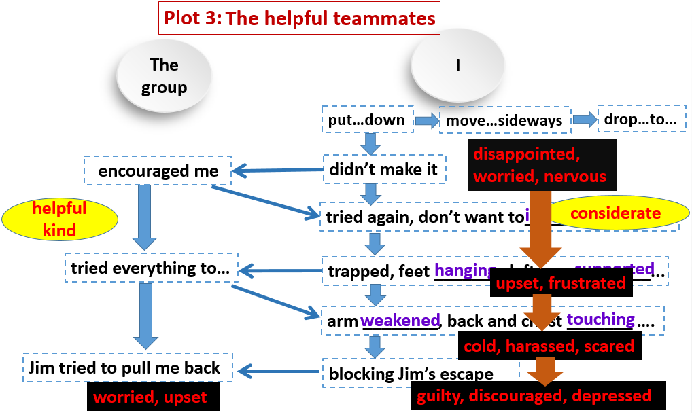

4. More expressions to describe negative emotions and positive emotions

5. Theme: It was the teamwork that helped me out.

6. The given sentences:

**Paragraph 1:**

With the risk of the low body temperature, the group supplied me with their own jackets. ____________________________________________________________

(1)Did the jacks make me warm?

(2)How did I feel?

(3)What did the group do for me? Did Jim do something for me?

**Paragraph 2:**

After eight hours, Luca found the rescue team. _____________________________

(1)How did the rescue team rescue me?

(2)Did Luca do something?

(3)How did I feel in the end?

**Tip2: Have a good understanding of the story before writing.**

【设计意图】（1）对文本各段大意和六要素（其中how是续写内容）的分析，有助于学生从整体上把握记叙文的结构。（2）以故事发展过程中的三个情节为明线，人物的情绪变化为暗线，透过三个情节中的动词描写，分析人物内心情绪的变化，抓住人物的个性特点，分析故事的主题思想，从而发展学生的分析、推理等思维

能力。在情节分析中强调动词的正确使用，补充有关情绪描写的表达，为续写做好语言上的准备。（3）分析段首句，以提问的形式对段首句中有可能展开的情节进行删选，引导学生在续写时做到情节设计上与原文保持逻辑一致。

【导构卡】

1. Outline for Paragraph 1

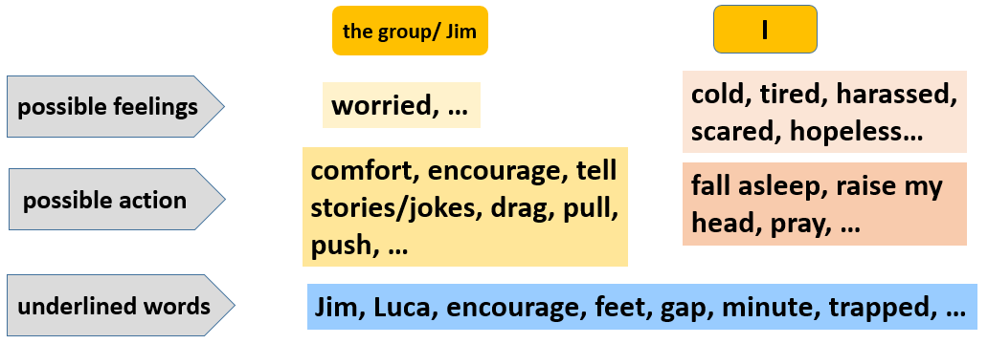

2. Outline for Paragraph 2

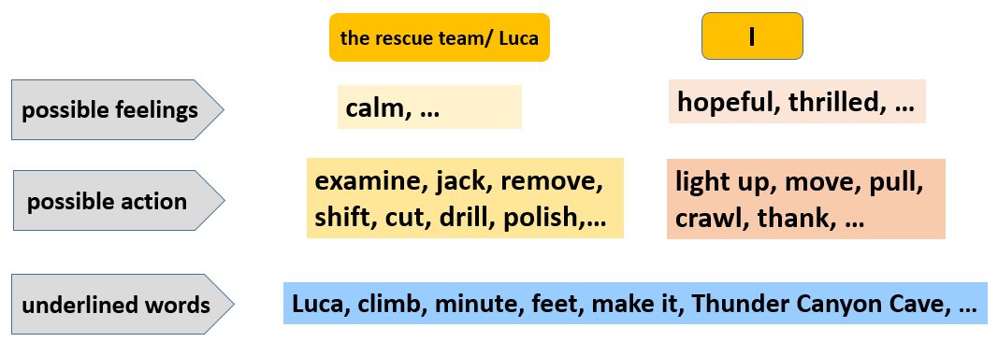

**Tip3: Focus on the given sentences and underlined words.**

【设计意图】通过对故事和段首句的分析，引导学生从以下三个方面寻找情节构思的突破口：主人公可能存在的情绪、行为和有可能使用的划线的关键词，同时要求学生注意段首句与后续句子之间的衔接、第一段与第二段之间的衔接。

【导评卡】

|  |  |  |
| --- | --- | --- |
| 评价项目 | 内容描述 | 得分（优秀3，良好2，一般1） |
| 主题思想 | 主题明确，积极向上 |  |
| 情节构思 | 续写情节与原文高度相关 |  |
| 两个续写段落之间衔接合理 |  |
| 续写段首语与后续情节连贯 |  |
| 语言表达 | 用词准确，语法正确 |  |
| 语言丰富（细节描写、句式多样） |  |
| 使用5个以上划线的关键词 |  |
| 总分 | / |  |

1. Passage 1 for grading:

***With the risk of the low body temperature, t****he group supplied me with their own jackets.* Nevertheless, they were of no use for me to warm up. Feeling I couldn’t make it alive, I was seized by a strong sense of panic. Jim, whose escape was blocked by me, was surprisingly calm. As I was ready to bear his stormy blame, he began to crack jokes to comfort me. With the encouragement from the group, I firmly believed Luca could find someone to rescue me. ( How many scores? Why?)

2. Passage 2 for grading:

***After eight hours, Luca found the rescue team.*** When I saw them, I breathed freely. The rescue team used their technique to save me from the gap. I saw my parents near the rescue team. At that time tears welled up my eyes. After this experience, I knew that a thin body is important when you go through a gap. ( How many scores? Why?)

**Tip4: Keep the marking criterion in mind while writing.**

【设计意图】从语意的衔接、语言表达的准确性和多样性对续写内容进行评价、打分，引导学生了解续写的评价标准，学会自我评价和改进，培养学生的批判性思维和自主学习能力。

【附录】

阅读下面短文,根据所给情节进行续写，使之构成一个完整的故事。

One Sunday last year, eight of us hiked for a couple of hours through the desert near San Diego to reach Thunder Canyon Cave. We had to abseil(沿绳滑下) through an icy waterfall to get inside, so we put on our wetsuits and lowered ourselves 30 feet down. By 11:00 a.m. we were inside. After we climbed further, we reached a nine-inch crack. Having moved for four hours, I was tired and wet.

The group leader, Luca, was guiding three cavers. One of them, Steve got stuck in the crack. There was 10 minutes of pulling and pushing until Steve was free. He was tired and needed to leave. Luca, assuming I’d been through the crack before, guided Steve through the cave for another 15 minutes to an exit. I was second from last to go through. I didn’t realize that Luca wasn’t there — if I’d known, I wouldn’t have attempted the crack, as I needed an experienced guide.

The challenge is to put your feet first down the length of the crack, and then move your body sideways to swing along, before dropping five feet to the floor of the next space. On my first attempt, I knew I wouldn’t make it through, but the group encouraged me to try again. I didn’t want to inconvenience anyone by having to make the long trip back through the cave, so I backed out and took off my wetsuit. In just my T-shirt, I tried to slide through again but my hips(屁股) were trapped. My feet were hanging on the other side and my left arm supported my body. My hand rested on a wooden board that had been left covering boulders(大圆石) to protect cavers from slipping. Luca returned and the team tried everything to shift me as I mentally focused on escape.

After two hours my arm weakened, so I slid further into the crack, where the gap was only 8.5 inches wide. My body weight was on my left hand, my back and chest touching the cold stone walls. The guy behind me, Jim, tried unsuccessfully to pull me back. Of course, I was blocking his escape, too.

注意：

1.所续写短文的词数应为150左右；

2.至少使用5个短文中标有下划线的关键词语；

3.续写部分分为两段，每段的开头语已为你写好；

4.续写完成后，请用下划线标出你所使用的关键词语。

**Paragraph 1:**

With the risk of the low body temperature, the group supplied me with their own jackets. ______________________________________________________________

___________________________________________________________________________________________________________________________________________________________________________________________________________________________________________________________________________________________________________________________________________________________________________________________________________________________________________________________________________________________________

**Paragraph 2:**

After eight hours, Luca found the rescue team. _______________________________

___________________________________________________________________________________________________________________________________________________________________________________________________________________________________________________________________________________________________________________________________________________________________________________________________________________________________________________________________________________________________