**M2 U1 Cultural Heritage 教学设计**

**主题语境：**

本版块围绕“了解怎样解决问题（How to solve a problem）”展开，引导学生分析探讨在修建阿斯旺大坝的过程中，文化遗产的保护所面临的挑战和问题，以及解决过程和方法。促使学生在理解的基础上，关注国际合作在问题解决过程中的关键作用，重视文化遗产的保护与社会经济发展的平衡与协调关系。鼓励学生积极面对挑战，善于合作，不断努力，寻求解决问题的合理途径和方法。

**文本分析：**

本文是一篇记述时间发展过程的叙事文体，作者按照时间顺序记述了问题的产生和解决过程：问题的提出与分析（para.1-2）, 问题的解决（para.3-4），意义与启示（para.5-6）。文章首位呼应，思路清晰，用时间线索将问题的产生、解决以及结果清晰地展现出来，有助于学生学生了解文化遗产保护过程中问题的复杂性和艰巨性，认识到文化遗产保护需要世界各国和全社会的共同努力，从而进一步思考自己在生活中如何切实参与到文化遗产保护的行列中。

**教学重难点：**

帮助学生理解阅读文本的主要信息和篇章结构；引导学生根据合适文本题材运用阅读策略“制作有关时间线的思维导图”（a mind map）;指导学生综合概括问题和解决的方法和过程，阐述文物保护的必要性和重要意义。

**教学过程：**

**Task 1: Warming up**

**[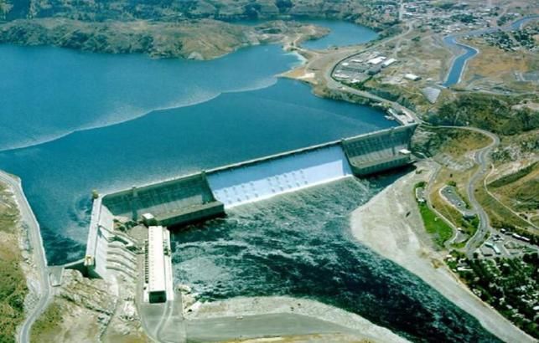](Abu%20Simbel%20and%20the%20Aswan%20High%20Dam.MP4)**

**The Aswan Dam**

Q1: What’s in the picture?

Q2: Where is the Aswan Dam?

Q3: When we talk about this country, what can you think of?

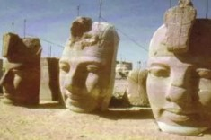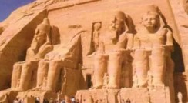**Task 2: Prediction**

**Picture 1 Picture 2**



Q1: What problems might occur when a dam was built across the Nile?

Q2: What messages might be included according to the pictures and the title? Make a prediction.

**Task 3: Skimming**

Look through the passage quickly and put it into three parts.

Problems: (para. _________)

Solutions: (para. _________)

Significance/Inspiration: (para. _________)

**Task 4: Scanning**

**Problems:**

What problems are mentioned in the text?

**Solution:**

Draw a mind map to show your understanding of how the problems were solved.

How were the temples saved?

**Significance:**

Q1: Why is the Aswan Dam a great success?

Q2: What is the spirit of the Aswan Dam project?

**Task 5: Debate**

Do you think it worthwhile to spend a lot of time and money to protect these temples. Why or why not?

**Task 6: Summary**

How to balance economic development and cultural heritage p_________ can be a big challenge. In Egypt, the p________ of building the Aswan Dam met with p_______ for fear of d________ the temples and cultural relics. The government t______ to the UN for help and e__________ a committee to prevent the l____ of cultural heritage and raise f______ internationally. Thanks to the hard work of the g______ community, the project was completed successfully with the cultural heritage preserved.