**The World**（**0916-0930**）材料分析和教学目标：

本次选用的材料：①*Newsweek*的*Is college worth it?*（大学值得上吗？）、②*The New York Times*的*Price Increases Are Easing, Report Shows*（英国物价上涨正在缓解）、③*Readers Digest* 的*EATING OLD FOOD（*过期食物能不能吃？）、④*The Washington Post*的*More than 3,000 chemicals from food packaging have entered our bodies*（食品包装中发现3000多种潜在有害化学物质）、 和⑤BBC的新闻报道。通过语法填空、阅读理解、分析长难句、翻译句子、听力填空和词汇拓展等方式，让学生从多角度提升学习兴趣，提高分析句子、运用词块和听力能力。外媒英语新闻可以让学生体验真实语境下的语言运用，拓展学生的国际视野，了解时事，逐步提升跨文化沟通能力，形成正确的世界观、人生观和价值观。

教学思路：

**Part 1: News Report 1 *Newsweek* (September 20, 2024 P10&11)**

**Is college worth it?** 大学值得上吗？

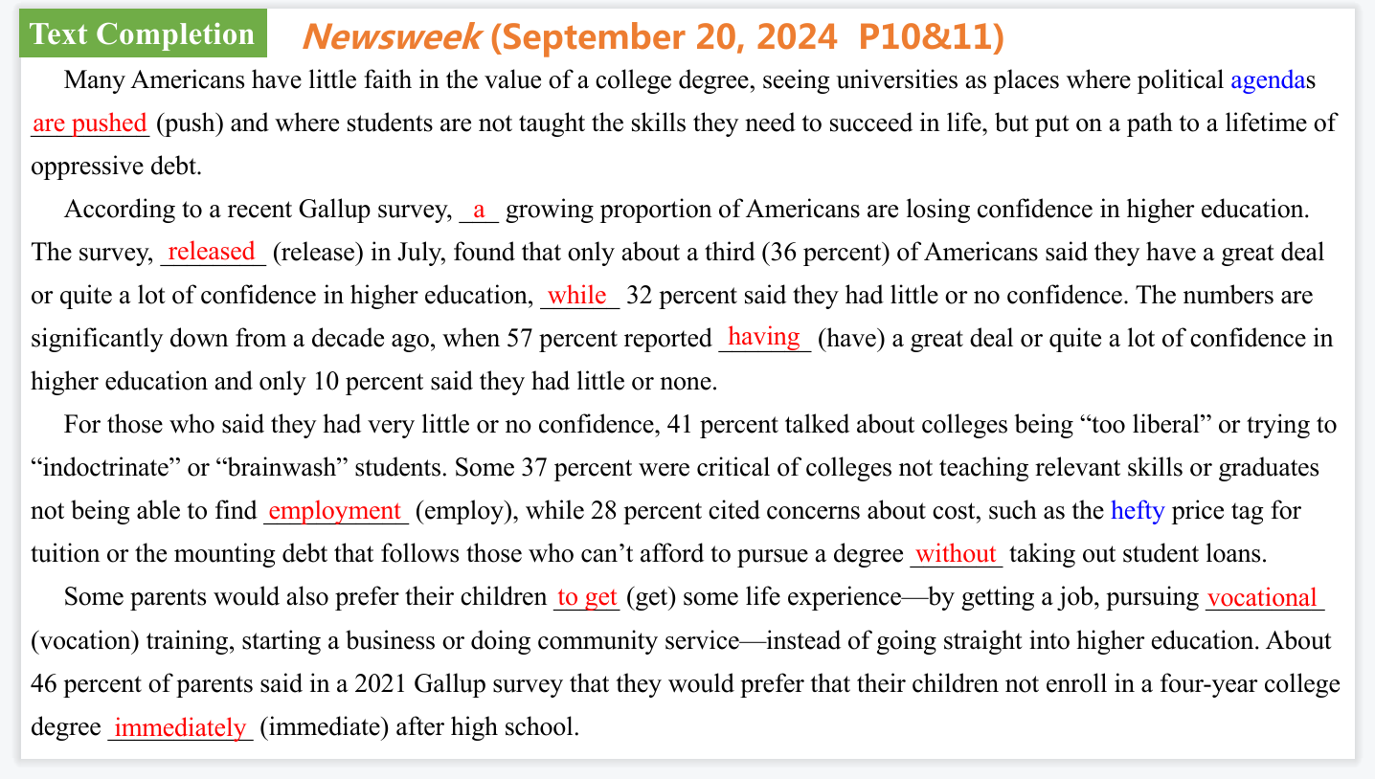

【设计意图】通过语篇填空的形式帮助学生理解新闻的主要内容，同时训练语言语法的运用能力：在语篇的视角下如何正确使用所给词汇，根据语法规则确定词汇的正确形式，使得文章通顺，激活学生的思维和语言。该新闻主题语境是关于“人与社会”中“社会热点问题”这一子主题，通过学习让学生了解美国高中生及其家长对上大学的看法。

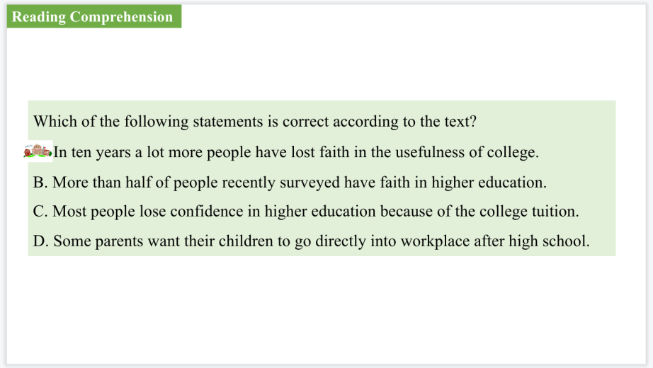

【设计意图】通过阅读理解的形式帮助学生理解新闻的主要内容。

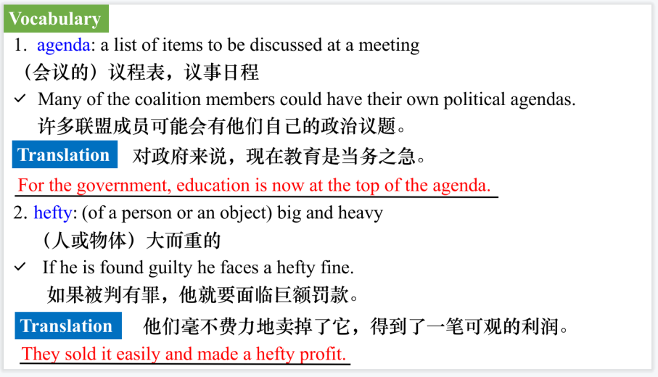

【设计意图】对文本中的词汇进行解读，并通过翻译句子对其进行巩固。

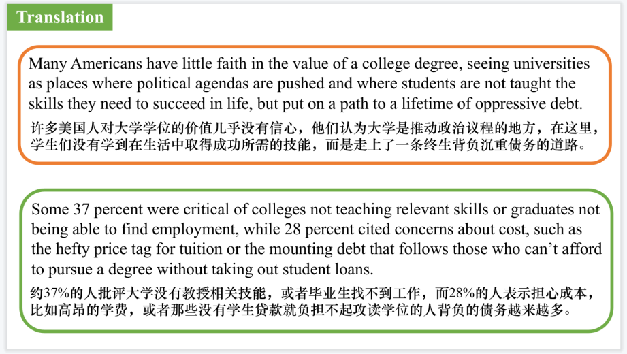

【设计意图】对文中的两个句子进行翻译练习，对其中单词、词组、句法进行巩固并关注句子结构。

**Part 2: News Report 2 *The New York Times*  (September 28, 2024 B1)**

**Price Increases Are Easing, Report Shows 英国物价上涨正在缓解**

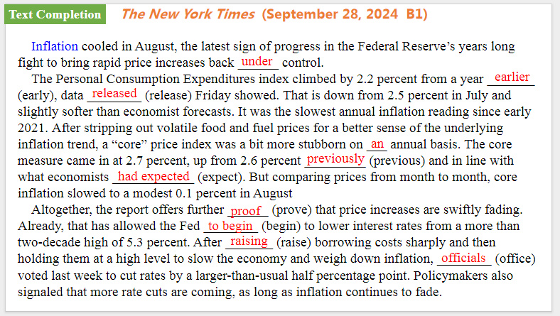

【设计意图】通过语篇填空的形式帮助学生理解新闻的主要内容，同时训练语言语法的运用能力：在语篇的视角下如何正确使用所给词汇，根据语法规则确定词汇的正确形式，使得文章通顺，激活学生的思维和语言。该新闻主题语境是关于“人与社会”中“社会热点问题”这一子主题，通过学习让学生了解英国物价上涨正在缓解的现象。

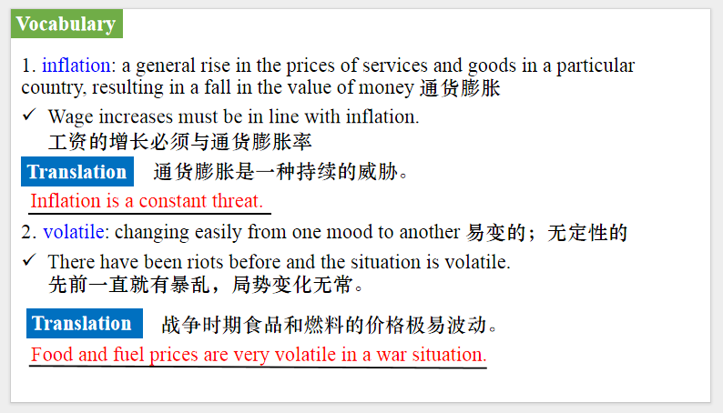

【设计意图】对文本中的词汇进行解读，并通过翻译句子对其进行巩固。

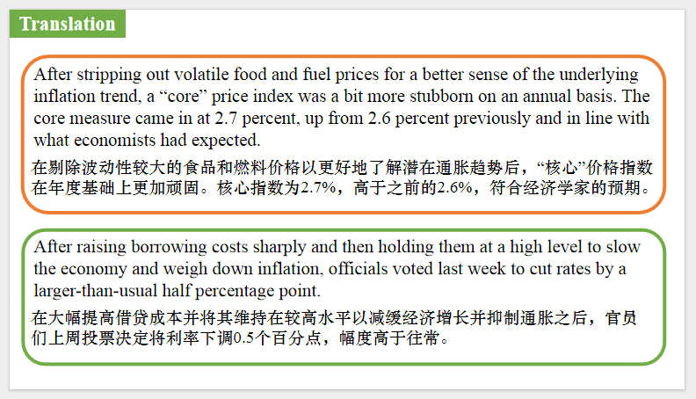

【设计意图】对文中的两个句子进行翻译练习，对其中单词、词组、句法进行巩固并关注句子结构。

**Part 3: News Report 3 *Readers Digest USA*  (September, 2024 P95)**

**EATING OLD FOOD过期食物能不能吃？**

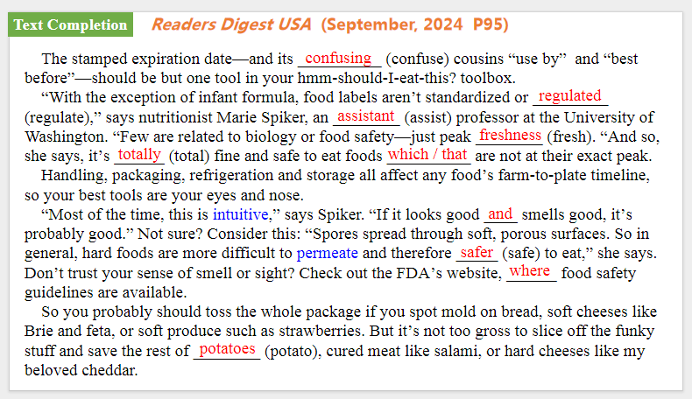

【设计意图】通过语篇填空的形式帮助学生理解新闻的主要内容，同时训练语言语法的运用能力：在语篇的视角下如何正确使用所给词汇，根据语法规则确定词汇的正确形式，使得文章通顺，激活学生的思维和语言。该新闻主题语境是关于“人与社会”中“社会热点问题”这一子主题，通过学习让学生了解过期食物能不能吃的科普知识。

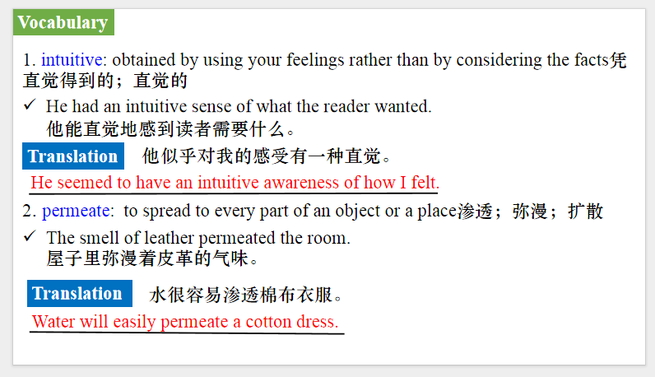

【设计意图】对文本中的词汇进行解读，并通过翻译句子对其进行巩固。

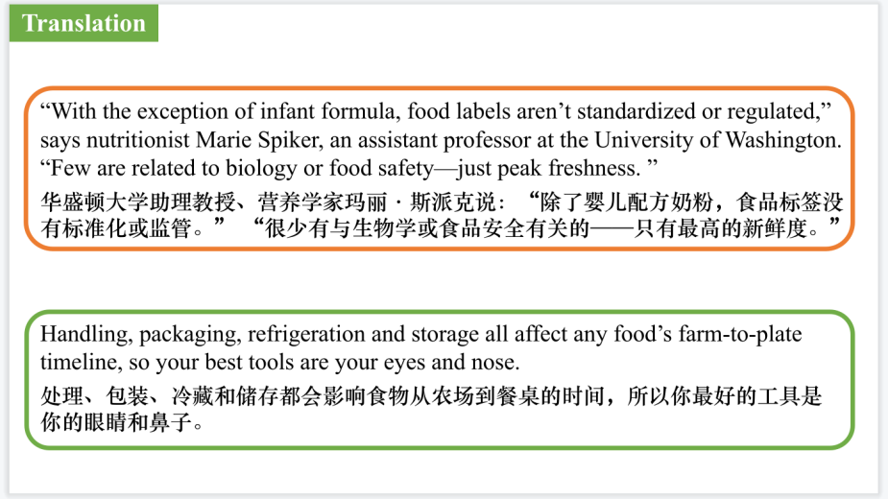

【设计意图】对文中的两个句子进行翻译练习，对其中单词、词组、句法进行巩固并关注句子结构。

**Part 4: News Report 4 *The Washington Post* (September 19, 2024 A9)**

**More than 3,000 chemicals from food packaging have entered our bodies** 食品包装中发现3000多种潜在有害化学物质

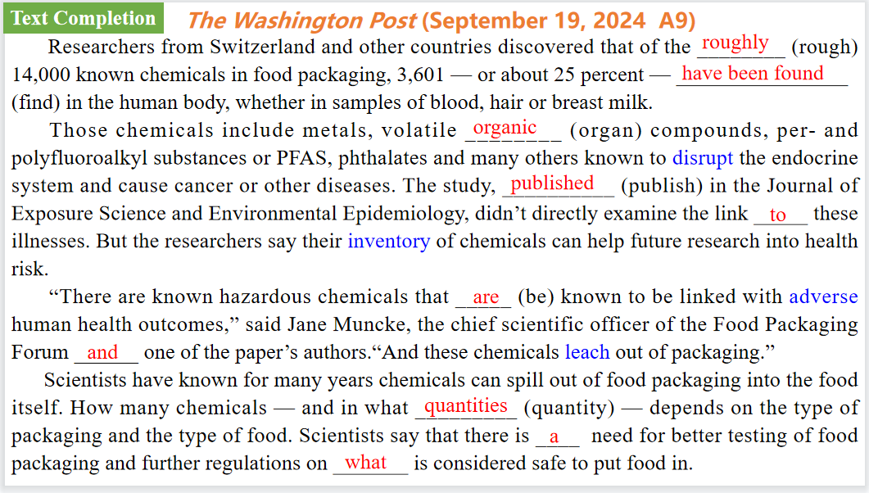

【设计意图】通过语篇填空的形式帮助学生理解新闻的主要内容，同时训练语言语法的运用能力：在语篇的视角下如何正确使用所给词汇，根据语法规则确定词汇的正确形式，使得文章通顺，激活学生的思维和语言。该新闻主题语境是关于“人与社会”中“社会热点问题”这一子主题，通过学习让学生了解食品包装中发现3000多种潜在有害化学物质。

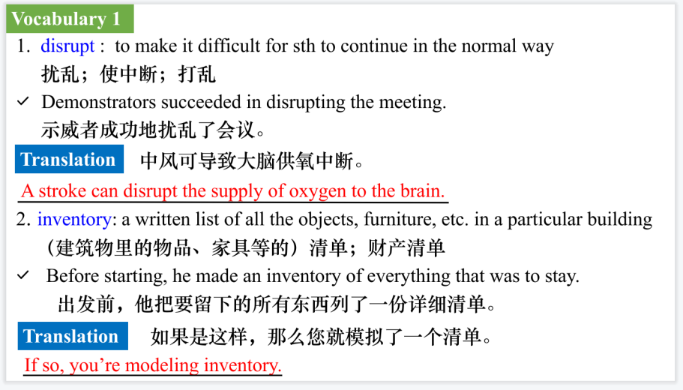

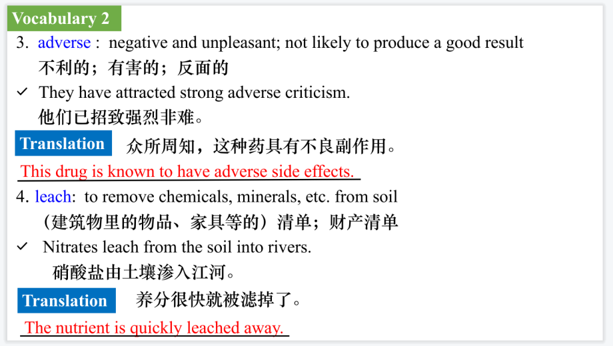

【设计意图】对文本中的词汇进行解读，并通过翻译句子对其进行巩固。

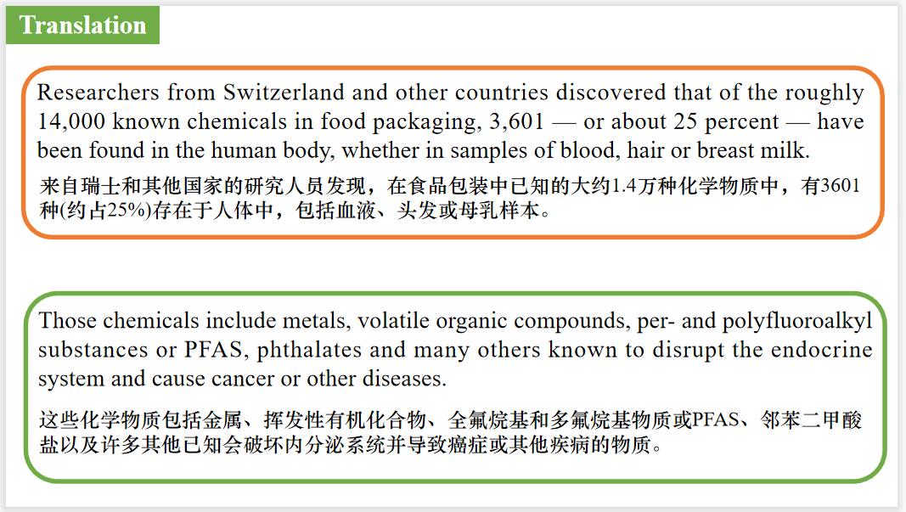

【设计意图】对文中的两个句子进行翻译练习，对其中单词、词组、句法进行巩固并关注句子结构。

**Part 5: BBC News 09/19/2024**

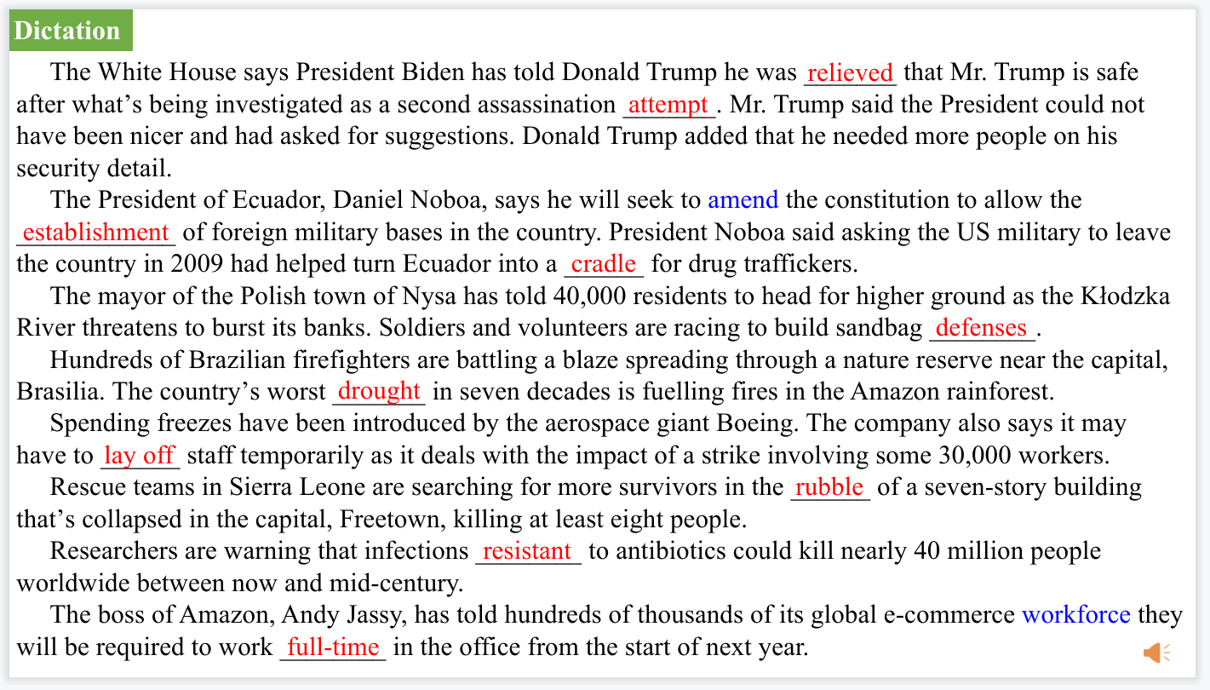

【设计意图】听一则材料，通过听力填空的方式理解文本，考察听力辨识词汇的能力。

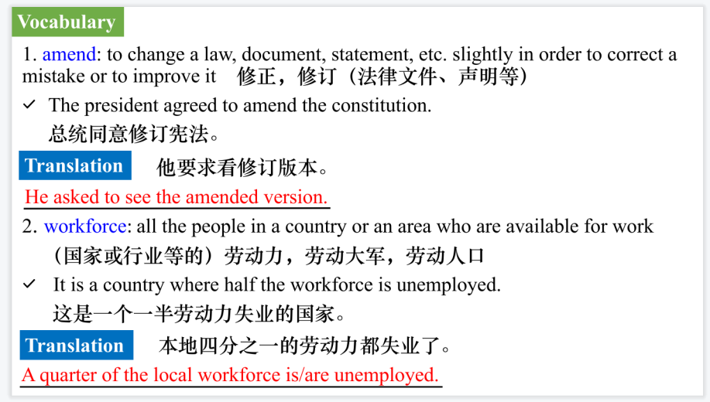

【设计意图】对文本中的词汇进行解读，并通过翻译句子对其进行巩固。

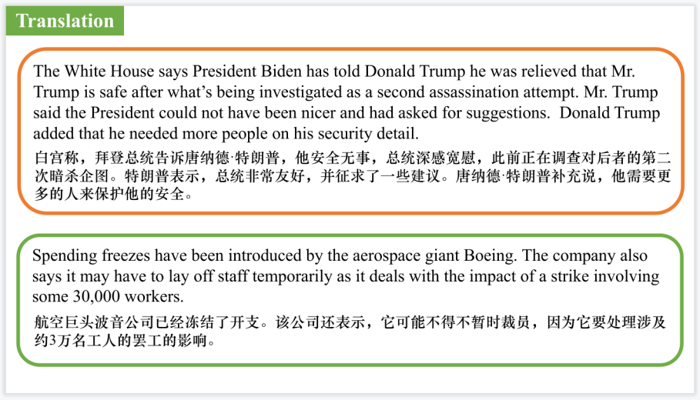

【设计意图】对文中的两个句子进行翻译练习，对其中单词、词组、句法进行巩固并关注句子结构。

附：外刊原文

**Part 1: News Report 1 *The Week* (September 30, 2024 P10&11)**

**Is college worth it?** 大学值得上吗？

Jordan Reconnu, 23, of Dallas, Texas, has no regrets about not getting a college degree. During the one semester of college she attended after graduating from high school in 2019, she felt like she wasn’t learning anything new. The idea of continuing did not appeal to her, and realizing how much her college education would end up costing, she quit and now works as a manager of a fast-food restaurant.

“I wasn’t thrilled with taking basic classes for two years and wasting even more money going to the same classes that we covered in high school,” she told Newsweek.

Higher education would not have improved her career prospects, she said, adding that she feels it is only worth pursuing for those hoping to work in fields that require it. “I feel like experience is what makes people marketable,” she said. Her mother, Jacque Abron, agrees with the sentiment.

Abron earned a college degree before becoming a teacher, but she is glad her daughter won’t be saddled with student debt that for her has soared to more than $100,000 with added interest over the years. College is “overrated,” Abron said. “I don’t see the use of a degree in this day and age. Employers are demanding higher education, and they serve no purpose.”

Reconnu and Abron are among many Americans who have little faith in the value of a college degree, seeing universities as places where political agendas are pushed and where students are not taught the skills they need to succeed in life, but put on a path to a lifetime of oppressive debt.

According to a recent Gallup survey, a growing proportion of Americans are losing confidence in higher education. The survey, released in July, found that only about a third (36 percent) of Americans said they have a great deal or quite a lot of confidence in higher education, while 32 percent said they had little or no confidence. The numbers are significantly down from a decade ago, when 57 percent reported having a great deal or quite a lot of confidence in higher education and only 10 percent said they had little or none.

For those who said they had very little or no confidence, 41 percent talked about colleges being “too liberal” or trying to “indoctrinate” or “brainwash” students. Some 37 percent were critical of colleges not teaching relevant skills or graduates not being able to find employment, while 28 percent cited concerns about cost, such as the hefty price tag for tuition or the mounting debt that follows those who can’t afford to pursue a degree without taking out student loans.

Another survey, conducted by EAB, formerly the Education Advisory Board, found that parents of students applying to college were most concerned about college costs (60 percent), receiving scholarships (40 percent) and the amount of student debt (39 percent). After that, their biggest concern was for the safety of their children on campuses, a concern that was higher for families of color.

Some parents would also prefer their children to get some life experience—by getting a job, pursuing vocational training, starting a business or doing community service—instead of going straight into higher education. About 46 percent of parents said in a 2021 Gallup survey that they would prefer that their children not enroll in a four-year college degree immediately after high school.

Abron said she would urge her other children, aged 4 and 12, to “check out trade schools or invest in other ways to build wealth.” But, ultimately, she said it would “come down to what they decide to do for their career and the requirements necessary.”

**Part 2: News Report 2 *The New York Times*  (September 28, 2024 B1)**

**Price Increases Are Easing, Report Shows**

报告显示，价格上涨正在缓解

Inflation cooled in August,the latest sign of progress in the Federal Reserve’s years long fight to bring rapid price increases back under control.

The Personal Consumption Expenditures index climbed by 2.2percent from a year earlier, data released Friday showed.That is down from 2.5 percent in July and slightly softer than economist forecasts. It was the slowest annual inflation reading since early 2021.

After stripping out volatile food and fuel prices for a better sense of the underlying inflation trend, a “core” price index was a bit more stubborn on an annual basis. The core measure came in at 2.7 percent,up from 2.6 percent previously and in line with what economists had expected. But comparing prices from month to month, core inflation slowed to a modest 0.1 percent in August

Altogether, the report offers further proof that price increases are swiftly fading. Already,that has allowed the Fed to begin to lower interest rates from a more than two-decade high of 5.3 percent. After raising borrowing costs sharply and then holding them at a high level to slow the economy and weigh down inflation, officials voted last week to cut rates by a larger-than-usual half percentage point. Policymakers also signaled that more rate cuts are coming, as long as inflation continues to fade.

**Part 3: News Report 3 *Readers Digest USA*  (September, 2024 P95)**

**EATING OLD FOOD过期食物能不能吃？**

The stamped expiration date—and its confusing cousins “use by” and “best before”—should be but one tool in your *hmm-should-I-eat-this?* toolbox

“With the exception of infant formula, food labels aren’t standardized or regulated,” says nutritionist Marie Spiker, an assistant professor at the University of Washington. “Few are related to biology or food safety—just peak freshness."And so,she says,it's totally fine and safe to eat foods that are not at their exact peak.

Handling, packaging, refrigeration and storage all affect any food’s farm-to-plate timeline, so your best tools are your eyes and nose.

“Most of the time,this is intuitive,”says Spiker. “I fit looks good and smells good, it’s probably good.” Not sure? Consider this:“Spores spread through soft, porous surfaces. So in general, hard foods are more difficult to permeate and therefore safer to eat,” she says. Don’t trust your sense of smell or sight? Check out the FDA’s website, where food safety guidelines are available.

So you probably should toss the whole package if you spot mold on bread, soft cheeses like Brie and feta, or soft produce such as strawberries. But it's not too gross to slice off the funky stuff and save the rest of potatoes,cured meat like salami, or hard cheeses like my beloved cheddar.

**Part 4: News Report 4 *The Washington Post* (September 19, 2024 A9)**

**More than 3,000 chemicals from food packaging have entered our bodies** 食品包装中发现3000多种潜在有害化学物质

Shrink-wrap sealed around a piece of raw meat. Takeout containers filled with restaurant leftovers. Plastic bottles filled with soft drinks.

These are just a few types of food packaging that surround humans every day. And a study released this week shows the chemical toll of all that wrapping — and how it might affect the human body.

Researchers from Switzerland and other countries discovered that of the roughly 14,000 known chemicals in food packaging, 3,601 — or about 25 percent — have been found in the human body, whether in samples of blood, hair or breast milk.

Those chemicals include metals, volatile organic compounds, per- and polyfluoroalkyl substances or PFAS, phthalates and many others known to disrupt the endocrine system and cause cancer or other diseases. The study, published in the Journal of Exposure Science and Environmental Epidemiology, didn’t directly examine the link to these illnesses. But the researchers say their inventory of chemicals can help future research into health risk.

“There are known hazardous chemicals that are known to be linked with adverse human health outcomes,” said Jane Muncke, the chief scientific officer of the Food Packaging Forum and one of the paper’s authors.“And these chemicals leach out of packaging.”

Scientists have known for many years that chemicals can spill out of food packaging into the food itself. How many chemicals — and in what quantities — depends on the type of packaging and the type of food.

High temperatures can cause chemicals to leach more quickly into food, which is why scientists recommend avoiding microwaving food in takeout containers. Foods that are high in fat or high in acidity also tend to absorb more chemicals from their packaging, as do foods that are tucked into smaller containers — the more cramped the container, the more contact it has with the food inside.

Muncke recalled a recent flight where she was given a tiny container of salad dressing. “They served the salad with a 15-milliliter little plastic bottle with olive oil and vinegar that you could pour over it,” she said. “I thought,‘Well, I’m not doing that.’”

To conduct their analysis, scientists made an inventory of the chemicals known to be in food

packaging or food processing equipment, and then searched global tissue databases for evidence that the chemicals had been found in the human body.

“We don’t think about how the (mostly) plastic packaging adds chemicals to our food, but it’s an important source of human exposures,” R. Thomas Zoeller, an emeritus professor of biology at the University of Massachusetts at Amherst who was not involved in the research, said in an email.“This is an early indication that harmful chemicals — largely unregulated — are making it into the human population.”

Most of the chemicals leaching from food packaging come from plastics, but not all of them“Probably the worst one is recycled paper and cardboard,”Muncke said.“And I know that’s a

hard one to stomach.” Recycling paper, cardboard or plastic for food packaging leads to nonfood

grade inks mixed in next to food, she explained, adding to the chemical risks.

In a statement responding to the study, Erich Shea, a spokesperson for the American Chemistry Council, a chemical trade group, noted that its members do extensive scientific analyses to verify the safety of their materials. “The report references broad categories of chemistries, each having unique uses and profiles, so it is problematic to group them all together,” he added.

Scientists say that there is a need for better testing of food packaging and further regulations on what is considered safe to put food in. “We need to be thinking about constructive ways forward, how we can ensure the safety of these materials,”Muncke said. “What worries me a lot is that’s not happening.”