**How to write linking sentences**

**based on cohesion theory**

**Teaching Objectives**

In this class, you will:

1. Learn about the features of linking sentences.

2. Figure out the tips of writing linking sentences.

3. Assess and polish linking sentences based on the tips.

**Explore and Conclude**

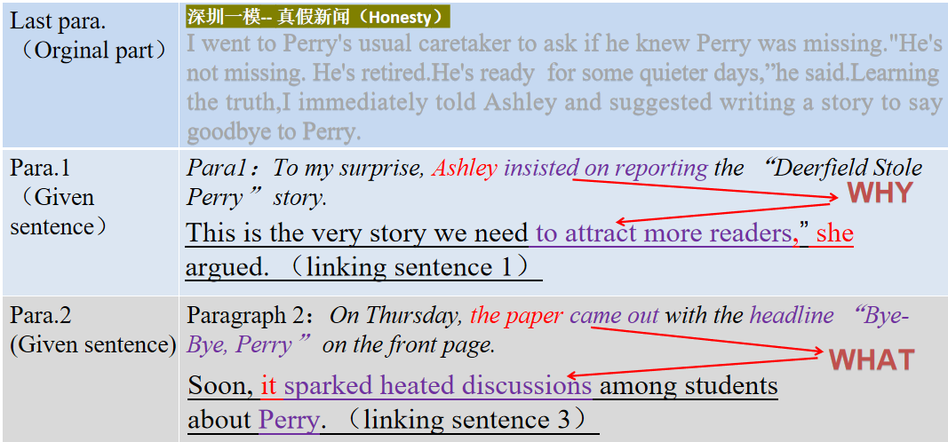

**Tip 1：______________________________________________________________**

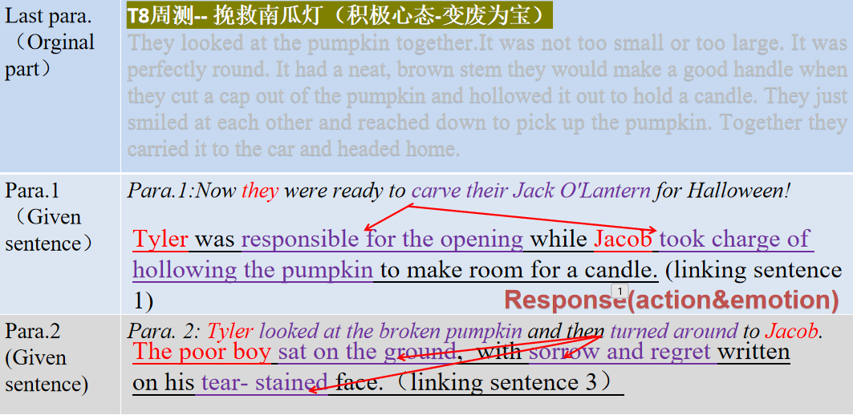

**Tip 2：______________________________________________________________**

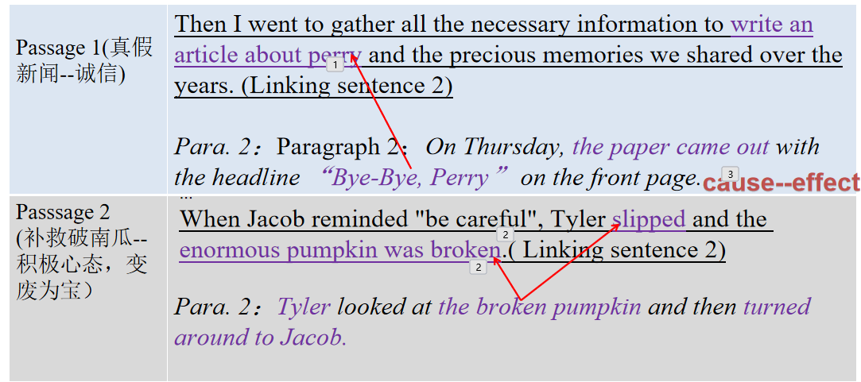

**Tip 3：______________________________________________________________**

**Language Accumulation**

**句型1：形容词（短语），主+谓**

* _______________________________________________(百感交集）, my girls came to realize that it was time for our Squirt to return to where it belonged to.
* _____________________(又开心又激动）, I gave a jump in the air.

**句型2：Doing sth, 主+谓...**

___________________________（他后悔地低下头）, the little boy murmured an apology to Tyler.

**句型3：so+adj.+谓+主 that主+谓... （so +adj位于句首倒装）**

___________________( 如此羞愧）that I could feel my face _____________.(脸红了）

**句型4：with复合结构/独立主格**

* He sighed (失望地）_________________. (with+情感名词）
* ______________________________(她的计划因为这次意外泡汤了）, she let out a cry of anger. (with+sth+done)
* ______________________ (眼睛充满泪水；独立主格)，he showed the police his heart-felt gratitude，____________________( 声音颤抖；with复合结构）in excitement .
* He sat on the sofa motionlessly, crossing his fingers in his lap, ____________________ on his tear-stained face.（悲伤和遗憾写在满是泪水的脸上；with+sth+done）

**Assessing students’ writing**

**Student 1**

Para1: Now they were ready to carve their Jack O’ Lantern for Halloween!

Looking at the pumpkin，they held a deep breath，gathered their courage and began to carve.

...

With a sense of panic, they finally realized the problem but everything seemed too late.

Para2: Tyler looked at the broken pumpkin and then turned around to Jacob.

I believed that we could use the the broken pumpkin to carve Jack O’ Lantern.

**Student 2**

Para1: Now they were ready to carve their Jack O’ Lantern for Halloween!

They found a knife, stuck it into the pumpkin deeply and began to carve it softly.

...

Tyler and Jacob widened their eyes and wind flew over their face. The pumpkin was broken.

Para2: Tyler looked at the broken pumpkin and then turned around to Jacob.

She asked, “what’s wrong with you,dear?” with tears of guilty.

**Student 3**

Para1: Now they were ready to carve their Jack O’ Lantern for Halloween!

They kicked the door of their neighbors，and asked in an excited voice：“trick or treat”

...

A strange wind blew through the room and the table was broken under the pressure.

Para2: Tyler looked at the broken pumpkin and then turned around to Jacob.

Jacob was good at drawing, and he used the black pens to draw the three holes.

**Polished version**

____________________________________________________________________________________________________________________________________________________________________________________________________________________________________________________________________________________________________________________________________________________________________________________________________________________________________________________________________________________________________________________________________________________________________________________

**Assessment Criteria**

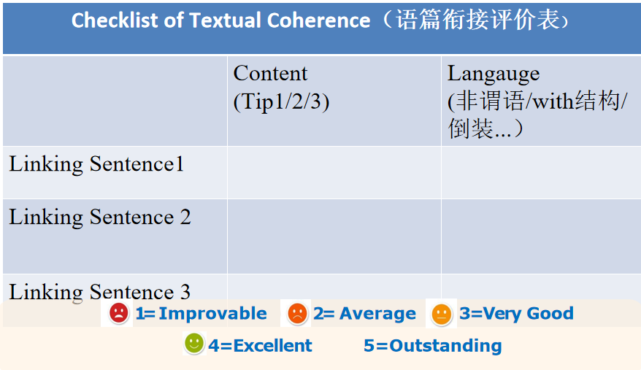

续写1：南瓜灯 （原文）

One bright October morning, Tyler woke up and noticed that the sun was shining in her bedroom window. Everything seemed more colorful than usual. The sky was very blue, and the leaves on the big maple tree were turning yellow and red. "Jacob, wake up!" she called. "Fall is here!"

Jacob opened Tyler's bedroom door and smiled. "I'm already up. Mom said we could go to the pumpkin (MA) field today," he said. Jacob and Tyler got dressed and ate breakfast quickly. They were very excited to head to the pumpkin field. Once they got there, Iyler ran over to a big barrel (tif) that was full of tiny, orange pumpkins. "Let's get these!" she cried. "No way," Jacob said. "Those are much too small to carve into a good Jack O'Lantern."

They kept walking into the pumpkin patch. They walked slowly so they wouldn't trip on the vines(藤）or any of the bright orange pumpkins. "What about this one?" Jacob asked. He reached down to pick up a pumpkin so enormous that he couldn't even lift it off the ground. Tyler laughed. "How could we get it in the car?" They kept looking, but they could not agree on a perfect pumpkin. There was always something not quite right.

Sometimes the stem was too long, or the pumpkin had a flat side.

As they were about to give up and head home, Jacob tripped over a pumpkin. Tyler caught his arm before he fell to the ground. They looked at the pumpkin together. It was not too small or too large. It was perfectly round. It had a neat, brown stem that would make a good handle when they cut a cap out of the pumpkin and hollowed it out to hold a candle. Tyler and Jacob didn't say a word. They just smiled at each other and reached down to pick up the pumpkin. Together they carried it to the car and headed home.

注意：

1.续写词数应为150左右；

2. 请按如下格式在答题卡的相应位置作答。

Paragraph 1: Now they were ready to carve their Jack O' Lantern for Halloween!

Paragraph 2:Tyler looked at the broken pumpkin and then turned around to Jacob.

续写2：真假新闻（原文）

In our weekly staff meeting,our editor Ashley was not pleased with the quality of our reporting.“Our readership is way down. We need better stories for this Thursday's school newspaper.Does anybody have any ideas?"she said.

I handed her my article about our basketball team beating Deerfield High School the previous night by one point.“Sports stories are fun,"she said,“but not good enough for the front page.We need something to really get people's attention."

After our meeting,we left the newsroom together and heard someone screaming,“Perry is missing!”Perry was a big red parrot and had been our school mascot(吉祥物)for ten years. He played an important role in students 'lives, both in and out of class.He had also been a constant presence at school events,inspiring a sense of unity among students.

Everyone gathered around Perry's empty cage,heartbroken.Suddenly,a student from the crowd came over and showed me a photo."You're a reporter for the school paper,right?I happened to take this yesterday,”he said.In the photo was a Deerfield High School basketball player with something large hidden under his shirt around the size of a parrot.

“He must have stolen Perry to get back at us for winning the game!”Ashley cried. We hurried back to the newsroom, agreeing to run the photo on the front page with the headline “Deerfield Stole Perry.”“This is just the story we need.Everyone will read it,”Ashley said confidently

After she left,I took a closer look at the photo.The clock in the background read 4:15 pm, but our game against Deerfield hadn't started until 4:30 pm.Why would the boy have taken Perry before we even played?An uneasy feeling came over me that we might have falsely accused someone.

I went to Perry's usual caretaker to ask if he knew Perry was missing."He's not missing. He's retired.He's ready for some quieter days,”he said. Learning the truth, I immediately told Ashley and suggested writing a story to say goodbye to Perry.

注意：1.续写词数应为150 左右；2.请按如下格式在答题卡的相应位置作答。

|  |
| --- |
| To my surprise,Ashley insisted on reporting the “Deerfield Stole Perry”story.  On Thursday,the paper came out with the headline “Bye-Bye,Perry”on the front page. |