人教版新教材选择性必修三 Unit4 Discover useful structures
教学设计
Ⅰ.Teaching aims:
1. Knowledge:
a. The structure of the present perfect Continuous tense.
b. The usages of present perfect Continuous tense.
2. Ability:
a. Enable students to use the correct tense in their writing and speaking.
b. Enable students to use the right words in the present perfect Continuous tense.
3. Feelings and attitude:
a. Let the students know the importance of English grammar.
b. Try to build up students’ confidence in themselves
c. Encourage students to speak English in public.

Ⅱ. Important Points:
- let the students understands the usages of present perfect Continuous tense.
- The differences between past simple tense and present perfect Continuous tense.

Ⅲ. Difficult Points:
Help students use present perfect progressive tense with verbs to describe events happen at a particular point in time and to describe events that can continue over a period of time.

Ⅳ.Teaching methodology:
The New Senior English Curriculum Standards aims education for all students and stressed quality-oriented education. The main task of education is to stimulate and cultivate students’ interest and their confidence in learning the language, help them develop good learning habits and form effective learning strategies, facilitate autonomy and cooperative spirit in learning ; enable students to master basic English language knowledge and skills in listening, speaking, reading and writing.
According to the new standards, the students should be the center of the class and the teacher serves as a controller, organizer, participant, or resource-provider most times. Considered with the characteristic of the teaching contents and the learners, I will apply explanation and practicing in my teaching. Most of the usages will be summarized by students themselves.

Ⅴ.Teaching aids ：A computer, a projector, black board, chalks
Ⅵ. Teaching procedures:
Step1. Revision & lead-in (2min)
- Make a guess:
They have been looking after you since you were born. They have been providing you with whatever you want. They have been loving you deeply. Do you know who they are?
- Observe and Discover: show two pictures to make the dialogues.
It has been raining for two hours.
This is the adventure that I have been dreaming of.
We are now camped on the rice and we have been managing to survive, but spring is coming, and the ice will soon begin to melt.
We have been struggling for days, but things on Elephant Island are going from bad to worse.

3. Show some sentences on the board.
We have been struggling for days.
be doing进行时态
have /has done
现在完成时态
现在完成进行时
FORM: have/has been doing

Step2. Objectives 目标 Present perfect Continuous tense
- Be able to tell the form of the present perfect progressive tense;
The Present Perfect Continuous Tense
基本结构：“have / has been + 现在分词”
基本含义：表示动作从过去某一时间开始一直持续到现在，可能刚刚停止，也可能仍在继续。
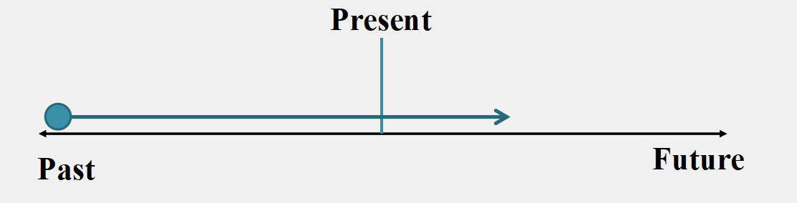

Task 1: Complete the conversation. Put the verbs into the present perfect progressive.
Interviewer: Liu Fang, what___________________ (do) recently?
Liu Fang: Well, I _______________ (give) concerts in America.学
Interviewer: Have you ______________(play) any new pieces?
Liu Fang: Yes. I __________________ (play) some classical American tunes.
Interviewer: What else have you____________ (do)?
Liu Fang: I __________________(learn) how to play the konghou.

- Correctly understand the meaning of sentences with the present perfect progressive tense;
- Discover1: He has been working on it for two hours and is still struggling.
- Discover2: I have been waiting for an hour.
Conclusion: We use the present perfect progressive tense to talk about non-stop actions that have just finished but are still connected to the present in some way.

c. Discover 3: He has been learning English for 6 years/since 2010.
Conclusion2: We also use the present perfect progressive tense to talk about actions that started in the past and are still continuing.
Summary1: 现在完成进行时表示动作从 开始一直持续到现在，这动作可能刚 也可能 .
Practice: combine the two sentences using the present perfect progressive tense
1: It began to rain this morning.It is 6 pm now and it is still raining.
_____________________________________
2: He is still waiting now. He has waited for a car for 20 minutes.
_____________________________________
3: He began to learn Chinese since December. He is still learning Chinese now.
_____________________________________
4: Mike began looking for a job six months ago. He is still looking now.
_____________________________________
5. She _________________ (study) in the library every night over the last three months.
6. I’m tired out. I __________________(shop) with my wife all afternoon.
7. Can’t you see how busy I am? I ______________ (type) the whole morning
8. I _______________ (sit) here enjoying the music all the morning.

Summary2: Summarize the time adverbial
Common time adverbials. (常见的时间状语)
for+时间段 /since+时间点
all day /all night /all the morning /all the time
this week /this month
recently/over(in) the recent(past) few days最近

- To tell the differences in implies meaning conveyed by the two tenses.
Spot the difference between the tenses.
have/has been doing VS. be(was/were) doing
have/has been doing VS. have/has done
- I have read the book.
I was reading the book.
I have been reading the book all the morning.
- Lin Zipeng has read the book.
Lin Zipeng was reading the book.
Lin Zipeng has been reading the book all the morning.
- Spot the difference between have been doing and have/has done
A. the present perfect tense
B. the present perfect continuous tense
1.________is used to talk about an action completed in the recent past but are connected with the present.
2. _______is used to talk about an action that started in the past and is still happening or a non-stop action or a repeated action until recently.
Practice:
---Mr. Wolf, what have you been busy with these days?
---I ________________ (try) to catch goats, but ______never ________ (catch) a single one so far.
Summary3 Difference
be(was/were) doing强调过去某时刻或某段时间正在进行的动作;
动作的结果
have/has done强调动作已经完成/结束, 行为结果在现在能感受到;
have/has been doing强调动作仍在持续，有时候带有感情色彩。
动作的延续性

Task 2: Complete the passage with the correct form of the verbs.
Last night, I___(went /have been) to see a concert by the Chinese- born Canadian artist Liu Fang. She was born in China and____(studied /has been studying) music in Shanghai, but she_____(lived /has been living) in Canada since 1996. She_____(played /has been playing) traditional Chinese music since she was very young. Last night, she____(performed /has performed) a series of classical Chinese pieces for the pipa and the guzheng. I____(bought /have bought) a CD of her music after the concert and I ___(listened /have been listening) to it all day today!

- Grasp the usage of the present perfect progressive tense and apply it in writing;
Step3: WORK IN PAIRS
TASK3: Interview your partner about something about he/she: hobbies, new habits, family, hometown and dream etc. The following questions might help you.

Do you have any hobbies or interests?
How long have you been learning / playing …?
What have you been doing recently?
……………………..

REQUIREMENT: Use the present perfect continuous if possible.

Step 4. Show time

Enjoy a song Way Back into Love and fill in the blanks, and then try to learn to sing the song.
I have been living with a shadow overhead.
I have been sleeping with a cloud above my bed.
I have been hiding all my hopes and dreams away.
I have been setting aside time.
I have been watching but the stars refuse to shine.
I have been searching but I just do not see the signs.
I have been looking for someone to shed some light.

Step 5. Summary & homework
- Summary.
After finishing the exercises, let several students stand up and repeat what they have learned this class, then if necessary, the teacher adds something they missed.
2. Homework
Write a short report about something about your friend: hobbies, new habits, family, hometown and dream etc. according to your interview. Remember to use the present perfect continuous tense.

