**衢州、丽水、湖州2022年4月三地市高三教学质量检测英语—读后续写**

1. **原题重现**

Sedona hiking trails can be fun and relaxing, but sometimes can also be challenging and dangerous.

Rogers, 33, an on-duty airman, was in town from Colorado Springs for adventures on Sedona trails. Even he had just taken a sharp turn on his mountain bike in April 2020 when he was stopped short by the sight of a woman sitting on the side of the trail. She was cute and had long blonde hair and big expressive eyes. What he didn’t know then was that she was also in extreme pain.

Sydney Linden, 28, had been jogging down Adobe Jack Trail in Sedona, Arizona, for a picturesque sunset view of the Red Rocks when she hopped over a rock and her leg over extended on the landing. The pain was instant.

Her right leg collapsed and she hit the dirt hard. Linden tried to stand but collapsed. She wasn’t sure if she had torn her ACL(十字韧带), broken her leg, or something else. All she knew was that the pain was a 15 out of 10.

Although it was spring, the Arizona sun beat down relentlessly(无情地). Linden dragged herself to the shade, as if an animal preparing to die. She’d called a friend, but after 30 minutes, her friend was lost. That’s when she saw the mountain biker.

Roger was trying to play it cool. He casually rode by at a slower speed, stealing a glance at the woman. Sensing her suffering, Rogers stopped and asked if he could help. Linden explained her situation and that’s when he noticed the swelling under he leggings. She needed a hospital--now.

Rogers helped Linden to her feet and they began the steep(陡坡) over the rocky region and desert bushes. It was a long way to go. Leaning on Rogers, Linden tried to hop along, but the pain was severe. She would never make it to the trailhead (登山口) this way.

Paragraph 1:

Then Rogers had another idea.________________________________________________

_____________________________________________________________________________

Paragraph 2:

It was after the operation that Linden found Rogers gone. _________________________

_____________________________________________________________________________

**二、主题语境分析和文本故事解读**

本文主要讲述的是两个素不相识的人在步道相遇，女主人公因扭伤而无法继续行走，正在等待救助。男主人公先是被女主人公外貌吸引，后发现其脚扭伤的事实，了解情况后进行救助。续写情节要求写救助的过程以及女主人公获救之后的故事。本文属于人与社会，人与自然主题语境下的人际交往相关的内容，体现了在社会中存在的真善美，在社会中的每次偶遇都有可能成为人生的一次难忘际遇。

**三、设计思路**

**Activity 1: Reading for information**

从故事5W和1H要素进行阅读，利用思维导图对文章内容要点进行信息整理分类，获得直指续写的信息。

1. Where did the story take place?
2. Why did Sydney Linden go to the Sedona hiking trails?
3. Why did Rogers go to the Sedona hiking trails?
4. How did the writer describe Sydney Linden? (by describing her appearance)
5. What happened to Linden?
6. What did she do to seek for help?
7. What was the weather like?
8. How did the writer describe the meeting of Linden and Rogers? (by describing actions)
9. What’s the conflict then?

**Mind map**

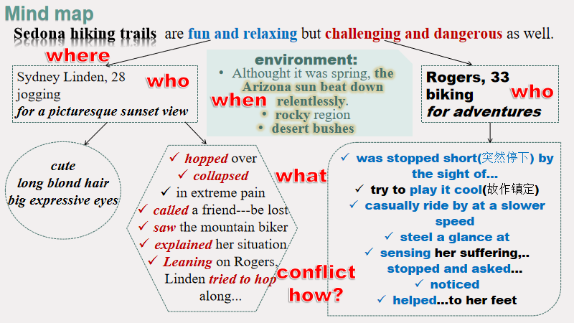

**Activity 2: Summarizing the features of writing**

阅读文本，概括总结所给文本的写作风格，语言特点，为续写定好写作方向。

* language: using third person forms/ without direct speech / v-ing/ figure of speech/ ...
* description: time/ environment/ appearance/ actions

**Activity 3: Plotting**

根据所给的两个段落首句推断故事情节。

1. 找出首句中的关键信息词。
2. 根据第一段的首句推断第一段第二句的内容。
3. 根据逆推法，从第二段推断第一段的内容以及第一段的结尾。
4. 根据第二段的首句 推断第二段第二句内容。
5. 将几个衔接点联系起来进行段落情节的推断。
6. 回到原文找伏笔，达到续写内容和原文的一致性。

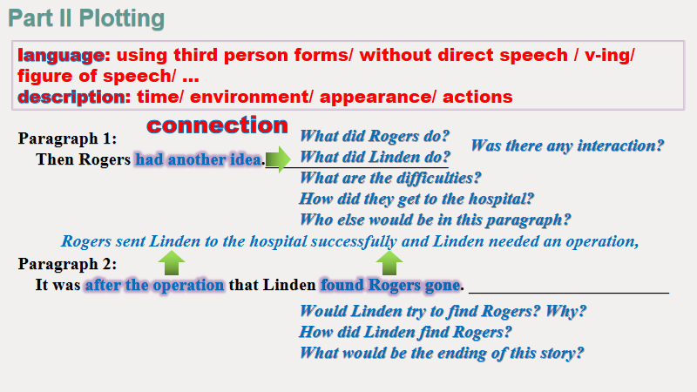

**Activity 4: Writing**

根据构思将原文下划线单词运用到续写中。

One possible version

Paragraph 1:

Then Rogers had another idea. Gently sitting her down on a rock, he deserted his mountain bike under a tree. Surprised as Linden was, she grinned at him gratefully with the extreme pain from the leg. Seeing her pale face, Rogers sensed her pain, helped her to her feet and lifted her over his shoulder. With the sun burning, he continuously talked with her about his own stories and asked her questions now and then to distract her from the unbearable pain. After a 30-minute trek to the trailhead, Rogers carefully loaded Linden onto the car and rushed her to the hospital straight away. At the hospital, Linden learned she needed an operation and Rogers called Linden’s friend.

Paragraph 2:

It was after the operation that Linden found Rogers gone. Linden tried to look for Rogers on Facebook but in vain. Recalling the experience on the trails with Rogers, Linden was sure enough that she wished she could thank him face to face. She shared the story with her friend and asked whether there would be a way to reach him. It was when reading news on the Internet that they came up with the idea of publishing the story on the newspaper and it was on the same day that the journalist sent her an email informing her Rogers had read the article and wanted to get in touch with her. It was a week later that Rogers saw her expressive eyes again. It was really a dangerous but rewarding adventure!

**Activity 5: Appreciating and learning to use**

利用所给原文中的句型和相关表达进行续写仿写。

1. 2020年4月，他骑着山地车刚刚急转弯，就突然停下因为他看到一位坐在步道边的女子。（had just done...when）

仿句: 他刚把山地车停到一棵树下就看到了痛苦地站在烈日下的Linden，苍白的脸上冒着汗。

2. 她很可爱，有一头长长的金发和一双明亮的大眼睛。(外貌描写)

3. 他当时不知道的是她也处于极度的疼痛中。(主语从句+表语从句)

仿句：她当时不知道的是George也在四处搜寻她的信息。

4. 28岁的西德尼·林登在亚利桑那州塞多纳市的奥多比·杰克小道上慢跑，想要欣赏美丽的红石日落美景时她跳过一块岩石，落地时腿伸展过了头。（had been doing sth when）

仿句：他们正在谈论之前在步道上的经历来分散由于热引起的不适时登山口出现在了视线中。

5. 林登试图站起来，但却倒下了。(动作描写)

6. 她不确定自己的前交叉韧带撕裂了，腿骨折了，还是其他什么。（并列结构）

7. 虽然是春天，亚利桑那州的阳光却无情地照射下来。（环境描写）

仿句：阳光无情地照射下来，他们艰难地朝着登山口走去。

8. 林登拖着身子走到阴凉处，就像一只准备死去的动物。（修辞）

仿句：林登在病房里等待着消息，就像一个等待着考试结果的学生。

9. 他漫不经心地以较慢的速度骑过，偷偷地看了那女人一眼。（非谓语动词）

仿句：他感激地朝Rogers点点头，艰难地往前跳去。

10. 感觉到她的痛苦，罗杰斯停下来问她是否需要帮助。（非谓语动词）

11. 林登靠在罗杰斯身上，想往前跳，但痛得厉害。

仿句：看到她苍白的脸，Rogers感受到了她的疼痛，帮助她站起来，把她扛上肩。