原文本欣赏：Chicken Soup for the Soul: Thanks Dad!  *By Jack Canfield*

**Watching Over Me**

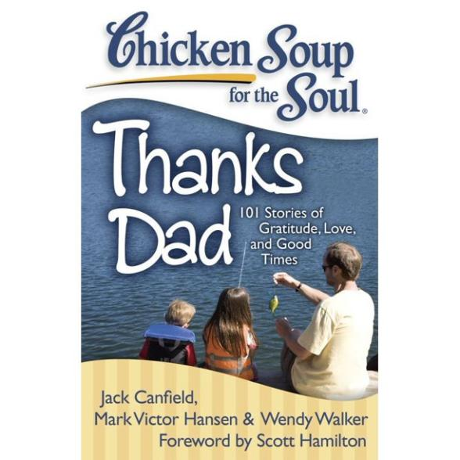

We can only be said to be alive in those moments when our hearts are conscious of our treasures.

---Thornton Wilder

There is nothing more wonderful than the smell of the
Adirondack air! It fills your lungs with a purity and freshness that invigorates and motivates a love for living. Every weekend in the summer, my father would plan a trip from our home in upstate

New York to one of the magnificent lakes nestled among the tall pines and thick forests of the Adirondack Mountains. There were no favorites; instead, each lake was an adventure to explore and
enjoy.

One trip that I will never forget was a visit to Oneida Lake at the foothills of the mountains. After arriving at the lake beach area we emptied the car of our picnic supplies, towels, blankets and beach chairs, carrying them through a wooded path that seemed like a forever distance. Once we located the perfect picnic spot, my dad, sister and I ran into the splashing waves with our beach ball, leaving my mother behind to “set up.” In the lake, we immediately played “monkey in the middle” for at least an hour, and then after retiring the ball, my father let us dive from his knee, throwing us up in the air and flipping us like flapjacks on a grill. This timeless game went on and on as our begging for more, more never ceased.

When we finally tired of our games, my dad stopped to watch
my older sister. She loved synchronized swimming and started practicing skills that her team used in competition. My father, being an athlete himself, became engrossed in her demonstration. I was sad that no one was playing with me; no one was watching me. I became bored and jealous watching her show off. Sulking, I decided to swim by myself and try some of my sisters stunts on my own in deeper water, far from both of them. The waves were getting stronger, but I didn't care. I just wanted to do what my sister could do so that I could capture my father’s attention.

As I tried a jackknife dive from my tiptoes, a huge wave engulfed me just as I took a breath to submerge. I unexpectedly swallowed water, and a huge undercurrent swept me deeper beneath the waves. I panicked under the water, lost buoyancy and any hope for a breath. I remember trying to stand up, but the sandy bottom had disappeared. As I came up searching for the surface, struggling for oxygen, sputtering to clear my lungs, I felt a firm grasp on my arm and a pull to safety. It was my dad! He hugged me tightly and carried me back to a place where I could stand. There was no scolding, no interrogation, just a big hug and smile because he knew I was all right
What a great feeling I had at that time; I will never forget it. He had been watching me all along! He had never taken his eye off me, even as he had the other eye on my sister. He had protected me. Being told by someone that you are loved is great, but experiencing that love is awesome. So thank you, Dad, not only for the love of the outdoors that you instilled in me from those summer adventures, but also for the sense of security and well being. Your unrelenting love has helped me through life’s challenges. Without your caring, without your watching over me, without your loving me, I would not be the strong woman I am today.