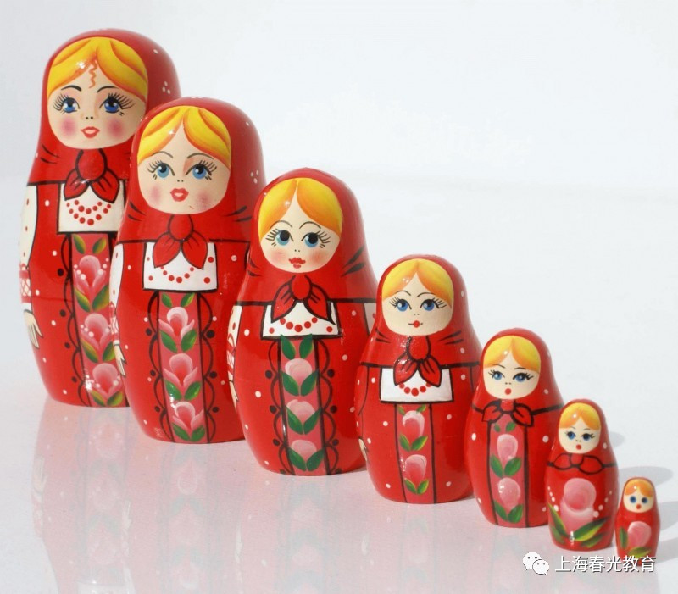

**There’s a hole in the bottom of the sea.  
There’s a hole in the bottom of the sea.  
There’s a hole. There’s a hole.  
There’s a hole in the bottom of the sea.**

**There’s a log in the hole  
in the bottom of the sea.  
There’s a log in the hole  
in the bottom of the sea.  
There’s a log. There’s a log.  
There’s a log in the hole  
in the bottom of the sea.**

**There’s a branch on the log in the hole  
in the bottom of the sea.  
There’s a branch on the log in the hole  
in the bottom of the sea.  
There’s a branch. There’s a branch.  
There’s a branch on the log in the hole  
in the bottom of the sea.**

**There’s a bump on the branch on the log  
in the hole in the bottom of the sea.  
There’s a bump on the branch on the log  
in the hole in the bottom of the sea.  
There’s a bump. There’s a bump.  
There’s a bump on the branch on the log  
in the hole in the bottom of the sea.**

**There’s a frog on the bump on the branch  
on the log in the hole in the bottom of the sea.  
There’s a frog on the bump on the branch  
on the log in the hole in the bottom of the sea.  
There’s a frog. There’s a frog.  
There’s a frog on the bump on the branch  
on the log in the hole in the bottom of the sea.**

**There’s a speck on the frog on the bump on the branch  
on the log in the hole in the bottom of the sea.  
There’s a speck on the frog on the bump on the branch  
on the log in the hole in the bottom of the sea.  
There’s a speck. There’s a speck.  
There’s a speck on the frog on the bump on the branch  
on the log in the hole in the bottom of the sea.**

**There’s a flea on the speck on the frog  
on the bump on the branch on the log  
in the hole in the bottom of the sea.  
There’s a flea on the speck on the frog  
on the bump on the branch on the log  
in the hole in the bottom of the sea.  
There’s a flea. There’s a flea.  
There’s a flea on the speck on the frog  
on the bump on the branch on the log  
in the hole in the bottom of the sea.**

**In the hole in the bottom of the sea.**