**Unit 4 Book 2 学案**

1. **Confucius [kən'fju:ʃjəs]n. _______**

**破拆法：confuc-(confuse使困惑)+-ius(形容词后缀)：令人困惑的 助记：________的一些理论令人很困惑**

1. **mansion ['mænʃ(ə)n]n._________;________**

**破拆法：man(人)+-sion(名词后缀)：给人住的宅子——_______;________。**

1. **cemetery ['semɪtrɪ]n. ________;________**

**破拆法：ce-(co-共同)+met-(meet见面)+-ery(名词后缀)：最终大家见面的地方——________**

1. **philosophy [fɪ'lɒsəfɪ]n. ________,________;_________**

**词根词缀：philo-(爱) + -sophy(智慧)**

**音意相通：肥了社会 助记：合适的________能够促进社会的发展。**

1. **descendant [dɪ'send(ə)nt] n._______;_______adj. _________;_________**

**破拆法：de-(向下)+scend-(send送)+-ant(名词/形容词后缀)：往下送的的人——________,________。**

1. **individual [ɪndɪ'vɪdjʊ(ə)l；ɪndɪ'vɪdʒuəl] adj. ________;________n. _______,_______**

**词根词缀：in-(否定前缀)+divid-(divide分开)+-ual(形容词后缀)：不可再分开的——________**

1. **heel [hiːl]n. 脚后跟；踵**

**Achilles' [ə'kili:z] heel（希腊神话）________________**

1. **kingdom /'['kɪŋdəm]/ n.________;________**

**词根词缀：king(国王)+-dom(名词后缀)：国王的领地——________**

1. **chief [tʃiːf]n. _______;_______;_________adj. ________;________【pl:________】**

**词源:cap(头，帽子)——>chief：当头的——_______;_______（c-ch, a-ie, p-f）**

**音意相通：欺负 助记：当______的不能欺负下属。**

1. **puzzle ['pʌz(ə)l]vt. ___________vi. _______;___________n.______;________;_________**

**词根词缀：puzz-(put摆放)+-le(反复)：反复摆在你的面前——_______,________,__________**

**_________________________对某事感到困惑**

1. **nearby ['nɪəbaɪ]adj. ________,________adv.________prep. ___________**
2. **join ... to/with ...__________________________**

|  |  |
| --- | --- |
|  | 指的是任何事物的直接连接，连接的程度可紧可松，含有“还能分开”之意。常用结构join ...to, join up。若非直接连接，则可与connect换用。 |
|  | 指的是通过某种媒介物把事物连接起来，事物的特征还保持着，常表示与技术有关的连接以及火车、飞机等实行联运。常用结构connect ...with/to。 |
|  | 着重指两个或两个以上的人或事物为了共同的目的而结合在一起，结合后原来的部分可能仍不改变，但也可能失去其本性，常用结构combine ...with。 |
|  | 强调紧密地结合成一个整体体，含极难分开之意，常用结构unite ...with。 |

1. **break away (from sb/sth)_______;_______;_______;_______**

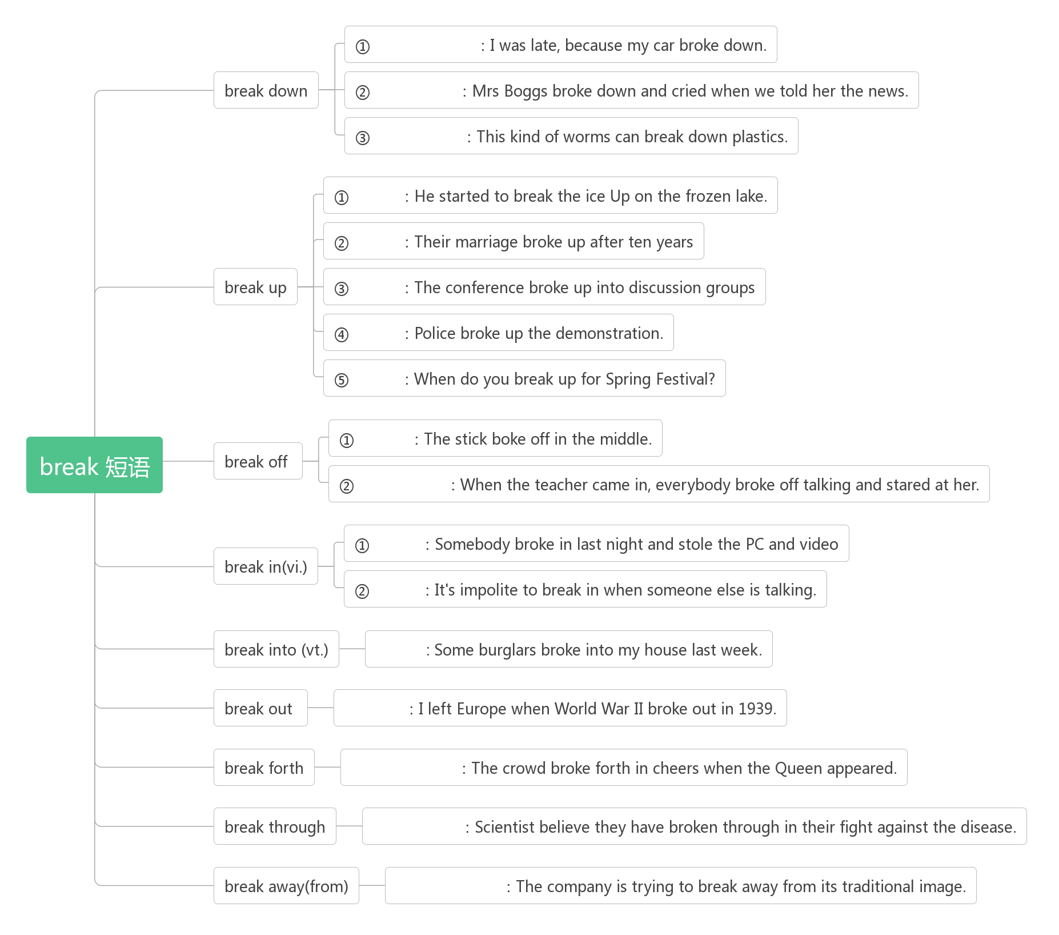

1. **belong [bɪ'lɒŋ]vi. _______;_________**

**___________属于**

**belonging [bɪ'lɒŋɪŋ]n. _________;________;________**

1. **as well ____**

**as well as ______,________;__________**

**as good as ________________;________________**

1. **currency ['kʌr(ə)nsɪ]n. ________;________**

**词根词缀：curr-(跑/流通)+-ency(名词后缀)：流通的东西——________**

**current ['kʌr(ə)nt]adj. ________;________;_________**

**currently ['kʌrəntlɪ]adv. ________;________**

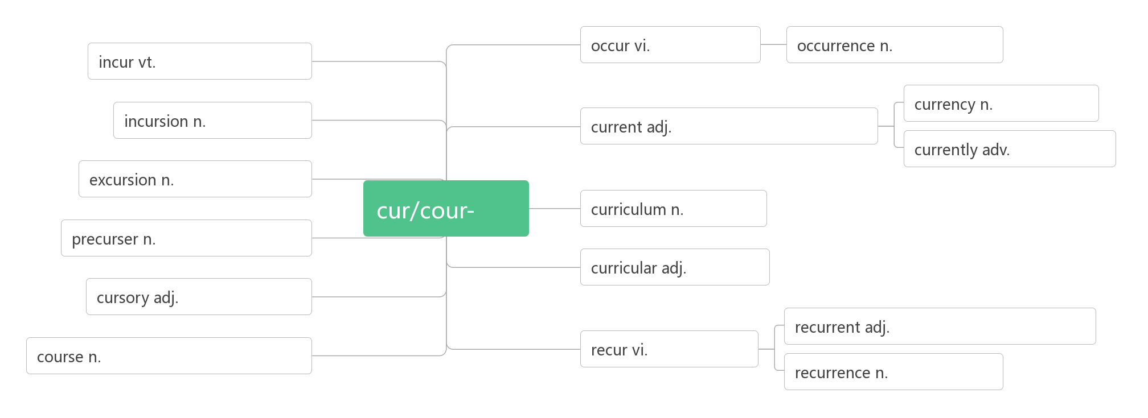

1. **military ['mɪlɪt(ə)rɪ]adj. _________,_________**

**词根词缀：mil-(mile英里)+-it-(走)+-ary(形容词后缀)：走到远方去参军——________**

**____________________军训**

1. **defence [dɪ'fens]n. ________;________;________**

**___________________为了保卫……；为……辩护**

**defend [dɪ'fend]vt. _______;___________vi. _______;________**

**_______________________ 保卫A不受B的伤害**

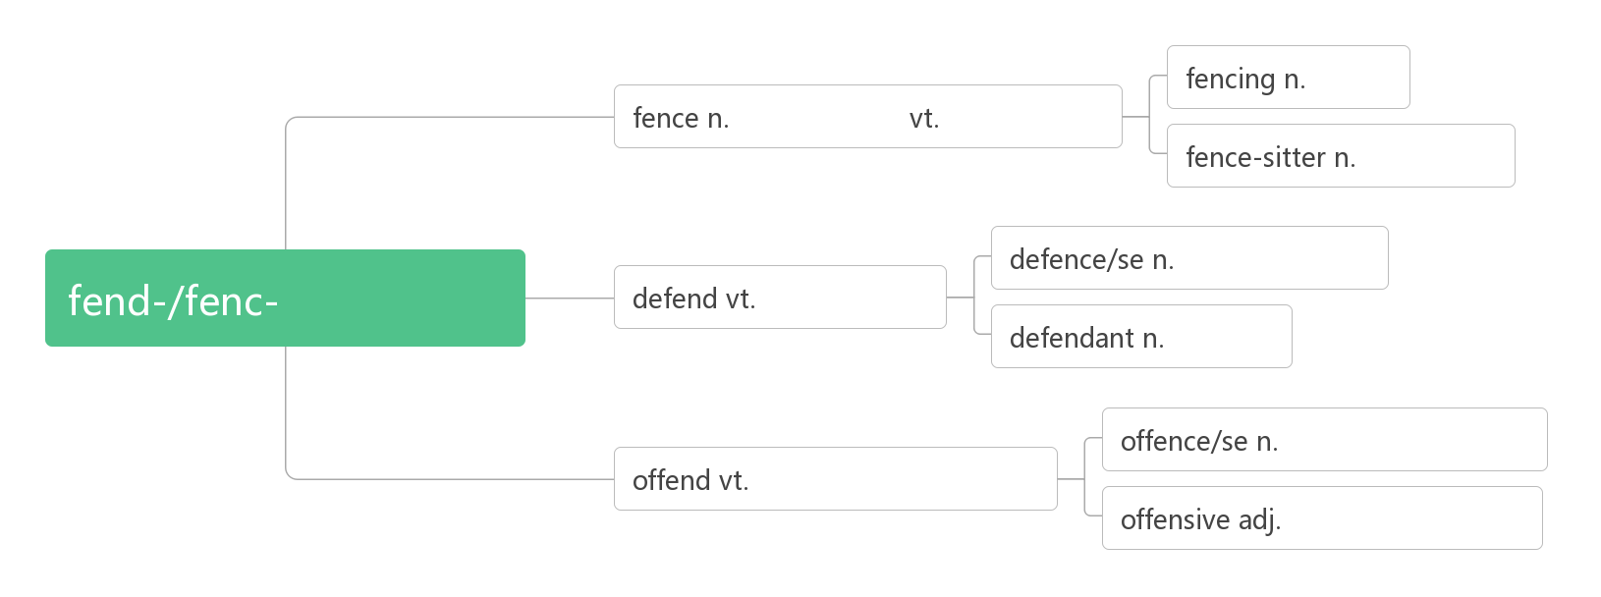

1. **legal ['liːg(ə)l]adj. _________;_________;_________**

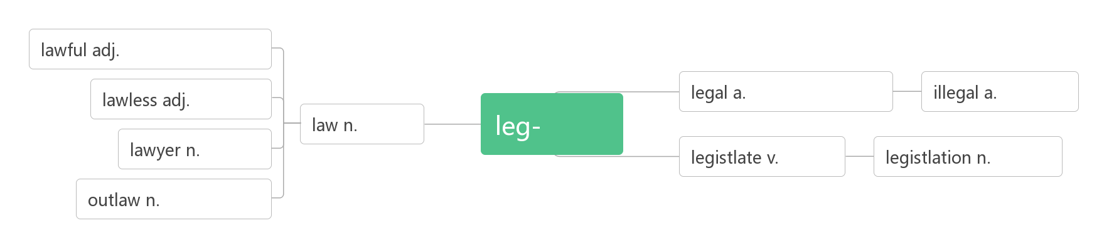

1. **surround [sə'raʊnd]vt. ________,_________**

**词根词缀:sur-(强调)+round(在周围)：在……周围——________,_______**

**___________________________被……所包围，被……所围绕**

**______________ [sə'raʊndɪŋ]adj. 周围的，周边的**

**________________ [sə'raʊndɪŋz]n. 环境；周围的事物【pl】**

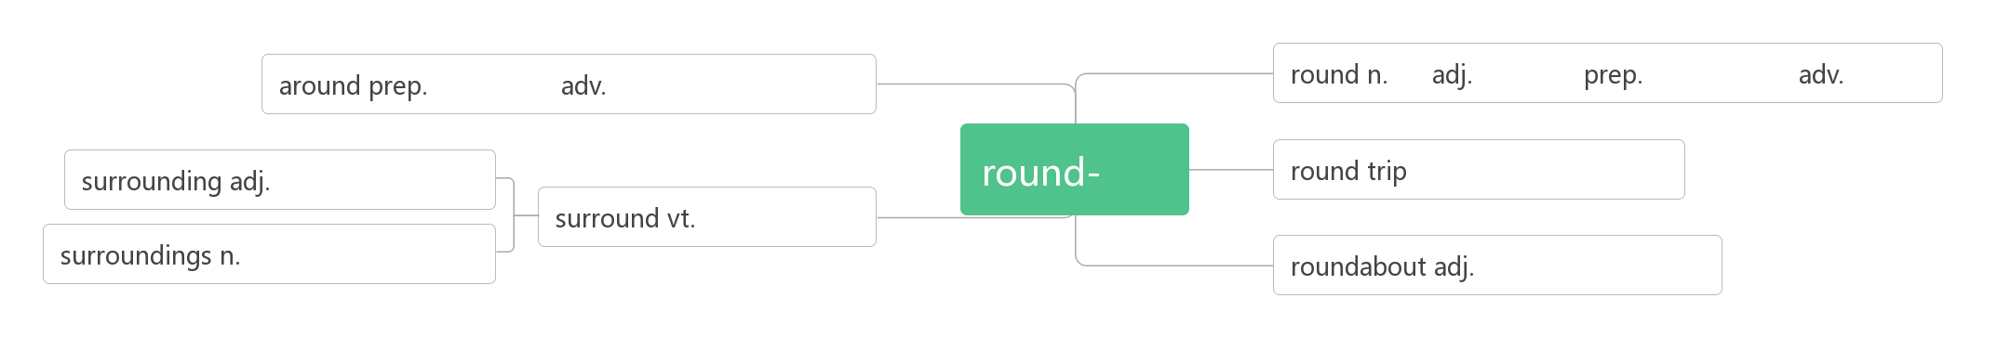

1. **evident ['evɪd(ə)nt]adj. ________;_________**

**词根词缀：e-(外)+vid-+-ent(形容词后缀)：从外面就能看出来的——________**

**evidence ['evɪd(ə)ns]n. ________;________**

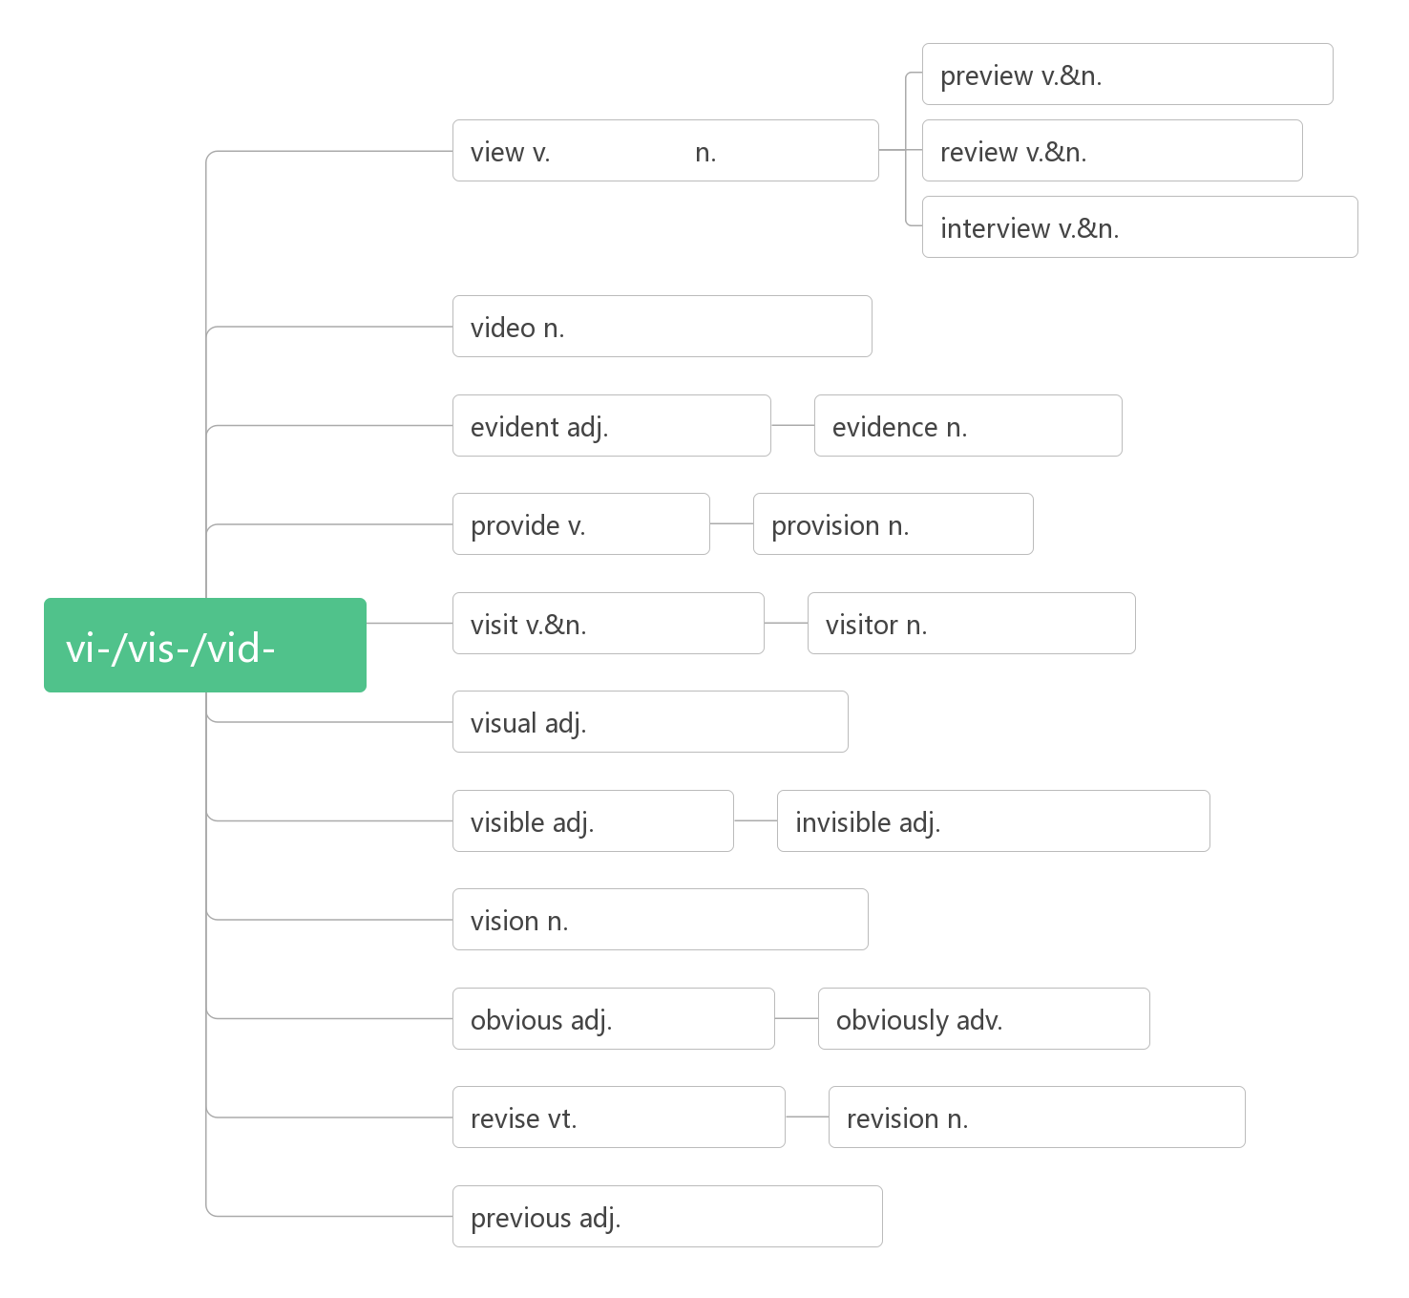

1. **achieve [ə'tʃiːv]vt. ________;_________;________**

**词根词缀：a-(去，到)+chiev-(chief头)+e：走到头——________**

**achievement [ə'tʃiːvm(ə)nt]n. ________;________**

1. **locate [lə(ʊ)'keɪt]vt._______;___________**

**____________________ 位于，座落于**

**____________ [lə(ʊ)'keɪʃ(ə)n]n. 位置；地点**

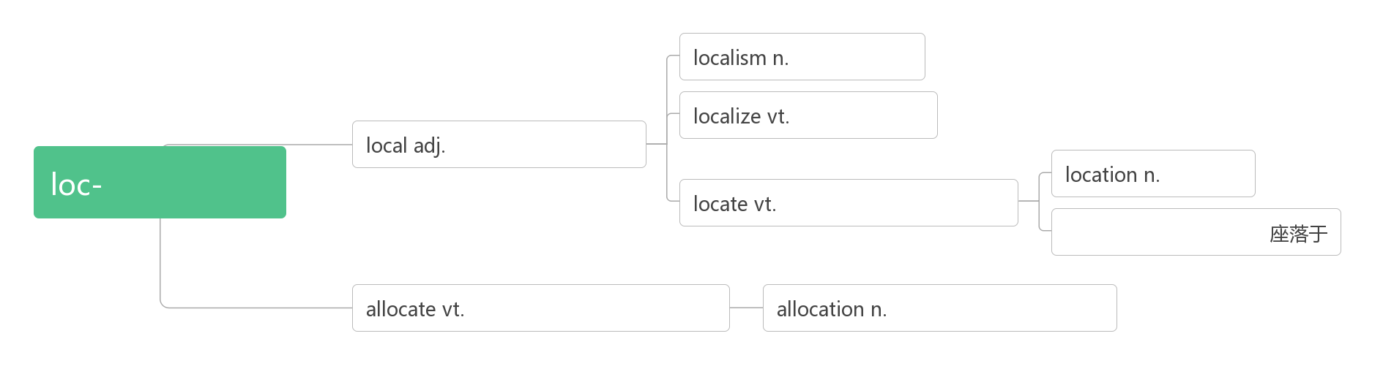

1. **conquer ['kɒŋkə]vt. ________,________,________vi. ________,________**

**词根词缀：con-(全部)+-quer(寻求)：全部寻求到了——________,________**

**____________[ˈkɒŋkərə(r)]n.征服者，胜利者**

**___________ ['kɒŋkwest]n. 征服，战胜；战利品**

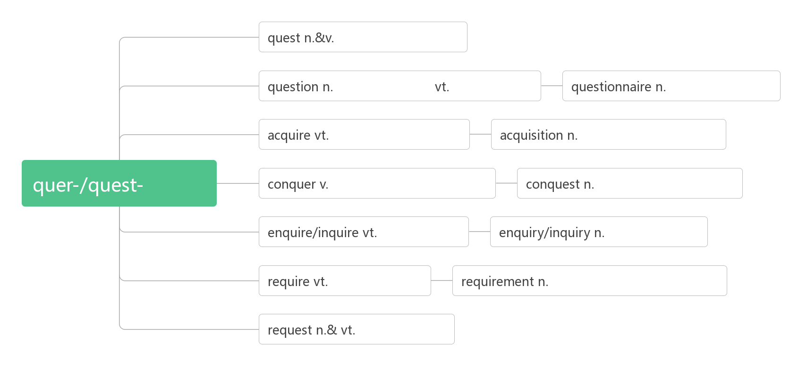

1. **battle ['bæt(ə)l]n.vi. & vt.________;________;_______**

**词根词缀：bat-(打)+-tle(名词后缀，表反复)：反复打——________;________**

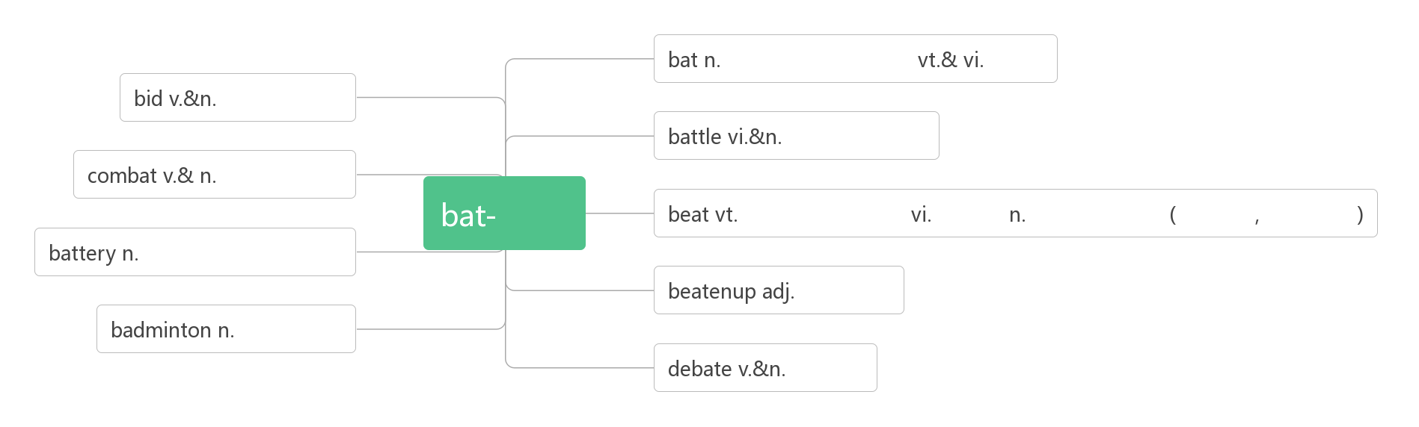

1. **port [pɔːt]n. _______,________**

**import [ɪm'pɔ:t; 'ɪm-]n. &vt. vi. ________,________**

**export [ɪk'spɔːt; 'ek-]n. &vt.vi.________,________;__________**

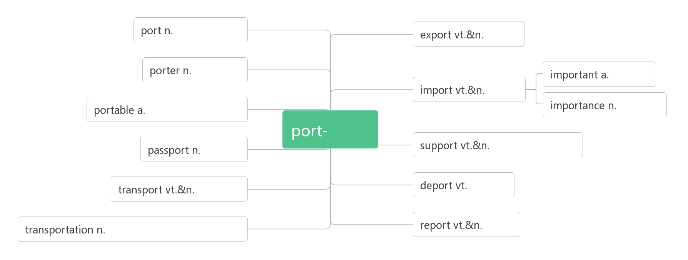

1. **fascinate ['fæsɪneɪt]vt. _______,_________,__________**

**词根词缀：fasc-(抓住)+-in(内)+-ate(动词后缀)：从内心抓住你——_______,________**

**_______________ ['fæsɪneɪtɪŋ]adj. 迷人的；吸引人的；使人神魂颠倒的**

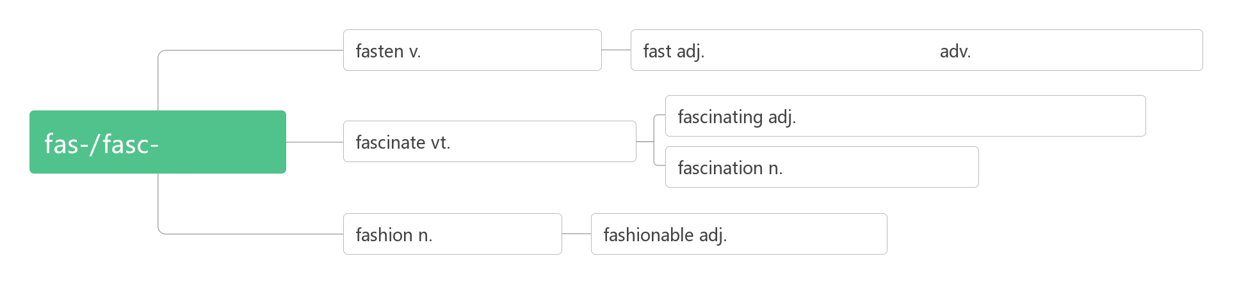

1. **___________________________留心；留意**

**____________________照看；留意；密切关注**

1. **charge [tʃɑːdʒ]n._______;________;________vt._______;________;_______**

**巧句助记：**

**He was charged with being mean to the employees after he took charge of the company, which had been in the charge of his father, for he began to charge the staff for charging their electric bicycles.**

**他被______在他_____了他父亲_____的公司后对员工很刻薄，因为他开始向员工______给电动车_____的费用。**

**______________________为某事向某人收取费用**

**___________________ 免费**

**___________________ 被指控犯……罪**

**___________________主管，负责**

**_________________________由某人负责/主管**

**___________________接管，掌管**

1. **announce [ə'naʊns]vi. ________;________;_______**

**词根词缀：an-(强调)+nounc-(宣告)+e：________,________**

**_________________[ə'naʊnsm(ə)nt]n. 公告；通告；声明**

**_______________ [ə'naʊnsə]n.播音员；告知者**

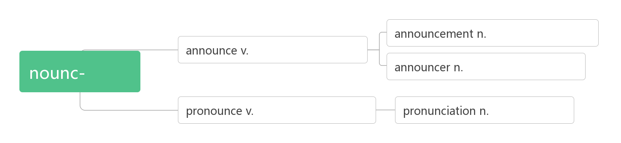

1. **amount [ə'maʊnt]vi. _______,________,__________n. _______;________,________**

**amount to ___________,________**

**______________________________许多的，大量的**(该短语只修饰不可数名词，且谓语的数由amount的数决定)

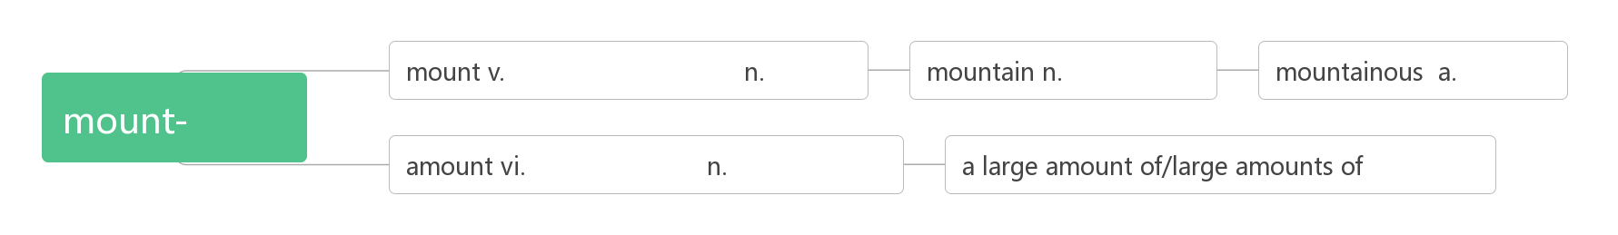

1. **gallery ['gæl(ə)rɪ]n.________________;_________**

**破拆法：al-(all)+glery(glory)：都荣耀 助记：作品能被_______收藏都是一种荣耀。**

1. **approach [ə'prəʊtʃ]n. _______;_______;_______vt. _______;__________vi. ________**

**词根词缀：ap-(去)+pro-(向前)+-ach(动词后缀)：去向前——________,________**

**_____________________________做某事的方法**

1. **ensure [ɪn'ʃʊə]vt. ________;________;________**

**词根词缀：en-(使)+sure(确定)：使确定——_______;_______**

1. **generous ['dʒen(ə)rəs] adj.________,________;________**

**词根词缀：gener-(产出)+-ous(形容词后缀)：不断产出的——________,________**

**____________________ 慷慨于某物**

**______________ [dʒenə'rɒsətɪ]n. 慷慨，大方；宽宏大量**

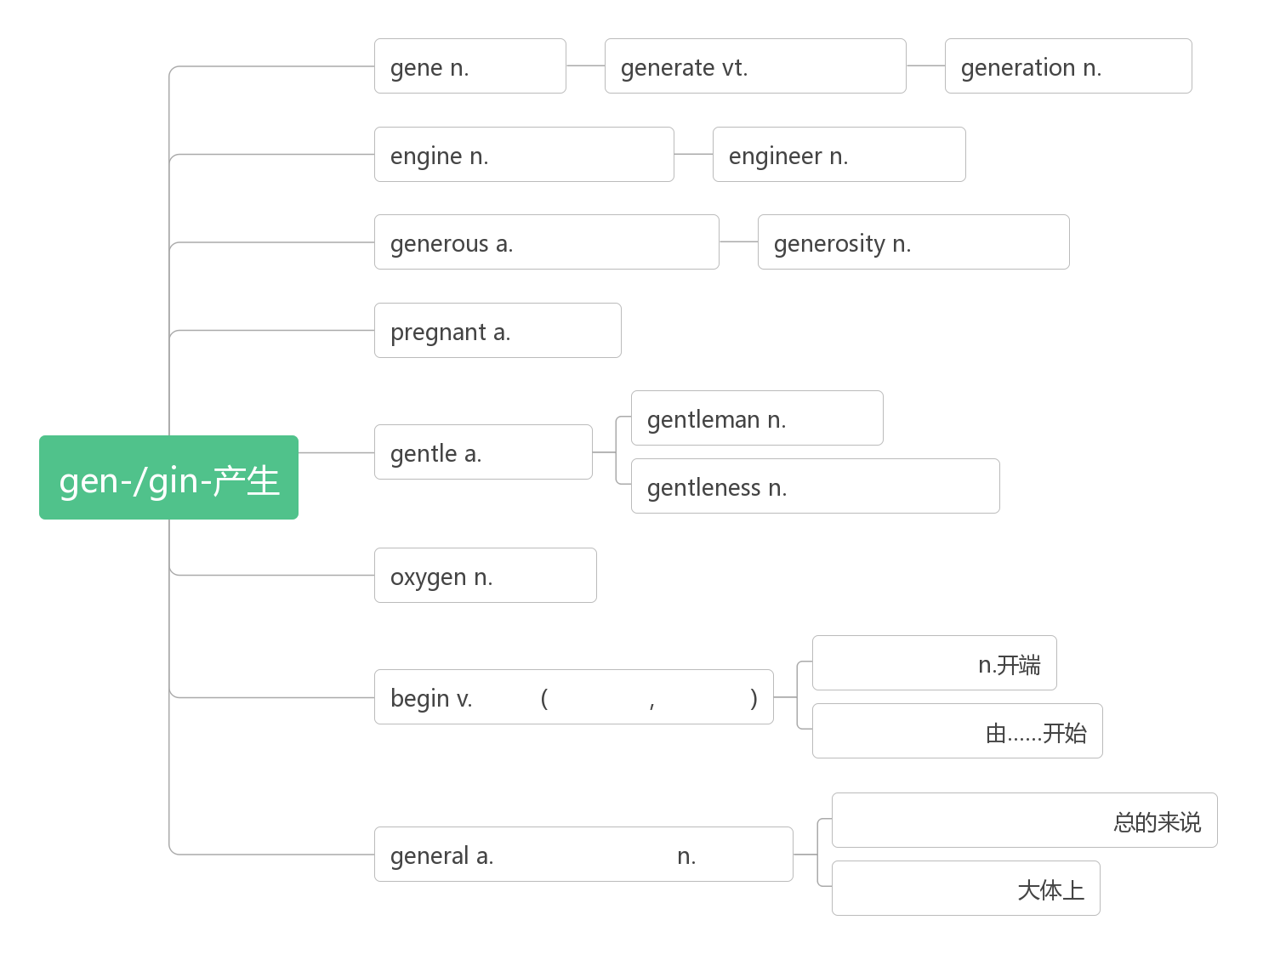

1. **butter['bʌtə]vt.____________;________n. ________;_______;_________**
2. **honey ['hʌnɪ]n. ________;________;________**
3. **ancestor ['ænsestə]n. ________,________**

**词根词缀：ance-(前)+st-(站)+-or(名词后缀)：站在前面的的人——_________**

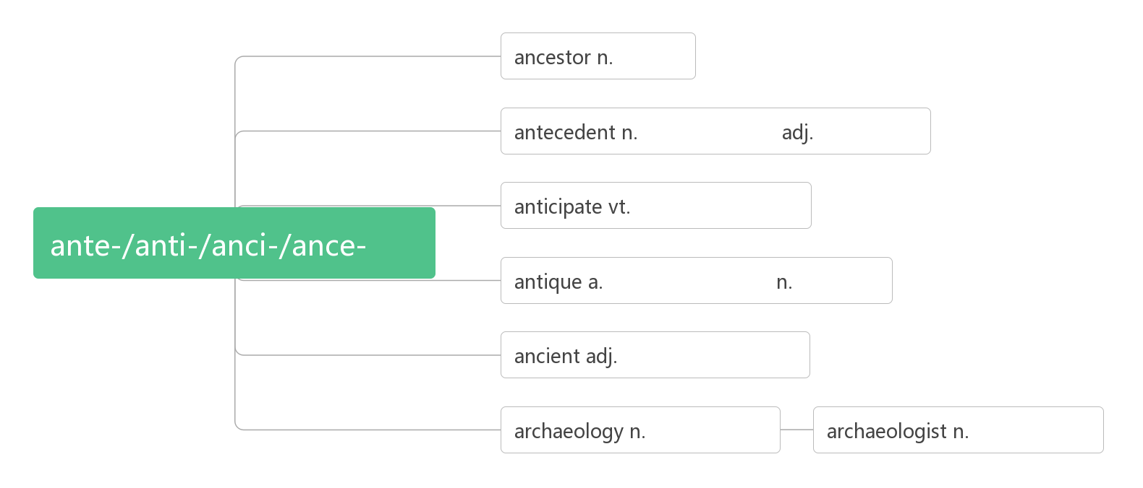

1. **position [pə'zɪʃ(ə)n]n. ______,_______;_______vt. _______;_________**

**词根词缀：pos-(放置)+-ition(名词后缀)：_____________**

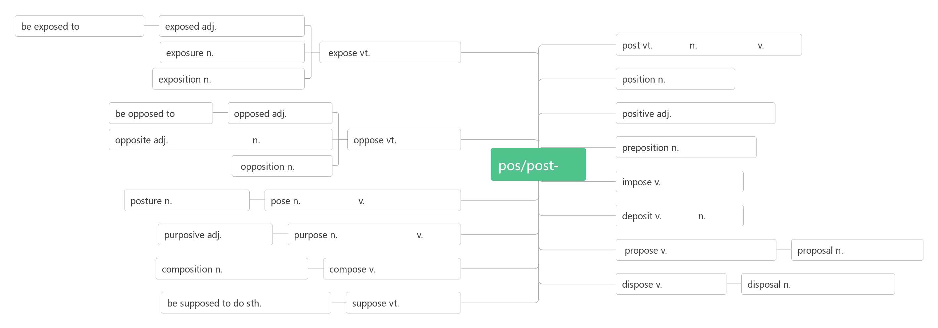

1. **courtyard ['kɔːtjɑːd]n. _______,_______**

**合成法：court(法庭，宫廷)+yard(院子)：________**

1. **snack [snæk]n. ________,________**

**词源演变：snap(拟声词：打响指)——>snack(快速吃完：________)**

1. **eager ['iːgə]adj._________;________;_________**

**音意相通：一哥 助记：他_______成为一哥。**

**_________________渴望做某事**

**_________________渴望得到某物**

1. **poet ['pəʊɪt]n. ________**

**词根词缀：poe-(诗)+-t(人)：________**

**poem ['pəʊɪm]n. _____**

**poetry ['pəʊɪtrɪ]n.____________;___________**

1. **county ['kaʊntɪ]n. ______;______**

**词源演变：court(______)——>count(______)——>county(伯爵的领地：_______)**

1. **feast [fiːst]vt. _______;_______,_______n. _______,_______;_______vi. _______;__________**

**词源演变：feat(功绩)——>feast(庆祝功绩：_______,_______）**

**___________________用……款待某人**

**___________________尽情欣赏，饱览**

1. **roll [rəʊl]vt. ____；_______；____vi. ______;______;______**

**___________________摇滚乐**

**______________春卷**

1. **dot [dɒt]n. _____,________vt. _______;________**
2. **cattle ['kæt(ə)l]n._______;_______(集合名词，复数概念)**

**联想记忆：三个复数概念的集合名词：The _______ help ________ catch ________.警察帮人民抓牛。**

1. **roar [rɔː]vi. &n._______;_______;_______**

**音意相通：拟声词，模拟狮子的吼声。类似拟声词：owl[aʊl]n. ________ wolf [wʊlf]n. _____**

1. **ocean ['əʊʃ(ə)n]n. ________**

**Oceania [ˌəʊʃiˈɑːniə]n. _________**

1. **scent [sent]n. ________;_______**

**同源词：sense(感觉)——>scent(感到的气息：_______)**

1. **greet [griːt]vt._______,________;________,________**

**联想：great——>greet 助记：You are great to greet us with such warm greetings.**

**greeting [ˈɡriːtɪŋ] n._______,________**

1. **pub[pʌb]n. _______,_______**

**词源：public house的缩写**

1. **wine [waɪn]n. _________;________**

**词源：W：起伏——>wind(_______)——>vine(_______,________)——>wine(________)**

1. **beer [bɪə]n. _______vi. _______**

**音意相通：音译词：beer(____)酒**

1. **stew [stjuː]n._______ vt._____,______**

**联想：Steward：斯图亚特；管家 助记：名叫斯图亚特的管家爱吃______。**

1. **custom ['kʌstəm]n.________;_______;________**

**音意相通：卡死他们 助记：到国外生活很困难，光是适应当地的___________就可能卡死他们了。**

**____________ [əˈkʌstəmd] adj. 习惯的,惯常的**

**___________ [ˈkʌstəmə(r)] n. 顾客，主顾**

**___________ [ˈkʌstəm] n. 海关，关税**

The___________ are _____________ to the _________ to offer small gifts at the local __________.

顾客们习惯了在当地海关提供小礼物的风俗。

1. **strike [straɪk]vt.vi.&n._____,_____,_______;________;_______(_________,________)**

**_____________在罢工**

**_________________ 擦燃火柴**

**striking ['straɪkɪŋ]adj._________,_________,_________**

1. **transition [træn'zɪʃən] n. ________,________**

**词根词缀：trans-(转变)+it-(走)+-ion(名词后缀)：转走的过程——________,________**

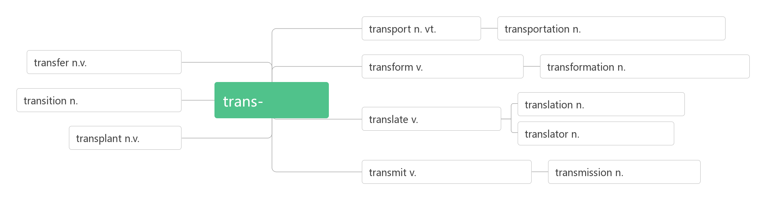**60. crowd [kraʊd] n._______;_______vt._______;__________vi.________;________**

**词源：group（______）——>crowd（______）(g-c, u-w, p-d)**

**crowd in________;___________**

**____________ [ˈkraʊdɪd] a. 拥挤的**

**_________________挤满了……**