**M3U3 Diverse Cultures**

**Period 5 Reading for Writing**

**Teaching Objectives：**

1. get more information of the Chinatown in San Francisco

2. make use of some good expressions to introduce a place

3. describe a place with distinctive cultural identity

4. focus on Chinese culture by reading and writing and enhance the cultural confidence

**Teaching Important and Difficult Points：**

1. help students figure out the cultural identity in the passage

2. help students apply the writing skills learned today and before to their writing

**Teaching Procedures:**

**hundred**

**thousand**

**million**

**____________关于**

**Step Ⅰ: Lead-in**

Play a video of a uploader visiting Chinatown in San Francisco.

Attract the interest of students and let them have a rough idea of Chinatown.

**StepⅡ: Read for the organization**

1.Students will be asked to read the passage quickly and master the main idea, style and the purpose of the passage.

2. Scan the passage and students need to find out the key information: the passage talks about Chinatown in San Francisco and what visitors can do there except going sightseeing.

3.Read the passage carefully and fill the form .Make sure students can grasp the organization of the whole passage.

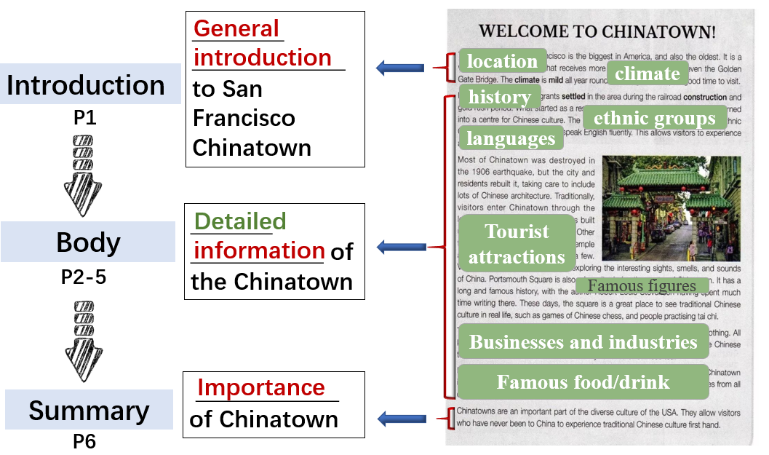

4.Inspire students to think about how to stress the cultural feature in writing.

**StepⅢ: Read for the expressions**

1. The author introduces the place objectively and comprehensively. Read the passage again and find out the useful expressions to help in writing.
2. Collect the expressions in the way of words and sentence patterns.
3. Fill the blanks and check the detailed information while students will be encouraged to imitate the sentence pattern by making sentences.

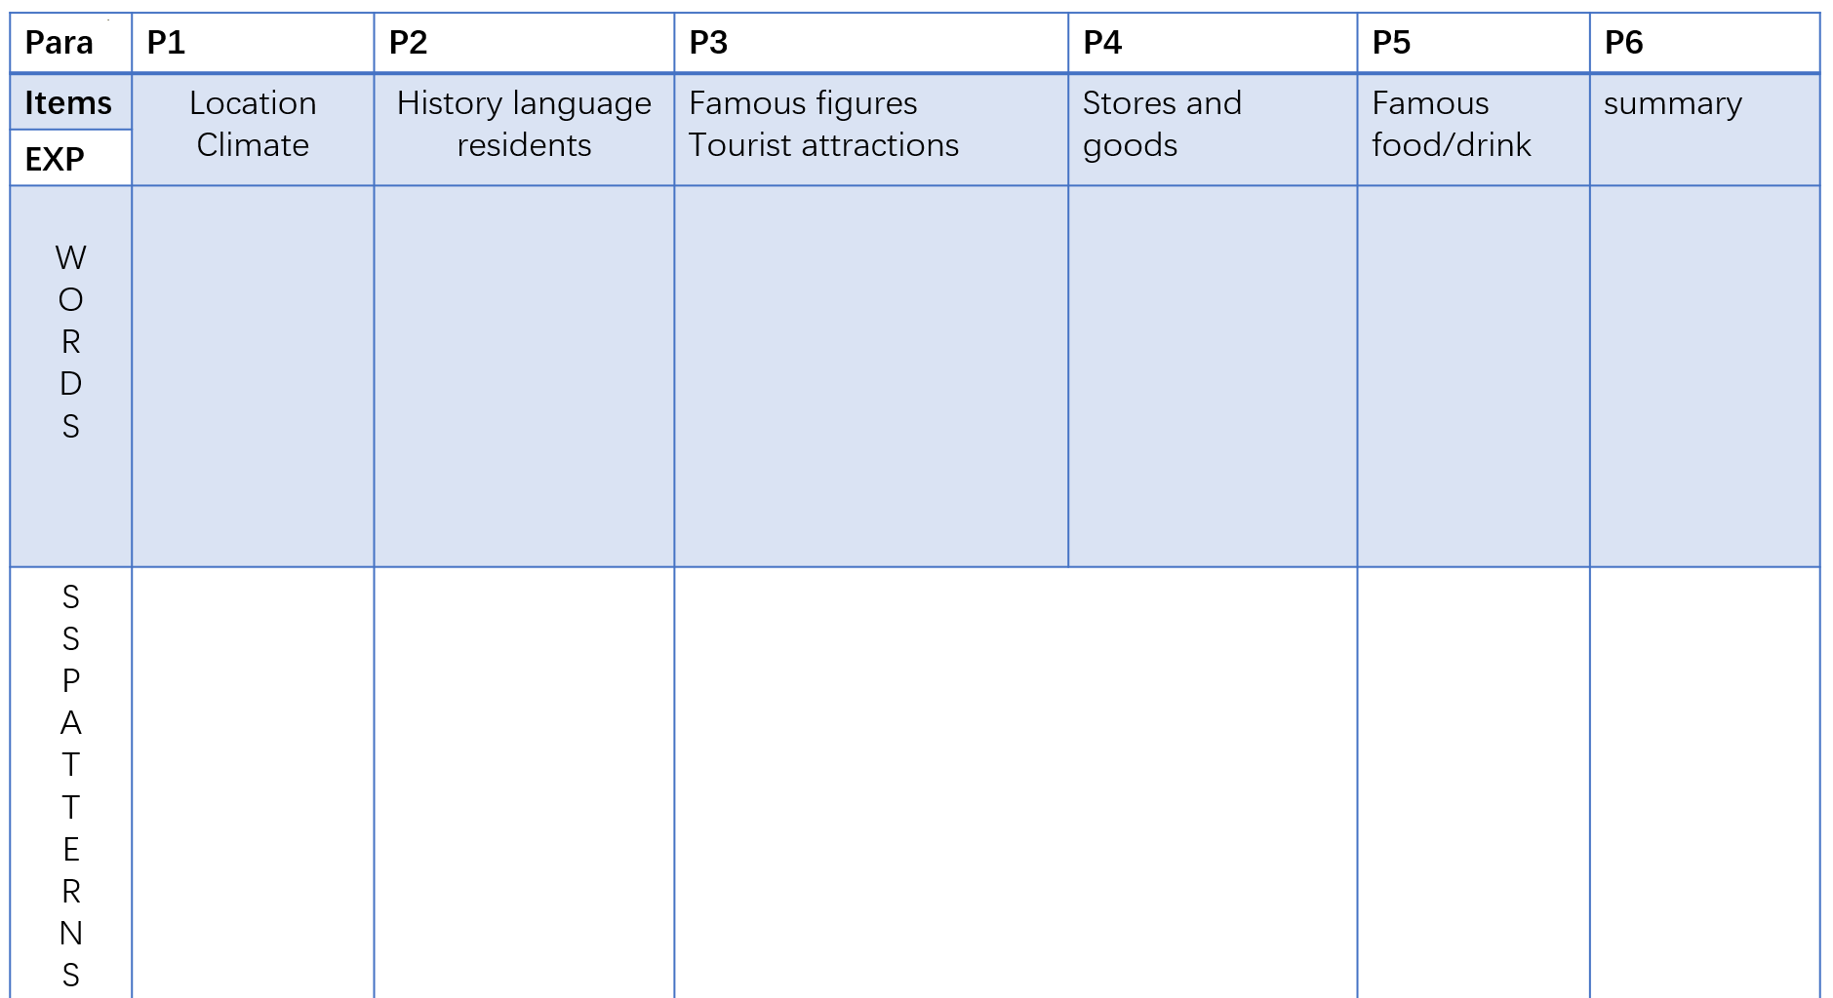

**StepⅣ: Get ready for writing**

1. introduce Hang Zhou by a video. Let students put down some information they can use in writing.
2. Present a mind map of Hangzhou according to the items mentioned in the reading passage. Students will be divided in groups to discuss about the different items about Hangzhou and finish the mind map together.

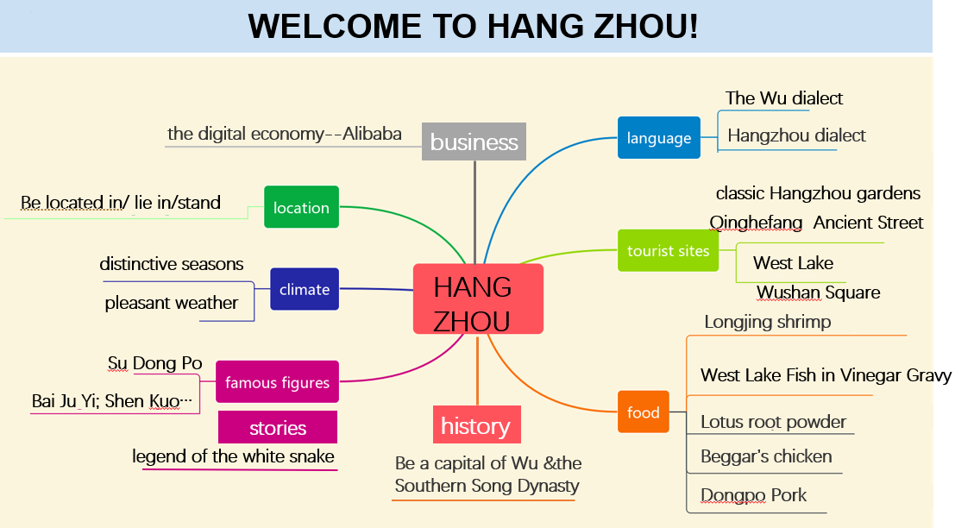

1. Show them an extra ppt referring to the landscapes and food in Hangzhou. If necessary, they can make some notes.

**StepⅤ: Writing**

1. make an example of how to start describing a place.
2. Show students the way to imitate the paragraph in the reading passage.
3. Remind students to refer to the passage they have learned before—how to describe a place.
4. Enable them to complete the whole writing by imitation.
5. Show them a possible sample for reference and a possible short passage for examination.