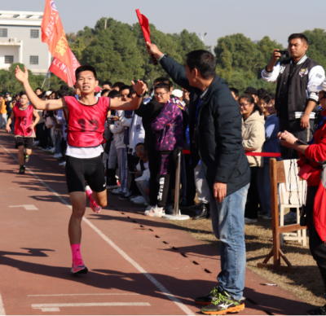

This photograph was captured on the playground just as runner number 12 was about to cross the finish line. In this thrilling instant, the runner was speeding down the track, arms pumping, his face etched with steely determination. In the backdrop, the roaring crowd burst into an uproar of cheers as the athlete drew nearer to the finish line. The brilliantly shining sun further added to the electric atmosphere of the race.

How to describe a photo?

1. _____________________________

2. _____________________________

3. _____________________________

4. _____________________________

5. _____________________________

6. _____________________________

**\*Use specific verbs, adjectives, adverbs and rhetorical devices**

**Photo Description of Campus Spring**

|  |  |  |
| --- | --- | --- |
| When and where? | Element 1 (Objects) | Element 2 (People) |
|  |  |  |

How to set a tone for the photo?

1. Figure out the connection among all the elements in the photo?
2. Use theme-related expressions.