The World (October 16th-31st, 2023)

**1.《国家地理》2023年10月刊 EXPLORE版面**

1）阅读理解

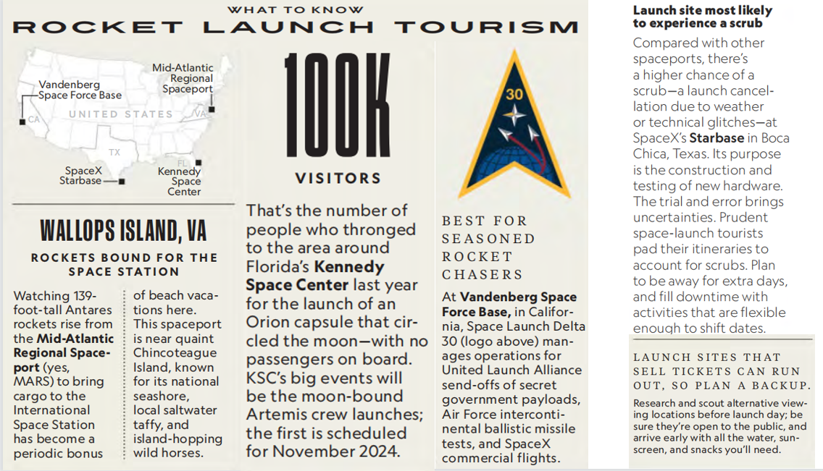

1. Which of the following statements is correct?

A. Manned spacecrafts will be lauched at MARS.

B. Kennedy Space Center had the most visitors last year.

C. Vandenberg is suitable for less experienced liftoff fans.

D. Other viewing sites may not be accessible to the general public.

2. Tourists to which launch site had better have a backup plan?

A. Mid-Atlantic Regional Spaceport. B. Kennedy Space Center.

C. Vandenberg Space Force Base. D. SpaceX Starbase.

3. Where is the text probably taken from?

A. An engineering book. B. An astronomy magazine.

C. A science paper. D. A physics textbook.

2）翻译句子

人们成群结队地去看他的新戏。_______________________________________________________________________________

刚开始一项锻炼计划时循序渐进总是明智的。

_______________________________________________________________________________

**2.《泰晤士报》2023年10月21日 50页**

1）语法填空

When Amazon introduced the outside world to its ______ (late) new recruit, the reac-tion was not entirely ______ it had hoped for. The new figure stacking boxes on shelves in its vast warehouse in Seattle was a robot, one, moreover,that _________ (resemble) a human and was doing a job that until now a human being would do.

Yet the robot, 175cm tall, able to carry up to 16kg and named “Digit”, is not alone. Amazon is intent on using automation to speed up its vast retail operation _____this, in turn, has posed questions about the future of its human employees and the advance of artificial intelligence more _________ (general).

Digit can walk forwards and backwards, can crouch and can sense, avoid and navigate around _________ (obstacle), including its human colleagues. It points to the fact _____ Digit’s human-like form is not entirely incidental. It was designed to work in environments suited to people. It has the ability ______ its arms and legs and to rebalance itself if _________ (knock), according to Agility’s website, which — conspicuously — also points out that the robot is able to run for 16 of 24 hours, double the average daily shift of ___ full-time human employee.

2）翻译句子

他命令他们在他背后堆放一些枕头。_______________________________________________________________________________

你怎么才能设法走出森林？

_______________________________________________________________________________

**3.《泰晤士报》2023年10月19日 36页**

1）语法填空

Thousands of homes could __________ (create) in London if owners of empty office buildings converted them into flats, a report has claimed.

The proportion of vacant office space in the capital has almost doubled since the onset of the pandemic __ about 8.5 percent, according to CBRE, the property agent behind the report. In all, there is an estimated 16 million sq ft of older, empty blocks that, ___ re-purposed, could create close to 28,000 new homes, the report said. London, like the rest of the country, is in the grip of a housing crisis: CBRE estimates that 90,000 fewer homes ______________ (build) over the past decade than were needed. The ________ (short) is likely to worsen over the coming years, with new home applications and planning permissions falling this year given the jump in financing costs and ___ onerous planning process, which CBRE’s report said “remains a key hindrance”. At the same time, there is an excess of office space. ________ (turn) empty offices into homes would help to solve both of those problems. Re-purposing is on the minds of some investors, _____ since last year have spent ￡l.3 billion buying offices in London for re-purposing, albeit most of those are for hotels or ___________ (laboratory).

CBRE expects more and more office buildings will have to be retrofitted or repurposed. “The previous strategy of _______ (simple) demolishing an old office to replace it with a new building is becoming largely redundant,” the report said.

2）翻译句子

当时国家处于经济萧条期。

_______________________________________________________________________________

价格高是使潜在买主却步的主要阻碍。

_______________________________________________________________________________

**4.《科学新闻探索》2023年10月刊 4页**

1）语法填空

For the first time, scientists—have spotted a star _____ (eat) a planet. The planet was probably about 10 times the mass of Jupiter and orbited a star about 10,000 light-years away. The stellar meal gave off a burst of light ________ (capture) by telescopes on Earth and in space. Stars were long suspected to eat their own planets, says Kishalay De. ____ no one knew how often this happened.

He’s an astrophysicist at MIT _________ led the research. De was hunting for pairs of stars that orbit each other. One cosmic event from 2020 caught his eye. A spot of light in the sky quickly got about 100 times as bright as it was before —maybe two stars merging? But a ______ (close) look revealed one one-thousandth of the energy that would __________ (expect) from merging stars. Plus, the area lacked the hot plasma De expected _____ a star collision. Instead, it was full of chilly dust.

If the flash was from two objects smashing into each other, he determined, they weren’t both stars. One was probably __ giant planet. As the star chowed down on the planet, a stream of cold dust sailed away like cosmic breadcrumbs. His team shared the discovery in Nature. The planet-eating star in this study is turning into a red giant. But it’s still early in its _____________ (transform). This dramatic end may give a glimpse of Earth’s future. Our sun will _________ (eventual) evolve into a red giant, consuming Earth—in about 5 billion years.

2）翻译句子

这些村庄扩大了并且结合成了一个大集镇。_______________________________________________________________________________

他的车和一辆摩托车撞上了。

_______________________________________________________________________________

1. **BBC News 10/16/2023**
2. 听力填空

A prominent Italian journalist has been found guilty of ________ the prime minister Giorgia Meloni and handed a ________ fine. Roberto Saviano had called her a bastard because of her hardline views on immigration. His fine of 1,000 euros was much less than prosecutors wanted, and he’ll only have to pay it if he repeats the _______. Mr. Saviano is best known for his book about the mafia “Gomorrah”.

A judge in Brazil has overturned a ruling against the former Brazilian Formula One racing champion, Nelson Piquet for alleged racist and homophobia _________ he made about the British driver Lewis Hamilton. Piquet had been ordered to pay $1 million ________________ Hamilton. The Brazilian anti-racism groups that initiated the case are expected to ______.

India has rejected the latest global ___________ that ranks the country 111 out of 125 surveyed nations. India’s ranking has dropped by four places in this year’s report, ____________ most South Asian countries except Afghanistan. The report is compiled by the Irish aid agency Concern Worldwide and German organization Welthungerhilfe. The index looks at undernourishment, the number of children under the age of five with the low height and weight and child ________. India, the world’s 5th biggest economy has fallen into the “serious” category. But the Indian government says the __________ for the report was too small.

2）翻译句子

嫌疑犯今天被逮捕了。

_______________________________________________________________________________

世界上营养不良的人数有所增加。

_______________________________________________________________________________