**Worksheet**

**My Experiences With Computer Games**

1. **Read the passage carefully and complete the table.**

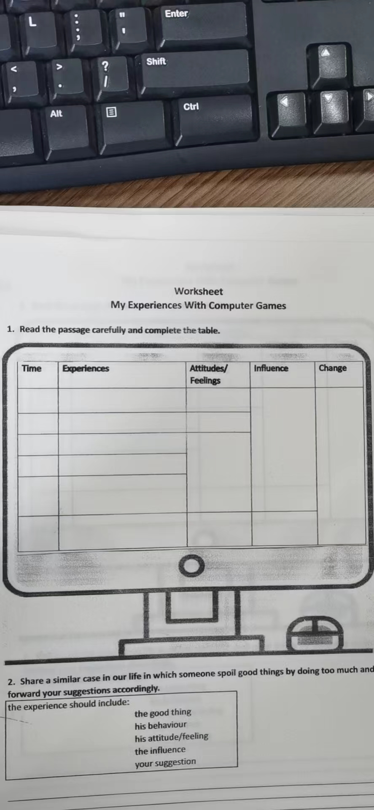

1. **Share a similar case in our life in which someone spoil good things by doing too much and put forward your suggestions accordingly.**

the experience should include:

the good thing

the behaviour

the attitude/feeling

the influence

your suggestion

____________________________________________________________________________________________

____________________________________________________________________________________________

____________________________________________________________________________________________

____________________________________________________________________________________________

____________________________________________________________________________________________