**M3U2 Morals And Virtues**

**Period 1 Reading for Writing**

**Teaching Objectives：**

By the end of the class, students will be able to

1. understand the main idea of the story and the purpose of the author of writing the story

2. know the definition of a review and the basic structure of a review

3. write down the review of the story step by step

**Teaching Important and Difficult Points：**

How to make students work out the basic structure of a review.

How to make students express their opinions on the moral dilemmas fluently.

**Teaching Procedures:**

**hundred**

**thousand**

**million**

**____________关于**

**Step 1: Lead-in**

**Activity 1: Look and say**

Students will be asked to look at a picture and answer the following questions:

Q1: What are we reading in the picture? A story? A comment? Or something else?

Q2: What is a review?

Q3: What’s the difference between a comment and a review?

Q4: How to write a review?

(此环节目的一方面在于通过一则关于书评的截图引入话题，帮助学生了解什么是书评；另一方面在于锻炼学生观察、分析和总结的能力，通过这张截图内容、结构的分析归纳出书评的基本特征；最后带着写书评的目的去读“路上的石头”这则故事。）

**Step 2: Read For Basic Information**

Students will be asked to look at a picture and turn to page20 to answer the following questions:

1. What’s the title of the story?
2. What kind of story is it?  
   3. What’s the main idea of the passage? Use a sentence (5W+H).

4.Can you write the first para of the review according to these answers? (3minutes for students to write the first part, and show some students’ writing)

(此环节目的旨在为第一段写作服务，学生带着书评第一段内容的相关问题去快速浏览故事文本，再用自己的话将相关问题回答连接成一段话，目的在于锻炼学生连句成段的能力）

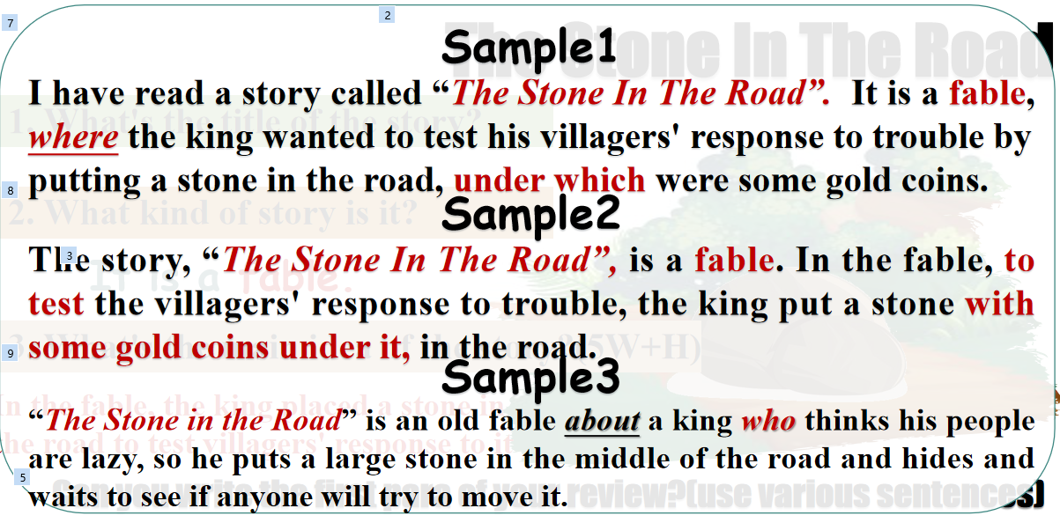

**Step 3: Read For Analysis**

Students will be asked to read the story again to get some more details:

1. Why did the king carry out such an experiment?(thinking)
2. What was the response from different villagers? (p21)
3. Did the king achieve his purpose? How do you know?
4. Can you write the second para of the review according to these answers? (3minutes for students to write the first part, and show some students’ writing)

(此环节目的旨在学生在对故事文本较为熟悉的情况下，带着自己的思考去概括这篇故事，对学生的综合语言运用能力有一定要求。）

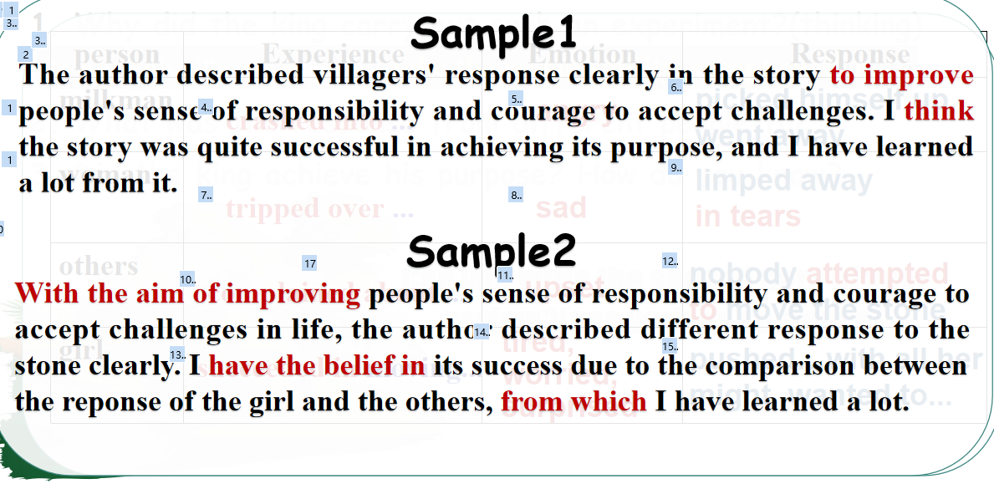

**Step 4: Discussion**

Students will be asked to read the story again to discuss the following questions:

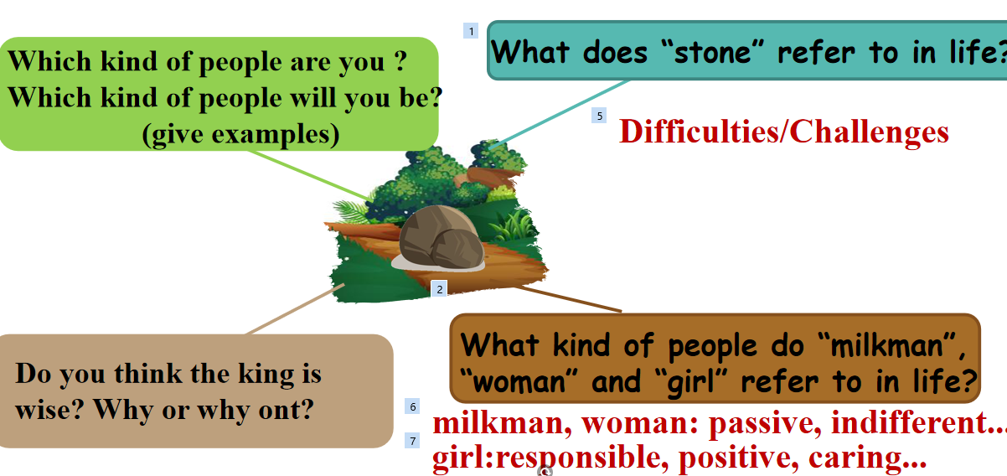

Can you write the second para of the review according to these answers? (3minutes for students to write the first part, and show some students’ writing)

(此环节目的旨在学生在对故事文本非常熟悉的情况下，去剖析这则寓言故事和实际生活的联系。由故事中的人物分析到自我分析，并写成小作文，帮助学生树立正确的价值观和人生观。）

