**2024年2月新阵地应用文学案**

假如你是某学生会主席李华, 为了迎接国际志愿者日(International Volunteer Day)的到来, 请你以学生会的名义向全校师生写一封英文倡议信，号召参加主题为“互助， 互爱”(mutual assistance andcare) 的志愿者活动。

内容包括：

1. 倡议目的;

2. 活动内容;

3. 呼吁参加。

注意：

1. 写作词数应为 80个左右；

2. 请按如下格式在答题纸的相应位置作答。

Dear teachers and schoolmates,

______________________________________________________________________________________________________________________________________________________________

_______________________________________________________________________________

_______________________________________________________________________________

_______________________________________________________________________________

The Students’ Union

【审题】

体裁：

时态：

人称：

语气：

交际对象：

主题语境：

【谋篇布局】

首段：__________________________________________________________________________

Q1:如何阐释背景？

_______________________________________________________________________________

Q2:号召某人做某事怎么表达？

______________________________________________________________________________________________________________________________________________________________

1. 随着国际志愿者日的临近，我很激动呼吁你参加志愿者活动，活动的主题为互助互爱，由我们学校组织，活动体现了人道主义价值。

With the International Volunteer Day , I to participate in volunteer activities mutual assistance and care organized by our school, which embody .

1. 随着国际志愿者日的临近，我很激动告知你许多相关志愿者活动，活动由我们学校组织，这些志愿活动反应了人道主义的真正价值。

As the International Volunteer Day , I am excited to several

activities organized by our school, which reflect the .

1. 作为学生会主席，我很激动和你分享即将到来的国际志愿者日的相关消息，国际志愿者日强调互助与互爱的价值。为了做好准备，我们学校组织志愿者活动，这些活动体现出贡献与人道主义的核心价值。

I, President of the Students’ Union, am share with you the news about the , of mutual assistance and care. In preparation for this day, our school will be organizing volunteer activities aimed at of contribution and humanity.

中段：__________________________________________________________________________

Q3：可以写哪些活动？What？

______________________________________________________________________________________________________________________________________________________________

Q4:怎么衔接？how？

______________________________________________________________________________________________________________________________________________________________

1. 活动的开始于校园美化活动，许多活动将会被组织，包括植树活动以及装饰先前相对单调的校园墙壁。

The relevant activities beautifying campus events. A variety of activities will be organized, including planting trees, and .

2.接下去的志愿服务是养老院志愿者服务。我们按照计划实施许多互动性的活动，包括帮助养老院老人处理家务，帮助他们掌握基本的电脑操作技能。

What follows next is volunteering at the . During the stay, we are designed toconduct with the elderly, which involve assisting them in and .

3.为受灾地区的帮助问题，学校组织的一系列慈善捐献，比如捐献二手书以及高质量的文具，我们要做的是清洁以及打包捐献物去帮助那些需要帮助的人。

Subsequent to it, concerning the assistance for disaster-stricken areas, a series of charity contributions are scheduled by our school, such as . What we are supposed to do is cleaning and packing the donations for the people in need.

尾段：__________________________________________________________________________

Q5:可以采用哪些句式发出号召？

______________________________________________________________________________________________________________________________________________________________

1.到了我们去参加志愿者活动的时候。有了共同的努力，我们注定会建立一个更加和谐的社会。

we attend the volunteer activities. , we to establish a more harmonious society.

2.你做的毫无疑问会对那些需要帮助的人帮助很大。让我们携手去立即采取行动。

What you do definitely/absolutely in need. Let’s join hands and .

3.你的每一点努力都很重要。让我们让我们一起采取行动去对我们身边的人产生积极影响，为更美好的世界做出贡献。

It is every bit of what you do that truly counts/matters. Let us work together to those around us and contribute to a better world for all.

【下水作文】

Dear teachers and schoolmates,

With the International Volunteer Day in full swing, I am thrilled to appeal to you to participate in volunteer activities on the theme of mutual assistance and care organized by our school, which embody humanistic principles.

The relevant activities commence with beautifying campus activities. Varieties of activities will be organized, including planting trees together, and decorating the initially dull walls, from which we can fully realize the importance of mutual assistance. What follows next is working for the nursing home. During the stay, we are designed to engage them in several interactive games, which involves assisting the elderly in handling daily chores and teaching them to obtain basic computer skills. Subsequent to it, concerning the assistance for disaster-stricken areas, a series of charity contributions are scheduled by our school, such as contributing second-hand reference books and high-quality stationery. What we are supposed to do is cleaning and packing the donations for the people in need. It is worth mentioning that we can exert enough attention to the left-behind children in our daily activities. Personally, all the above volunteer activities are bound to render us rewarding experiences.

It is every bit of what you do that truly counts/matters. Let us work together to make a positive difference to those around us and contribute to a better world for all.

The Students’ Union

1.----要点1（活动内容）

----要点2（活动意义）：

----要点3（篇章衔接词）：

2.词块积累：

With the International Volunteer Day in full swing

appeal to you to participate in

embody humanistic principles

commence with

decorate the initially dull walls

what follows next is

engage them in several interactive games

handle daily chores

subsequent to it

second-hand reference books and high-quality stationery

it is worth mentioning that

exert enough attention to

are bound to

【评价】

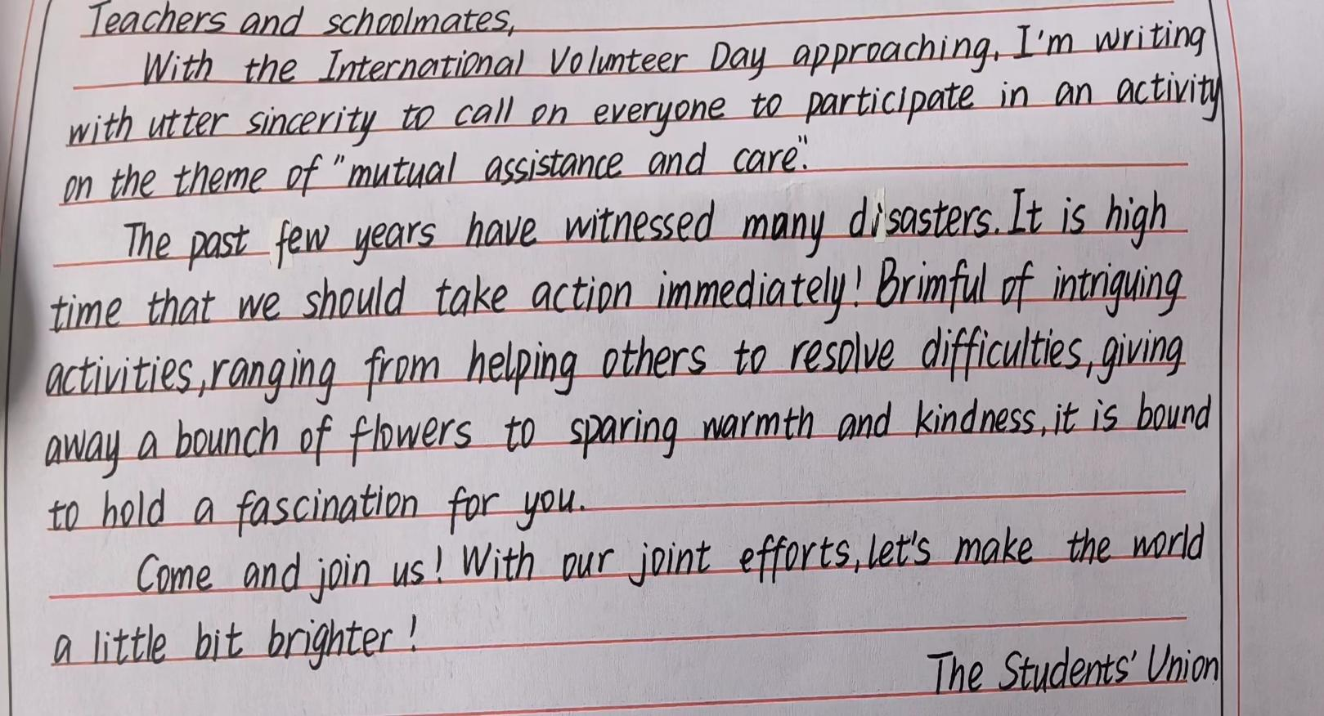

内容：

结构：

语言：

不足：

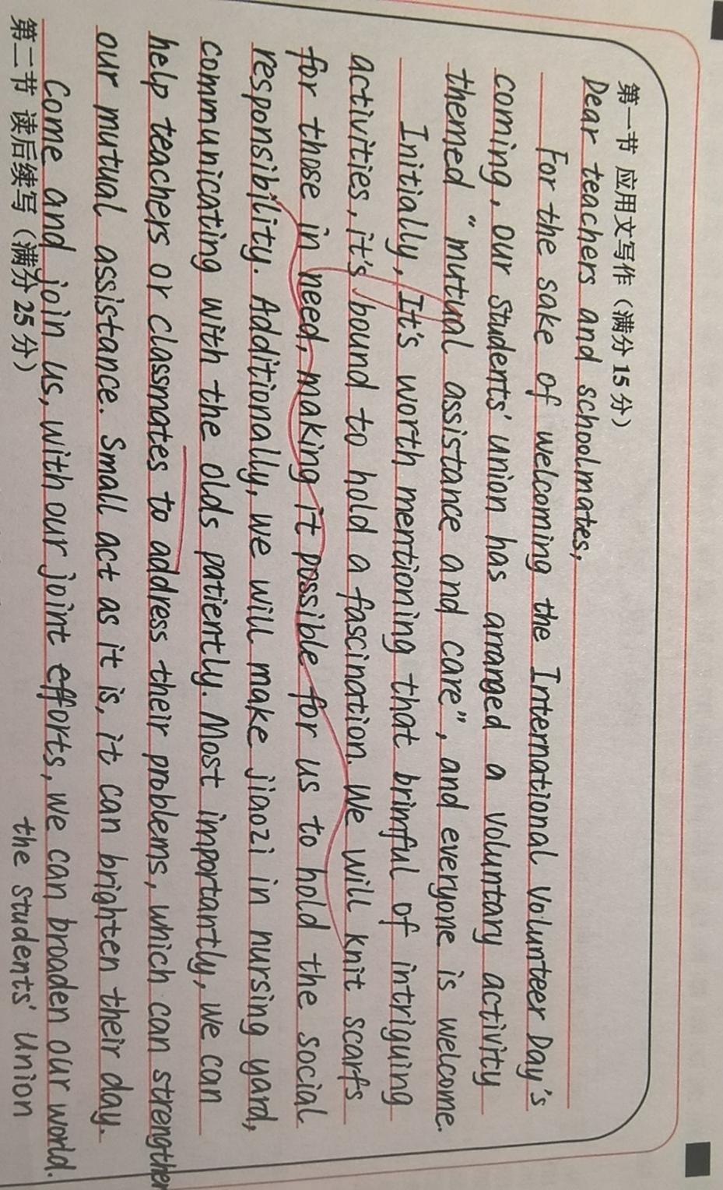

内容：

结构：

语言：

不足：

【相关话题应用文】

（2023.3 福建模拟）假定你是李华，上周日你校举办了以“The Power of Voluntary Work”为主题的演讲比赛。请你为校英文报写一篇报道，内容包括：1.参加人员；2.比赛过程；3.活动反响。

The Power of Voluntary Work

Targeted at provoking students’ awareness of dedication to assisting others, a speech competition with the title of “the power of voluntary work” was held as scheduled in our school last Sunday.

After several rounds of fierce competition, 10 finalists gained access to the final. At the very start, the opening speech was delivered by the principal, who laid emphasis on the core value of volunteer work. Subsequent to it, each contestant was required to deliver a pertinent speech within 5 minutes, embodying the essence of volunteer work. Eventually, centered on their immediate performance and the content, 3 students were awarded certifications in recognition of their distinguished performance.

Thunderous applause marked the end of the competition. Not only could it ignite students’ zest for volunteering, but it could shed light on the significance of individual’ s deeds, which would contribute to the improvement of the society.

1.----要点1（活动内容）

----要点2（活动意义）：

----要点3（篇章衔接词）：

2.词块积累：

Targeted at provoking students’ awareness of

gained access to the final competition

was delivered by the principal

lay emphasis on

deliver a pertinent speech

Subsequent to it

in recognition of

thunderous applause

ignite students’ zest for

shed light on

【语料积累】

1）告知相关信息:

2）目的是/旨在:

3）活动由…开始:

4) 紧接着是:

5) 激发兴趣：

6) 唤起热爱：

7) 使…了解：