**The World**（**1016-1031**）材料分析和教学目标：

本次选用的材料：①《国家地理》的*Rocket Launch Tourism*（观看火箭发射）、②《泰晤士报》的*Digit adds pointer in the debate about AI* （亚马逊人工智能新动向）、③《泰晤士报》的*Empty offices may contain solution to housing crisis*（空置的办公室可缓解住房问题）、④《科学新闻探索》的*Telescopes caught a star gobbling up a planet*（望远镜捕捉到一颗恒星正在吞噬一颗行星）

和⑤BBC的新闻报道。通过语法填空、阅读理解、分析长难句、翻译句子、听力填空和词汇拓展等方式，让学生从多角度提升学习兴趣，提高分析句子、运用词块和听力能力。外媒英语新闻可以让学生体验真实语境下的语言运用，拓展学生的国际视野，了解时事，逐步提升跨文化沟通能力，形成正确的世界观、人生观和价值观。

**教学思路：**

**Part 1: News Report 1《国家地理》2023年10月刊EXPLORE版面**

**Rocket Launch Tourism 观看火箭发射**

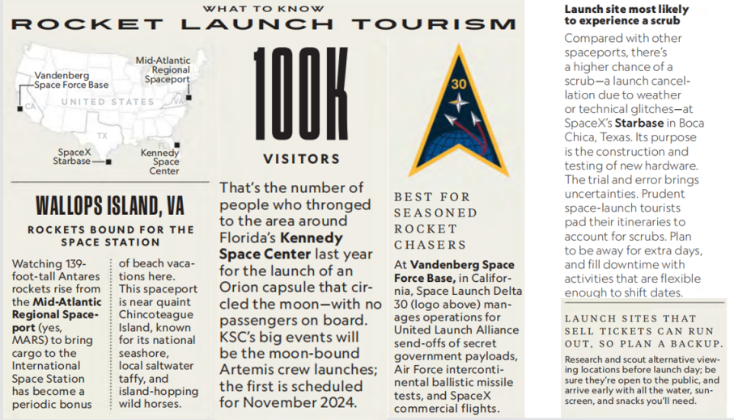

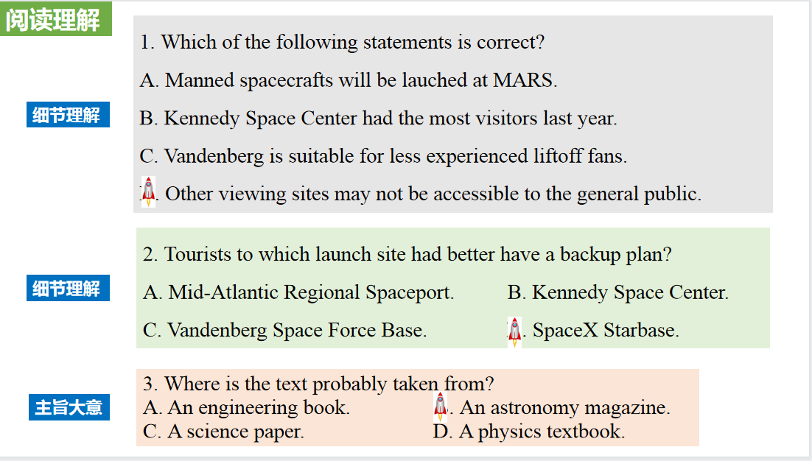

【设计意图】通过阅读理解的形式帮助学生理解新闻的主要内容。该新闻主题语境是关于“人与社会”中“社会热点问题”这一子主题，通过学习让学生了解在美国四个主要火箭发射基地观看太空发射的信息。

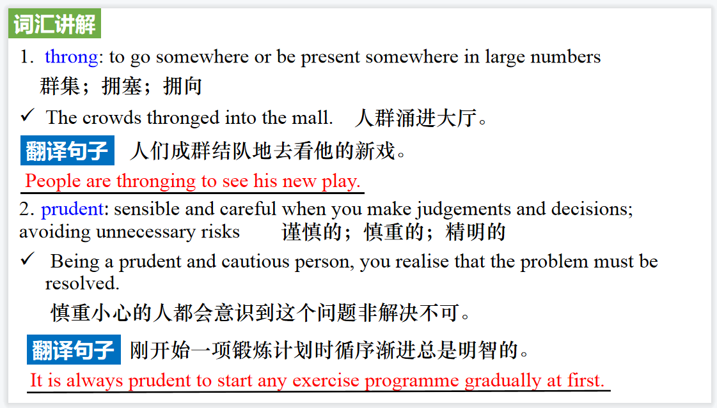

【设计意图】对文本中的词汇进行解读，并通过翻译句子对其进行巩固。

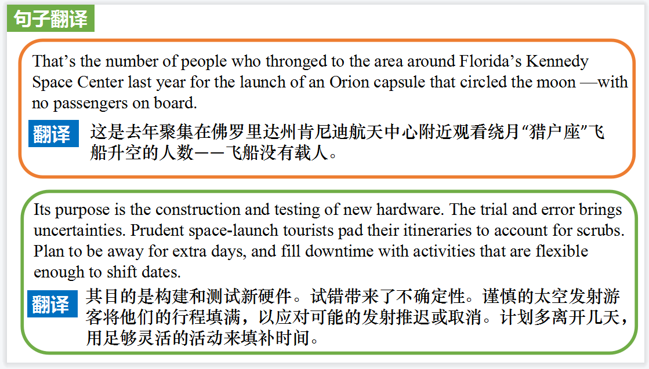

【设计意图】对文中的两个句子进行翻译练习，对其中单词、词组、句法进行巩固并关注句子结构。

**Part 2: News Report 2《泰晤士报》2023年10月21日 50页**

**Digit adds pointer in the debate about AI**

**亚马逊人工智能新动向**

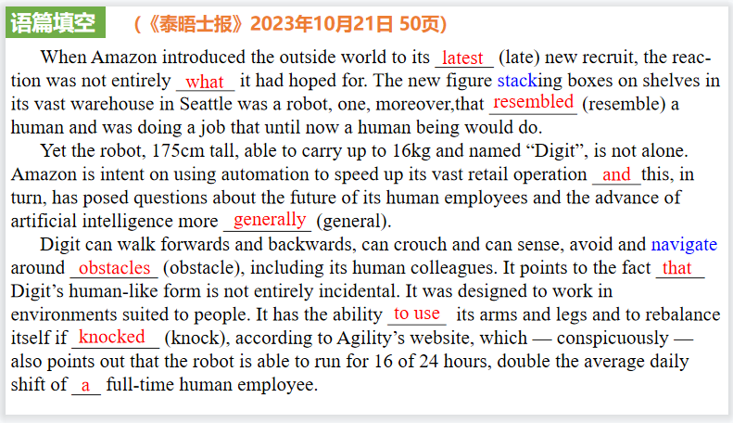

【设计意图】通过语篇填空的形式帮助学生理解新闻的主要内容，同时训练语言语法的运用能力：在语篇的视角下如何正确使用所给词汇，根据语法规则确定词汇的正确形式，使得文章通顺，激活学生的思维和语言。该新闻主题语境是关于“人与社会”中“社会热点问题”这一子主题，通过学习让学生了解亚马逊新员工长得像一个人的机器人。

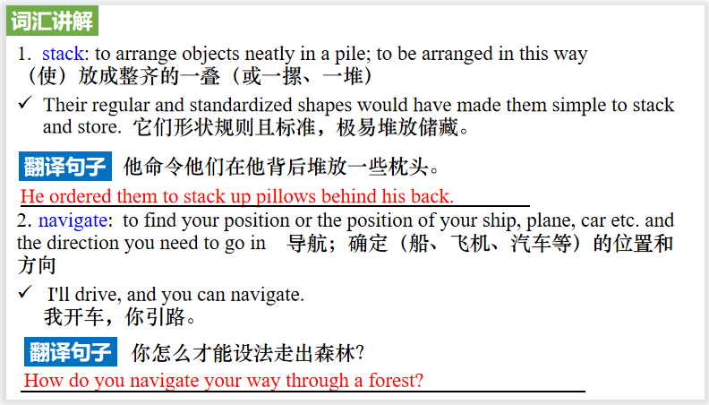

【设计意图】对文本中的词汇进行解读，并通过翻译句子对其进行巩固。

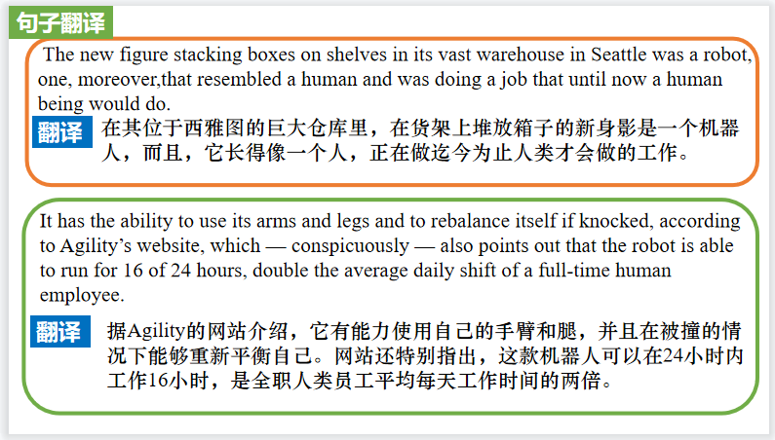

【设计意图】对文中的两个句子进行翻译练习，对其中单词、词组、句法进行巩固并关注句子结构。

**Part 3: News Report 3《泰晤士报》2023年10月19日 36页**

**Empty offices may contain solution to housing crisis**

**空置的办公室可缓解住房问题**

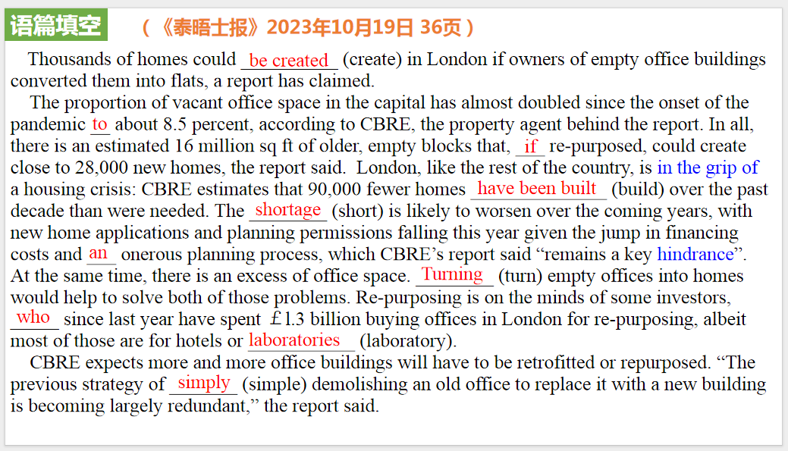

【设计意图】通过语篇填空的形式帮助学生理解新闻的主要内容，同时训练语言语法的运用能力：在语篇的视角下如何正确使用所给词汇，根据语法规则确定词汇的正确形式，使得文章通顺，激活学生的思维和语言。该新闻主题语境是关于“人与社会”中“社会热点问题”这一子主题，通过学习让学生了解利用空置的办公室缓解住房问题的社会举措。

【设计意图】对文本中的词汇进行解读，并通过翻译句子对其进行巩固。

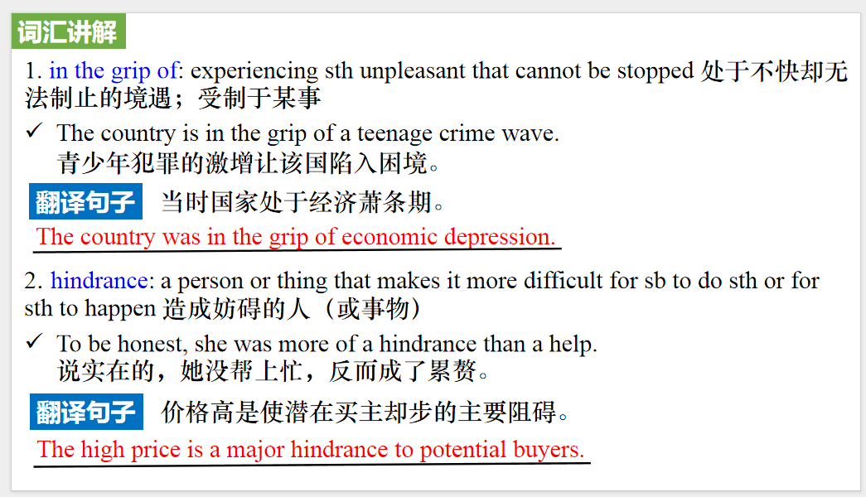

【设计意图】对文中的两个句子进行翻译练习，对其中单词、词组、句法进行巩固并关注句子结构。

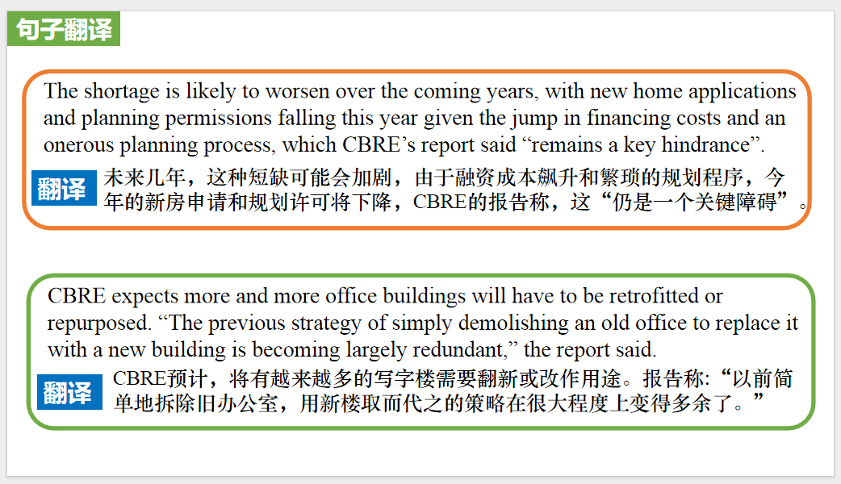

**Part 4: News Report 4《科学新闻探索》2023年10月刊 4页**

**Telescopes caught a star gobbling up a planet**

**望远镜捕捉到一颗恒星正在吞噬一颗行星**

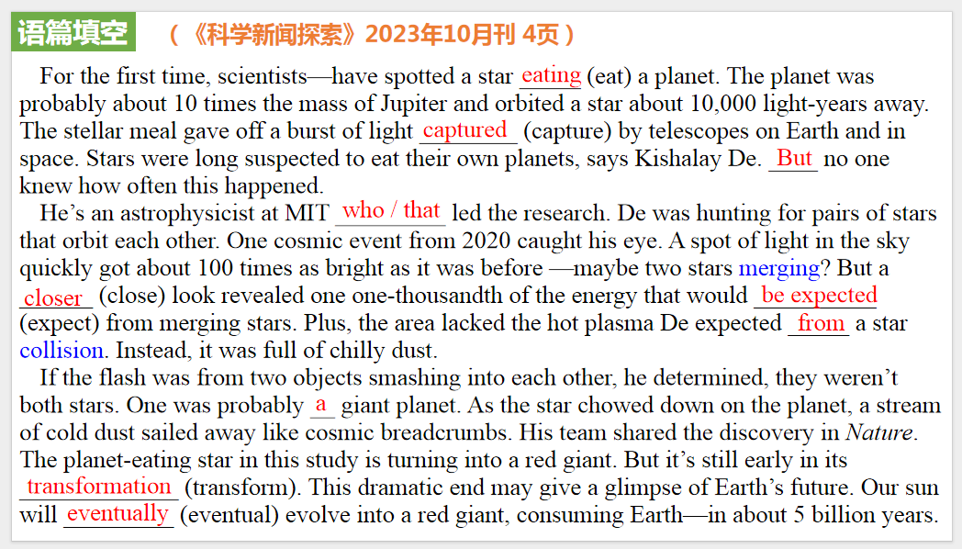

【设计意图】通过语篇填空的形式帮助学生理解新闻的主要内容，同时训练语言语法的运用能力：在语篇的视角下如何正确使用所给词汇，根据语法规则确定词汇的正确形式，使得文章通顺，激活学生的思维和语言。该新闻主题语境是关于“人与社会”中“社会热点问题”这一子主题，通过学习让学生了解望远镜捕捉到一颗恒星正在吞噬一颗行星的天文现象。

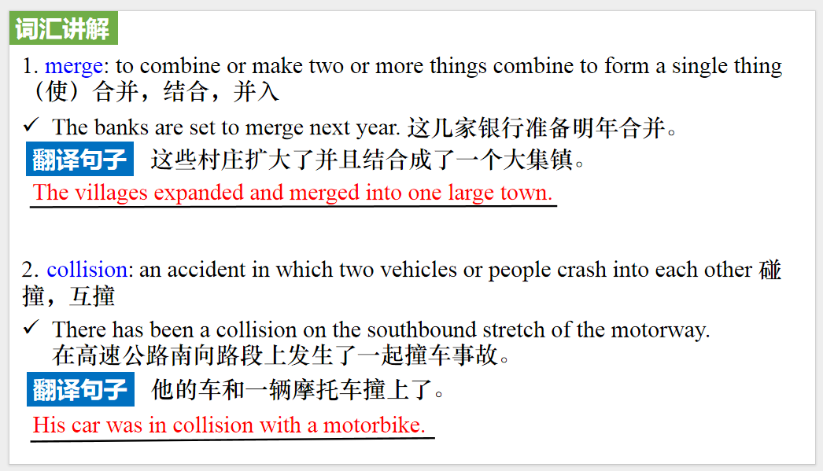

【设计意图】对文本中的词汇进行解读，并通过翻译句子对其进行巩固。

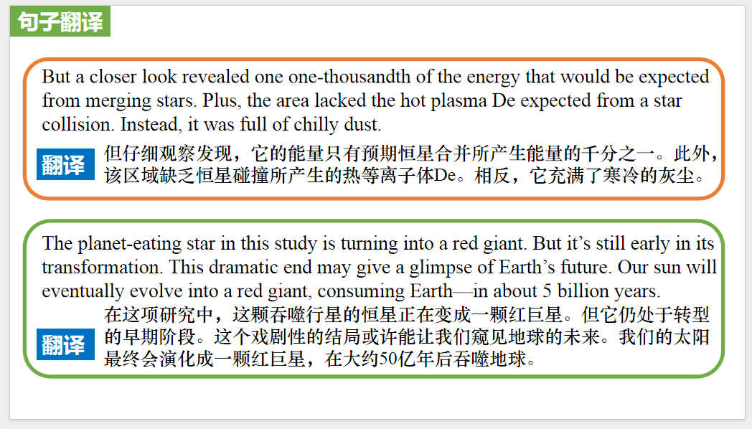

【设计意图】对文中的两个句子进行翻译练习，对其中单词、词组、句法进行巩固并关注句子结构。

**Part 5: BBC News 10/16/2023**



【设计意图】听一则材料，通过听力填空的方式理解文本，考察听力辨识词汇的能力。



【设计意图】对文本中的词汇进行解读，并通过翻译句子对其进行巩固。



【设计意图】对文中的两个句子进行翻译练习，对其中单词、词组、句法进行巩固并关注句子结构。

附：外刊原文

**Part 1: News Report 1《国家地理》2023年10月刊EXPLORE版面**

**Rocket Launch Tourism 观看火箭发射**

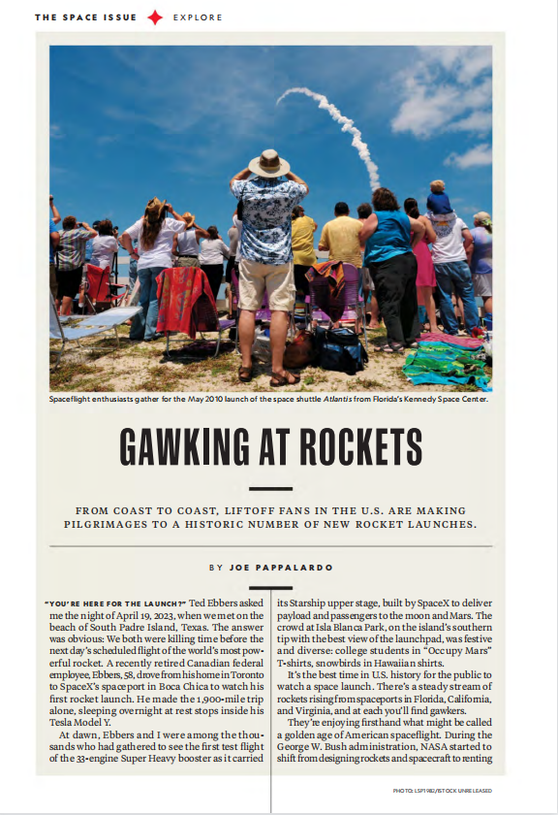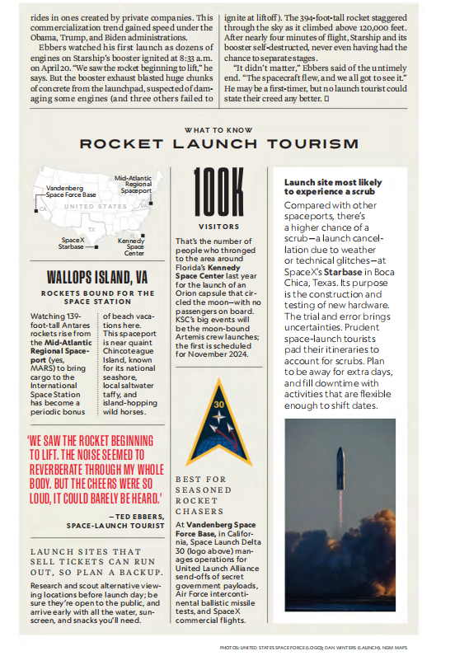

**Part 2: News Report 2《泰晤士报》2023年10月21日 50页**

**Digit adds pointer in the debate about AI**

**亚马逊人工智能新动向**

When Amazon introduced the outside world to its latest new recruit, the reaction was not entirely what it had hoped for. The new figure stacking boxes on shelves in its vast warehouse in Seattle was a robot, one, moreover,that resembled a human and was doing a job that until now a human being would do.

Yet the robot, 175cm tall, able to carry up to 16kg and named “Digit”, is not alone. Amazon is intent on using automation to speed up its vast retail operation and this, in turn, has posed questions about the future of its human employees and the advance of artificial intelligence more generally.

This week, for example, the group unveiled another robotics system: Sequoia enables Amazon to identify and store stock at its warehouses up to 75 per cent more quickly and to reduce the time needed to process an order by up to 25 per cent. And this time last year the company said it had reached another key moment in its robotics race. The Sparrow robotic arm became its first that could sort through millions of unpackaged items to detect and select an individual product, a job that once had been the exclusive domain of Amazon employees.

Then, of course, there is Digit itself. Developed by Agility Robotics, an Oregon-based start-up that has been backed by Amazon’s $1 billion venture capital fund, the robot is still in its relatively infant stages. The movement of its arms and legs is not completely fluid, its grip is pincer-like rather than something akin to the dexterity of a human hand and the steps it takes are small and slightly stilted. But it can walk forwards and backwards, can crouch and can sense, avoid and navigate around obstacles, including its human colleagues.

It points to the fact that Digit’s human-like form is not entirely incidental. It was designed to work in environments suited to people. It has the ability to use its arms and legs and to rebalance itself if knocked, according to Agility’s website, which — conspicuously — also points out that the robot is able to run for 16 of 24 hours, double the average daily shift of a full-time human employee.

That promises both time benefits and cost savings if Digit starts work throughout the company and realises ambitions to take on and master many more tasks than simply picking up boxes.

Amazon now has 750,000 robots operating in its facilities. Developed markets such as Britain, which is Amazon’s third largest, are at a more advanced stage of mechanisation. The group employs 1.5 million people worldwide, about 75,000 of them in its British business.

Tye Brady, Amazon Robotics’ chief technologist, says he aims “to eliminate all the menial, the mundane and the repetitive, no matter where it is in the chain”, but this week he conceded that the greater use of robotics would render some roles redundant. He argued that people would be freed to perform higher-skilled roles and to work “collaboratively” with robots, but would not be drawn on how warehouse employees had reacted to the testing of the Digit robots.

Amazon argues that more automation will create new types of jobs.“Imagine 25 years ago, the job of a social media co-ordinator, that didn’t exist,” Brady pointed out. Indeed, since the company accelerated its push into developing and deploying robotics, it claims that about 700 job types have been created.

Yet the extent to which companies such as Amazon will be able to retrain and redeploy employees working in manual roles remains uncertain. Brady, a former Nasa engineer, countered:

“You do not need to know robotics. You need to be human, you need to understand common sense, you need to have reasoning.”

He suggested that even if the number of people working in individual facilities declined over time, improved efficiency would drive more demand for Amazon’s products and services.“If you’re doing your job right, you’re not going to have one building, you’re going to have ten more buildings, which far exceed the labour that has been done in one building.”

The efficiencies afforded by Amazon’s vast scale have not provided shelter from the broader economic pressures that have dampened consumer spending over the past year.

Andy Jassy, the group’s chief executive, has faced renewed pressure to rein in costs as revenue growth has slowed across the business. Increasing its warehouse capacity during the pandemic merely compounded the impact on profits as shoppers’ spending power has waned since then.

Is there a scenario in which Amazon’s warehouses are staffed entirely by robots? “There’s not any part of me that thinks that would ever be a reality,” Brady said. “I have never been around an automated system that works 100 per cent of the time. Ninety-nine per cent of the time may be good for others, but it’s not good for us when you ship eight billion packages [last year].”

Amazon’s staff will not be alone in watching whether the ecommerce group’s stance on human/robot hybrid working holds out.

**Part 3: News Report 3《泰晤士报》2023年10月19日 36页**

**Empty offices may contain solution to housing crisis**

**空置的办公室可缓解住房问题**

Thousands of homes could be created in London if owners of empty office buildings converted them into flats, a report has claimed.

The proportion of vacant office space in the capital has almost doubled since the onset of the pandemic to about 8.5 per cent, according to CBRE,the property agent behind the report.

In all, there is an estimated 16 million sq ft of older, empty blocks that, if re-purposed, could create close to 28.000new homes, the report said.

“London needs more homes and there is undoubtedly a growing amount of office stock that will need to be re-purposed, so the opportunity to convert these offices to residential use is there,” Luke Mills, CBRE’s residential managing director, said.

London, like the rest of the country, is in the grip of a housing crisis:CBRE estimates that 90,000 fewer homes have been built over the past decade than were needed.

The shortage is likely to worsen over the coming years,with new home applications and planning permissions falling this year given the jump in financing costs and an onerous planning process,which CBRE’s report said “remains a key hindrance”. At the same time, there is an excess of office space. Turning empty offices into homes would help to solve both of those problems.Re-purposing is on the minds of some investors, who since last year have spent ￡l.3 billion buying offices in London for re-purposing,albeit most of those are for hotels or laboratories.

CBRE expects more and more office buildings will have to be retrofitted or repurposed. “The previous strategy of simply demolishing an old office to replace it with a new building is becoming largely redundant,” the report said.

**Part 4: News Report 4《科学新闻探索》2023年10月刊 4页**

**Telescopes caught a star gobbling up a planet**

**望远镜捕捉到一颗恒星正在吞噬一颗行星**

For the first time, scientists—have spotted a star eating a planet. The planet was probably about 10 times the mass of Jupiter and orbited a star about 10,000 light-years away. The stellar meal gave off a burst of light captured by telescopes on Earth and in space.

Stars were long suspected to eat their own planets,says Kishalay De. But no one knew how often this happened. He’s an astrophysicist at MIT who led the research. De was hunting for pairs of stars that orbit each other. One cosmic event from 2020 caught his eye. A spot of light in the sky quickly got about 100 times as bright as it was before —maybe two stars merging? But a closer look revealed one one-thousandth of the energy that would be expected from merging stars. Plus,the area lacked the hot plasma De expected from a star collision. Instead, it was full of chilly dust.

If the flash was from two objects smashing into each other, he determined, they weren’t both stars. One was probably a giant planet. As the star chowed down on the planet,a stream of cold dust sailed away like cosmic breadcrumbs. His team shared the discovery in *Nature*. Planet-devouring stars are probably pretty common, says Smadar Naoz. She is an astrophysicist at the University of California, Los Angeles. A young star might chomp a planet that wanders too close. Or a dying star will swell up to become a supersized star called a red giant. In the process, that star might swallow up a planet in its orbit.

The planet-eating star in this study is tuning into a red giant.But it’s still early in its transformation.This dramatic end may give a glimpse of Earth’s future. Our sun will eventually evolve into a red giant, consuming Earth—in about 5 billion years.