选择性必修第三册
Unit 4 ADVERSITY AND COURAGE
Period 1 Reading and thinking
年 级 | Senior Grade 2 | 授 课  教 师 | 郭文昇 | 学 科 | English | 授 课  日 期
课 题 | A successful failure |  |  | 课时  安排 | 2 | 课 型 | 新授课
文本解读
本单元的主题是“探讨冒险精神”，该阅读文本属于日记题裁，以第一人称叙述。阅读文本分为两个部分，第一部分是背景知识介绍，另一部分是以“坚忍号”服务员珀西布莱克博罗的口吻写下的三篇日记。从沙克尔顿带领“坚忍号”船员于伦敦启程到他们克服种种困难回到英国。三篇日记的时间跨度大，但是基本勾勒出了这次南极探险的故事脉络。
Ⅰ. Instructional objectives:
At the end of this class, students will be able to:
1. summarize the development of Shackleton's Antarctic expedition;
2. explore the spirit of adventure and learn how to overcome adversity from outstanding explorers;
3. infer character traits and emotions;
4. guess the meaning of phrases according to the context.
Ⅱ. Key points:
Infer character traits and emotions from supporting evidence.
Ⅲ. Teaching procedures:
Step1 Lead-in
Enjoy a short video named The Endurance. Then, students will know the background information of this unit and be inspired for the subsequent reading.
Q1. What does the video talk about?
Justification: arouse students’ interest and elicit the topic
Step2 Prediction
Students skim the title and pictures to predict the content.
Q1. What do you expect to read from the text?
Q2. What the content of the text is?
Q3. What is the text type of the passage?
Q4. What is the language features of diary entries?
Justification: prepare for reading
Step3 Skimming and scanning
After prediction, they are asked to skim the text quickly to match the main of each part and find the basic information about the expedition. Finally, students conclude the main idea of this passage.
Justification: to train students’ ability to summarize the main idea.
Step4. Detailed reading
Students read three diary entries carefully and grasp the keywords to answer the following questions. The most important thing is to explore and infer character traits and emotions.
Q1. How did Blackborow come to join the expedition?
Q2. Why did Shackleton throw away all his gold?
Q3. Why did he allow Hussey to keep his banjo?
Q4. What did Shackleton do to make sure all crew members could survive?
Q5. What did the crew members have to do to make sure they could survive?
Q6. How did Blackborow’s feelings change during the expedition?
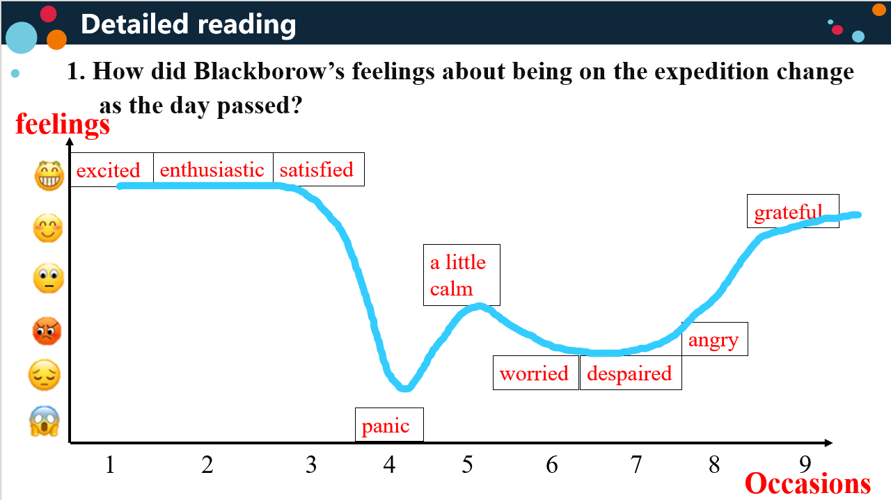
The students discuss the personal qualities of Shackleton and other explorers with their group members.
What personal qualities did Shackleton, Wild, and Blackborow, Thomas Orde-Lees exhibit? Find examples from the text to support your answers.
Justification: Practice reading a passage for details and language features. Help students to fully understand the text to support Step 5.
Step 5. Further thinking
After reading the whole passage, the teacher asks the students to discuss the following questions with their partners:
Q1. What does A Successful Failure mean? Or what does the success/ failure mean in the title?
Q2. Do you think it is a good title? Why (not)?
Q3. What do you think would happen next?
Justification: foster students’ critical thinking.
Ⅳ. Homework
Try to write diary 4 after Blackborow were rescued and survived.

