必修三 Unit 1 Reading and thinking
Teaching Procedures
Step One Lead-in：Listen and guess
Ss listen to five music clips and identify which festival it is respectively ?
Christmas Day Thanksgiving Day Halloween Mid-Autumn Day Spring Festival
Activity 1: Group discussion and voice opinons Think: Why do people celebrate festivals?
Step Two Fast reading
Activity 2: Skimming
T ask Ss read the passage quickly and identify the topic sentence of each para. T reminds Ss to pay attention to the first sentence of each paragraph, which can help them find the answer.
Para 1: Festivals are celebrated all over the world.
Para 2: Of all the traditional festivals, the harvest festival can be found in almost every culture.
Para 3: Customs play a significant role in festivals, but sometimes they can change over time.
Para 4: Festivals are becoming more and more commercial, with businesses taking advantage of the celebrations.
Para 5: Festivals are an important part of society.
Step Three Detail reading
1.Para1 Festivals are celebrated all over the world.
T ask ss to find out the details about this paragraph and tell ss to find the key word.
Key words: origin; custom; spirit;
T ask ss: why do we celebrate festivals around the world? Teacher ask ss think the two adjs: different and common and conclude that there are differences and similarities among all kinds of festivals.
seasons
religions
famous figures
important events
different origins different customs and unique charms

common spirit: sharing joy,gratitude, love, or peace
- Para2 Of all the traditional festivals, the harvest festival can be found in almost every culture.
Ss read para2 and figure out the reasons for people to celebrate harvest festivals and features of each harvest festival from three different cultures.
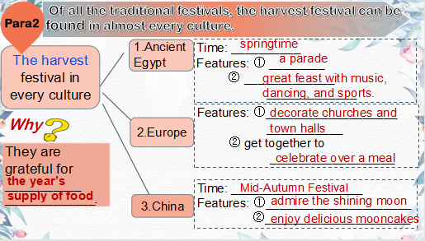
- Para3 Customs play a significant role in festivals, but sometimes they can change over time.
Go through para3 and answer:
Q1: Why do some traditions possibly fade away?
Because of the development of modern society and the spread of new ideas.
Q2: How does the author support the topic sentence? By giving examples.
Example One Why is setting off firecrackers stopped in Chinese Spring Festival?
A. To drive away evil spirits. B. To avoid pollution.
C. To become an exciting festival for children. D.To save money and spend more on gifts.
Example Two Another example is Halloween ,______ became an exciting festival for children, in spite of its _______ origins.
- Para4 Festivals are becoming more and more commercial, with businesses taking advantage of the celebrations.
Go through para4 and answer:
Q1: Are there any different attitudes to the commercialization of festivals? If any,what are they?
Q2: What’s the writer’s attitude towards the commercialization of festivals.
A. Favorable B. Critical C. Doubtful D. Objective
5. Para5 Festivals are an important part of society.
Significance: reflect people’s wishes, beliefs, faiths, and attitudes towards life; allow us to relax and enjoy life, and forget about our work for a little while; help us understand where we came from, who we are, and what to appreciate.
Step Four: After reading
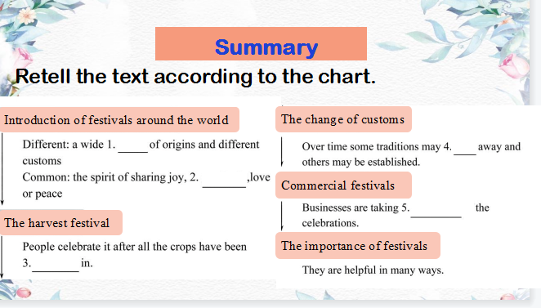
Step Five Deep thinking
Which do you prefer? The Spring Festival or Christmas? In pairs, discuss “ Should we celebrate western festivals?”
Step Six Homework Write a small passage about how to carry forward our traditional Chinese customs as a student ( provide at least 3 practical advice).

