**人教版选择性必修****三Unit 4** **Adversity and Courage**

**Reading and Thinking**

**A Successful Failure**

**【单元学习主题】**人与自然——逆境与勇气

**【语篇类型】**日记

**【设计思路】**

学生通过阅读这次南极探险历程中的几个重要事件，理解Ernest Shackleton与船员们面临的挑战和困境，分析不同人物的言行，了解主要人物的情感变化和性格品质，培养学生的分析和推理能力。探讨探险家的冒险精神，鼓励学生勇于挑战自我，以乐观和坚毅的态度面对人生的逆境和挫折。

**【文本分析】**

这篇文本分成两部分，第一部分是人员招募广告，第二部分是三篇日记，以第一人称叙事。第一篇日记讲述了Perce Blackborow加入南极探险队，展现了他对冒险充满渴望的内心世界；第二篇日记讲述了Ernest Shackleton弃船时如何冷静地组织船员应对危机，以身作则抛弃黄金，对船员的个人爱好给予鼓励，从侧面反应了他的领导者气质和探险家品质；第三篇日记描写了Perce在象岛上的日常生活，当他对未知的命运感到惶恐，对艰苦的客观环境感到不满、情绪低落时，队友的安慰和乐观让他重拾希望。

**【教学重点】**

引导学生通过阅读抓住“坚忍号”南极探险历程中的重要事件，理解主人公所面临的困境；启发学生透过表象的言行来分析人物的情感变化和性格品质。

**【教学目标】**

（1）语言能力目标：

阅读三篇南极探险日记，积累本单元的重点词汇，梳理“坚忍号”南极探险的艰险历程，分析主要人物的性格特点和心理变化，了解日记的叙事风格和语言特点。

（2）学习能力目标：

能够根据主要人物的具体言行分析其情感变化，解读其性格品质。

（3）文化意识目标：

了解南极探险的历史背景、典型人物的故事和探险精神；培养自己坚毅的品质和乐观的人生态度，勇于面对挑战、挫折与逆境。

（4）思维品质目标：

能够根据不同角度的叙事整理出“坚忍号”南极探险的大致历程；能够对文本中的细节进行推理分析，判断主要人物的心理状态和性格品质。

**【教学步骤】**

**◆ Pre-reading**

Step 1: Video appreciation

Q：What is the news mainly about?

[设计意图] “坚忍号”沉船最近在南极海底被发现，这个最近的新闻视频激发了学生的兴趣和好奇心，引出话题。

Step 2: Read the advertisement

Q: According to the advertisement, what kind of men was Ernest Shackleton looking for? What are the requirements? Are you qualified?

[设计意图] 帮助学生了解探险的艰难和船员应该具备的性格品质。

**◆ Reading**

Step 3 Reading for the text type

Q1. What is the text type of this passage?

Q2. In what person is the passage written?

[设计意图] 了解语篇类型：日记体裁，以第一人称叙事。

Step 4 Reading for the information

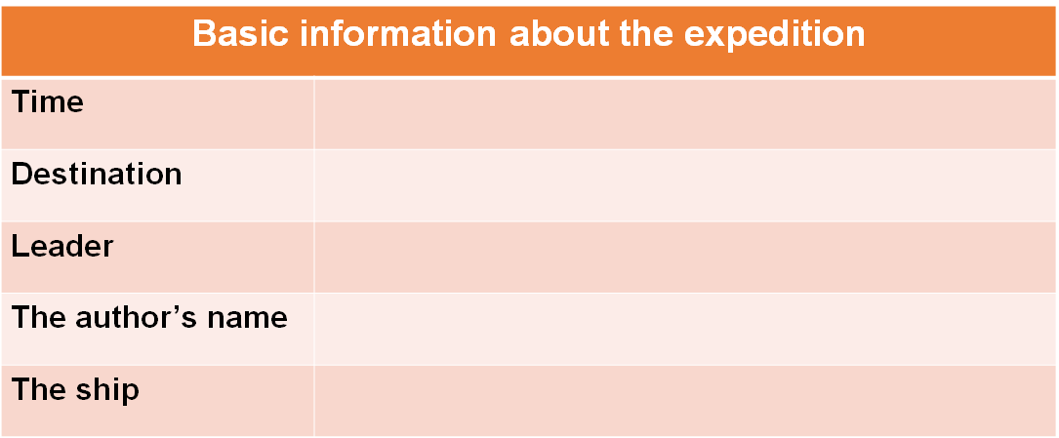

Main ideas：

Dairy 1：The author joined the …

Diary 2：Shackleton and his crew …

Diary 3：The crew members’ life on …

[设计意图] 借助表格呈现这次南极探险的基本信息，梳理语篇结构，同时归纳每篇日记的大意。

Step 5: Reading for details

Diary 1：The author joined the expedition.

Q: How did Blackborow come to join the expedition?

Diary 2：Shackleton and his crew abandoned the ship Endurance.

Q 1. What happened to *Endurance*?

Q 2. What did the crew members have to do?

Q 3. Why did Shackleton throw away all his gold? Why did he allow Hussey to keep his banjo?

Diary 3：The crew members’ life on Elephant Island.

Q: What did they do to make sure they could survive?

[设计意图] 基于日记的情节内容设计问题，帮助学生把握文章的脉络，获取文本重要信息，提升阅读理解能力。

Step 6: Analyzing the characters

Q: Who are the members of the expedition?

Q: How did Blackborow’s feelings about being on the expedition change?

Q: What personal qualities did Shackleton, Wild and Blackborow exhibit? Give supporting evidence.

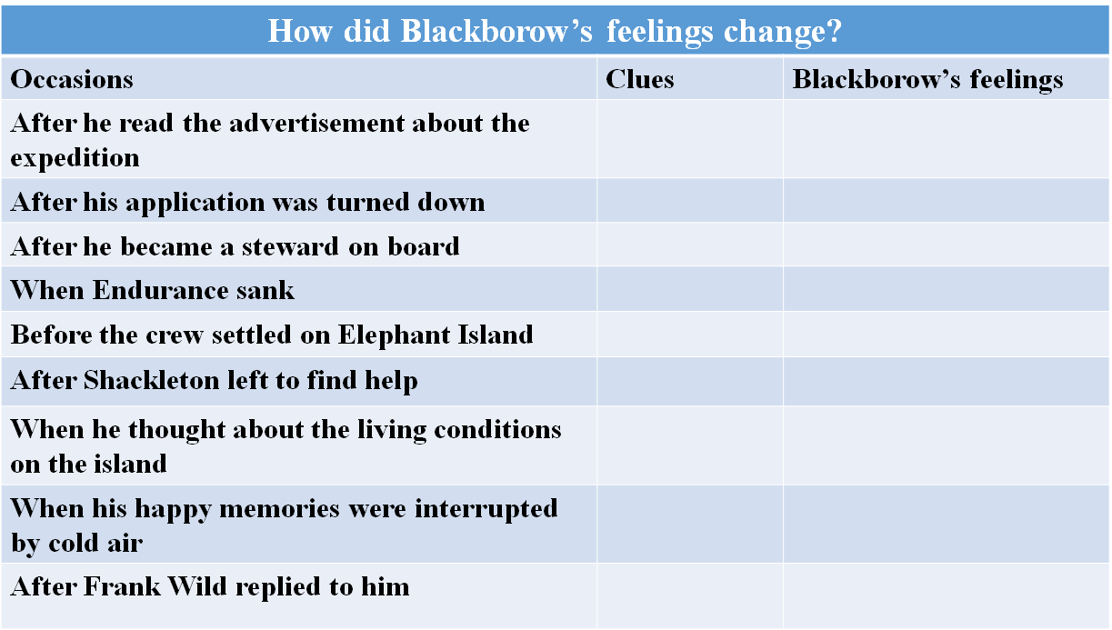

[设计意图] 根据日记中对不同人物的言行描写，讨论与分析主要人物的情感变化和性格品质，借助表格清晰地呈现要点，培养学生的分析和推理能力，促进思维品质的发展。

Step 7: Learning new words

Q: What do the highlighted words mean? Use your own words to explain them.

[设计意图] 引导学生基于上下文推断词义，帮助学生积累词汇，培养猜词能力。

Step 8: Appreciating the language

1. And when the ship sank, our hearts sank with it.

2. However, these happy memories are soon interrupted by a sudden cold rush of air.

3. Their genuine concern for others, their perseverance, and their resolve fill me with hope.

[设计意图]引导学生欣赏优美的句子并积累背诵。

Step 9: Critical thinking

Q: What is the figure of speech in the title? How do you understand the title?

Group discussion:

1. How did Blackborow feel on the deserted island? Would writing a diary help him deal with his feelings?

2. What could Blackborow do to kill time on the island? How do people keep track of date on a deserted island?

3. Why did Blackborow write diaries?

[设计意图] 引导学生思考课文标题的内涵，讨论successful和failure分别指代什么，并且讨论作者写日记的原因，帮助学生拓展思路，注重批判性思维的培养。

Step 10: Summary

1. Complete the passage with the correct forms of the words in the box.

2. How to read diaries?

[设计意图] 通过完成课文的大意概括，帮助学生更好地理解文本大意。再结合这节课的各环节安排，总结归纳日记体裁文本的阅读技巧，帮助学生提升阅读能力。

**◆ Post-reading**

Step 11: An interview

***Have an interview!*** *One student acts as a journalist to interview another student who acts as Perce Blackborow, talking about the expedition to Antarctic. Work in groups.*

[设计意图] 在课堂结尾，设计一份采访的对话任务，目的是让学生能巩固和积累本节课的所学知识，注重语篇知识的迁移，有助于提升语言表达能力。