**利用10篇高考真题突破书评类阅读理解**

**一．课程标准解读**

**普通高中英语课程语篇知识内容要求**

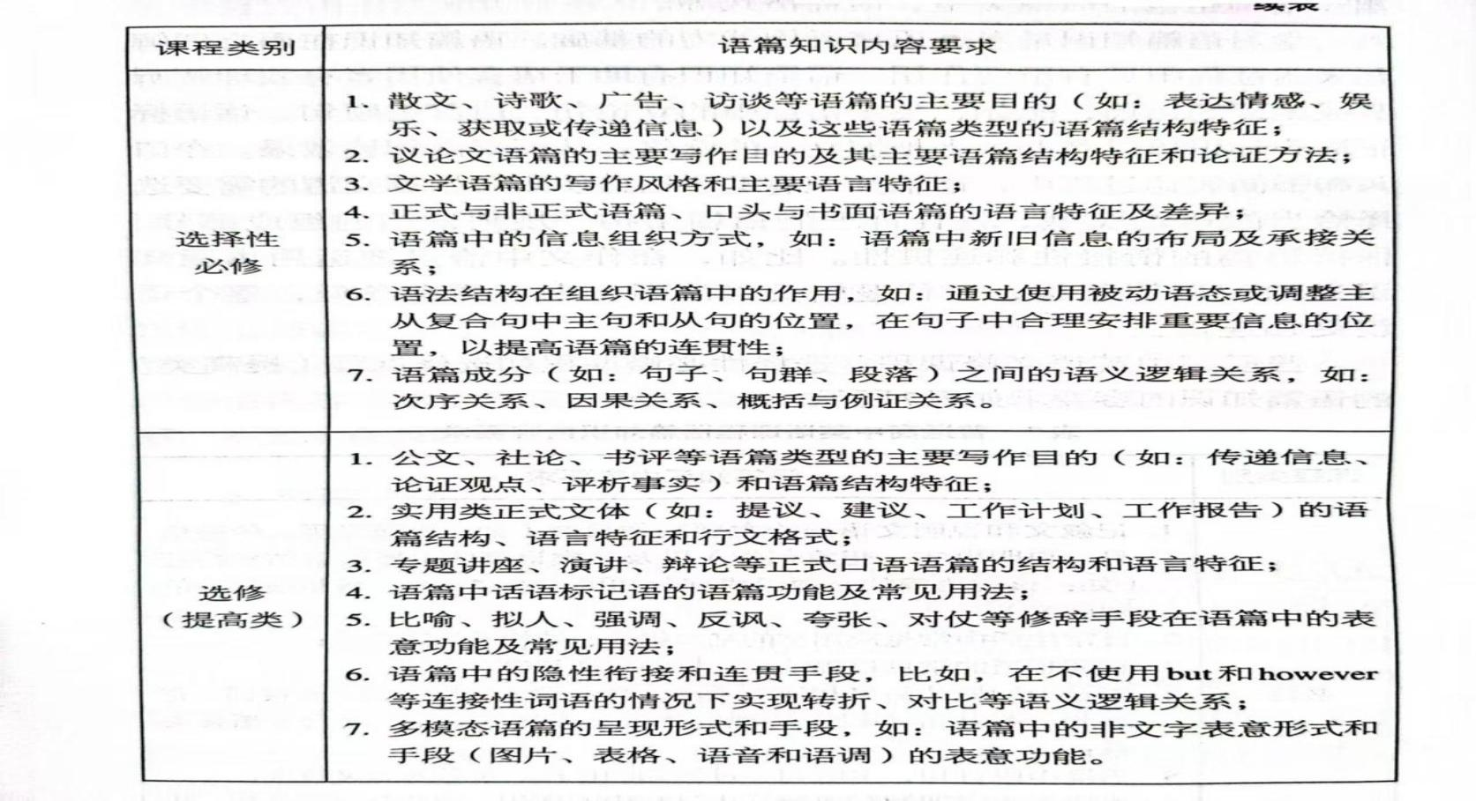

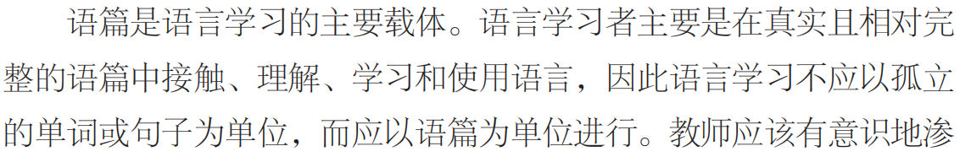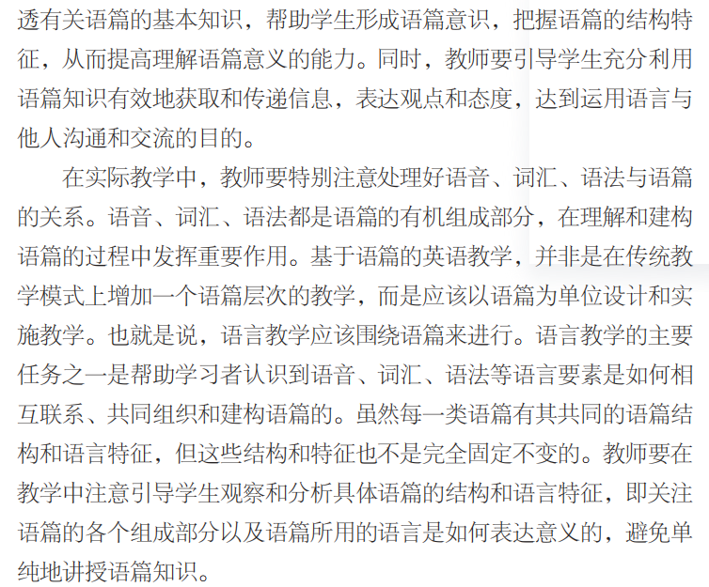

**二．“书评类”阅读理解高考真题汇编**

|  |  |  |  |  |  |  |
| --- | --- | --- | --- | --- | --- | --- |
| 试卷 | 年份 | 语篇类型 | 主题语境 | 主题内容 | 考察题型 | 主题意义 |
| 新课标II卷 | 2024 | 书评  D篇 | 人与社会 | AI by Design : A plan for Living with Artificial Intelligence | 词义猜测：32  理解具体信息：33,34  写作目的：35 | 引导学生对AI快速发展进行辩证思考 |
| 全国甲卷 | 2024 | 夹叙夹议  D篇 | 人与社会 | 探讨文学作品结局的特点、如何写出令人满意的结局，并推荐阅读 | 理解具体信息：32,34  推理判断：33,35 | 为学生平时欣赏文学作品和开展写作提供了有益建议 |
| 新课标I卷 | 2024 | 说明文  C篇 | 人与社会 | 纸质书阅读比数字阅读更有优势 | 词义猜测：28  理解具体信息：29,30  推理判断：31 | 引导学生在面对科技发展给生活和学习带来便利时要树立客观正确的态度 |
| 新课标I卷 | 2023 | 书评C篇 | 人与自我 | 数字极简主义生活方式 | 理解具体信息：28,30,31  词义猜测：29 | 向学生传达合理利用网路和电子设备的新理念，倡导数字时代健康简单的生活方式，引导学生生养成自律的习惯 |
| 新课标II卷 | 2023 | 书评C篇 | 人与社会 | 《阅读艺术：书籍爱好者的艺术》让我们看到了超越文化与时间的共同人性 | 推理判断：28  理解具体信息：29  词义猜测：30  写作意图：31 | 引导学生养成喜爱读书，善于求知的学习习惯 |
| 全国甲卷 | 2023 | 书评  C篇 | 人与社会 | 《苏格拉底快车》让读者深刻思考日常生活中的欲望、孤独等哲学问题 | 理解具体信息：28  推理判断：29,30,31 | 通过哲学对现实生活的指导意义，引导考生重视书籍阅读和知识积累，丰富学识，积淀文化底蕴 |
| 浙江卷 | 2022 | 书评  B篇 | 人与社会 | 讲述了蒸汽、电气时代为美国发展带来的影响以及在那个时代下诞生的发明家。 | 推理判断：24,25,26 | 引导学生关注时代工业的发展，探索、钻研科学知识，为社会发展作出贡献 |
| 全国乙卷 | 2022 | 书评B篇 | 人与社会 | Nothing Daunted:The Unexpected Education of Two Society Girls in the West | 理解具体信息：24，26  推理判断：25，27 | 引导学生了解书评文体特征，形成批判性思维能力；倡导学习故事主人公的精神，克服苦难，勇于磨砺，为贫苦地区提供援助 |
| 山东卷 | 2020 | 书评C篇 | 人与社会 | 介绍一本有关乌  兹别克斯坦游记的书 | 理解具体信息：28  词义猜测：29  推理判断：30,  写作意图：31 | 拓宽学生知识视野，了解国外生活及文化 |
| 浙江卷 | 2020 | 一本书的引言A篇 | 人与社会 | 作者对其写书的目的和书中的内容做了介绍 | 理解具体信息21,22,23  推理判断：24 | 让学生更深入了解西方戏剧并感悟作者对戏剧的热爱 |

**Passage 1 2024年新课标II卷D篇**

Given the astonishing potential of AI to transform our lives, we all need to take action to deal with our AI-powered future, and this is where *AI by Design: A Plan for Living with Artificial Intelligence* comes in. This absorbing new book by Catriona Campbell is a practical roadmap addressing the challenges posed by the forthcoming AI revolution (变革).

In the wrong hands, such a book could prove as complicated to process as the computer code (代码) that powers AI but, thankfully, Campbell has more than two decades’ professional experience translating the heady into the understandable. She writes from the practical angle of a business person rather than as an academic, making for a guide which is highly accessible and informative and which, by the close, will make you feel almost as smart as AI.

As we soon come to learn from *AI by Design*, AI is already super-smart and will become more capable, moving from the current generation of “narrow-AI” to Artificial General Intelligence. From there, Campbell says, will come Artificial Dominant Intelligence. This is why Campbell has set out to raise awareness of AI and its future now — several decades before these developments are expected to take place. She says it is essential that we keep control of artificial intelligence, or risk being sidelined and perhaps even worse.

Campbell’s point is to wake up those responsible for AI — the technology companies and world leaders — so they are on the same page as all the experts currently developing it. She explains we are at a “tipping point” in history and must act now to prevent an extinction-level event for humanity. We need to consider how we want our future with AI to pan out. Such structured thinking, followed by global regulation, will enable us to achieve greatness rather than our downfall.

AI will affect us all, and if you only read one book on the subject, this is it.

32. What does the phrase “In the wrong hands” in paragraph 2 probably mean?

A. If read by someone poorly educated.

B. If reviewed by someone ill-intentioned.

C. If written by someone less competent.

D. If translated by someone unacademic.

33. What is a feature of *AI by Design* according to the text?

A. It is packed with complex codes.

B. It adopts a down-to-earth writing style.

C. It provides step-by-step instructions.

D. It is intended for AI professionals.

34. What does Campbell urge people to do regarding AI development?

A. Observe existing regulations on it.

B. Reconsider expert opinions about it.

C. Make joint efforts to keep it under control.

D. Learn from prior experience to slow it down.

35. What is the author’s purpose in writing the text?

A. To recommend a book on AI. B. To give a brief account of AI history.

C. To clarify the definition of AI. D. To honor an outstanding AI expert.

语篇结构思维导图

***AI by Design: A Plan for Living with Artificial Intelligence***

Para 1

Para 2

Para 3

Para 4

Para 5

**Passage 2 2024年新课标I卷 C篇**

Is comprehension the same whether a person reads a text onscreen or on paper? And are listening to and viewing content as effective as reading the written word when covering the same material? The answers to both questions are often “no.” The reasons relate to a variety of factors, including reduced concentration, an entertainment mindset (心态) and a tendency to multitask while consuming digital content.

When reading texts of several hundred words or more, learning is generally more successful when it’s on paper than onscreen. A large amount of research confirms this finding. The benefits of print reading particularly shine through when experimenters move from posing simple tasks – like identifying the main idea in a reading passage – to ones that require mental abstraction – such as drawing inferences from a text.

The differences between print and digital reading results are partly related to paper’s physical properties. With paper, there is a literal laying on of hands, along with the visual geography of distinct pages. People often link their memory of what they’ve read to how far into the book it was or where it was on the page.

But equally important is the mental aspect. Reading researchers have proposed a theory called “shallowing hypothesis (假说).” According to this theory, people approach digital texts with a mindset suited to social media, which are often not so serious, and devote less mental effort than when they are reading print.

Audio (音频) and video can feel more engaging than text, and so university teachers increasingly turn to these technologies – say, assigning an online talk instead of an article by the same person. However, psychologists have demonstrated that when adults read news stories, they remember more of the content than if they listen to or view identical pieces.

Digital texts, audio and video all have educational roles, especially when providing resources not available in print. However, for maximizing learning where mental focus and reflection are called for, educators shouldn’t assume all media are the same, even when they contain identical words.

28. What does the underlined phrase “shine through” in paragraph 2 mean?

A. Seem unlikely to last. B. Seem hard to explain.

C. Become ready to use. D. Become easy to notice.

29. What does the shallowing hypothesis assume?

A. Readers treat digital texts lightly.

B. Digital texts are simpler to understand.

C. People select digital texts randomly.

D. Digital texts are suitable for social media.

30. Why are audio and video increasingly used by university teachers?

A. They can hold students’ attention.

B. They are more convenient to prepare.

C. They help develop advanced skills.

D. They are more informative than text.

31. What does the author imply in the last paragraph?

A. Students should apply multiple learning techniques.

B. Teachers should produce their own teaching material.

C. Print texts cannot be entirely replaced in education.

D. Education outside the classroom cannot be ignored.

语篇结构思维导图

***Reading on screen VS.on paper***

Para 1

Para 2

Para 3

Para 4

Para 5

Para 6

**Passage 3 2024年全国甲卷D篇**

“I didn’t like the ending,” I said to my favorite college professor. It was my junior year of undergraduate, and I was doing an independent study on Victorian literature. I had just finished reading *The Mill on the Floss* by George Eliot, and I was heartbroken with the ending. Prof. Gracie, with all his patience, asked me to think about it beyond whether I liked it or not. He suggested I think about the difference between endings that I wanted for the characters and endings that were right for the characters, endings that satisfied the story even if they didn’t have a traditionally positive outcome. Of course, I would have preferred a different ending for Tom and Maggie Tulliver, but the ending they got did make the most sense for them.

This was an aha moment for me, and I never thought about endings the same way again. From then on, if I wanted to read an ending guaranteed to be happy, I’d pick up a love romance. If I wanted an ending I couldn’t guess, I’d pick up a mystery (悬疑小说). One where I kind of knew what was going to happen, historical fiction. Choosing what to read became easier.

But writing the end — that’s hard. It’s hard for writers because endings carry so much weight with readers. You have to balance creating an ending that’s unpredictable, but doesn’t seem to come from nowhere, one that fits what’s right for the characters.

That’s why this issue (期) of *Writer’s Digest* aims to help you figure out how to write the best ending for whatever kind of writing you’re doing. If it’s short stories, Peter Mountford breaks down six techniques you can try to see which one helps you stick the landing. Elizabeth Sims analyzes the final chapters of five great novels to see what key points they include and how you can adapt them for your work.

This issue won’t tell you what your ending should be — that’s up to you and the story you’re telling — but it might provide what you need to get there.

32. Why did the author go to Prof. Gracie?

A. To discuss a novel. B. To submit a book report.

C. To argue for a writer. D. To ask for a reading list.

33. What did the author realize after seeing Prof. Gracie?

A. Writing is a matter of personal preferences.

B. Readers are often carried away by characters.

C. Each type of literature has its unique ending.

D. A story which begins well will end well.

34. What is expected of a good ending?

A. It satisfies readers’ taste.

B. It fits with the story development.

C. It is usually positive.

D. It is open for imagination.

35. Why does the author mention Peter Mountford and Elizabeth Sims?

A. To give examples of great novelists.

B. To stress the theme of this issue.

C. To encourage writing for the magazine.

D. To recommend their new books.

语篇结构思维导图

***The art of crafting literary ending***

Para 1

Para 2

Para 3

Para 4

Para 5

**Passage 4 2023年新课标I卷C篇**

①The goal of this book is to make the case for digital minimalism, including a detailed exploration of what it asks and why it works, and then to teach you how to adopt this philosophy if you decide it's right for you.

②To do so, I divided the book into two parts. In part one, I describe the philosophical foundations of digital minimalism, starting with an examination of the forces that are making so many people's digital lives increasingly intolerable, before moving on to a detailed discussion of the digital minimalism philosophy.

③Part one concludes by introducing my suggested method for adopting this philosophy: the digital **declutter**. This process requires you to step away from optional online activities for thirty days. At the end of the thirty days, you will then add back a small number of carefully chosen online activities that you believe will provide massive benefits to the things you value.

④In the final chapter of part one, I'll guide you through carrying out your own digital declutter. In doing so, I'll draw on an experiment I ran in 2018 in which over 1,600 people agreed to perform a digital declutter. You'll hear these participants' stories and learn what strategies worked well for them, and what traps they encountered that you should avoid.

⑤The second part of this book takes a closer look at some ideas that will help you cultivate（培养） a sustainable digital minimalism lifestyle. In these chapters, I examine issues such as the importance of solitude（独处） and the necessity of cultivating high-quality leisure to replace the time most now spend on mindless device use. Each chapter concludes with a collection of practices, which are designed to help you act on the big ideas of the chapter. You can view these practices as a toolbox meant to aid your efforts to build a minimalist lifestyle that works for your particular circumstances.

28.What is the book aimed at?

A. Teaching critical thinking skills. B. Advocating a simple digital lifestyle.

C.Solving philosophical problems. D. Promoting the use of a digital device.

29.What does the underlined word "declutter" in paragraph 3 mean?

A. Clear-up. B. Add-on.    C. Check-in. D. Take-over.

30.What is presented in the final chapter of part one?

A. Theoretical models. B. Statistical methods. C. Practical examples. D. Historical analyses.

31. What does the author suggest readers do with the practices offered in part two?

A. Use them as needed. B. Recommend them to friends.

C. Evaluate their effects. D.Identify the ideas behind them.

语篇结构思维导图

***The digital minimalism lifestyle***

Para 1

Para 2

Para 3

Para 4

Para 5

**Passage 5 2023年新高考II卷 C篇**

*①Reading Art: Art for Book Lovers* is a celebration of an everyday object — the book, represented here in almost three hundred artworks from museums around the world. The image of the reader appears throughout history, in art made long before books as we now know them came into being. In artists’ representations of books and reading, we see moments of shared humanity that go beyond culture and time.

② In this “book of books,” artworks are selected and arranged in a way that emphasizes these connections between different eras and cultures. We see scenes of children learning to read at home or at school, with the book as a focus for relations between the generations. Adults are portrayed (描绘) alone in many settings and poses —absorbed in a volume, deep in thought or lost in a moment of leisure. These scenes may have been painted hundreds of years ago, but they record moments we can all **relate to**.

 ③Books themselves may be used symbolically in paintings to demonstrate the intellect (才智), wealth or faith of the subject. Before the wide use of the printing press, books were treasured objects and could be works of art in their own right. More recently, as books have become inexpensive or even throwaway, artists have used them as the raw material for artworks — transforming covers, pages or even complete volumes into paintings and sculptures.

 ④Continued developments in communication technologies were once believed to make the printed page outdated. From a 21st-century point of view, the printed book is certainly ancient, but it remains as interactive as any battery-powered e-reader. To serve its function, a book must be activated by a user: the cover opened, the pages parted, the contents reviewed, perhaps notes written down or words underlined. And in contrast to our increasingly networked lives where the information we consume is monitored and tracked, a printed book still offers the chance of a wholly private, “off-line” activity.

28. Where is the text most probably taken from?

A. An introduction to a book. B. An essay on the art of writing.

C. A guidebook to a museum. D. A review of modern paintings.

29. What are the selected artworks about?

A. Wealth and intellect. B. Home and school.

C. Books and reading. D. Work and leisure.

30.What do the underlined words “relate to” in paragraph 2 mean?

A. Understand.            B. Paint. C. Seize.                 D. Transform.

31. What does the author want to say by mentioning the e-reader?

A. The printed book is not totally out of date. B. Technology has changed the way we read.

C. Our lives in the 21st century are networked. D. People now rarely have the patience to read.

语篇结构思维导图

***Reading Art: Art for Book Lovers***

Para 1

Para 2

Para 3

Para 4

**Passage 6 2023年高考甲卷 C篇**

① I was about 13 when an uncle gave me a copy of Jostein Gaarder’s *Sophie’s World*. It was full of ideas that were new to me, so I spent the summer with my head in and out of that book. It spoke to me and brought me into a world of philosophy (哲学).

 ②That love for philosophy lasted until I got to college. Nothing kills the love for philosophy faster than people who think they understand Foucault, Baudrillard, or Confucius better than you — and then try to explain them.

 ③Eric weiner’s *The Socrates Express: In Search of Life Lessons from Dead Philosophers* reawakened my love for philosophy. It is not an explanation, but an invitation to think and experience philosophy.

 ④Weiner starts each chapter with a scene on a train ride between cities and then frames each philosopher’s work in the context (背景) of one thing they can help us do better. The end result is a read in which we learn to wonder like Socrates, see like Thoreau, listen like Schopenhauer, and have no regrets like Nietzsche. This, more than a book about understanding philosophy, is a book about learning to use philosophy to improve a life.

 ⑤He makes philosophical thought an appealing exercise that improves the quality of our experiences, and he does so with plenty of humor. Weiner enters into conversation with some of the most important philosophers in history, and he becomes part of that crowd in the process by decoding (解读) their messages and adding his own interpretation.

 ⑥*The Socrates Express* is a fun, sharp book that draws readers in with its apparent simplicity and gradually pulls them in deeper thoughts on desire, loneliness, and aging. The invitation is clear: Weiner wants you to pick up a coffee or tea and sit down with this book. I encourage you to take his offer. It’s worth your time, even if time is something we don’t have a lot of.

8. Who opened the door to philosophy for the author?

A. Foucault.          B. Eric Weiner. C. Jostein Gaarder.          D. A college teacher.

9. Why does the author list great philosophers in paragraph 4?

A. To compare Weiner with them. B. To give examples of great works.

C. To praise their writing skills. D. To help readers understand Weiners’ book.

10. What does the author like about The Socrates Express?

A. Its views on history are well-presented. B. Its ideas can be applied to daily life.

C. It includes comments from readers. D. It leaves an open ending.

11. What does the author think of Weiners book?

A. Objective and plain. B. Daring and ambitious.

C. Serious and hard to follow. D. Humorous and straightforward.

语篇结构思维导图

**从《苏菲的世界》到《苏格拉底快车》**

Para 1

Para 2

Para 3

Para 4

Para 5

Para 6

**Passage 7 2022年浙江卷B篇**

①The United States rose to global power on the strength of its technology, and the lifeblood of that technology has long been electricity. By providing long-distance communication and energy, electricity created the modern world. Yet properly understood, the age of electricity is merely the second stage in the age of steam, which began a century earlier.

②“It is curious that no one has put together a history of both the steam and electric revolutions.” writes Maury Klein in his book *The Power Makers: Steam, Electricity, and the Men Who Invented Modern America*. Klein, a noted historian of technology, spins a narrative (叙述) so lively that at times it reads like a novel.

③The story begins in the last years of the 18th century in Scotland, where Watt perfected “the machine that changed the world.” Klein writes, “America did not invent the steam engine, but once they grasped its possibilities they put it to more uses than anyone else.”

④Meanwhile, over the course of the 19th century, electricity went from mere curiosity to a basic necessity. Morse invented a code for sending messages over an electromagnetic circuit. Bell then gave the telegraph a voice. Edison perfected an incandescent bulb (白炽灯泡) that brought electric light into the American home.

⑤Most importantly, Edison realized that success depended on mass electrification, which he showed in New York City. With help from Tesla, Westinghouse’s firm developed a system using alternating current (交流电), which soon became the major form of power delivery.

⑥To frame his story, Klein creates the character of Ned, a fictional witness to the progress brought about by the steam and electric revolutions in America during one man’s lifetime. It’s a technique that helps turn a long narrative into an interesting one.

24. What is Klein’s understanding of the age of electricity?

A. It is closely linked to the steam age. B. It began earlier than people thought.

C. It is a little-studied period of history. D. It will come to an end sooner or later.

25. What can be inferred about Ned?

A. He was born in New York City. B. He wrote many interesting stories.

C. He created an electricity company. D. He lived mainly in the 19th century.

26. What is the text?

A. A biography. B. A book review.

C. A short story. D. A science report.

语篇结构思维导图

***The Power Makers: Steam, Electricity, and the Men Who Invented Modern America***

Part 1(Para 1)

Part2 (Para 2)

Part3(Para 3-5)

Part 4 (Para 6)

**Passage 8 2022年高考乙卷 B篇**

①In 1916, two girls of wealthy families, best friends from Auburn, N. Y.—Dorothy Woodruff and Rosamond Underwood—traveled to a settlement in the Rocky Mountains to teach in a one-room schoolhouse. The girls had gone to Smith College. They wore expensive clothes. So for them to move to Elkhead, Colo. to instruct the children whose shoes were held together with string was a surprise. Their stay in Elkhead is the subject of*Nothing Daunted: The Unexpected Education of Two Society Girls in the West* by Dorothy Wickenden, who is a magazine editor and Dorothy Woodruff's granddaughter.

②Why did they go then? Well, they wanted to do something useful. Soon, however, they realized what they had undertaken.

③They moved in with a local family, the Harrisons, and, like them, had little privacy, rare baths, and a blanket of snow on their quilt when they woke up in the morning. Some mornings, Rosamond and Dorothy would arrive at the schoolhouse to find the children weeping from the cold. In spring, the snow was replaced by mud over ice.

④In Wickenden's book, she expanded on the history of the West and also on feminism, which of course influenced the girls' decision to go to Elkhead. A hair-raising section concerns the building of the railroads, which entailed（牵涉)drilling through the Rockies, often in blinding snowstorms. The book ends with Rosamond and Dorothy's return to Auburn.

⑤Wickenden is a very good storyteller. The sweep of the land and the stoicism（坚忍）of the people move her to some beautiful writing. Here is a picture of Dorothy Woodruff, on her horse, looking down from a hill top: "When the sun slipped behind the mountains, it shed a rosy glow all around them. Then a full moon rose. The snow was marked only by small animals: foxes, coyotes, mice, and varying hares, which turned white in the winter."

24. Why did Dorothy and Rosamond go to the Rocky Mountains?

A. To teach in a school. B. To study American history.

C. To write a book. D. To do sightseeing.

25. What can we learn about the girls from paragraph 3?

A. They enjoyed much respect. B. They had a room with a bathtub.

C. They lived with the local kids. D. They suffered severe hardships.

26. Which part of Wickenden's writing is hair-raising?

A. The extreme climate of Auburn. B. The living conditions in Elkhead.

C. The railroad building in the Rockies. D. The natural beauty of the West.

27. What is the text?

A. A news report. B. A book review.

C. A children's story.       D. A diary entry.

语篇结构思维导图

***Nothing Daunted: The Unexpected Education of Two Society Girls in the West***

Part 1(Para 1)

Part2 (Para 2-3)

Part3(Para 4)

Part 4 (Para 5)

**Passage 9 2020年山东卷C篇**

①In the mid-1990s, Tom Bissell taught English as a volunteer in Uzbekistan. He left after seven months, physically broken and having lost his mind. A few years later, still attracted to the country, he returned to Uzbekistan to write an article about the disappearance of the Aral Sea.

②His visit, however, ended up involving a lot more than **that**. Hence this book, *Chasing the Sea: Lost Among the Ghosts of Empire in Central Asia*, which talks about a road trip from Tashkent to Karakalpakstan, where millions of lives have been destroyed by the slow drying up of the sea. It is the story of an American travelling to a strange land, and of the people he meets on his way: Rustam, his translator, a lovely 24-year-old who picked up his colorful English in California, Oleg and Natasha, his hosts in Tashkent, and a string of foreign aid workers.

③This is a quick look at life in Uzbekistan, made of friendliness and warmth, but also its darker side of society. In Samarkand, Mr Bissell admires the architectural wonders, while on his way to Bukhara he gets a taste of police methods when suspected of drug dealing. In Ferghana, he attends a mountain funeral (葬礼) followed by a strange drinking party. And in Karakalpakstan, he is saddened by the dust storms, diseases and fishing boats stuck miles from the sea.

④Mr Bissell skillfully organizes historical insights and cultural references, making his tale a well-rounded picture of Uzbekistan, seen from Western eyes. His judgment and references are decidedly American, as well as his delicate stomach. As the author explains, this is neither a travel nor a history book, or even a piece of reportage. Whatever it is, the result is a fine and vivid description of the purest of Central Asian traditions.

8. What made Mr Bissell return to Uzbekistan?

A. His friends’ invitation. B. His interest in the country.

C. His love for teaching. D. His desire to regain health.

9. What does the underlined word “that” in paragraph 2 refer to?

A. Developing a serious mental disease.

B. Taking a guided tour in Central Asia.

C. Working as a volunteer in Uzbekistan.

D. Writing an article about the Aral Sea.

10. Which of the following best describes Mr Bissell’s road trip in Uzbekistan?

A. Romantic. B. Eventful. C. Pleasant. D. Dangerous.

11. What is the purpose of this text?

A. To introduce a book. B. To explain a cultural phenomenon.

C. To remember a writer. D. To recommend a travel destination.

**语篇结构思维导图**

***Chasing the Sea: Lost Among the Ghosts of Empire in Central Asia***

Para 1

Para 2

Para 3

Para 4

**Passage 10 2020年浙江6月卷A篇**

①I am an active playgoer and play-reader, and perhaps my best reason for editing this book is a hope of sharing my enthusiasm for the theater with others. To do this I have searched through dozens of plays to find the ones that I think best show the power and purpose of the short play.

②Each play has a theme or central idea which the playwright(剧作家) hopes to get across through dialogue and action. A few characters are used to create a single impression growing out of the theme. It is not my intention to point out the central theme of each of the plays in this collection, for that would, indeed, ruin the pleasure of reading, discussing, and thinking about the plays and the effectiveness of the playwright. However, a variety of types is represented here. These include comedy, satire, poignant drama, historical and regional drama. To show the versatility(多面性) of the short play, I have included a guidance play, a radio play and a television play.

③Among the writers of the plays in this collection, Paul Green, Susan Glaspell, Maxwell Anderson, Thornton Wilder, William Saroyan, and Tennessee Williams have all received Pulitzer Prizes for their contributions to the theater. More information about the playwrights will be found at the end of this book.

④To get the most out of reading these plays, try to picture the play on stage, with you, the reader, in the audience. The houselights dim(变暗). The curtains are about to open, and in a few minutes the action and dialogue will tell you the story.

21.What do we know about the author from the first paragraph?

A. He has written dozens of plays. B. He has a deep love for the theater.

C. He is a professional stage actor. D. He likes reading short plays to others.

22. What does the author avoid doing in his work?

A. Stating the plays’ central ideas. B. Selecting works by famous playwrights.

C. Including various types of plays. D. Offering information on the playwrights.

23. What does the author suggest readers do while reading the plays?

A. Control their feelings. B. Apply their acting skills.

C. Use their imagination. D. Keep their audience in mind.

24. What is this text?

A. A short story. B. An introduction to a book.

C. A play review. D. An advertisement for a theater.

语篇结构思维导图

**A book about plays**

Para 1

Para 2

Para 3

Para 4