**The World**（**0516-0531**）材料分析和教学目标：

本次选用的材料：①*The Guardian* 的*Half of Young People Wish the Internet Did Not Exist*（半数年轻人希望互联网不存在）、②*The Washington Post* 的*These Invisible ‘Wild Neighbors' Need Our Help* （“野生邻居”需要我们的帮助）、③The Washington Post的*Glacier collapse buries nearly all of Swiss Alpine village*（瑞士冰川坍塌致村庄毁灭）、④*New Scientist*的*The secret to chopping onions without crying*（切洋葱不流泪的秘密）和⑤BBC的新闻报道。通过语法填空、阅读理解、分析长难句、翻译句子、听力填空和词汇拓展等方式，让学生从多角度提升学习兴趣，提高分析句子、运用词块和听力能力。外媒英语新闻可以让学生体验真实语境下的语言运用，拓展学生的国际视野，了解时事，逐步提升跨文化沟通能力，形成正确的世界观、人生观和价值观。

**教学思路：**

**Part 1: News Report 1 *The Guardian* (May 20 2025 P10)**

**Half of Young People Wish the Internet Did Not Exist**

**半数年轻人希望互联网不存在**

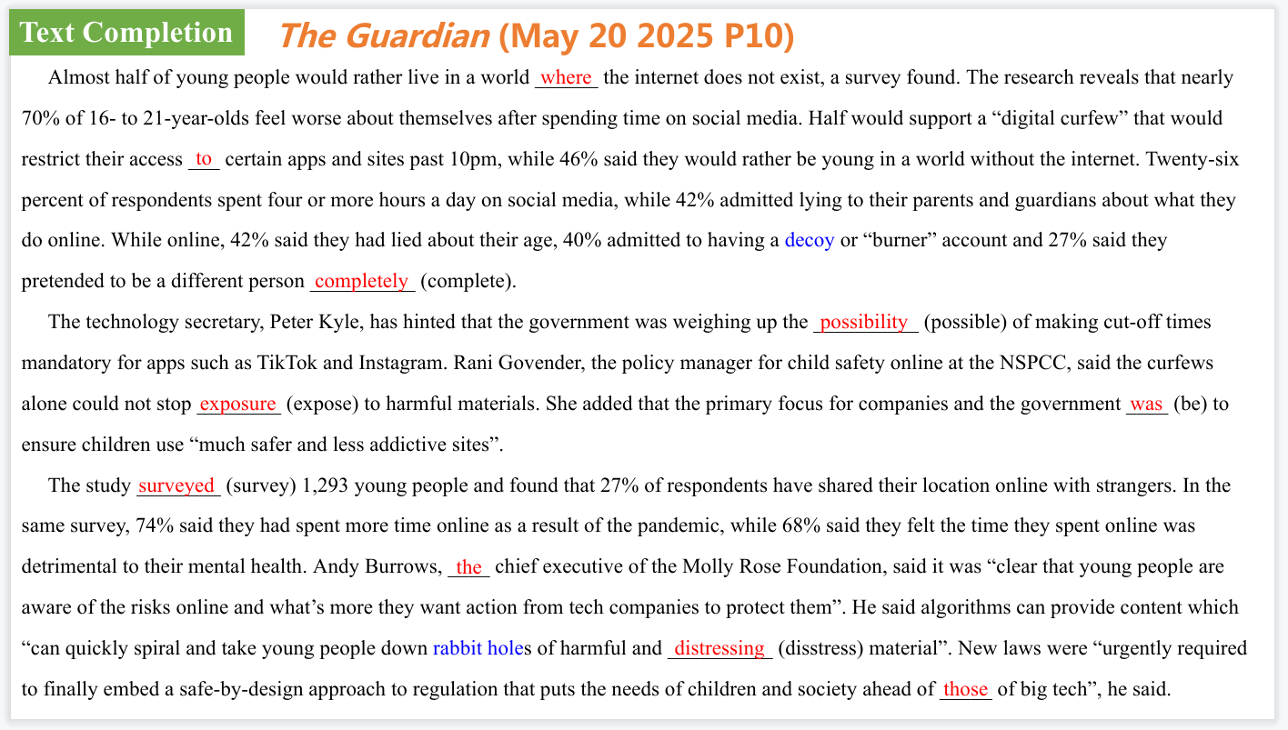

【设计意图】通过语篇填空的形式帮助学生理解新闻的主要内容，同时训练语言语法的运用能力：在语篇的视角下如何正确使用所给词汇，根据语法规则确定词汇的正确形式，使得文章通顺，激活学生的思维和语言。该新闻主题语境是关于“人与社会”中“社会热点问题”这一子主题，通过学习让学生了解互联网给英国年轻人带来的困扰。

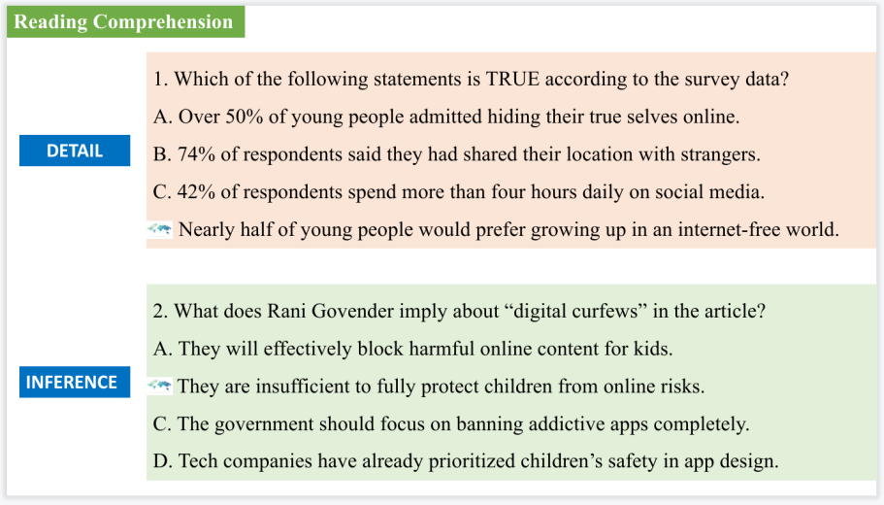

【设计意图】通过阅读理解的形式帮助学生理解新闻的主要内容。

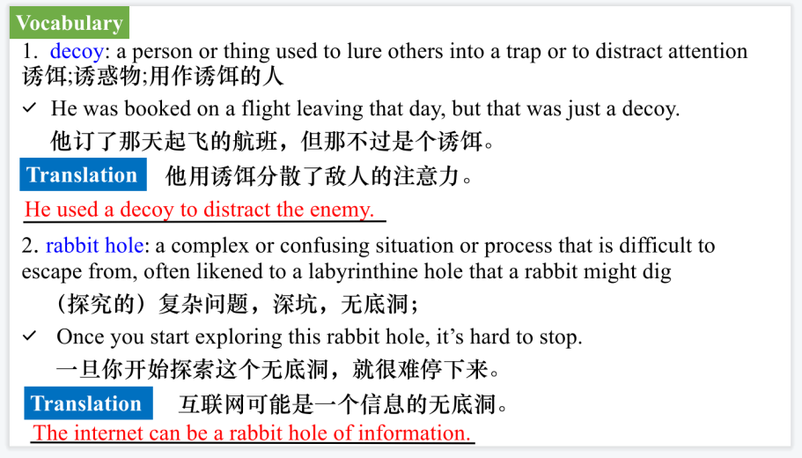

【设计意图】对文本中的词汇进行解读，并通过翻译句子对其进行巩固。

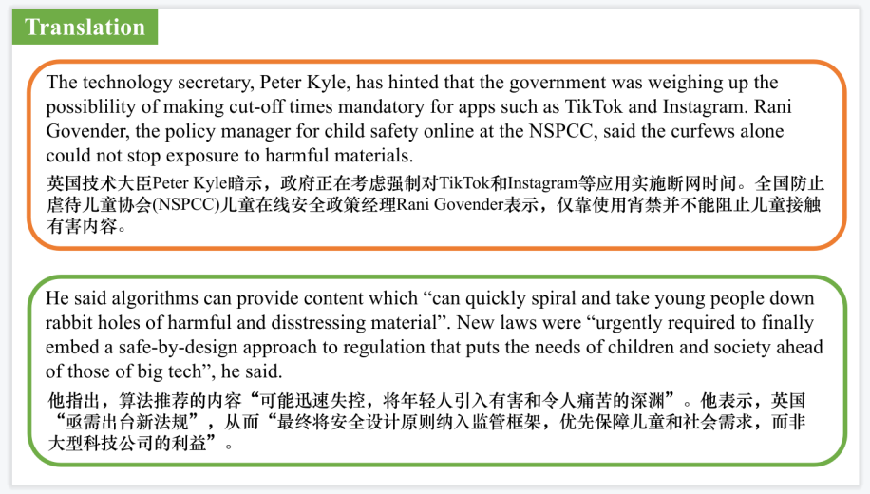

【设计意图】对文中的两个句子进行翻译练习，对其中单词、词组、句法进行巩固并关注句子结构。

**Part 2: News Report 2** ***The Washington Post* (May 27, 2025 A13)**

**These Invisible ‘Wild Neighbors' Need Our Help**

**“野生邻居”需要我们的帮助**

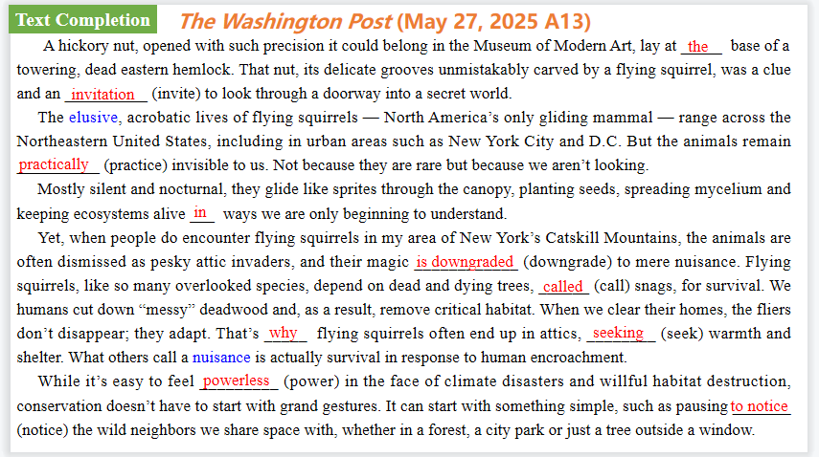

【设计意图】通过语篇填空的形式帮助学生理解新闻的主要内容，同时训练语言语法的运用能力：在语篇的视角下如何正确使用所给词汇，根据语法规则确定词汇的正确形式，使得文章通顺，激活学生的思维和语言。该新闻主题语境是关于“人与自然”中“人与环境、人与动植物”这一子主题，通过学习让学生了解从一些简单的事情做起，关爱与我们共享空间的野生生物。

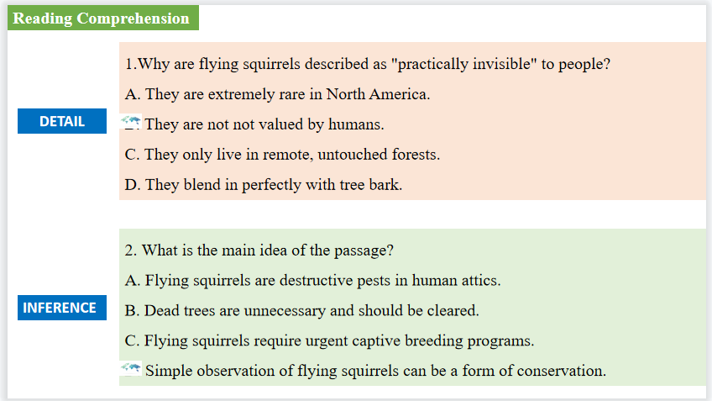

【设计意图】通过阅读理解的形式帮助学生理解新闻的主要内容。

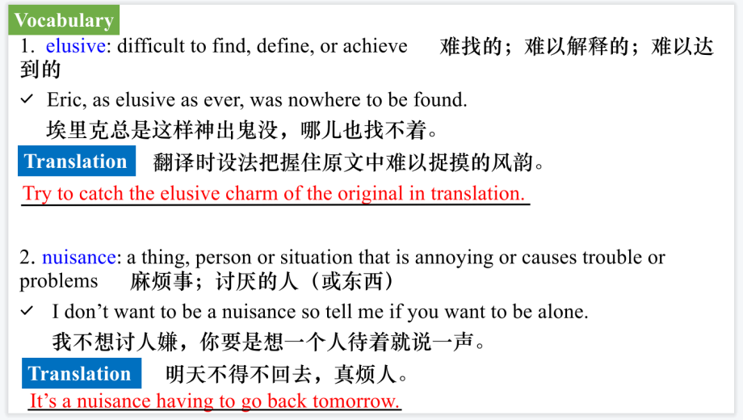

【设计意图】对文本中的词汇进行解读，并通过翻译句子对其进行巩固。

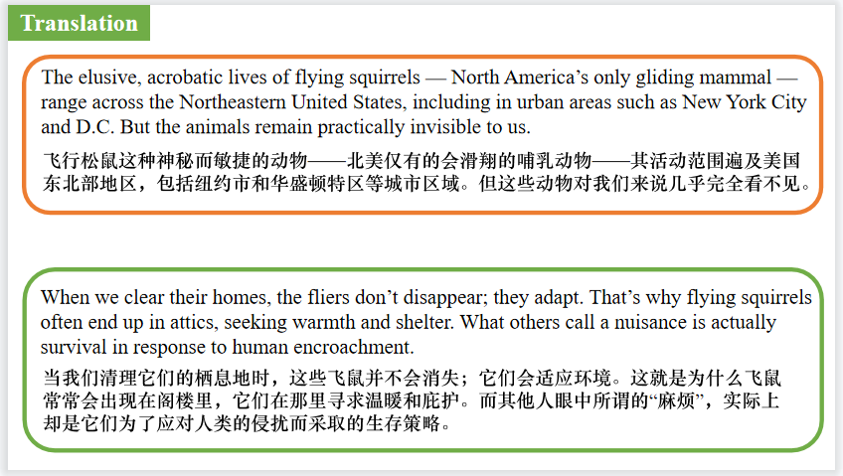

**Part 3: News Report 3 *The Washington Post*（May 30, 2025 A10)**

**Glacier collapse buries nearly all of Swiss Alpine village**

**瑞士冰川坍塌致村庄毁灭**

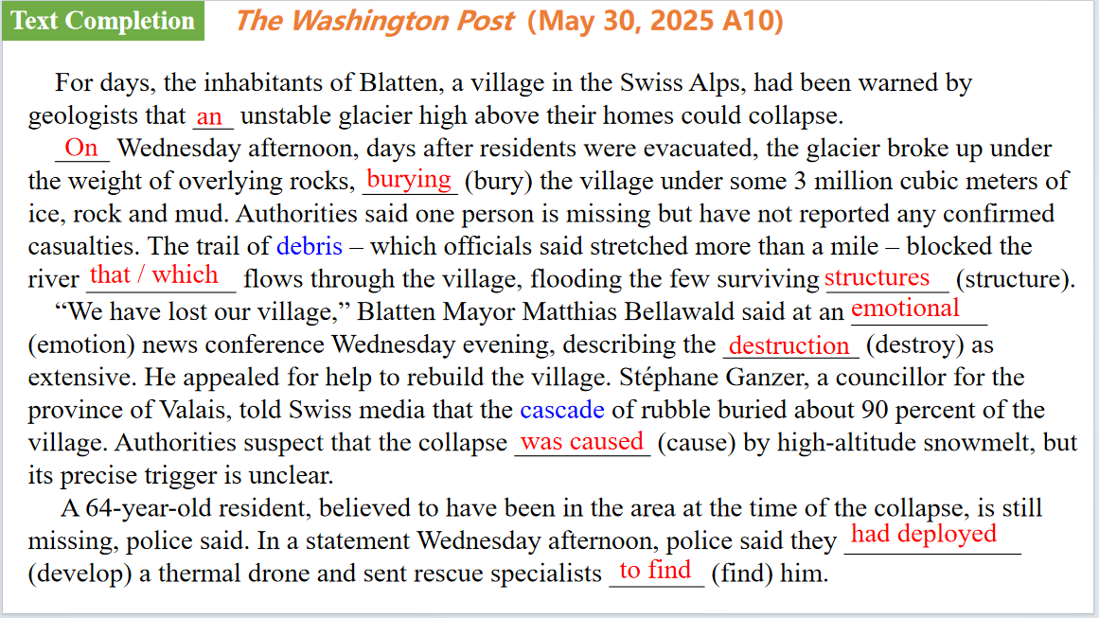

【设计意图】通过语篇填空的形式帮助学生理解新闻的主要内容，同时训练语言语法的运用能力：在语篇的视角下如何正确使用所给词汇，根据语法规则确定词汇的正确形式，使得文章通顺，激活学生的思维和语言。该新闻主题语境是关于“人与自然”中“自然灾难”这一子主题，通过学习让学生了解瑞士冰川坍塌致村庄毁灭的相关新闻报道。

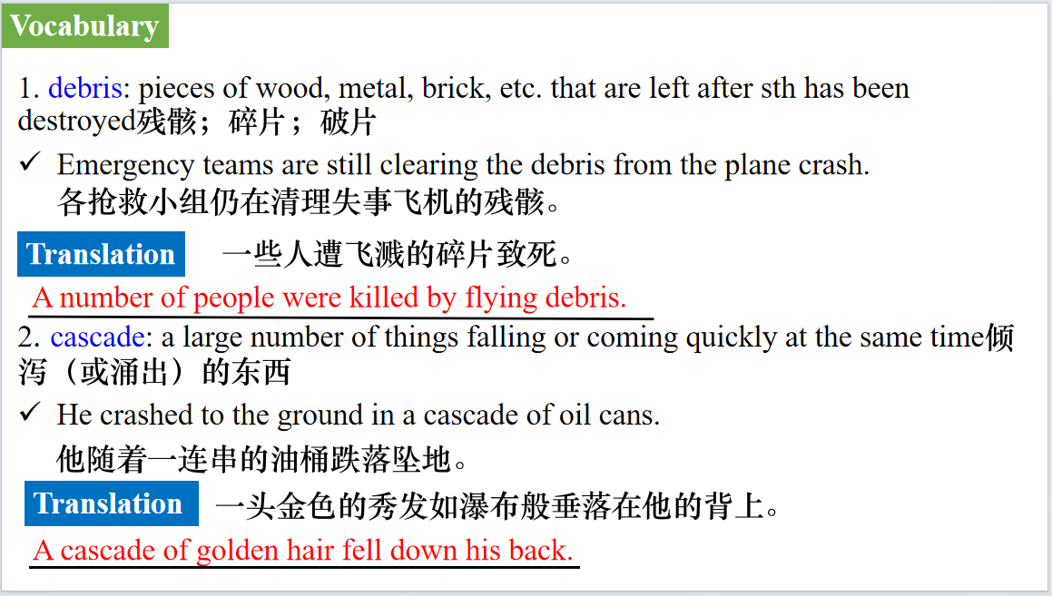

【设计意图】对文本中的词汇进行解读，并通过翻译句子对其进行巩固。

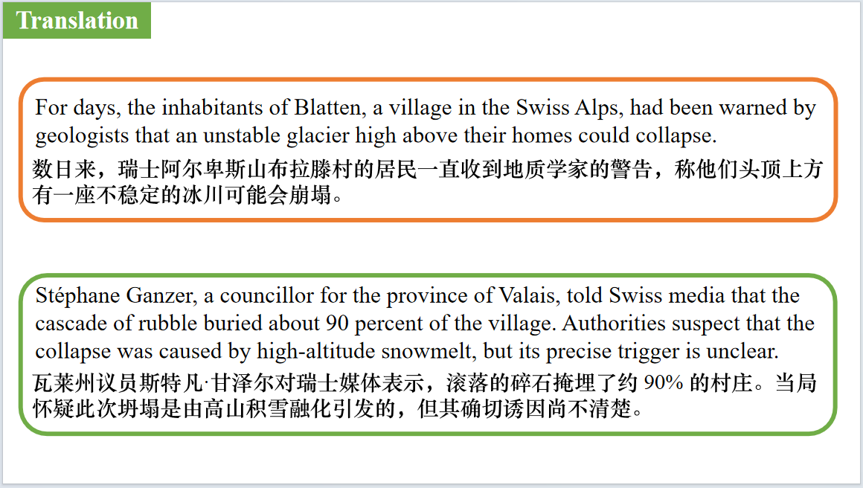

【设计意图】对文中的两个句子进行翻译练习，对其中单词、词组、句法进行巩固并关注句子结构。

**Part 4: News Report 4 *New Scientist*（May 24, 2025 P11)**

**The secret to chopping onions without crying**

**切洋葱不流泪的秘密**

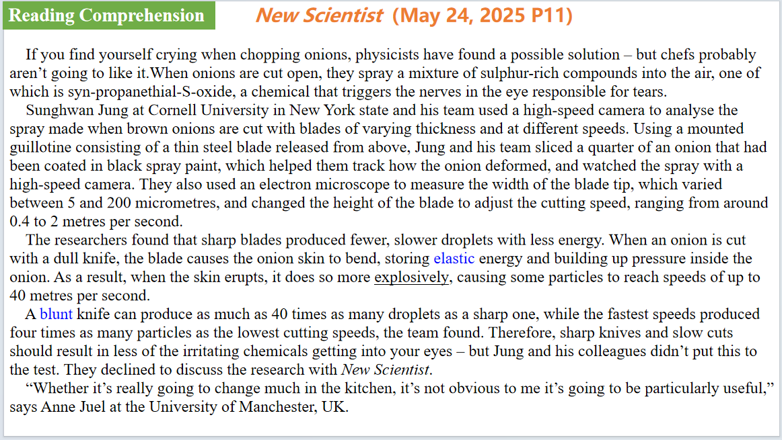

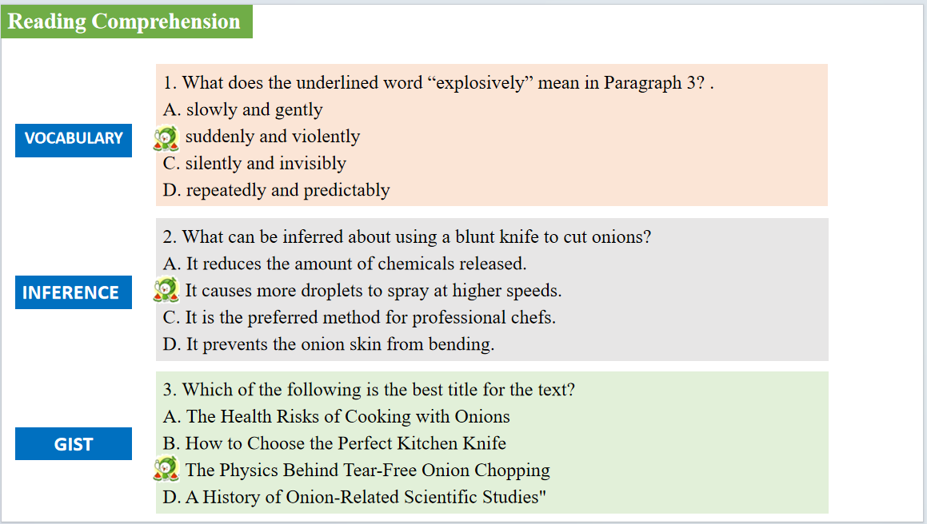

【设计意图】通过阅读理解的形式帮助学生理解新闻的主要内容。该新闻主题语境是关于“人与社会”中“科技发展”这一子主题，通过学习让学生了解切洋葱不流泪的秘密。



【设计意图】对文本中的词汇进行解读，并通过翻译句子对其进行巩固。

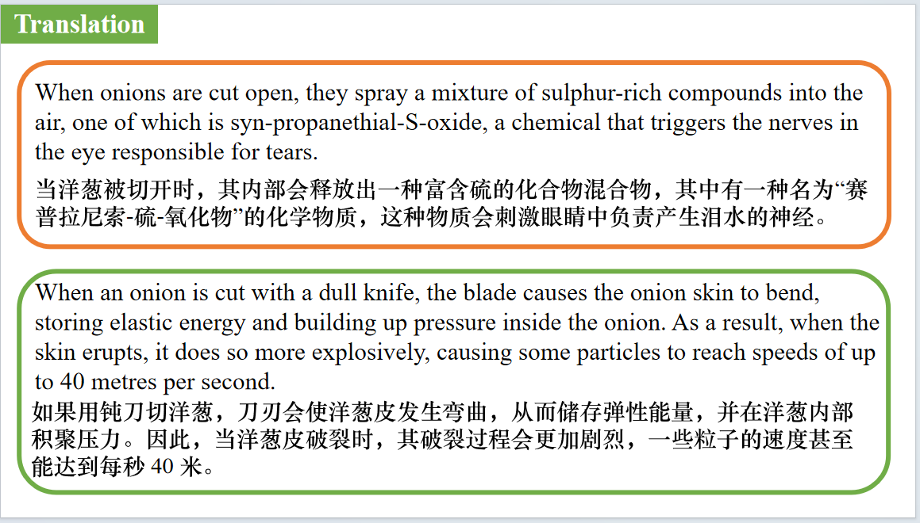

【设计意图】对文中的两个句子进行翻译练习，对其中单词、词组、句法进行巩固并关注句子结构。

**Part 5: BBC News 05/22/2025**



【设计意图】听一则材料，通过听力填空的方式理解文本，考察听力辨识词汇的能力。



【设计意图】对文本中的词汇进行解读，并通过翻译句子对其进行巩固。

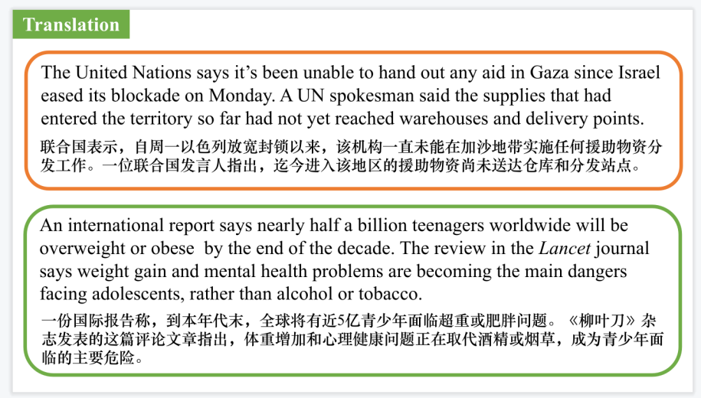

【设计意图】对文中的两个句子进行翻译练习，对其中单词、词组、句法进行巩固并关注句子结构。

附：外刊原文

**Part 1: News Report 1 *The Guardian* (May 20 2025 P10)**

**Half of Young People Wish the Internet Did Not Exist**

**半数年轻人希望互联网不存在**

Almost half of young people would rather live in a world where the internet does not exist, a survey found.

The research reveals that nearly 70% of 16- to 21-year-olds feel worse about themselves after spending time on social media. Half would support a “digital curfew” that would restrict their access to certain apps and sites past 10pm, while 46% said they would rather be young in a world without the internet.

Twenty-six percent of respondents spent four or more hours a day on social media, while 42% admitted lying to their parents and guardians about what they do online.

While online, 42% said they had lied about their age, 40% admitted to having a decoy or “burner” account and 27% said they pretended to be a different person completely.

The technology secretary, Peter Kyle, has hinted that the government was weighing up the possibility of making cut-off times mandatory for apps such as TikTok and Instagram.

Rani Govender, the policy manager for child safety online at the NSPCC, said the curfews alone could not stop exposure to harmful materials.

“We need to make clear that a digital curfew alone is not going to protect children from the risks they face online,” she said.

Govender added that the primary The focus for companies and the government was to ensure children use “much safer and less addictive sites”.

The study, conducted by the British Standards Institution, surveyed 1,293 young people and found that 27% of respondents have shared their location online with strangers.

In the same survey, 74% said they had spent more time online as a result of the pandemic, while 68% said they felt the time they spent online was detrimental to their mental health.

Andy Burrows, the chief executive of the Molly Rose Foundation, a suicide prevention charity, said it was “clear that young people are aware of the risks online and what's more they want action from tech companies to protect them”.

He said algorithms can provide content which “can quickly spiral and take young people down rabbit holes of harmful and distressing material”. New laws were “urgently required to finally embed a safe-by-design approach to regulation that puts the needs of children and society ahead of those of big tech”, he said.

**Part 2: News Report 2 *The Washington Post* (May 27, 2025 A13)**

**These Invisible ‘Wild Neighbors' Need Our Help t**

**“野生邻居”需要我们的帮助**

A hickory nut, opened with such precision it could belong in the Museum of Modern Art, lay at the base of a towering, dead eastern hemlock. That nut, its delicate grooves unmistakably carved by a flying squirrel, was a clue and an invitation to look through a doorway into a secret world.

The elusive, acrobatic lives of flying squirrels — North America's only gliding mammal — range across the Northeastern United States, including in urban areas such as New York City and D.C. But the animals remain practically invisible to us. Not because they are rare but because we aren't looking.

Mostly silent and nocturnal, they glide like sprites through the canopy, planting seeds, spreading mycelium and keeping ecosystems alive in ways we are only beginning to understand.

Yet, when people do encounter flying squirrels in my area of New York's Catskill Mountains, the animals are often dismissed as pesky attic invaders, and their magic is downgraded to mere nuisance. Flying squirrels, like so many overlooked species, depend on dead and dying trees, called snags, for survival. We humans cut down “messy” deadwood and, as a result, remove critical habitat. When we clear their homes, the fliers don't disappear; they adapt. That's why flying squirrels often end up in attics, seeking warmth and shelter. What others call a nuisance is actually survival in response to human encroachment.

While it's easy to feel powerless in the face of climate disasters and willful habitat destruction, conservation doesn't have to start with grand gestures. It can start with something simple, such as pausing to notice the wild neighbors we share space with, whether in a forest, a city park or just a tree outside a window.

Since our species has a bad habit of tidying up its surroundings, snags — especially the nesting cavities they offer — are often in high demand. This proved to be true in my backyard, with an assortment of “nosy neighbors,” including a tufted titmouse that would check out the nest boxes.

Pulled by obsessive curiosity about flying squirrels, I took small steps in my own backyard. I left dead trees standing if it was safe to do so, planted natives and installed nest boxes to help steward my surroundings. Over time, my backyard has transformed into not only a flier-friendly habitat but also a sanctuary for countless species, many that are overlooked, misunderstood or forgotten in the larger conservation narrative. (I'm looking at you, northern short-tailed shrews.)

What started as a quest to photograph flying squirrels turned into something much deeper: a practice in mindfulness, a way to remind myself that the world is full of small miracles, even when it feels like it's falling apart.

**Part 3: News Report 3 *The Washington Post*（May 30, 2025 A10)**

**Glacier collapse buries nearly all of Swiss Alpine village**

**瑞士冰川坍塌致村庄毁灭**

For days, the inhabitants of Blatten, a village in the Swiss Alps, had been warned by geologists that an unstable glacier high above their homes could collapse.

On Wednesday afternoon, days after residents were evacuated, the glacier broke up under the weight of overlying rocks, burying the village under some 3 million cubic meters of ice, rock and mud. Authorities said one person is missing but have not reported any confirmed casualties. The trail of debris – which officials said stretched more than a mile – blocked the river that flows through the village, flooding the few surviving structures.

“We have lost our village,” Blatten Mayor Matthias Bellawald said at an emotional news conference Wednesday evening, describing the destruction as extensive. He appealed for help to rebuild the village. Stéphane Ganzer, a councillor for the province of Valais, told Swiss media that the cascade of rubble buried about 90 percent of the village. Authorities suspect that the collapse was caused by high-altitude snowmelt, but its precise trigger is unclear.

A 64-year-old resident, believed to have been in the area at the time of the collapse, is still missing, police said. In a statement Wednesday afternoon, police said they had deployed a thermal drone and sent rescue specialists to find him.

**Part 4: News Report 4 *New Scientist（May 24, 2025 P11)***

**The secret to chopping onions without crying**

**切洋葱不流泪的秘密**

IF YOU find yourself crying when chopping onions, physicists have found a possible solution – but chefs probably aren’t going to like it.

When onions are cut open, they spray a mixture of sulphur-rich compounds into the air, one of which is syn-propanethial-S-oxide, a chemical that triggers the nerves in the eye responsible for tears.

Sunghwan Jung at Cornell University in New York state and his team used a high-speed camera to analyse the spray made when brown onions are cut with blades of varying thickness and at different speeds.

Using a mounted guillotine consisting of a thin steel blade released from above, Jung and his team sliced a quarter of an onion that had been coated in black spray paint, which helped them track how the onion deformed, and watched the spray with a high-speed camera.

They also used an electron microscope to measure the width of the blade tip, which varied between 5 and 200 micrometres, and changed the height of the blade to adjust the cutting speed, ranging from around 0.4 to 2 metres per second.

The researchers found that sharp blades produced fewer, slower droplets with less energy (arXiv, doi.org/ipnr). When an onion is cut with a dull knife, the blade causes the onion skin to bend, storing elastic energy and building up pressure inside the onion. As a result, when the skin erupts, it does so more explosively, causing some particles to reach speeds of up to 40 metres per second.

A blunt knife can produce as much as 40 times as many droplets as a sharp one, while the fastest speeds produced four times as many particles as the lowest cutting speeds, the team found. Therefore, sharp knives and slow cuts should result in less of the irritating chemicals getting into your eyes – but Jung and his colleagues didn’t put this to the test. They declined to discuss the research with New Scientist.

“Whether it’s really going to change much in the kitchen, it’s not obvious to me it’s going to be particularly useful,” says Anne Juel at the University of Manchester, UK.