U4 Natural Disaster
The night the earth didn't sleep

Lead in
1.Can earth sleep?
2. If the earth didn’t sleep,what would happen?_____________________________
Prediction（预测）
Q:If you were a reporter, what information may be reported to the world based
on the title and pictures?
__________________________________________________________________________________________________________________________________________
- A terrible________(what) happened in____________(where)_______________(when), causing great________, but with the help of______________(who), the city _______________(what result).
Read for main idea
Underline the topic sentence in each para. and summarize it in one phrase.
Para.1:_____________ before the earthquake.
Para.2:The _________ of the big earthquake.
Para.3:The destructive _________ of the earthquake.
Para.4:The ______ work
Para.5: The __________of the city
Reading tip 1: Get the main idea of each para.,pay attention to the first or last sentence.
Reading tip 2: Guess the meaning of news words based on context（上下文）.
Q:How many parts can the passage be further divided into?
______________________________________________________
Q: How is the passage developed?
The passage is developed in the order of___________.

Read for details
Part1:Describe the strange sights before the earthquake according to the pictures.
- The water in the well____________.
- ___________appeared in the well walls.
- __________came out of the cracks.
- Dogs ____________ inside the buildings.
- Chickens and pigs were_____________ eat.
- Mice ______ of the fields.
- Fish _________ of the water.
- _______________in the sky and loud noises were heard.
Part1: How to understand the last sentence in para.1“But the city's one million people were asleep as usual that night. ”?
__________________________________________________________________________________________________________________________________________
Part2: Can you find some supporting evidence to show the great damage?
__________________________________________________________________________________________________________________________________________
Read for language feature
Part2: How did the writer show the damage?
Part2: What aspect did the earthquake cause damage to ?
Part2: Besides numbers, what kind of figure of speech(修辞）did the writer use to show its damage?
Read for language feature
- personification（拟人）：the practice of representing objects, qualities, etc. as humans, in art and literature
- metaphor（暗喻）：a word or phrase used to show two things have same qualities.
- simile（明喻）：a word or phrase that compares sth to sth else，using the words “like” or “as”
- exaggeration（夸张）：a statement or description that make sth seem larger, better, worse than it really is.
__________________________________________________________________________________________________________________________________________
What is probably the text type?
A. narration（记叙文 ）
B. exposition（说明文）
C. argumentation（议论文）
D. literary journalism（文学新闻）
Further thinking
Part2: Why did it cause such great damage? Please think about it from the following aspects(层面）.
- the magnitude（震级） of earthquake：
- time it happened：
- people：
- technology:
...
Part2: If you had experienced the earthquake in Tangshan, what would you feel?
__________________________________________________________________________________________________________________________________________
Read for details
Part3: How did the people in Tangshan feel and why?
__________________________________________________________________________________________________________________________________________
Part3: Who came to the rescue? What did they do?
__________________________________________________________________________________________________________________________________________
Further thinking
Part3:What does the writer mean by “Slowly, the city began to breathe again.”
__________________________________________________________________________________________________________________________________________
Q:Part3: What can we learn from the event?
__________________________________________________________________________________________________________________________________________
Group discussion:
What else can we do in face of natural disaster?
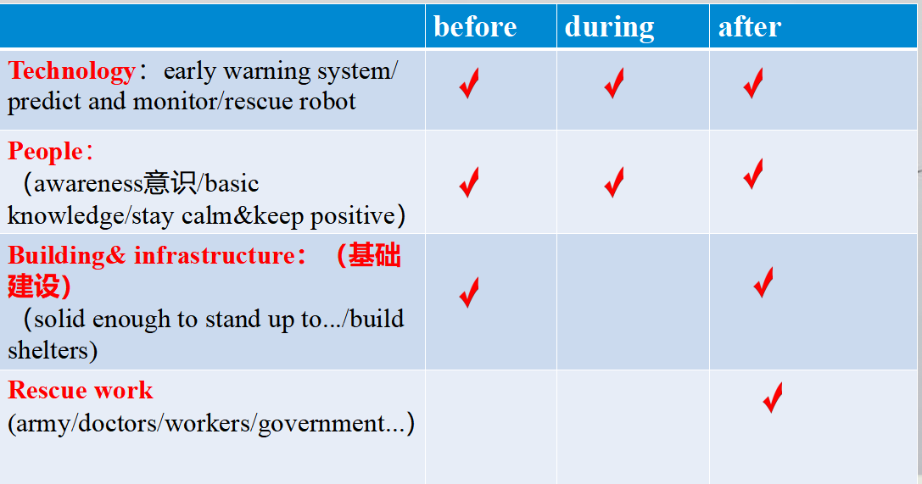
Assignment
Based on what we learned about the earthquake, can you make a news report for the natural disaster happening around us?
key points: time/place/event &destructive damage& rescue work
language feature: numbers& figure of speech

