Teaching procedures
Step one Lead in
Q1：What do you often share with others?
Answes：food；clothes；joy；love...
Q2：Have you ever shared knowledge with others? How to share knowledge?
Answes：Volunteer teachers help convey knowledge and love to poor children in remote villages.
Step Two Reading
Before reading1- Prediction
Predict the main idea by looking at the title “Volunteering in the bush”and the given pictures.
(A young Australian woman whose name is Joe worked as a volunteer teacher in Papua New Guinea for two years.)
Before reading2-Video clip about Papua New Guinea
While reading
Activity1 Skim the text and divide the text into 4 parts
Part 1(Para 1)Recieve a parcel from home.
Part 2(Para2-3)The conditions about the bush school and the students.
Part 3(Para4-7)What the author witnessed in Tombe’s village.
Part 4 (Para8)The author’s feeling after visiting the village.
Activity2 Careful reading
Para 2 The tough conditions of the high school
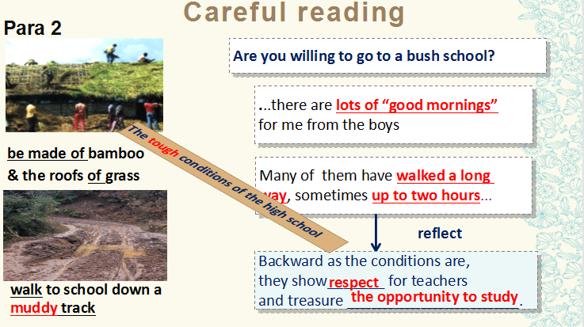
Para3 School life
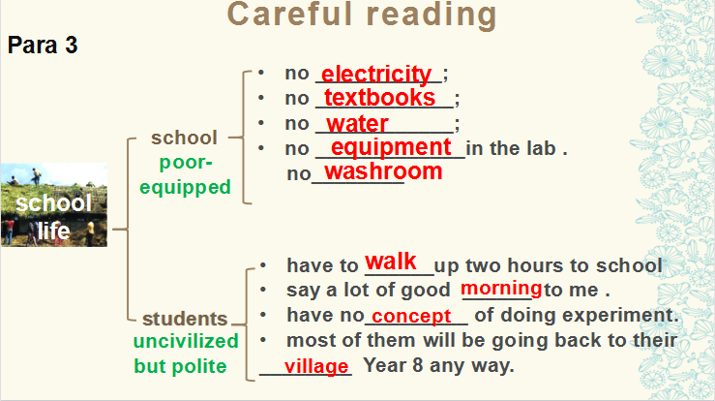
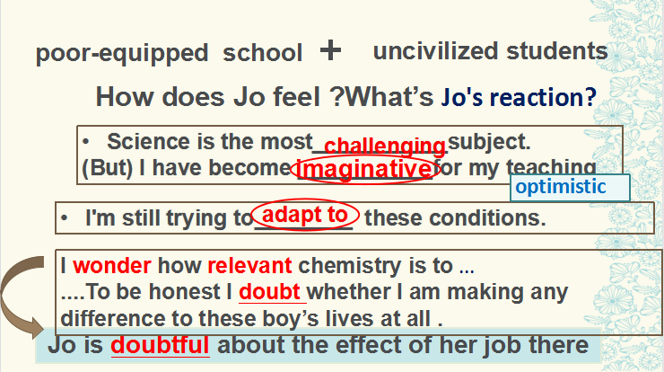
Para4 Local people
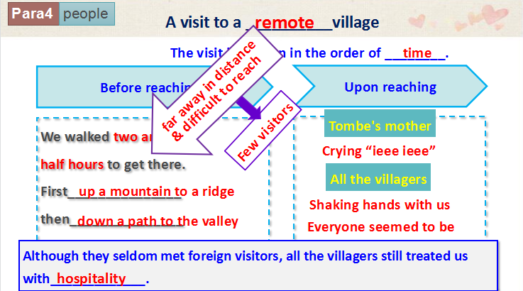
Para5-7 Living conditions ,eating habits and beliefs
Para8 After leaving
Q:What did Jo feel after she left the village? (physically tired but mentally satisfied)
Thinking: Will Jo still wonder whether she will make any difference?
Post reading -A mind map of the whole story
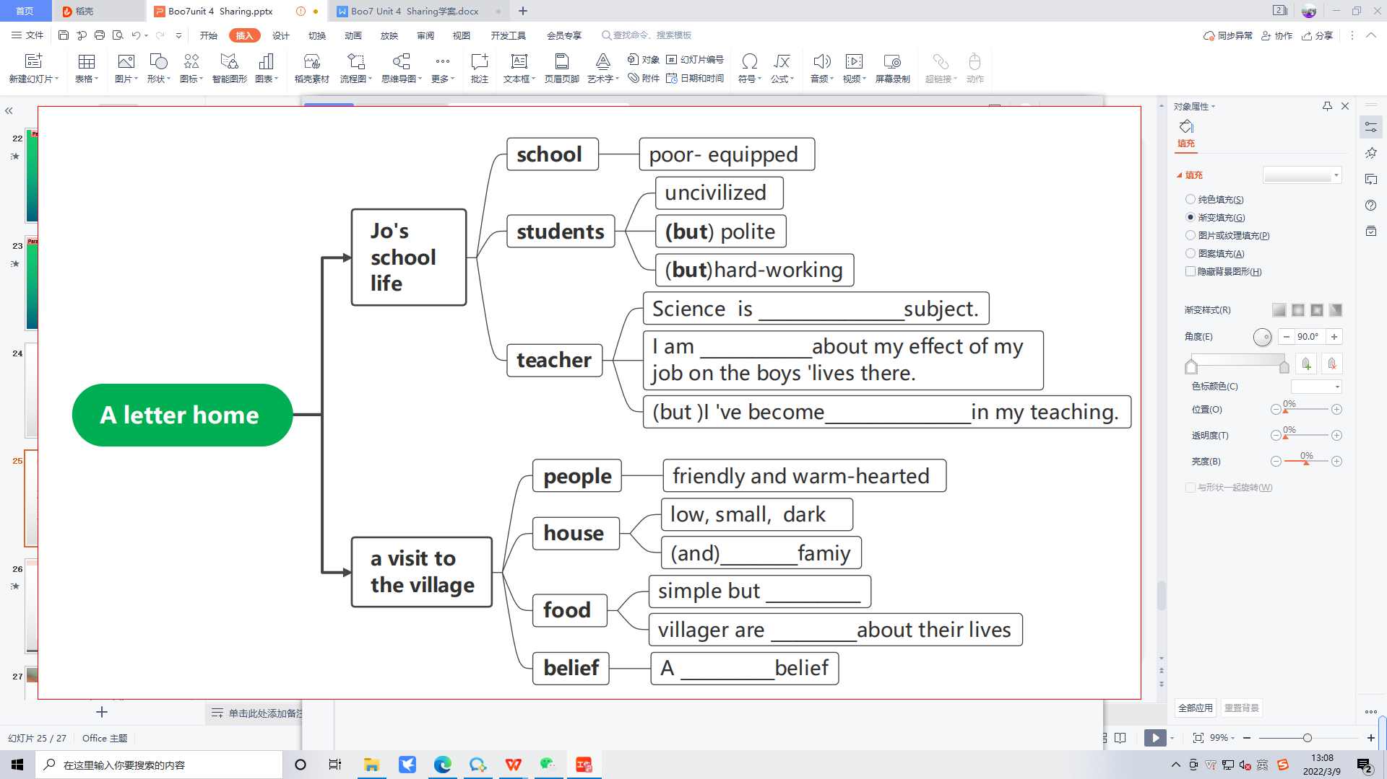
Step Three Further thinking
1.What does Jo share with the villager?
2.What change does she bring to the villagers?
3.If you have the chance to be a volunteer teacher , would you like to go there? Why?
Step Four Summary
Sharing is helping Sharing is giving
Sharing is understanding Sharing is love

