**Summary of the previous chapters:**

Tommy’s grandad used to be a famous footballer. Now Grandad embarrasses Tommy, the **goalie1** of the school football team, by turning up at his matches in his old football kit. But that day, in the match against Forest Hill Juniors, when Tommy’s team was short of one player, Grandad offered to play as a **striker2.**

**Chapter 4** [Adapted from Debbie White’s “Pass the Ball”]

1. Tommy could have died. There was Grandad squeezed into the **Junior School strip3.**His legs looked worse than ever. As for the shirt, it barely reached across his shoulders.
2. ‘Now just hold on there,’ said the **ref 4**, coming across to Grandad and his coach Mr Davies. ‘He can’t play. He’s a grown-up.’
3. ‘I’m past being one of those,’ said Grandad. ‘I’m over the hill and going fast down the other side. I’ll be seventy next month.’
4. ‘Oh, go on then...’ said the ref. He blew his whistle. ‘**Let me at ’em5**,’ said Grandad.
5. Tommy couldn’t believe his eyes. His grandad was really good. In fact, he was brilliant. Ducking and diving, dodging and weaving. His ball control was still masterly. At half-time, the score was one all.
6. Not bad. But Tommy could see Mr Davies was worried. He was chewing his scarf.
7. Then Tommy got the ball. He looked around. What should he do? He saw Grandad down the field. He kicked the ball straight to Grandad’s feet.
8. With only a minute to go, Grandad saw his chance. But then he came up against Forest Hill’s **sweeper6**. She towered over him.
9. Terri ‘Queen of the **Foul7**’ Taylor went to **tackle8**. But she didn’t go for the ball. Instead she caught Grandad behind the knee with her boot.
10. He was rolling on the floor, holding his knee. It was just outside the **penalty area9**. ‘She **whipped10** me legs out from under me, ref,’ cried Grandad.
11. ‘I never!’ yelled Terri. But no one believed her.
12. The ref blew his whistle. **Free kick11**!
13. ‘He’ll never be able to take that,’ thought Tommy.
14. But Grandad leapt to his feet and placed the ball with care.

1. Grandad was a hero. The team even tried to carry him off the pitch, but he was too heavy. They had to **make do with12** slapping his back and shouting, ‘Come on you Grandad.’
2. ‘I’m dead proud, Grandad,’ said Tommy, ‘Can we **dribble13** your football all the way home then?’ ‘Certainly,’ said Grandad and he set off.

（要求：一段式续写，词数不超过100词。）

**Glossary词汇表**

1.**goalie**[ˈɡəʊlɪ] ***n.***:(=goalkeeper)a player whose job is to stop the ball from going into his or her own team’s goal守门员

2**.striker**[ˈstraɪkə(r)] ***n***.:a player whose main job is to attack and try to score goals前锋

3**.Junior School strip** [strɪp] ***n.***:The uniform that is worn by the members of a Junior School sports team when they are playing小学队服

4.**ref** [ref]***n.***: (=referee)the official who controls the game in some sports裁判

5.**Let me at ’em** = Let me at them:To allow one to attack someone or something.让我来对付他们。

6.**sweeper**[ˈswiːpə(r)]***n.***: a player who plays behind the other defending players in order to try and stop anyone who passes them(足球中的)自由中卫；清道夫

7.**foul**[faʊl]***n.***:an action that is against the rules of the game; ***v.***to do something to another player that is against the rules of the game犯规

8.**tackle**[ˈtækl]***v.***:try and take the ball away from an opponent(足球比赛中)抢断,铲球

9.**penalty area**[ˈpenəlti eriə]:the area in front of the goal. If the defending team breaks the rules within this area, the other team is given a penalty.罚球区(足球场上每一个球门前的一个区域，在该区域内防守球员违反规则会导致对方球员获得点球。)

10.**whip** [wɪp]***v.***strike or beat violently拍打，猛打

11.**free kick**:an opportunity to kick the ball without any opposition, that is given to one team when the other team does something wrong任意球(在足球比赛中，对手不得干扰的踢球方式，尤指因对手违反规则而被判罚的任意球。)

12.**make do with**:to manage with something that is not really good enough凑合着

13.**dribble**[ˈdrɪbl]***v.***: to move the ball along with several short kicks, hits or bounces运(球);带(球);盘(球)

**Football pitch layout**

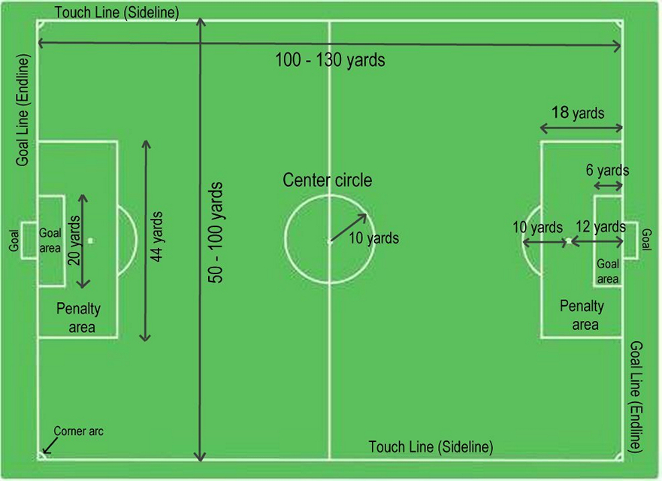(1 yard=0.91meters)