**高考临门一脚之主题语境下的应用文变式备考策略学案**

**姓名：_________ 班级：_________**

* **2024届T8联考高三第二次学业质量评价（2024.3）**

**假定你是李华，毕业在即，你校英文报举办了以“An Unforgettable Activity in High School” 为主题的征文活动。请你写一篇英文短文投稿，分享一次你参加过的校园活动。内容包括：**

**1. 活动内容；**

**2. 活动感受。**

**应用文变式思维导图**

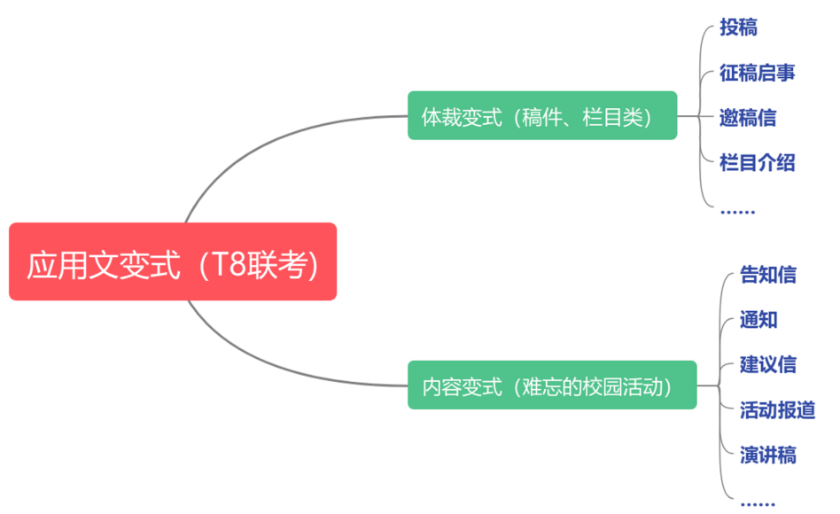

**（1）变式1：体裁变式（聚焦栏目、稿件类体裁）**

* 【征稿启事】假定你是校英文报主编李华，毕业在即，英文报举办了以“An Unforgettable Activity in High School” 为主题的征文活动。请你写一篇征稿启事，鼓励同学们来稿分享自己参加过的校园活动。内容包括：1. 活动目的；2. 稿件内容；3. 稿件要求

Contributions Wanted

______________________________________________________________________________________________________________________________________________________________

______________________________________________________________________________________________________________________________________________________________

______________________________________________________________________________________________________________________________________________________________

______________________________________________________________________________________________________________________________________________________________

* 【邀稿信】假定你是校英文报主编李华，毕业在即，英文报举办了以“An Unforgettable Activity in High School” 为主题的征文活动。请你给来自英国的交换生Tom写一封邀稿信，邀请他分享自己参加过的一次校园活动。内容包括：1. 发出约稿邀请；2. 说明稿件内容；3. 说明稿件要求

______________________________________________________________________________________________________________________________________________________________

______________________________________________________________________________________________________________________________________________________________

______________________________________________________________________________________________________________________________________________________________

______________________________________________________________________________________________________________________________________________________________

* 【栏目介绍】假定你是校英文报主编李华，毕业在即，英文报开设了以“An Unforgettable Activity in High School” 为主题的征文栏目。请你写一篇栏目介绍，内容包括：1. 开设目的；2. 栏目内容；3. 欢迎投稿

An Unforgettable Activity in High School

______________________________________________________________________________________________________________________________________________________________

______________________________________________________________________________________________________________________________________________________________

______________________________________________________________________________________________________________________________________________________________

______________________________________________________________________________________________________________________________________________________________

（2）变式2：内容变式（聚焦“一次难忘的校园活动之成人礼”)

* 【告知信】假定你是校学生会主席李华，毕业在即，上周你校学生会为高三学子举办了一场成人礼仪式。请你写一封信给你的外国友人Tom, 告知他此次活动的相关细节。内容包括：1. 活动目的；2. 活动内容； 3.活动感受

______________________________________________________________________________________________________________________________________________________________

______________________________________________________________________________________________________________________________________________________________

______________________________________________________________________________________________________________________________________________________________

______________________________________________________________________________________________________________________________________________________________

* 【通知】假定你是校学生会主席李华，毕业在即，学生会即将为高三学子举办一场成人礼仪式。请你以学生会的名义写一则通知，内容包括：1. 活动目的；2. 活动时间和地点；3.活动内容

Notice

______________________________________________________________________________________________________________________________________________________________

______________________________________________________________________________________________________________________________________________________________

______________________________________________________________________________________________________________________________________________________________

______________________________________________________________________________________________________________________________________________________________

* 【活动报道】假定你是校学生会主席李华，毕业在即，学生会于上周为高三学子举办了一场成人礼仪式。请你为该活动写一则报道，内容包括：1. 活动目的；2. 活动内容 3. 活动意义

The Coming-of-age Ceremony

______________________________________________________________________________________________________________________________________________________________

______________________________________________________________________________________________________________________________________________________________

______________________________________________________________________________________________________________________________________________________________

______________________________________________________________________________________________________________________________________________________________

* 【演讲稿】假定你是校学生会主席李华，毕业在即，你将代表高三学子在成人礼仪式上发言。请你写一则发言稿，内容包括：1. 表达对老师的感谢；2. 对成人的理解 3. 展望未来

Good morning, everyone!

______________________________________________________________________________________________________________________________________________________________

______________________________________________________________________________________________________________________________________________________________

______________________________________________________________________________________________________________________________________________________________

______________________________________________________________________________________________________________________________________________________________