**新人教版 选择性必修2**

**Unit 1** **S****cience and Scientists**

**Using Language（2）: Write about what makes a great scientist**

1. **Teaching analysis**

该板块的活动主题为“写一写伟大科学家的必备素养”（Write about what makes a great scientist）。该板块有两个阅读语篇，分别题为“The Father of China’s Aerospace”“A World of Pure Thought”。它们从不同角度简要叙述了科学家钱学森和史蒂芬霍金的经历、重要贡献、性格特点以及他们所具备的科学素养。在写作策略和技巧上，两个语篇都有效使用了一些衔接词语，如：however、nevertheless、because、in general、besides、furthermore、above all等。关注语篇的衔接和连贯是对学生写作能力的较高要求。阅读文本中的范例有助于学生领会、体验衔接词语的意义和作用，为他们接下来完成写作任务提供指导。考虑到文本的长度以及阅读难度，笔者设计了两个课时。

1. **Teaching objectives**

By the end of the class, students will：

1. learn about the life story of Qian Xuesen and Stephen Hawking;
2. be able to express opinions on outstanding personalities of scientists;
3. write about what makes a great scientist;
4. learn to use the linking words and phrases to make the writing in a logical order.
5. **Teaching procedures**

**Step one: Lead-in**

**Activity one: Act out the dialogue**

Invite two students to act out the dialogue.

—— “Can we Chinese possibly make missiles?”

—— “Why not? We Chinese are able to make the same things that other people make.”

Q; Who is he? What’s his another name?

[设计意图] 引入话题人物钱学森，同时活跃课堂气氛，引起学生好奇心。

**Step two: Pre-writing**

**Activity two: Read for the main idea and structure**

Read the texts quickly and match the main idea of each paragraph.

**The Father of China's Aerospace**

Para. 1 His personality

Para. 2-5 General description of Qian Xuesen

Para. 6 His death and people’s appreciation of him

Para. 7 His personal history and accomplishments

**A World of Pure Thought**

Para. 1 His claim to fame

Para. 2 Characteristics that made him great

Para. 3 Physical description of Stephen Hawking

Q: What type of writing are these two texts?

What does biography usually consist of?

[设计意图] 厘清文本内容与结构，在结构上概括两则传记相同点。

**Activity three: Read for details**

Complete the table and underline the linking words and phrases.

|  |  |  |
| --- | --- | --- |
| **scientist** | **personalities and qualities** | **examples** |
|  |  |  |
|  |  |
|  |  |
|  |  |
|  |  |  |
|  |  |
|  |  |
|  |  |

Q:What are similarities of these two scientists?

What are functions of the linking words and phrases?

[设计意图] 在内容上，比较两位科学家的品质，为讨论最重要的科学精神做铺垫。在语言上，积累文本中表示时间与地点，因果，转折等的连接词，为写作做铺垫。

**Activity four: Work in groups**

Q: What do you think a great scientist need most? Why?

professional knowledge logical reasoning (逻辑推理)

research methods the questioning mind

leadership patriotism (爱国主义)

devotion determination

imagination creativity

inspiration(灵感) talent ...

[设计意图] 讨论最重要的科学精神，为写作做铺垫，同时发展学生批判性思维。

Step three: While-writing

**Activity five: Micro-writing**

Choose one personal quality a scientist must have to be successful and write a short paragraph. Refer to your character cards and add some stories to illustrate the scientific spirit.

**Useful sentence structures:**

What impresses me most is...

What matters to a scientist is (not...but...)

My reasons are as follows...

The definition of scientific spirit is...

Take ... for example.

...play(s) a crucial/ significant role in...

[设计意图] 基于讨论的内容，结合实例，进行微写作。

**Activity six:**Write an essay about the scientific spirit.

discuss about the framework of the essay

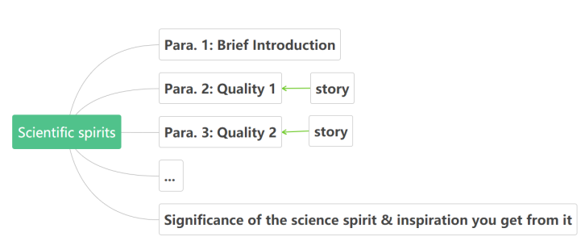

organize the body in time order and use linking words and phrases

work by yourself to write an essay about the scientific spirit

Step four: Post-writing

Exchange your draft with a partner. Use this checklist to help you revise the draft. Then take your draft back and revise it using your partner’s comments.

Does the writer explain clearly the personal qualities that make up the scientific spirit?

Does the writer give examples from the lives of the scientist(s) to illustrate the points?

Does the writer describe the personality of a great scientist?

Does the writer use appropriate linking words and phrases to tie the ideas together?

Does the writer use separate paragraphs, each with its own function?

1. **Teaching reflection**
2. **文本较长，学生阅读难度大，老师应适当给与帮助。**
3. **考虑适当增加前期语言的输入，为写作做铺垫。**