**2023年12月浙江Z20联盟高三第二次联考**

**读后续写学案（父子关系修复）**

**Part 1 Text analysis and Appreciation**

【题目呈现】

第二节 读后续写（满分25分）

阅读下面材料，根据所给情节进行续写，使之构成一篇完整的故事。

Jeff and I had many conversations during the year, but I will always remember the time he told me about his family. His father, a successful physician, was cold and strict in Jeff’s words. His father had even paved the way for Jeff to attend the same college from which he had graduated.

Jeff was twenty-seven and a successful business planner at a company—without a degree. His passion was skiing. When he graduated from high school, he decided to decline his father’s offer and, instead, to work with a ski patrol (滑雪巡逻队). With pain in his eyes, Jeff told me he still remembered the day when he told his father he was going to give up college and take a job at a ski resort.

Hearing Jeff’s decision, his father looked off into the distance. Then came the words that still echoed in Jeff’s mind: “You lazy kid. No son of mine is going to work with a ski patrol and does not attend college. I should have known you’d never amount to anything!” The two had not spoken since that conversation.

Later, he was back in the area near where he grew up and he certainly did not want his father to know he was attending college. He was doing this for himself, not for his father. He said it over and over again. Jeff’s sister had always remained supportive of Jeff’s decisions. She stayed in contact with their father, but Jeff had made her promise that she would not share any information about his life with him.

The day when the graduation ceremony came, I walked around talking to people before it started. I noticed a man with a confused expression.

“Excuse me,” he said as he politely approached me. “What is happening here today?”

“It’s graduation day,” I replied, smiling. “Well, that’s odd,” he said, “my daughter asked me to meet her at this address.” His eyes sparkled and he smiled. “Maybe she completed her associate’s degree and wanted to surprise me!” I helped him find a seat.

注意：1．续写词数应为150个左右； 2．请按如下格式在答题卡的相应位置作答。

***Paragraph 1:***

*As I left him, he said, “Thank you. By the way, my name’s Dr. Holstrom.”*

***Paragraph 2:***

*Jeff was the last person to cross the stage.*

**【Step1: 文本伏笔与协同要素分析】**

Jeff and I had many conversations during the year, but I will always remember the time he told me about his family. His father, a successful physician, was cold and strict in Jeff’s words. His father had even paved the way for Jeff to attend the same college from which he had graduated.

**From the first sentence, what basic information can we learn？**

Content: ____________________________________________________________________________________________

Narrative Perspective: ____________________________

**From the first paragraph, what can be inferred about Jeff’s father？**

Personality: _______________________________________________________________________________________

Jeff’s sister had always remained supportive of Jeff’s decisions. She stayed in contact with their father, but Jeff had made her promise that she would not share any information about his life with him.

“It’s graduation day,” I replied, smiling. “Well, that’s odd,” he said, “my daughter asked me to meet her at this address.” His eyes sparkled and he smiled. “Maybe she completed her associate’s degree and wanted to surprise me!” I helped him find a seat.

**From these paragraphs, what can be guessed about the man？**

The man’s identity:

____________________________________________________________________________________________

Supporting evidence:

_______________________________________________________________________________________

**【Step2: 中心人物Jeff动态分析】**

**stick to his enthusiasm**

**become more mature**

**【Step3: 语料积累与语言风格】**

His father had even _______________ (为……铺路) Jeff to attend the same college from which he had graduated.

____________________（眼中带有痛苦）, Jeff told me he still remembered the day when he told his father he was going to give up college and take a job at a ski resort.

Then came the words that still ________(回响) in Jeff’s mind.

I noticed a man with a __________（confuse） expression.“Excuse me,” he said as he politely approached me.

His eyes ____________（闪耀） and he smiled.

**本文的语言特点：**

____________________________________________________________________________________________

_______________________________________________________________________________________

**Part 2 Plot weaving and Continuation**

**【Step1: 提示句入手——情节阶梯模型】Try to raise questions and find answers to complete the plot-weaving.**

A happy ending showcasing the theme of the article.

Jeff was the last person to cross the stage.

Jeff was the last person to cross the stage.

As I left him, he said, “Thank you. By the way, my name’s Dr. **Holstrom**.”

**【Step2: 主题协同】Figure out the theme of the article**

**________________________________________________________________________________________________________________________________________________________________________________________**

**【Step3: 微场景刻画】How to depict Mini Scenes using vivid language**

**方法1：丰富的内心独白**

The name ringing in my mind, I froze on the spot. Jeff Holstrom!

Could this be the cold, stern father who demanded his son attend college or never enter his home again?

**【描写妙处】**

**____________________________________________________________________________________________**

**Expansion: Expressions for describing someone’s astonishment**

**方法2：激越的氛围营造**

Speeches given, the dean began to read the names of the graduates.With each graduate walking onto the stage, the auditorium broke into waves of thunderous applause, which seemed to brim out of the place. **(personification**)

**【表达异构】**

**____________________________________________________________________________________________**

**方法3：情感赋能画面**

Suddenly, a lone figure popped into his eyes—Dr. Holstrom.I didn’t know how their eyes met. I could feel a flood of memories must be rushing through their hearts, binding father and son in an unspoken embrace. **The room seemed to hold its breath, as if time itself had paused to witness the reunion.** The years apart melted away as their eyes met, and a fragrance of family love **permeated** in the air.

**【亮点品鉴】**

**____________________________________________________________________________________________**

**方法4：主题升华深刻**

In the end, he realized that **family love and bond** could **break through the icy fortress**, allowing love to **seep back into** each other's hearts.

In their reunion, a **tapestry** of love, forgiveness, and acceptance unfolded, weaving a bond that **time and distance could no longer unravel**.

**【反思提升】**

**____________________________________________________________________________________________**

**Part 3 Sample writing and Assessment**

**【范文】**

As I left him, he said, “Thank you. By the way, my name’s Dr. Holstrom.”The name ringing in my mind, I froze on the spot. Jeff Holstrom! Could this be the cold, stern father who demanded his son attend college or never enter his home again? Curiosity and doubt bubbling up, I turned around to get a glimpse of Dr. Holstrom, attempting to find some facial resemblances. Beaming and scanning, Dr. Holstrom seemed to be looking for his daughter. Speeches given, the dean began to read the names of the graduates, inviting them onto the stage one by one to receive their diplomas.

Jeff was the last person to cross the stage. Having received his diploma, he turned toward the audience, radiant with joy. Suddenly, a lone figure popped into his eyes—Dr. Holstrom. I was not sure how Jeff spotted him in the crowd, but I could tell their eyes met. Dr. Holstrom, gazing at Jeff thoughtfully for a few seconds, opened his arms as if to embrace the air around him. For a moment time seemed to stand still. Jeff came down, smiling with tears in eyes. “My father is here,” he whispered to me, “I think I’m going home.”

你觉得本文的得分是_________

理由与可取之处：______________________________________________________________________________________________________________________________________________________________

**【学生习作】**

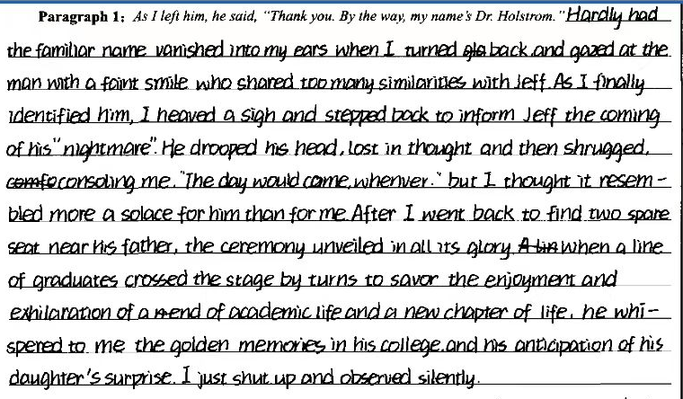

**本段写作问题与亮点**

**_______________________________________________________________________________________________________________________________________________________________________________________________________**

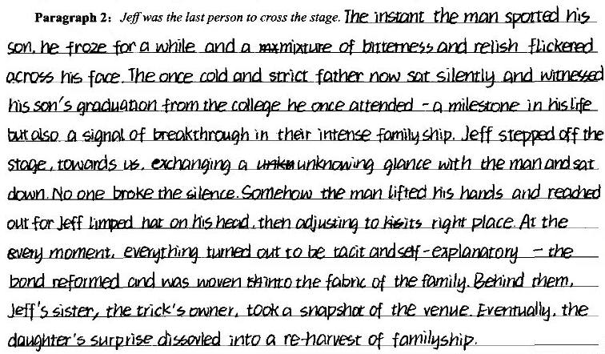

**本段写作问题与亮点**

**_______________________________________________________________________________________________________________________________________________________________________________________________________**

**Part 4 Further thinking and Expansion**

When you read the whole passage ,what is the deep-rooted reason for the separation between Jeff and his father？

__________________________________________________________________________________________________________________________________________________________________________________________

**【同类型话题篇章迁移】**

At home, his son, my father, could be quiet and withdrawn. I wouldn’t want to make him sound humorless. He wasn’t. Silly things would amuse him. He had phrases that he liked to use, “It’s immaterial to me” being one of them. “I don’t mind” would have done just as well but he liked the word “immaterial.” I realize that, deep down, he was probably disappointed that he hadn’t made more of his life. He left school without qualifications and became apprenticed to a plumber. Plumbing was not something he was passionate about. It was just what he did. He was never particularly ambitious, though there was a moment when he and Mum thought of emigrating to Canada, but it came to nothing. Where he came into his own was around the house. He had an “eye for the job.” Be it bookshelves or a cupboard—what he could achieve was astonishing.

Of the three options, moors, woods or river—the river was the one that usually got my vote. On a stretch of the river I was allowed to disappear with my imagination into another world, an ideal world defined by myself. With a fishing net over my shoulder I could set off in sandals that were last year’s model, with the fronts cut out to accommodate toes that were now right to the end. I’d walk along the river bank looking for a suitable spot where I could take off the painful sandals and leave them with my picnic while I ventured out, tentatively, peering through the water for any fish that I could scoop up with the net and take home.

I wanted to leave school as soon as possible but that seemed an unlikely prospect until one day my father announced, “They’ve got a vacancy for an apprentice gardener in the Parks Department. I thought you might be interested.” In one brief moment Dad had gone against his better judgment. He might still have preferred it if I became a carpenter. But I like to feel that somewhere inside him was a feeling that things might just turn out for the best. Maybe I’m deceiving myself, but I prefer to believe that in his heart, although he hated gardening himself, he’d watched me doing it for long enough and noticed my unfailing passion for all things that grew and flowered and fruited.

**What is the message the writer want to convey?**

A. Living without a motive is equal to sailing without a compass.

B. Despite other’s mockeries, fragrant flowers are on the up way.

C. Passion, if not deserted, equips you with chance to pay off eventually.

D. Reflection and interaction serve as treatments for bridging the gap.

**【同类型话题篇章训练-人与社会之家庭关系】**

As a country music song goes, "She's a wild one with an angel's face." That is my younger sister, lulu. When I think of er, I think of trying to tame a wild horse.

It is hard to find words to describe my relationship with Lulu. "All-out nuclear warfare" could not interpret it quite exactly. The irony is that we are very much alike: we share the hot-tempered and fast-forgiving personality.

Speaking of personalities, the Chinese Zodiac (属相) describes Lulu and me perfectly. People born in the Pig Year are "stubborn" and "tough" and often "fly into anger," although they "never harbour a grudge (记仇)" as they are honest and warm-hearted. That is Lulu and I exactly, with an age gap of twelve years.

I had my first face-off with Lulu when she was about five. It was a freezing winter afternoon in New Haven, Connecticut. Mum and Dad were at work. Babysitting Lulu at home, I decided that it would be the perfect time to introduce Lulu to the piano as I was in the learning process myself. Excited about working together - with her brown curls, round eyes, and China doll face, Lulu was desperately cute - I put her on the piano bench, on top of some comfortable pillows. I then demonstrated how to play a single note with a single finger, and asked her to do the same. A small request, but Lulu refused, preferring instead to smash at many notes at the same time with two open palms. When I asked her to stop, she smashed harder and faster. When I tried to pull her away from the piano, she began yelling, crying, and kicking angrily.

Fifteen minutes later, she was still yelling, crying, and kicking, and I had had it! Avoiding her blows, I dragged the screaming demon (恶魔) to our back door, and threw it open. The wind chill was six degrees below zero, and my own face hurt from just a few seconds' exposure to the icy air.

注意:

1. 所续写短文的词数应为 150 左右;

2. 续写部分分为两段, 每段的开头语已为你写好;

Paragraph 1:

But I was determined to teach the little wild one a lesson.

____________________________________________________________________________________________

Paragraph 2:

Lulu's teeth were clicking repeatedly together because of cold, but she shook her head again.

_____________________________________________________________________________________________

**Sample writing**

But I was determined to teach the little wild one a lesson."You can't stay in the house if you don't listen to me." I said sternly. Instead of being obedient, Lulu stepped outside, facing me in a challenging way. A dull dread began seeping through my body - the little one was wearing only her sweater and tights."Okay, you've decided to behave," I said quickly."Come in now." However,Lulu shook her head with a stubborn look in her eyes.”Don't be silly, Lulu." I was panicking."It's freezing. You're going to get sick. Come in now."

Lulu's teeth were clicking repeatedly together because of cold, but she shook her head again. It suddenly dawned on me that I had underestimated Lulu. She would rather freeze to death than give in. My mind racing. I changed tactics immediately, begging and bribing Lulu to come back into the house. When Mum and Dad arrived home, they found Lulu contentedly soaking in a hot bath, dipping a biscuit in a steaming cup of hot chocolate, desperately cute. Anyway, I love Lulu, a similar wild one with an angel's face.