Extra Good Luck教学设计

嵊州市高级中学 尹 娟

**Teaching Aims:**

By the end of the class, the students will have:

1. appreciated the powerful love from mothers.
2. understood the theme of the passage
3. learnt to appreciate their ow parents’ love and be gratitude to their own parents.
4. known how to read between lines and make prediction by analysing the given information.

**Teaching Important and Difficult points:**

1. How to help the Ss analyse the theme of the passage.
2. How to cultivate the Ss’ logical thinking by analysing the given information.
3. How to make the Ss show gratitude to their own parents for what they have done for them.
4. How to enable the Ss to develop their confidence to overcome all the difficulties.

**Teaching Aids:**

1. The blackboard
2. The CAI

**Teaching Procedures:**

**Step one: Greeting and Warming up**

Show the picture about two dollar bill and have a brief brainstorm:

**Suppose you are given a two dollar bill, what will you do with it?**

**【设计意图】**通过直观的2美元的图片导入，让学生思考他们会用这2美元做什么，从而引出文章的话题，让学生的思维火花和文章作者的思维产生碰撞，让他们明白我们可以将无形的精神礼物寄托在小小的物件之中。

**Step Two: Read for background information**

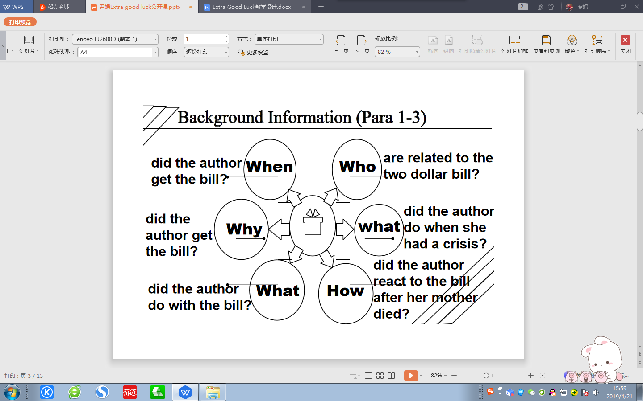**Tip One: Try to figure out the elements of the story & get the background information.**

**【设计意图】**在阅读过程开始前，提供一些特殊疑问词，这些特殊疑问词均围绕记叙文的几个核心要素提出，目的在于让学生在阅读之初有意识地去关注记叙文的背景内容介绍，这将帮助学生在解读接下去的文章时，有一个更清晰的全面观，能够清楚地知道故事的起始。

**Step Three: Read for the detailed formation of the story**

**Question:**

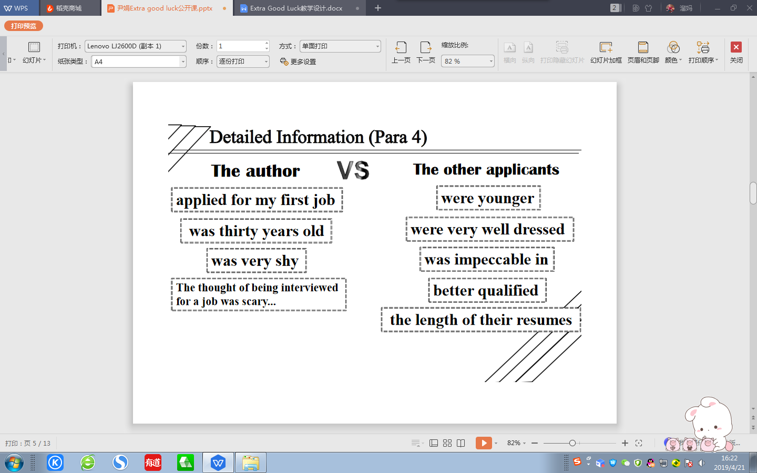Did the author have advantages over the other applicants for applying for the job?

**Tip Two: Analyse the detailed information and make contrast if necessary.**

**【设计意图】**有了背景内容介绍的铺垫，对文章的进一步细节处理就有了抓手。第四段文本最重要的一个特征就是作者与其他应聘者的对比，从对比中不难看出其他应聘者的优势，以及作者相对应的劣势，这样强烈的对比，让读者不禁要为作者捏一把汗，读者会觉得作者获得工作的机会非常渺茫。因此，在解读原文过程中，我们需要利用文章中出现的对比，进行逻辑的推进，以此来更好地突出文章的重点。

Detailed Information (Para 5)

Question: What makes the author feel she is qualified for the job?

1. I really needs this job and there is nothing I cannot do.---honest & sincere & confident

(2) As I exited her office, I turned around and said... ---value every chance

(3) I learn quickly and can be a very productive member of the team.---confident & promising

(4) I thanked her and went home ...---polite

(5) Tomorrow would be another day.---optimistic

**Tip Three: Read between lines & analyse the implied meaning.**

**Step Four: Prediction & Appreciation (Para 6)**

**The given sentence:**

That evening as I was getting ready for bed, I received a phone call from Mrs. Martin.

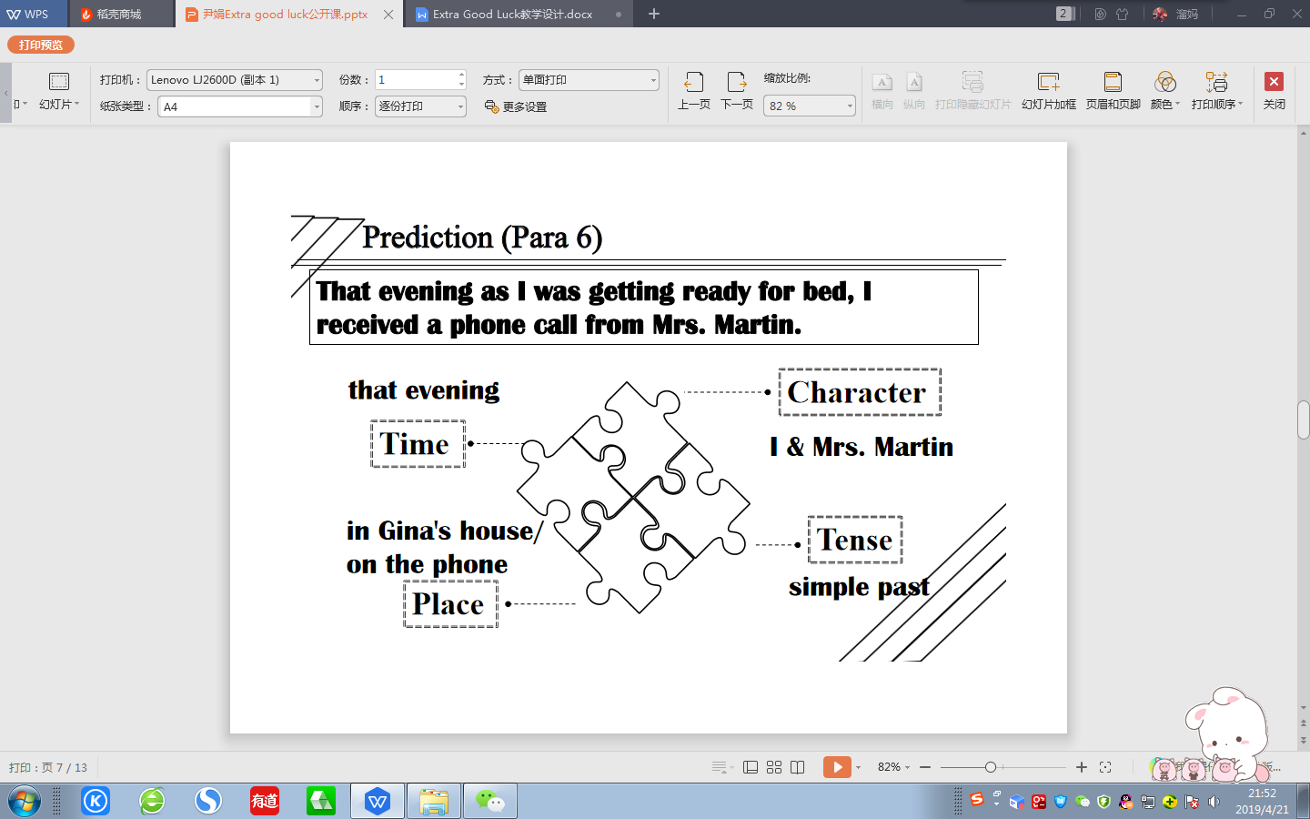

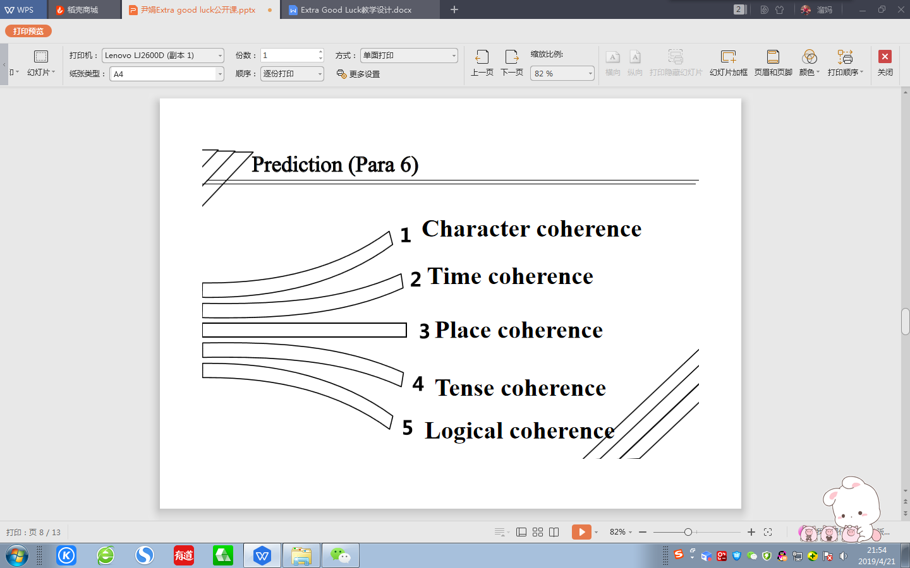**Tip Four: Pay special attention to the various coherence of the passage.**

**【设计意图】**本环节是基于文本阅读之后的续写构思预测，旨在让学生能够在阅读的基础上，获得逻辑上的情节发展趋势，并根据所给首句，进行合理的情节推测。在推测的过程中，让学生特别关注角色协同、时间协同、地点协同、时态协同以及语言协同。合理推测在学生阅读过程中起着举足轻重的作用，它能帮助学生培养利用所提供的文本进行合理的推断和情节的延伸，这对于训练学生的读后续写能力有很大帮助。学生在品读文本时养成推测的习惯，这将有助于学生续写时思路清晰，下笔通顺。

Question:

(1) What was the result?

1. How did Gina feel about the result ?

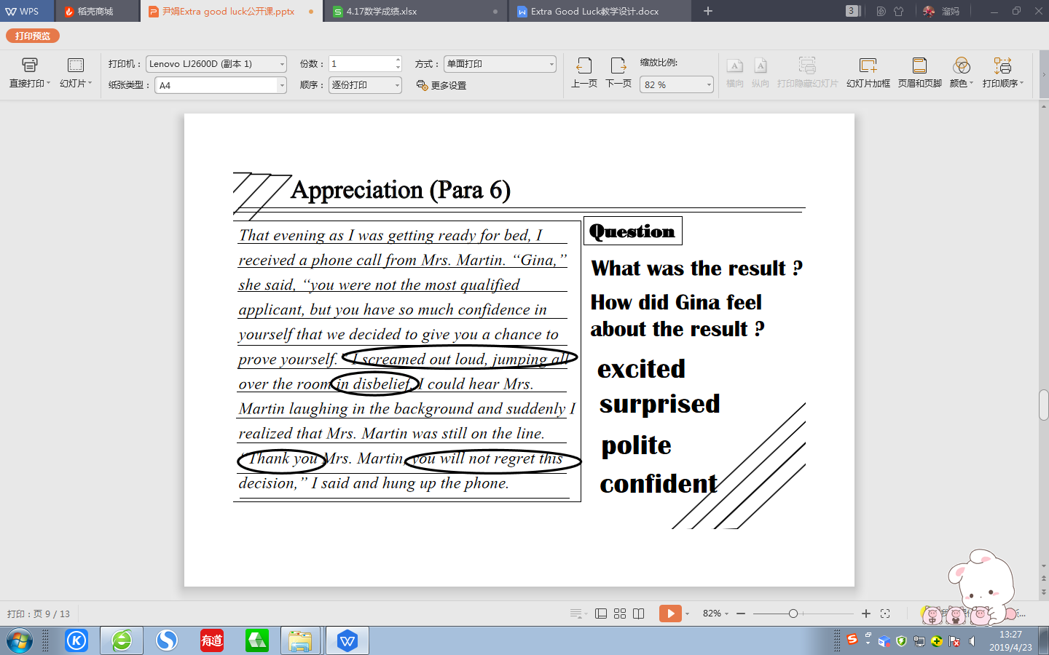

**Tip Five: Try to show rather than tell when trying to describe something.**

**【设计意图】**在上个预测环节的基础上，本环节是赏析文本。让学生结合所给文本，对自己的预测进行交叉对比，让学生检测他们自己的构思和文本构思的相似或是相异，在比较的过程中，了解自己的预测构思是否合情合理。

**Step Five: Prediction & Discussion (Para 7)**

**The given sentence:**

I got my wallet and took out my two dollar bill.

 **【设计意图】**本环节旨在再次利用推测的基本要素，再一次将几个读与写中的协同利用起来，进行最后一段的情节预测。学生根据之前所学，进行实践操作，巩固理论知识，强化读与写之间千丝万缕的联系。让学生带着思考赏文本，带着逻辑品文本，带着作者的意图析文本。通过与同学的思维交流，碰撞出主题的火花。让学生学会读与写相融合，已读促写，以写促读。

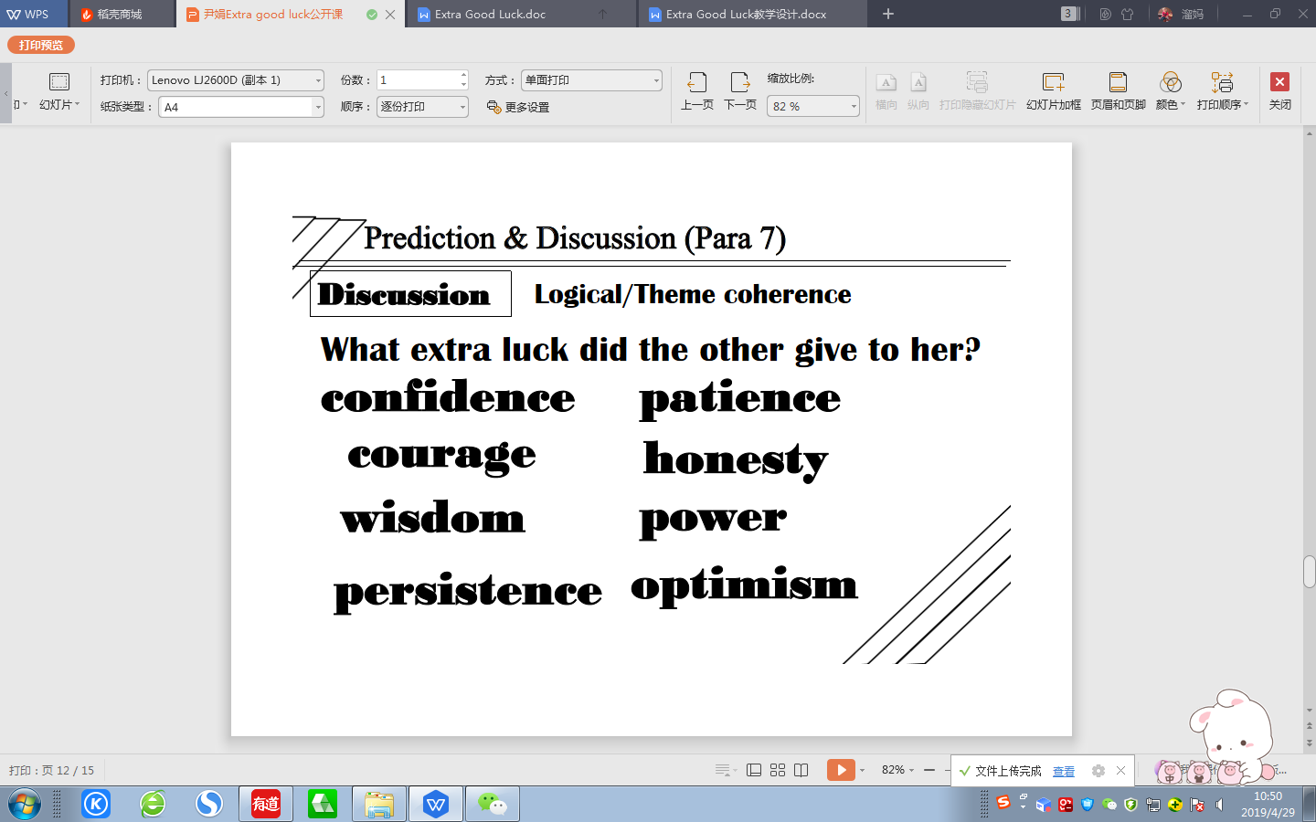

**【设计意图】**本环节通过对最后一段的预测来呼应标题的Extra Good Luck，让学生从本节课的解读过程中分析出标题的涵义，以What extra good luck did the other give to her?为问题，让学生能进行主题的升华。

**Step Six: Conclusion & thinking**

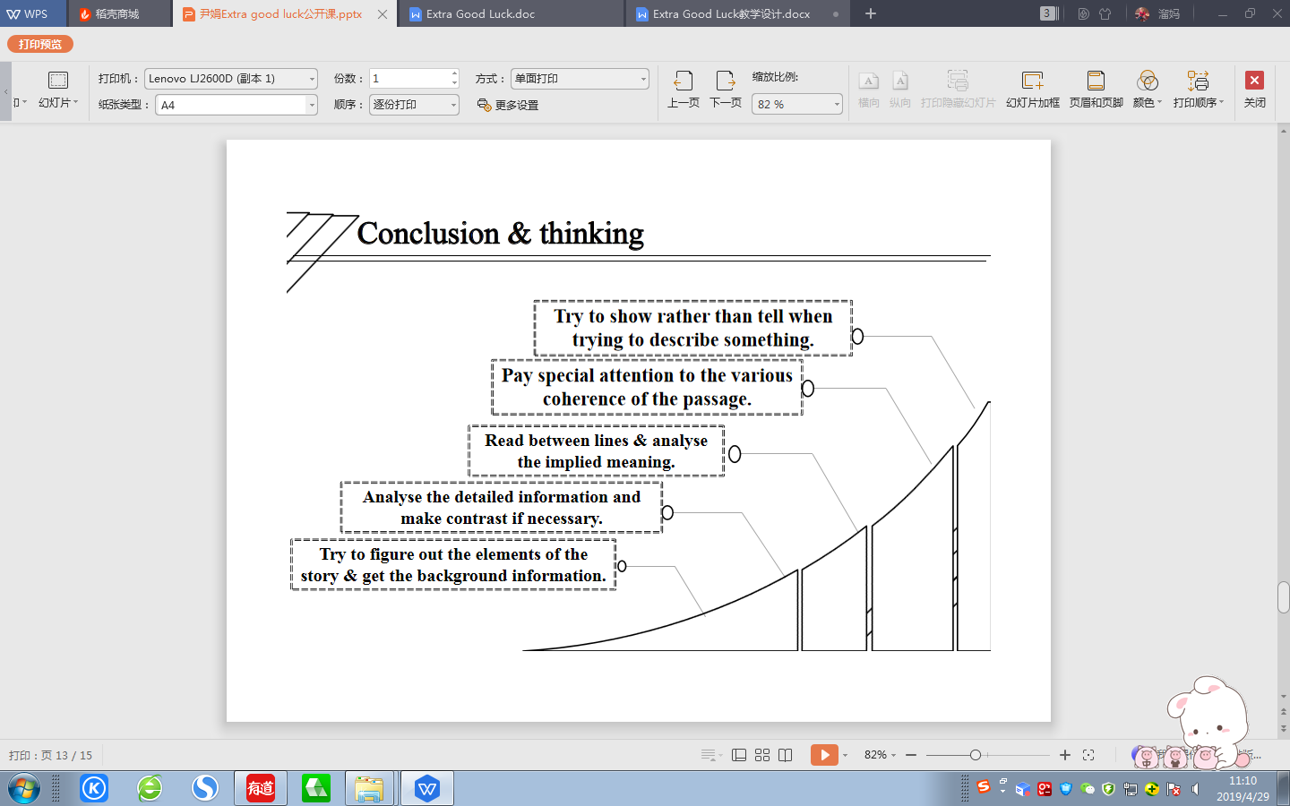

**【设计意图】**本节课结束之前，巩固总结课堂的读写技巧，让学生有一个系统的读写思路，在今后读与写的过程中可以更加具有目的性、整体性和逻辑性，而不是盲目的过程。在读的过程中，只有读懂读通读透原文，才能理解作者的思路和作者通过作品想要表达的主题和内涵；在写的过程中，只有关注人物、时间、时态、地点、逻辑、主题等方面的协同性、一致性，才能更好地完成写的任务。

**Step Seven:** **Homework (Writing)**

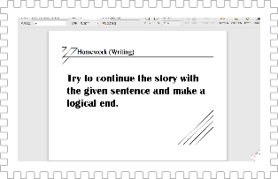

**【设计意图】**本篇文章的总体思路就是让学生读写中关注读与写之间的联系。因此，这篇文章的结尾成为一个开放式的结尾，让学生通过之前的思维碰撞和头脑风暴进行最后写作的完成。在充分输入的前提下，能有有效的输出。