**M3U5 The Value Of Money**

**Period 1 Listening and Speaking**

**Teaching Objectives：**

At the end of the class, students will be able to

1. master the new words in this period: on the basis of, take out a loan, plastic...

2. discuss the views of money in the lyrics and share their own views of money

3. improve their listening skills of identifying the characters and the relationship among them in listening

**Teaching Important and Difficult Points：**

How to make students work out the job, relationship of the characters in listening.

How to make students realize their views of money.

**Teaching Procedures:**

**hundred**

**thousand**

**million**

**____________关于**

**Step 1: Lead-in**

**Activity 1: Enjoy a short video**

Students will be asked to enjoy a short video about money and fill in the lyrics:

**ABBA ----money money money**  
I work all night, I work all day, to _____ ____ _______ I have to pay  
**Ain't it sad**  
And still there never seems to be a_______ _______ left for me  
**That's too bad**  
**In my _________ I have a plan  
If I got me a __________ man  
I wouldn't have to work at all, I'd fool around and have a ball...**Money, money, money  
**Must be _________**  
In the rich man's world  
Money, money, money  
**Always __________**  
In the rich man's world  
Aha-ahaaa  
**All the_________ I could do  
If I had a little money**  
It's a rich man's world  
A man like that is______ to find but I can't get him off my ______  
Ain't it _____  
And if he happens to be free I _____ he wouldn't _______ me  
That's too_____  
**So I must leave, I'll have to go**  
To Las Vegas or Monaco  
And win a ________in a game, my life will never be the same...  
Money, money, money  
...

**Activity 2: Have a look into the lyrics**

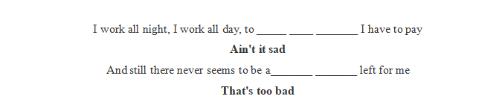

Q1: How do you figure out these lyrics? Why do people work so hard but still have no money?

(unreasonable consumption)

T: “ Money is a good servant and bad master”

Q2: What does this quotation mean? Do you want the money be your servant or master?

T: We should make good use of money.

C:\Users\Administrator\Desktop\1.png1

Q1: Do you agree with opinion? What can we do with money? What cannot we do with money?

Q2: How can we enrich our spiritual world?(reading)

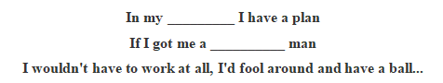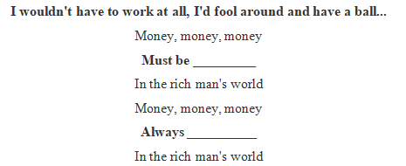

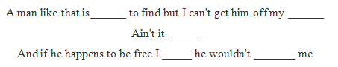

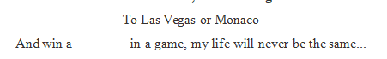

Q1: Do you agree with opinion? Is money the basis of a happy life?

Q2: There are two views of money in the lyrics, what are they? And what do you think of their views?

Q3: What should be our attitude to money? (Don’t let money direct you)

**Step 2: Listening**

**Activity1:Listen for the general information**

1. Students will be asked to listen for the first time to get the main idea of listening material

**Listening tip 1**: For news, we should pay attention to **5W+H** to get the main idea of the listening material

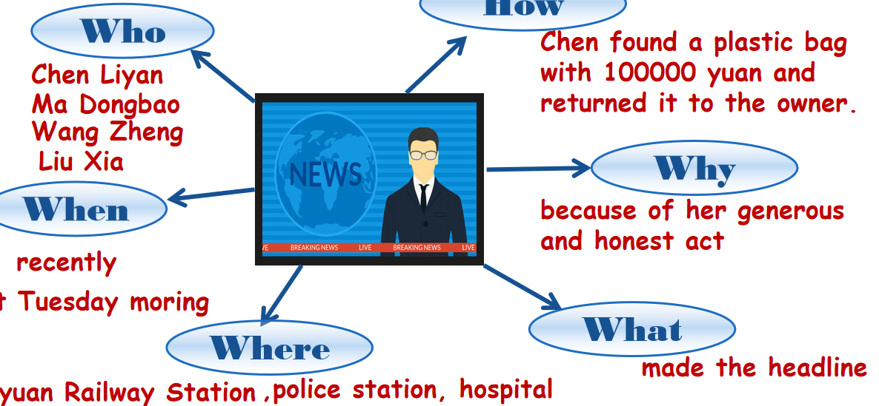

1. Students will be asked to guess what happened in the news according to the answers.

**Activity2:Listen for characters**

Students will be asked to listen for the second time to make out the jobs and relationships of the characters.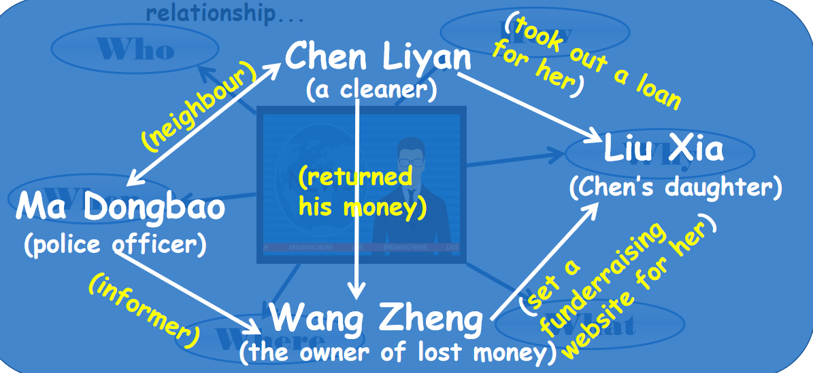

**Activity3:Listen for the detailed story**

Students will be asked to read the sentences and try to put the story into the right order, according to the hidden timeline in the sentences, and then listen again to check their prediction.(**Listening tip 2)**

*____ Chen Liyan found Wang Zheng’s money and returned it to him.*

*____ Chen gave an interview to the local newspaper.*

*____ Wang built a website to help raise funds for Liu Xia.*

*____ Ma Dongbao shared Chen’s story with Wang.*

*____ Chen spent all her savings and took out a large loan.*

*____ Wang offered Chen 5,000 yuan.*

**Activity4:Listen and decide**

*1. It was the first time Chen Liyan’s story was reported.*

*2. Chen found 10,000 yuan in a small plastic bag in Taiyuan railway station.*

*3. Wang Zheng apologised to Chen because he couldn’t offer her more money.*

*4. Chen took out a large loan to cure her daughter.*

*5. Wang set up a fundraising website for Chen’s daughter after Chen told him about her situation.*

**Listening tip 3**: Take down the key words, and correct the wrong places.

Q1: From the story, what can we know about Chen’s view of money?

Q2: Is there any similar example of this happened around you?

**Step 3: Post-listening**

Students will be asked to finish the gap filling of the listening material and analyse the structure of a piece of news.

Part1: Lead paragraph (5W+H)

Part2: Main body (detailed information, in time order)

Part3: Conclusion (Writer’s opinion on the issue)

**Language feature:**

content：wide

language：concise

timeliness：strong

