**金丽衢十二校 2024学年高三第一次联考应用文评析**

**— 快乐农场，寓教于劳**

**陕西省咸阳市礼泉县教研室 高小聪**

**Contents：**

**Step1. Read the task & circle the key information**

**Step2. Analyse the writing task**

**Step3. Build up corpuses**

**Step4. Apply corpuses to Writing**

**Step5. Reflection & advice**

**Step6. Conclusion**

**Teaching steps:**

**Step1. Read the task & circle the key information**

**第一节：应用文写作（满分15分）**

**假定你是李华 ，是你们学校刚刚开设的开心农场（ Happy Farm ）负责人。请你向来访的美国兄弟学校的同学介绍开心农场的情况，内容包括：**

**1．开心农场设立的目的；**

**2．开心农场提供的活动。**

**注意：**

**1．写作词数为80左右；**

**2．请在答题纸的相应位置作答。**

**Step2. Analyse the writing task**

|  |  |
| --- | --- |
| **Writing Style** | **Exposition** |
| **Form** | **A welcome speech** |
| **Topic** | **School education and Labour education** |
| **Person** | **The first\second\third person** |
| **Targeted readers** | **The students from the visiting American brother-school** |
| **Tenses** | **Simple present tense；Simple future tense**  **Simple past tense** |
| **Mood** | **Sincere; Polite; Comfortable and friendly** |
| **Structure** | **Para1. Welcome and self-introduction.**  **Para2. The purpose of establishing the Happy Farm and the activities it offers and their meanings.**  **Para3. Expectation and hope.** |

**Step3. Build up corpuses**

**Corpus1. 表示欢迎及自我介绍。**

**① Welcome to our school. I’m Li Hua, in charge of the Happy Farm, a new project that our school has set up recently.**

**② On behalf of our school, I would like to convey my sincere welcome for visiting the Happy Farm.**

**③ First of all, please allow me to express our welcome to you on behalf of our school Happy Farm.**

**④ As the person in charge of our school Happy farm，I’d like to extend my heartfelt welcome to you. Glad to share its general introduction with you.**

**Corpus2. 开心农场设立的目的。**

**①Considering students' preference for online games Happy Farm, our real-life version of Happy Farm has been developed on this basis，whose aim is to stimulate their curiosity and interest in nature and farming.**

**② The establishment of the Happy Farm is to build up a correct view of labour, form a sense of responsibility and and deeply understand the significance of labor in creating a better life.**

**③In order to fuel the students’ passion for labour and experience “Labour creates a better life” first-hand, the Happy Farm has been set up recently.**

**④ Our school Happy Farm is intended/designed to make the students understand true understanding knowledge comes from practice**

**Corpus3. 开心农场提供的活动。**

**①As the name suggests, varieties of exciting activities are organized, ranging from planting vegetables, raising little animals, picking fruits to harvesting crops.**

**② Every class has a the practice base, where the students can choose what to plant and plan when to grow grass，flowers and vegetables. More importantly, they can make use of artificial intelligent to manage their Happy Farm.**

**③ The Happy Farm covers a series of activities. The students are guided to sow, grow seedlings, fertilize, control pests, harvest and exchange fruits regularly. What’s the most significance is that we can share experience and learn from each other.**

**Corpus4. 开心农场活动的意义。**

**① Such these activities can arouse the students’ curiosity and allow them to explore the world beyond their immediate experience and foster their multiple thinking.**

**② Only in this way, will the students be able to think independently in and team up with others in continuously changing environments and deal with the challenges effectively. At the same time, their planning ability will be bettered.**

**③ This is such an edu-fun way that it can help students’ solve problems in labor practice by integrating multidisciplinary knowledge. As a famous saying goes, more important than hard work is changing your way of thinking.**

**Corpus5. 期盼与希望。**

**① I believe that you will enjoy a true feast for the senses on the farm. The chirping of birds and the fragrance of flowers with tasty fruits and cute animals will make you unwilling to leave.**

**② I sincerely hope that you will have a good time, appreciating its beautiful scenery and experiencing the life on the Happy Life.**

**③ I do hope that you will get a meaningful experience here and your visit will surely promote our friendship.**

**④ May the Happy Farm excite and inspire you, offering you an educational and enjoyable experience!**

**Step4. Apply corpuses to Writing**

**教师下水作文1**

**Dear fellows,**

**Welcome to our school. I’m Li Hua, in charge of the Happy Farm. 1___________ (consider) students' preference for online games, our real-life version of Happy Farm 2__________________(develop) on this basis recently.**

**3____________ (stimulate) their curiosity and exploration in nature and farming, the Happy Farm 4_______(cover) a series of activities. The students are guided to sow, grow seedlings, 5________ (fertilizer) , control pests, harvest and exchange fruit 6_________(regular). Most significantly, they can apply artificial intelligent 7____the Happy Farm under the guidance of the teacher. Such this edu-fun way can help students’ solve problems in labor practice by 8__________ (integrate) multidisciplinary knowledge. As a famous saying goes, more important 9______ hard work is changing your way of thinking.**

**I sincerely hope that you will get a 10____________(mean) experience here and your visit will surely promote our friendship.**

**教师下水作文2**

**Dear fellows,**

**As the person in charge of our school Happy Farm，I’d like 1___________(extend)my heartfelt welcome to you. Glad to share its general 2_____________(introduce）with you.**

**The Happy Farm 3_________________(establish) to guide the students to get knowledge from nature and labour. As the name suggests, 4_________(vary) of exciting activities are launched, ranging from planting vegetables, 5________(raise) little animals, picking fruits 6____ harvesting crops. Such these activities do 7_______(well) to broadening our horizons and developing hands-on ability. Only by this means , can we feel that learning knowledge 8___ (be) like breathing fresh air, refreshing 9__________ (we).**

**May the Happy Farm excite and inspire you, offering you an amusing and 10_____________ (educate) experience!**

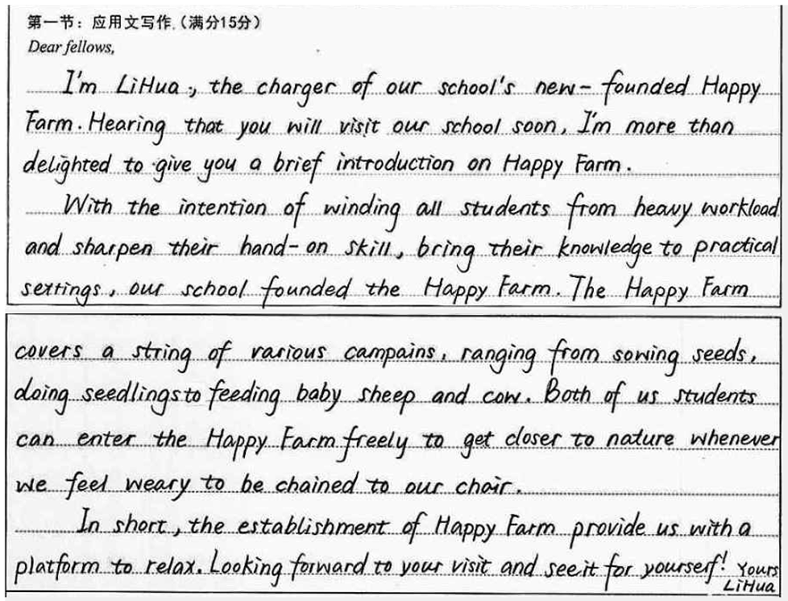**学生作品1**

**Evaluation and Appreciation:**

**第五档（13.5分）**

**理由：**

**1.要点齐全，结构完整；**

**2.词汇丰富，句式多变；**

**① Hearing that..., I’m more than delighted to...**

**② ...can enter... whenever we feel weary to be chained to our chairs.**

**③ with the intention of doing sth.**

**④ wind sb. from sth.**

**⑤ sharpen one's hands-on skills**

**⑥ range from... to...**

**⑦ feel weary to be chained to our chairs**

**3. 过渡自然，一气呵成；**

**4. 些许错误，不误大局；**

**5.卷面整洁，语意丰满。**

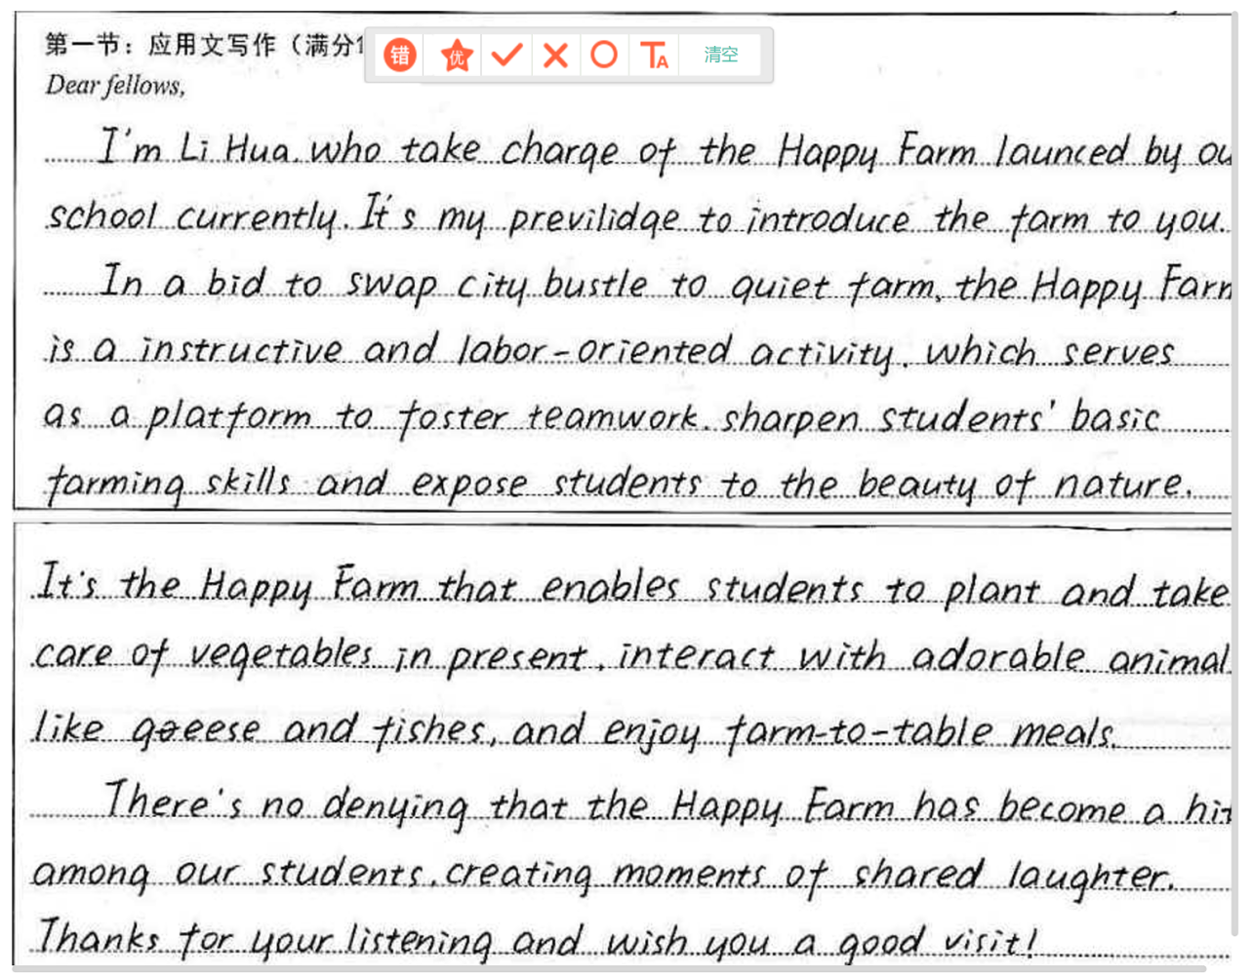**学生作品2**

**Evaluation and Appreciation:**

**第五档（14分）**

**理由：要点齐全，结构清晰；行文连贯，表达清楚；语言时尚，吸睛力强。**

**Language appreciations：**

**① take charge in 主管、负责 ② launch 发起、启动**

**③ It’s one’s privilege to do... 做某事是某人的荣幸**

**④ swap ... for...交换**

**⑤ instructive and labor-oriented有教育意义的和以劳动为导向的**

**⑥ foster teamwork 培养团队精神**

**⑦ sharpen one’s skills 提升技能**

**⑧ expose... to... 沉浸于......**

**⑩It’s the Happy Farm that enables students to... (强调句型）**

**⑩ farm-to-table从食品，到生活**

**它不只关乎于食品安全和饮食健康，更关乎人与自然的良性互动，关乎一种倡导生态有机的生活主张，关乎寄托于田野绿意间的生活美学和情感链接。**

**⑪There is no denying that...**

**不可否认...... (同位语从句）**

**学生作品3**

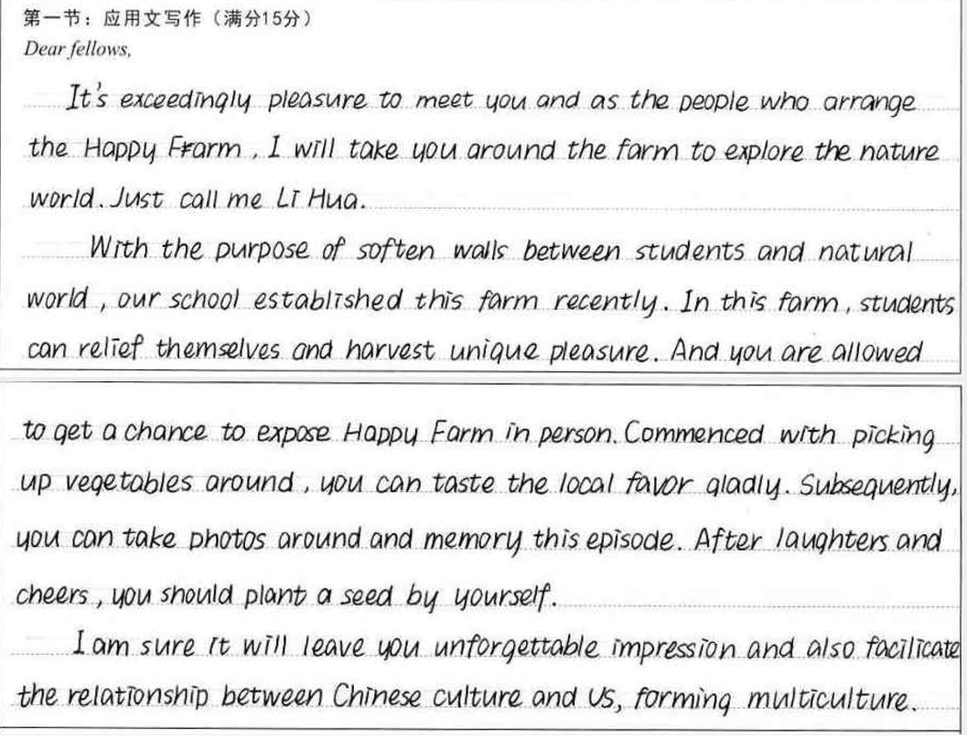

**Evaluation and Appreciation:**

第四档(12.5分)

理由：卷面整洁，结构完整，思路清晰，衔接自然，行文比较流畅。但文章缺乏高级句型，且有些许语法和词汇错误。综合考虑定为四档。

Language appreciations：

1. It’s my pleasure to do ... 我乐意做......

② explore the natural world 探索自然世界

③ soften the walls between... and... 软化......与....... 之间的壁垒

④ harvest unique pleasure 收获独特的乐趣

⑤ commence with 从...... 开始

⑥ subsequently adv. 随后，接着

⑦ memorize this episode记录这段经历

⑧ facilitate v. 促进；使便利

**学生作品4**

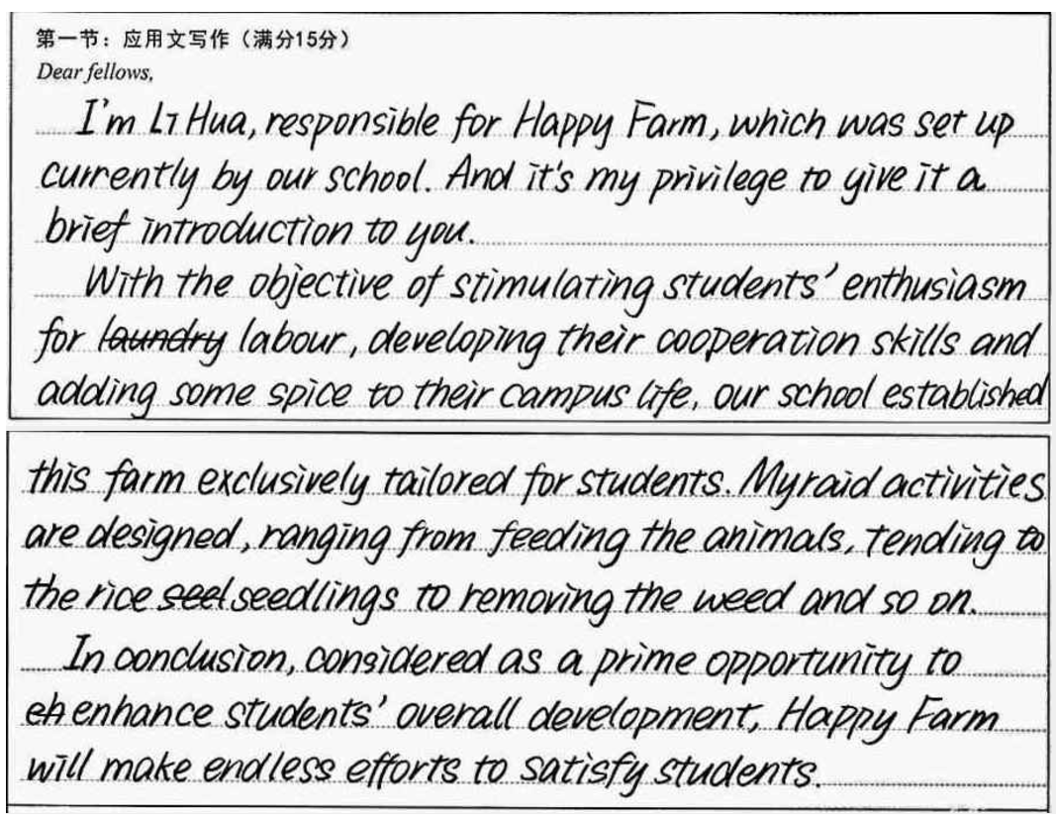

**Evaluation and Appreciation：**

**五档作文 （13.5分）**

**理由：要点齐全，卷面整洁，书写美观大方。高级词汇、句型较多。有少许错误是由于使用高级句式所致。**

**Language appreciation：**

**① be responsible for 为......负责**

**② It’s one’s privilege to do ...**

**做某事是某人的荣幸**

**④ stimulate one’s enthusiasm for sth.**

**激发某人对某事的热情**

**⑤ develop one’s co-operational skills**

**培养某人的合作技能**

**⑥ add... to... 添加......到......**

**⑦ range from... to... 范围从.......到......**

**⑧ enhance one’s overall development**

**促进某人的全面发展**

**⑨ Considered as a prime opportunity to... （过去短语做状语）**

**Step5. Reflection & advice**

**为了在有限的时间内，完成一篇高质量的应用文，我们在平时的读写课中，应做到：**

**① 认真读题，把握体裁、结构、要点和语气；**

**② 关注主题语言，尽可能多地储备语料知识；**

**③ 以语义场、词块的形式整理词汇和句型；**

**④ 设置语境（单句翻译、段落描述、课文缩写、改写、作文训练)，反复练习；**

**⑤ 反刍提高，理解内化。**

**Step6. Conclusion**

**美好品德的陶冶，智慧潜能的激发，健康体魄的养成，审美水平的提升，往往都离不开特定的劳动场景和劳动实践。**

**The cultivation of good virtues, the stimulation of intellectual potential, the development of a healthy body, and the improvement of aesthetic levels are often inseparable from specific labor scenes and labor practices.**

**— People’s Daily**