The World (March 1st-15th, 2023)

**1.《洛杉矶时报》2023年3月13日 A1&A2版面**

1）语法填空

“Everything Everywhere All at Once,” a sci-fi-action-comedy mash-up about a Chinese American immigrant _____ traverses the multiverse to keep her family together, claimed best picture at the 95th Academy Awards on Sunday night, ________ (beat) out a diverse field that included massive blockbusters as well as intimate arthouse fare.

Leading the field with 11 ___________ (nomination), “Everything Everywhere” won seven, including lead actress for Michelle Yeoh, supporting actor for KeHuy Quan and supporting actress for Jamie Lee Curtis, along with ________ (origin) screenplay and directing wins for co-directors Daniel Kwan and Daniel Scheinert.

“Everything Everywhere” proved a sleeper hit, grossing more than $100 million worldwide and, _________ (power) by its combination of crazy filmmaking and poignant themes of familial love and generational unpleasant experiences, __________ (gradual) established itself as a genuine competitor.

____ awards season heated up, the film picked up momentum, steamrolling through the major Hollywood guilds to emerge as ____ Oscar front-runner.

Yeoh took home the lead actress award for her turn as the no-nonsense matriarch of “Everything Everywhere,” making the Malaysian-born action idol the first Asian performer ______ (win) that prize. “____ all the little girls and boys who look like me watching tonight, this is a beacon of hope and possibilities,” Yeoh said. “And ladies, don’t let anybody tell you you are past your prime.”

2）翻译句子

她终于成了那支队的队员。_______________________________________________________________________________

两个人之间心碎的情书后来得以出版面世。

_______________________________________________________________________________

**2.《国家地理》2023年3月刊 EXPLORE版面**

1）阅读理解

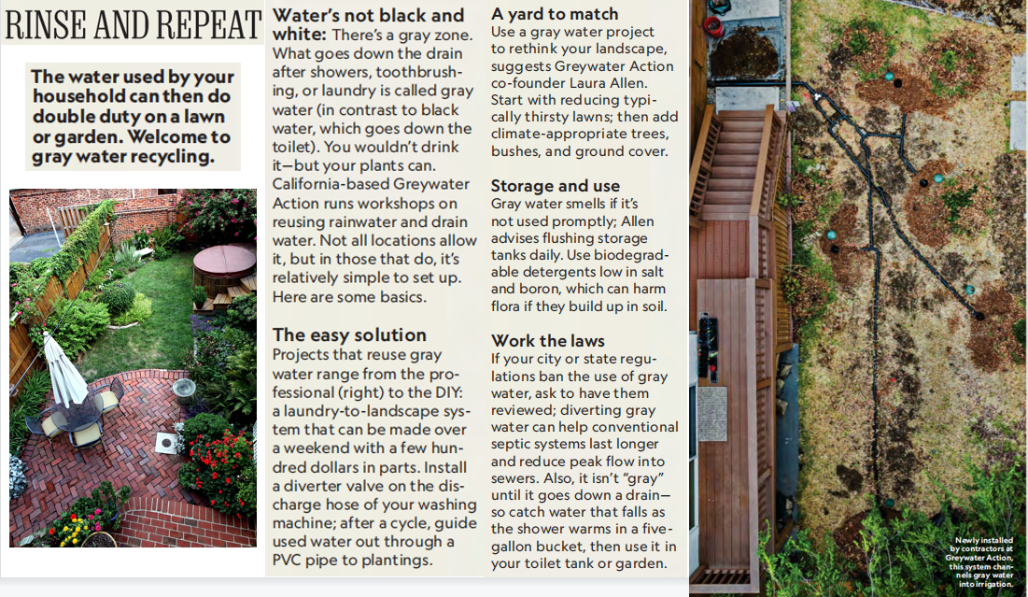

1. Which of the following statements about gray water is correct?

A. Water flushed by the toilet is gray water.

B. Gray water should not be used immediately.

C. People in all communities cannot recycle gray water.

D. Gray water facilities must be installed by professionals.

1. What is the text maily about?

A. How gray water can be reused B. How gray water can be reduced

C. Why gray water smells D. Why gray water exists

3. Where is the text probably taken from?

A. An advertisement B. A biology textbook

C. A magazine D. A research paper

2）翻译句子

每次用完洗发剂后都要用清水将头发冲洗几次。_______________________________________________________________________________

他们开始发烧，眼睛里分泌出一种水状物。

_______________________________________________________________________________

**3.《泰晤士报》2023年3月2日 18页**

1）语法填空

Scientists claim to have proved _____ many of us thought — the more rain- forest you cut down, the less rain falls.

For every percentage point of forest cover lost, precipitation declined ____ 0.6 per cent in the wet season and 0.2 per cent the rest of the year, according to a new ________ (science) paper.

It estimates that with ___ projected 40 per cent decline in forest cover in the Congo during the next 80 years, the region can expect _____ (see) 10 per cent less rain. Callum Smith, from the University of Leeds, a co-author of the study, said ____ this finding alone was “compelling evidence” to protect forests.

He ______ (add) that too much deforestation could lead to a vicious cycle. “Tropical ______ (forest) themselves rely on moisture to survive and remaining areas of forest will be impacted by a drier climate.”

The study compared rainfall patterns with changes in forest cover across the Amazon, Congo and southeast Asia. The results, _________ (publish) in the journal Nature, demonstrated a clear link.

Professor Dominick Spracklen, another co-author, said: “There need to be renewed efforts to stop forests _________ (lose) and to regenerate lost and degraded areas.”

2）翻译句子

其次，北极的大部分降水形式为雪。_______________________________________________________________________________

我们需要结束暴力和反暴力的恶性循环。

_______________________________________________________________________________

**4.《泰晤士报》2023年3月2日 18页**

1）语法填空

Help Your Pills Work Faster

If you want a pill to start bringing you relief as quickly as possible, try lying down on your right side. ______ (use) a computer simulation of a stomach, investigators at Johns Hopkins University in Maryland saw medications dissolve more than twice as quickly in this position, _________ (compare) to standing up or lying on the back. By contrast, lying on the left side was ______ (slow) than standing.

This ______ (make) sense if you think about gravity and the asymmetrical shape of your stomach: the opening that leads to the small intestine (肠), ______ pills are typically absorbed, is on the right side.

Smartwatches Can Detect Atrial Fibrillation

Devices like the Fitbit and Apple Watch have an electrocardiogram (心电图) (ECG) app that looks ____ signs of atrial fibrillation (心房颤动) (AFib), the most common heart-rhythm __________ (regular). Catching AFib is valuable, since the condition can lead to a stroke if untreated. But are smartwatches _______ (rely) compared to a standard ECG?

A recent Chinese study involving 2.8 million participants suggests they can be __________ (reasonable) accurate if you have AFib. However, the devices can get thrown off when someone has a different heart issue, or more than one. In short, you can use a smartwatch for ___ initial screening, but you’ll want to follow up with a doctor for a medical test.

2）翻译句子

为使训练真实，模拟是实时运行的。

_______________________________________________________________________________

定期进行乳腺癌筛查是必要的。

_______________________________________________________________________________

1. **BBC One-minute World 03/13/2023**
2. 听力填空

This is BBC world news, here are the headlines.

U.S. regulators have _________ Silicon Valley Bank, a major lender to tech companies, after it ran into ______________, the largest banking failure in the U.S. since the financial crisis of 2008.

The BBC’s _______ football program is in disarray. On-air staff pull out of Saturday’s show ___________ presenter Gary Lineker, who was told to ________ after criticizing the government’s new asylum bill.

Officials in the German city of Hamburg say the gunman who ________ seven people at a Jehovahss Witness Meeting hall was a former member of the religious group and left on bad terms.

And one of the strongest storms ____________ in the southern hemisphere has _____________ Mauritius and Madagascar for a second time. It’s now heading back towards Mozambique again.

This is BBC news.

2）翻译句子

我们的计划因她的到来而陷入一片混乱。

_______________________________________________________________________________

我还不知道你和她的关系这么不好。

_______________________________________________________________________________