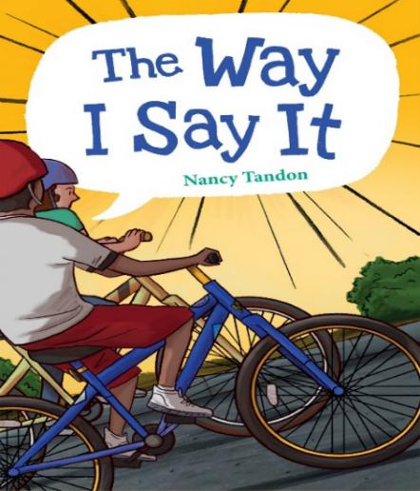 

**Author Bio --** **Nancy Tandon**

Nancy Tandon is a children’s book author who loves sharing all kinds of stories. She has worked as an elementary school teacher, a speech-language pathologist, and an adjunct professor of Phonetics and Child Language Development, all of which helped plant seeds for stories about awesome kids doing brave things. Her debut middle grade novel, *The Way I Say It* (Charlesbridge, 2022) was an American Booksellers Association Indies Introduce and Indies Next pick as well as a Junior Library Guild Gold Standard Selection. She is also the author of *The Ghost of Spruce Point*, forthcoming from Aladdin/Simon & Schuster (2022). Born and raised in Michigan, Nancy now lives with her family in Connecticut.

**The Book --The Way I Say It**

Sixth grader Rory still can’t say his r’s, but that’s just the beginning of his troubles. First Rory’s ex-best-friend Brent started hanging out with the mean lacrosse kids. But then, a terrible accident takes Brent out of school, and Rory struggles with how to feel.

Rory and his new speech teacher put their heads together on Rory’s r’s (not to mention a serious love of hard rock and boxing legend Muhammad Ali), but nobody seems to be able to solve the problem of Rory’s complicated feelings about Brent. Brent’s accident left him with brain-damage and he’s struggling. Should Rory stand up for his old friend at school–even after Brent failed to do the same for him?

*The Way I Say It* is honored to be a 2022 Indies Introduce title, a Jan/Feb ‘22 Indies Next pick, and a Junior Library Guild Gold Standard selection.

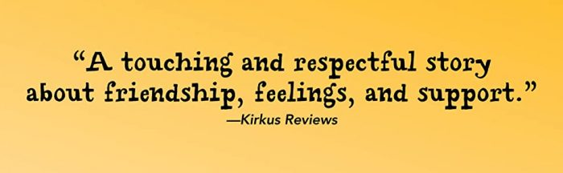

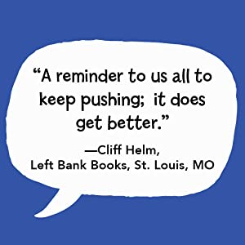 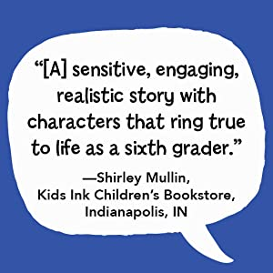 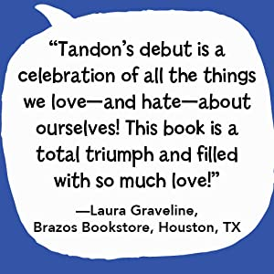

The Way I Say It Reading notes (1)

Chapter 1 Hello, My name is…

1. Standing in front of the class, I gripped and released the fabric of my mesh shorts (抓住然后松开带网眼的短裤的织物，其实就是揪着自己的衣服，表示紧张). I tried to take a deep breath but managed only a fluttery gulp(/ɡʌlp/大口的喘气). I looked toward the back of the room and focused on the crammed(挤满的) bookshelf. Anything but all the faces staring at me. “I am Wohwy.” I pushed the words out on a rush of air.

(Rory介绍自己时紧张心理的描写 故事的主人公不会发r 这个字母的音)

2. I pretended to clear my throat, and the cough came out as a dry little squeak(/skwiːk/ to speak in a very high voice, especially when you are nervous or excited（尤指紧张或激动时）尖声说话).

3. Just then the door creaked (/kriːk/) open. 门嘎吱一声开了。

Chapter 3 Me, myself and R

1. Then Tyson leant in (向前一步) and motioned us close. (( motion v. to make a movement, usually with your hand or head, to show somebody what you want them to do（以头或手）做动作，示意))

Chapter 4 The Champ

1. I wiped my hands on my shorts and knocked. No one answered. Through the door’s small rectangle （长方形的） window, I could see a guy with his eyes closed, drumming on a desk with two pencils. He has headphones on. I looked up and down the deserted(空无一人的) hallway. I knocked again, louder. (透过门上的窗户看到里面沉醉于音乐中的老师)

2. The room is tiny. A massive pile of papers sat on a desk that was crammed into the corner next to a small sink (n. 水槽) . A laptop balanced(保持平衡) precariously (/prɪˈkeəriəsli/ adv. 不稳地) on the pile. Mr Simms motions for me to sit down at a wobbly （/ˈwɒbli/ 不稳的） table. （老师办公室的描写）

3. He leaned back, his hands clasped (/klɑːsp/to hold something tightly in your hand握紧；攥紧；抓紧) behind his head, “So, why are you here?” (老师的动作你能否做一个呢？红色部分独立主格结构)

4. Mr Simms jumped from his chair and slammed (to put, push or throw something into a particular place or position with a lot of force用力一放；使劲一推；猛劲一摔) his hands on the table.

5. 请体会上网搜索资料的动作描写：

He grabbed his laptop and sat down next to me. I watched him click around, then enter Muhammad Ali in the search bar. “Wait till you see this,” he muttered (轻声低语) while the website was loading. He tapped the pause button on the screen.