# **Book 1 Welcome Unit导案**

1. **exchange/ɪksˈtʃeɪnd ʒ/n.&n.交换; 交流; 交易**

I’m an exchange student from the UK. 我是一名来自英国的交换生。（P2）

I'm going to go on an exchange visit to Paris. 我将到巴黎交流参观。

Our school does an exchange with a school in France. 我们学校与法国的一所学校进行交流。

I buy you lunch and you fix my computer. Is that a fair exchange ? 我请你吃午饭，你给我修计算机，这算是公平交易吧？

an open exchange of ideas and information思想和信息的公开交流

educational exchanges for young people面向年轻人的教育交流

trade and cultural exchanges with China与中国的贸易和文化交流

to exchange ideas/news/information交流思想/ 互通消息/ 交流信息

Everyone in the group exchanged email addresses.所有的组员都相互交换了电子邮件地址。

If the shirt doesn't fit, take it back and the store will exchange it. 如果衬衫不合适就把它拿回来，商店将给你掉换。

**in exchange for换取**

They sold eggs in exchange for salt and tea.他们把鸡蛋卖掉换取茶叶和盐。

Linda teaches me French in exchange for Chinese lessons.琳达教我法语，作为交换我教她汉语。

**exchange sth with sb.与某人交换某物**

I exchange learning experience with my classmates. 我与同学交流学习经验。

I shook hands and exchanged a few words with the manager.我与经理握手，相互交谈了几句。

**exchange A for B 把A换成B**

If you are not satisfied with the car, you can always exchange it for another.如果你对车不满意，可以随时另换一辆。

I am going to America next week, so I have to exchange some RMB for dollars.我下周要去美国，所以得把人民币兑换成美金。

# **lecture/ˈlektʃə(r)/n. &vt.(开)讲座；讲课；演讲; 训斥**

**词根词缀：lect-说+-ure(名词后缀)：去说——讲座；讲课；演讲；训斥**

**a lecture to sb 给某人的讲座/训斥**

**the lecture hall 在报告厅**

He gives a lecture to first-year students. 他给一年级学生讲课。

Did you ever lecture at Harvard? 你在哈佛大学开过讲座了吗？

I was asked to lecture on Chinese literature yesterday.昨天我应邀去讲中国文学。

**a lecture on/about sth 关于……的讲座/训斥**

Smith gives lectures on business management.史密斯教工商管理课。

I know I should stop smoking─don't give me a lecture about it.我知道我该戒烟，别再训斥我了。

**lecture sb about/on sth因某事指责/ 训斥某人**

He's always lecturing me about the way I dress. 他对我的衣着总是指手画脚的。

He used to lecture me about drinking too much.他以前常唠叨我喝酒太多。

**lecturer /ˈlektʃərə(r) / n.（大学或学院中的）授课者，（英美大学中的）讲师；演讲者**

He's a lecturer in French at Oxford. 他是牛津大学的法语讲师。

The lecturer spoke very clearly so that we could hear every word. 演讲者讲话很清楚,我们每个字都能听清。

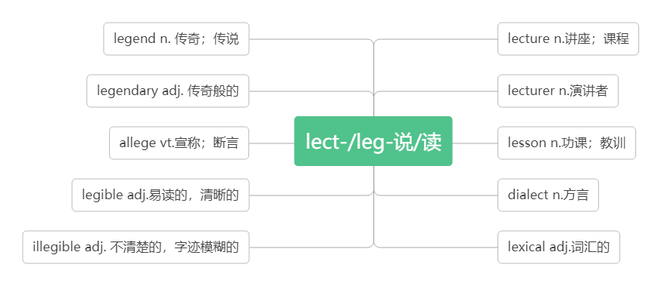

1. **register/ˈredʒɪstə(r)/vt.& vi登记；注册**

**词根词缀：re-(再，又)+gist-(gest-获取)+-er: 再次获取个人信息——登记；注册**

Have you come to register at the school? 你来学校注册了吗？

Check the number of people who have registered. 核实一下登记注册的人数。

We registered his birth. 我们给他进行了出生登记。

register a company/trademark 注册公司/商标

**register for为……注册/登记**

We have to register for classes on Friday.我们必须在星期五去注册课程。

She will register for the physics class. 她准备选修物理课.

**registration /ˌredʒɪˈstreɪʃn / n.登记；注册；挂号**

in the registration office 在登记处（P2）

The registration of students for the course will begin on Thursday morning.学生登记上的这门课将于星期四上午开始。

Please write your home address on the registration form.请在这张登记表上写下你的家庭住址。

They charge a small registration fee. 他们收一点注册费。

the registration of a child's birth婴儿出生登记

the registration of letters and parcels信件和包裹的挂号

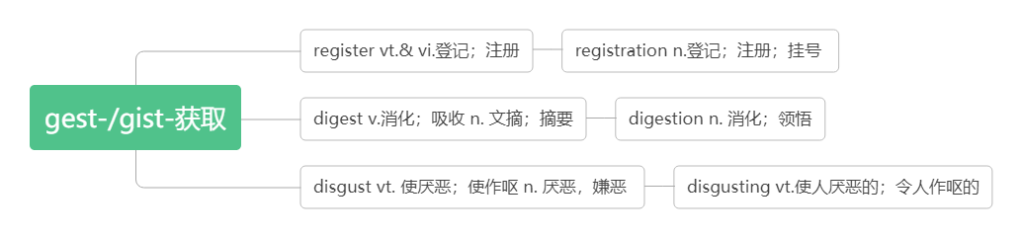

# **sex /seks/n.性别**

We don’t allow couples to choose the sex of their baby.我们不允许夫妇选择婴儿的性别。

Please indicate your sex and date of birth below.请在下面写明你的性别和出生日期。

1. **male /meɪl/adj.男的；雄性的n.雄株，雄性**

a male nurse/model 男护士/模特儿

a male flower 雄花

More females than males are employed in the factory.这家工厂雇用的女性比男性多。

**female /ˈfi:meɪl/adj.女的；雌性的n. 雌株，雌性**

She was the greatest female poet in America. 她是美国最伟大的女诗人。

The animal in the picture was a female elephant. 照片上的动物是头母象。

Fifty percent of the workers were female.50%的工人是女性。

Each female will lay just one egg in April or May. 每个雌体四五月份只产一粒卵。

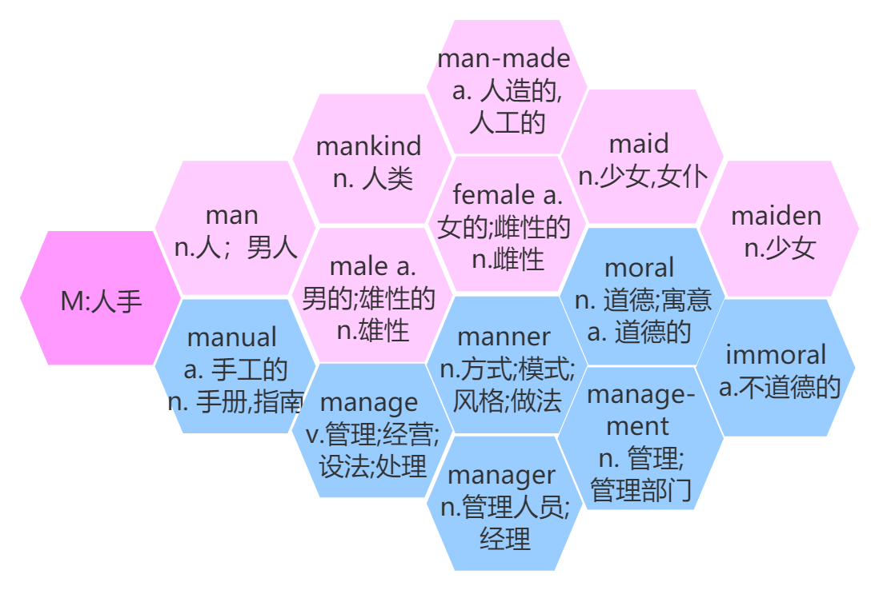

# **nationality /næʃəˈnæləti/ n.国籍; 民族**

When asked his nationality, he said British. 被问及国籍时，他说是英国。

The college attracts students of all nationalities. 这所大学吸引着各国的学生。

The Yi nationality is distributed mainly over Yunnan, Sichuan and Guizhou provinces.

彝族主要分布在云南 、 四川和贵州三省。

**nation /ˈneɪʃn/ n.国家; 民族**

It seemed that the nation's health was improving.好像该国的健康状况正在改善。

The British are known as a nation of dog lovers.英国人以爱犬而闻名。

The whole nation were watching the football game. 全国的人都在看这场足球赛。

**national /ˈnæʃnəl/ adj.国家的;民族的**

national and local newspapers全国性的和地方的报纸

national and international news国内和国际新闻

Agriculture plays an important part in the national economy.农业在国民经济中占重要地位。

Lin Zexu and Yue Fei are our national heroes.林则徐和岳飞是我们的民族英雄。

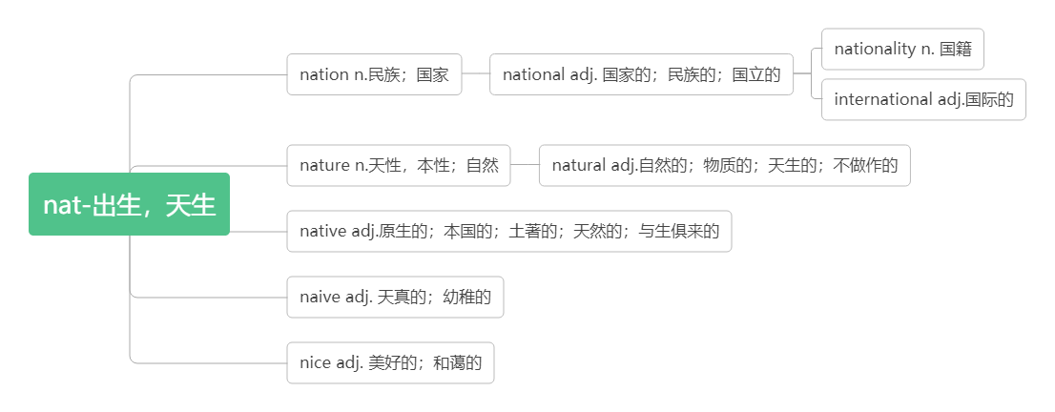

1. **design /dɪˈzaɪn/n.设计；方案；图案**

**词根词缀：de-(向下)+sign(符号)：画下来的符号——图案；设计；方案**

She came to London in 2019 to study fashion design. 她2019年来到伦敦学习时装设计。

The shoes were of good design and good quality.这些鞋样式新颖，质量上乘。

They drew up the design for the house in a week. 他们在一周内就画出了房子的图样。

**by design= on purpose 故意地**

I am sure he did it by design.我肯定他是故意做的。

We don't know if it was done by accident or by design. 我们不知道那是偶然的还是故意的.

**vt.设计；筹划**

design a car/a dress 设计汽车/连衣裙

This bridge was designed by Scott 这座桥是斯科特设计的。

He has a job designing websites. 他得到了一份网站设计工作。

We need to design a new course for the third year. 我们需要为三年级学生制订一个新的课程。

**be designed to do sth. 专门被用来做……**

The programme is designed to help people who have been out of work for a long time.

这项计划的目的是为长期失业者提供帮助。

These programs are designed to develop the economy.这些项目是为了发展经济而设计的。

**be designed for… 专为……而设计**

This training is designed for teachers. 这项培训是为老师设计的。

It's not designed for anyone under age eighteen. 它不是为18岁以下者设计的。

**be designed as…被设计为……**

The room is designed as a small reception hall for important visitors .

这个房间被设计为用来接待重要来宾的小型会客室。

**designer /dɪˈzaɪnə(r)/n.设计师，设计者**

--What does Amy want to be inthe future? --A designer.——艾米将来想做什么？——设计师。（P2）

My brother is a fashion designer. 我哥哥是一名时装设计师。

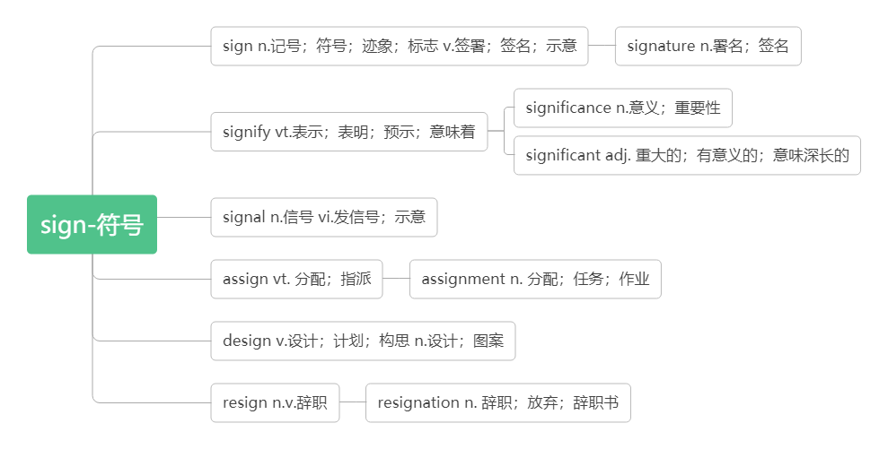

1. **campus/ˈkæmpəs/n.校园，校区**

词根词缀：camp(营地)+us(我们)：我们的营地——校园，校区

on (the) campus在校园里

An exchange student is talking to a teacher on campus.一个交换生正在校园里和一位老师谈话。（P3）

They spoke of the old days on the campus.他们谈起昔日的校园生活。

The campus of Harvard University is very beautiful. 哈佛大学的校园非常漂亮。

The campus covers an area of twenty square kilometers.这个校园占地二十平方公里。

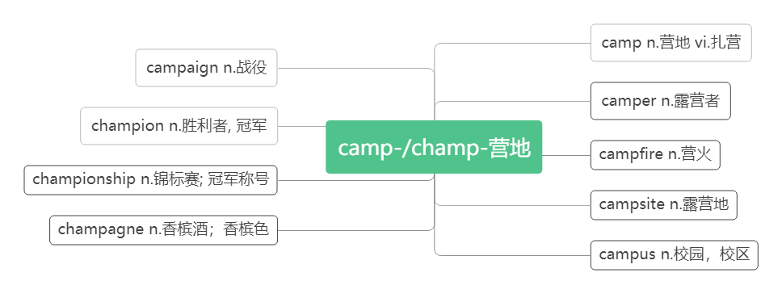

1. **formal /ˈfɔ:ml/ adj.正式的；正规的**

People speak in a more polite way in formal situations. 在正式场合人们说话更礼貌。（P3）

He wrote a very formal letter of apology to Mary. 他给玛丽写了一封非常正式的道歉信。

They had a formal dinner after the play. 演出结束后他们举行了一个正式的晚宴。

He didn't have any formal dance training.他没受过任何正规的舞蹈训练。

**formally /'fɔ:m əlɪ/ adv.正式地; 正规地**

We need to dress formally for the party. 我们需要穿得正式参加晚会。

Everyone was formally lined up to meet the king. 大家正式地列队迎接国王。

**informal /ɪnˈfɔ:ml/ adj. 非正式的；非正规的**

an informal meeting/visit 非正式的会议/访问

The house has an informal atmosphere. 房间里有一种轻松随意的氛围。

I would like it to be an informal occasion. 我希望把它办得不那么正式。

**informally/ɪn'fɔ:məlɪ/adv.非正式地**

They told me informally that I had got the job. 他们非正式地告诉我我已获得那份工作。

The guests were seated very informally around the table. 客人们很随意地坐在桌旁。

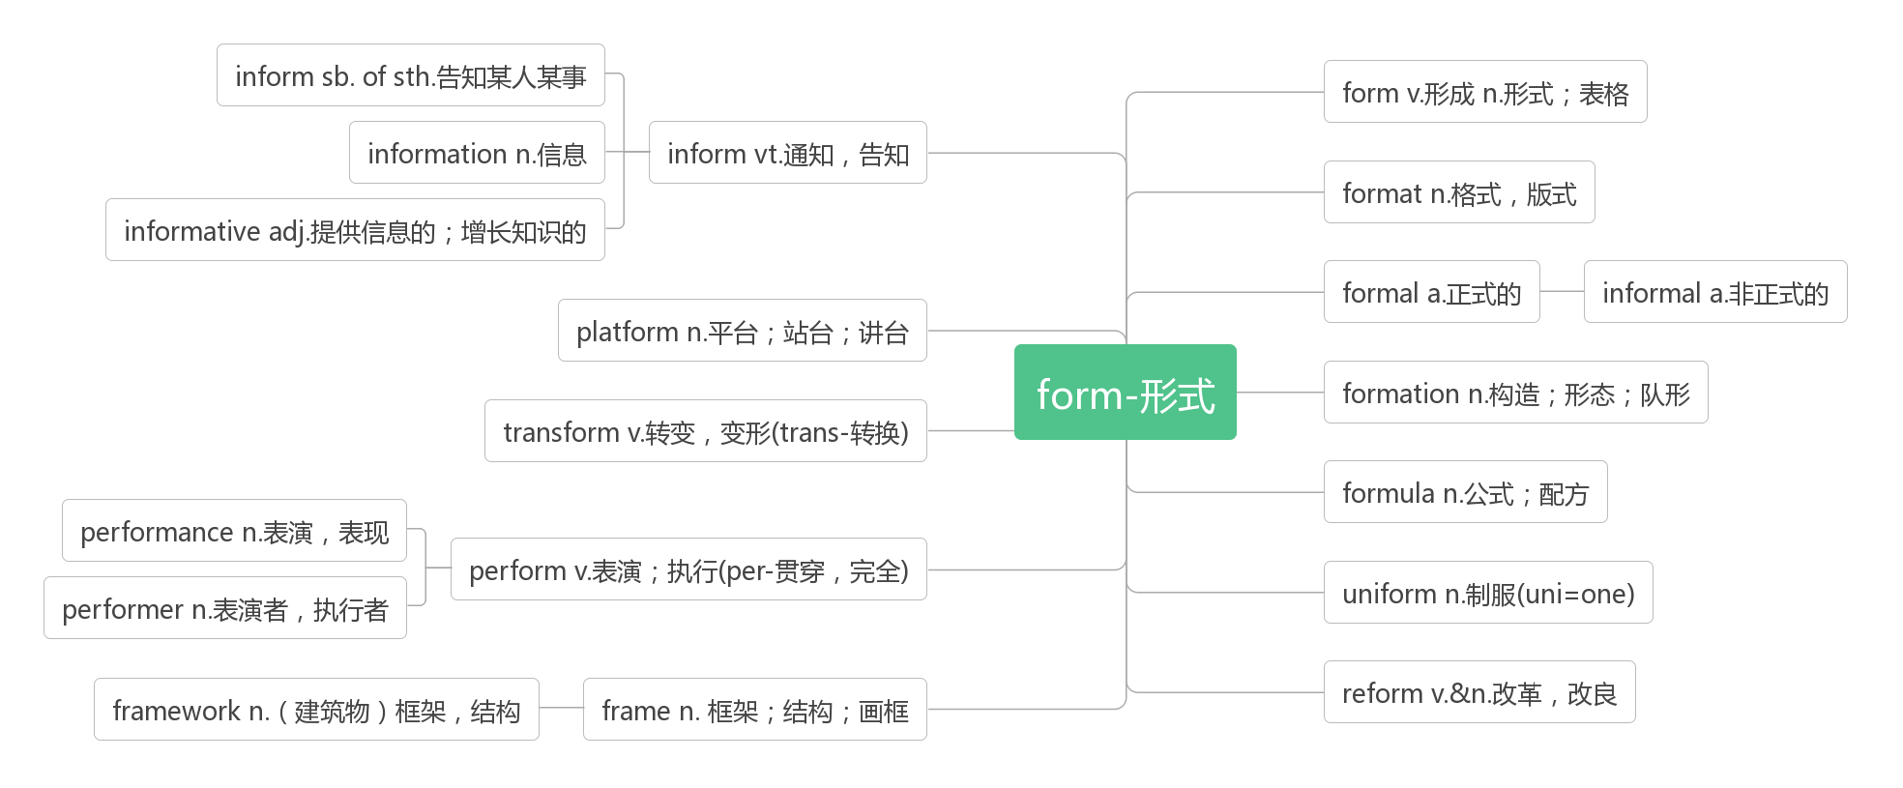

1. **anxious /ˈæŋkʃəs/ adj.焦虑的；担忧的；渴望的**

an anxious look/face/expression 忧虑的目光/面容/表情

Tom is a very anxious person.汤姆是个非常容易焦虑不安的人。

**be anxious about sth. 为某事焦虑**

He seemed anxious about the meeting.他似乎对这次会议忧心忡忡。

**be anxious for sb. 为某人担忧**

Parents are naturally anxious for their children.父母自然为儿女担心。

**be anxious to do sth. 渴望做某事**

She was anxious to finish school and get a job.她渴望毕业找一份工作。

**anxiously /'æŋkʃə slɪ/ adv.焦急地**

He is anxiously waiting for the result of the medical tests. 他焦急地等待着体检结果。

I hope for her letter anxiously. 我焦急地盼望着她的回信。

**anxiety /æŋˈzaɪəti/ n.焦虑；忧虑；渴望**

Her voice was full of anxiety. 她的声音满是焦虑不安。

Anxiety is modern man's natural state.焦虑是现代人的自然状态。

He shouted at her with anxiety.他焦急万分地对着她大喊大叫。

Tom's anxiety to succeed led him to work hard.汤姆对成功的渴望使他更加努力。

1. **annoy /əˈnɔɪ/ vt.惹恼，使恼怒**

She sometimes does things on purpose just to annoy me.她有时存心做些事来使我生气。

A fly was annoying him. 一只苍蝇搅得他心烦。

It annoyed me that I didn't have time to do more reading.腾不出时间多看会儿书让我很烦。

**annoying /əˈnɔɪɪŋ/ adj.令人恼怒的，恼人的**

Don’t ask lots of annoying questions.不要问许多烦人的问题。

You must have found the children annoying.你肯定觉得这些孩子讨人厌烦。

It is annoying that there is no hot water.没有热水,真烦人。

**annoyed /əˈnɔɪd/ adj.感到恼怒的，生气的**

Her mother was annoyed because she was so late. 她母亲生气了，因为她来晚了。

He was annoyed to learn that the train would be delayed. 他得知火车要晚点,心里感到烦恼。

**be annoyed with sb (at/about sth) (因某事)对某人恼火**

He was very annoyed with me about my carelessness. 因为我粗心大意，他对我恼火了。

1. **fright /fraɪt/ n.惊吓，惊骇**

I got the fright of my life. 我吓得要命。

**with/in fright 惊恐地；被吓得**

Pinocchio was beginning to tremble with fright. 皮诺乔开始吓得浑身发抖。

The birds smashed into the top of their cages in fright. 鸟儿们吓得猛撞笼顶。

The grandmother jumped up in her fright and asked him what that meant. 奶奶吓得跳起来，问他这是怎么回事。

**frighten /ˈfraɪtn/vt.使惊恐；吓唬**

Sorry, I didn't mean to frighten you.对不起，我没有吓唬你的意思。

Most children are frightened by the sight of blood. 大多数孩子见到血就害怕。

**frightened /ˈfraɪtnd/ adj.受惊吓的；感到害怕的**

a frightened child 受了惊吓的小孩

She was frightened that the plane would crash.她害怕飞机会坠毁。

Her frightened face showed us that something terrible had happened to her family. 她惊恐的神色向我们表明她家出了大事。

**be frightened of (doing) sth. 害怕(做)某事**

She was frightened of flying. 她害怕坐飞机。

I'm frightened of walking home alone in the dark. 我害怕在黑夜单独走路回家。

**be frightened to do sth. 不敢做某事**

She was too frightened to tell her family what had happened. 她太害怕了，不敢告诉家人发生了什么事。

**frightening /ˈfraɪtnɪŋ /adj.令人恐惧的；吓人的**

a frightening experience/thought可怕的经历/想法

The idea of death is frightening to most people. 死的想法对于大多数人都是可怕的。

It's frightening to think it could happen again.想到此事可能再次发生就使人不寒而栗。

1. **senior/ˈsi:niə(r)/adj.（级别、地位等）较高的; 年长的n.较年长者**

**senior high school（美国）高中**

So this is it— senior high school at last! 就是这样——终于上了高中！（P4）

a senior manager/lecturer高级经理/高级讲师

a senior post/position高级职务/职位

**senior to sb. 比某人资格高/年长**

He is senior to me. 他的职位比我高。

Williams felt himself to be senior to all of them. 威廉斯自认为比他们所有人资格都要老。

My brother is my senior by two years. 我哥哥比我大两岁。

1. **at last 终于; 最后**

The rainy season has ended at last. 雨季总算过去了。

At last they won their freedom. 他们终于赢得了自由。

His wish to visit China has at last come true. 他要访华的愿望终于实现了。

At first he was very tense and at last relaxed. 起初，他非常紧张，最后终于放松了下来。

1. **outgoing /ˈaʊtgəʊɪŋ/ adj.外向的；开朗的**

I'm not outgoing so I'm a little anxious right now. 我不外向，所以我现在有点焦虑。（P4）

He is an outgoing and lively person. 他是个性格开朗而又活泼的人。

She's friendly and outgoing. 她好相处,性格外向。

1. **impress/ɪmˈpres/vt. 使钦佩；使印象深刻vi. 留下印象；引人注目**

词根词缀：im-(里)+press(按压)：把……按到心里——留下印象

It impressed me that she remembered my name.令我佩服的是她记得我的名字。

What impressed me most was their brave spirit. 给我印象最深的是他们的无畏精神。

**impress sb with/by sth. 用……给某人留下深刻印象**

**be impressed with/by 对……印象深刻**

She was deeply impressed by/with the scenery in Guilin. 桂林的景色给她留下了深刻的印象。

**impress sth on sb. 把…印在…上; 使铭记**

My father impressed on me the importance of hard work. 我父亲要我牢记努力工作的重要性。

The scenery in Guilin never fails to impress. 桂林的景色永远让人叹为观止。

**impression/ɪmˈpreʃn/ n.印象**

There was a general impression that tomorrow meant a fresh start. 普遍的感觉是明天意味着一个新的开始。

**make/leave a ... impression on sb.给某人留下……的印象**

I want to make a good first impression. 我想给人留下好的第一印象。（P4）

I hope to make a good impression on your family. 我希望给你的家人留下个好印象。

Her words left a lasting impression on me. 她的话给我留下了难忘的印象。

**have/get an impression of 对……有印象**

I have a good impression of him. 我对他有很好的印象。

**first impression第一印象**

First impressions are the most lasting. After all, you never get a second chance to make a first impression.

第一印象是持久的。毕竟，你永远不可能再有一个机会去给别人再留一次第一印象。

**impressive /ɪm'presɪv/ adj.令人印象深刻的；感人的**

While I really don’t like art, I find his work impressive. 虽然我不喜欢艺术，但是我发现他的作品令人印象深刻。

This is an impressive book.这是一本感人的书。

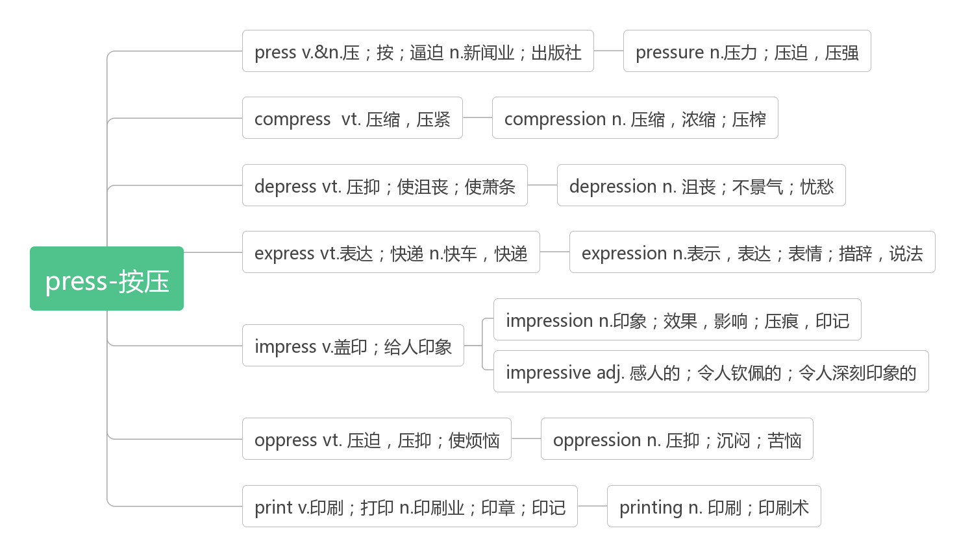

1. **what if 如果…会怎么样呢？**

what if 用于疑问句句首，尤用于询问不希望看到的事发生时的结果。

What if no one talks to me? 如果没人跟我说话怎么办？（P4）

What if it rains? 要是下雨怎么办 ?

What if anything should happen to the child? 万一这孩子出了差错怎么办？

So what if you make a mistake? 如果你犯了错那又怎样？

1. **guy/gaɪ/ n.小伙子；家伙**

I was working with a guy from Japan. 我与一个来自日本的小伙子一起工作。

Hi, guys. How are you doing? 嗨，伙计们，大家还好吧？

1. **concentrate/ˈkɒnsntreɪt/vt.& vi.集中（注意力）；专心于；聚精会神**

**词根词缀：con-(都)+centr-(中央)+-ate:都集中到中央——集中；专心；聚精会神**

I haven't been able to get enough sleep, and I'm too tired to concentrate in class.我睡眠不足，课上精力不集中。

**concentrate on（doing）sth. 集中注意力于（做）某事**

I couldn’t concentrate on the experiment.我无法集中精力做实验。（P4）

You should concentrate on food while eating. 吃饭时，你应该把注意力放在食物上。

Water companies should concentrate on reducing water waste.自来水公司应该专注于减少水浪费。

**concentrate sth. on（doing）sth 把……集中于（做）某事**

You should concentrate your energy on reading and writing. 你应该集中精力于阅读和写作。

I decided to concentrate all my efforts on finding a place to live in. 我决定全力以赴找个住的地方。

**concentration /ˌkɒnsnˈtreɪʃn/ n.集中; 专心，全神贯注**

This book requires a great deal of concentration. 这本书需要全神贯注才能读懂。

With great concentration she worked out the problem. 她聚精会神地解出了这个问题。

1. **experiment /ɪkˈsperɪmənt/ n.实验；试验**

**do/perform/conduct an experiment 做实验**

What do we learn from the experiment ? 我们从这个实验中学到了什么？

Many people do not agree to do experiments on animals. 许多人不赞成在动物身上做试验。

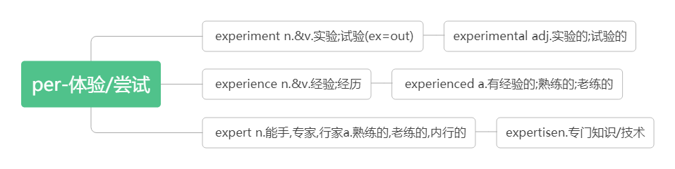

1. **leave...alone** **不打扰..., 不惊动...**

I really wanted to tell him to please be quiet and leave me alone!我真想告诉他请安静点，别打扰我。（P4）

I've told you before─leave my things alone! 我告诉过你——-别碰我的东西！

Leave the birds' nests alone. 不要去碰鸟巢。

1. **awkward /ˈɔ:kwəd/ adj.尴尬的；笨拙的；棘手的**

I didn't feel awkward or frightened at all.我一点也不觉得尴尬或害怕。（P4）

They were trying to get out of this awkward situation.他们正设法摆脱困境。

There was an awkward silence in the meeting room. 会议室里一阵令人尴尬的沉默。

She's got to an age where she is being awkward. 她到了难相处的年龄。

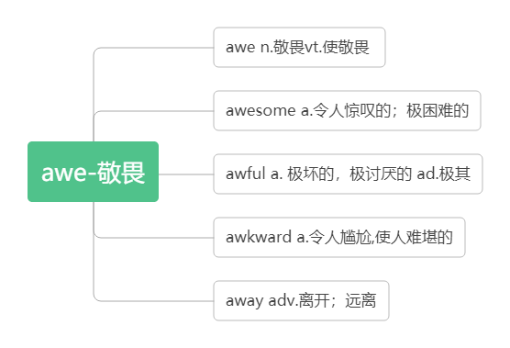

1. **junior /ˈdʒu:niə(r)/adj.地位/职位/级别低下的n.职位较低者;(体育运动中的)青少年**

**junior high school（美国）初级中学**

I miss my friends from junior high school, but I believe I will make new friends。

我想念我初中的朋友，但我相信我会结交新朋友。

My daughter is 16 and my boy is already in junior high school. 我女儿16 岁了，我儿子已经上初中了。

We could give the job to somebody junior. 我们可以把这份工作交给职位较低的人.

office juniors 办公室的一般职员

She has coached many leading juniors. 她训练过许多名列前茅的青少年运动员。

**junior to sb. 比某人资格低/年青**

That teacher's assistant is at least ten years junior to the professor in experience.

那位助教的资历起码比那位教授少十年。

1. **explore /ɪkˈsplɔ:(r)/vt.& vi.探索，探测；勘探**

**词根词缀：ex-(外)+plo-(应用)+re(反复)：反复到外面去找有用的东西——探索，探测；勘探**

I believe I will make new friends here, and there's a lot to explore at senior high.（P4）

我相信我会在这里交到新朋友，而且在高中有很多东西要探索。

As soon as they arrived in the town they went out to explore.他们一到这城镇就外出察看周围环境。

What does the author say about America's aim to explore space?作者对美国探索太空的目标有何评论？

Children who have chances to explore natural areas tend to develop a strong love for science.

有机会探索自然区域的儿童往往会培养对科学的强烈热爱。

The city is best explored on foot. 最好是徒步考察这个城市。

**explore for 勘探**

The companies are allowed to explore for oil and gas.这些公司被允许勘探石油和天然气。

**exploration /ekspləˈreɪʃn/n.探索；勘探；探险**

We have made great progress in space exploration.我们在探索太空方面取得了很大进展。

The new method saves the cost of oil exploration. 这种新方法节省石油勘探成本。

The answer to this question is now under exploration. 该问题的解决办法在探讨中。

This book is about a scientific exploration. 这本书是关于科学探险的。

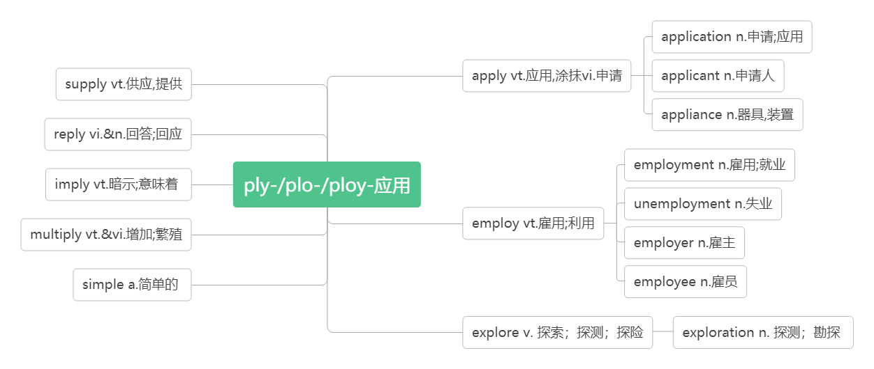

1. **confident/ˈkɒnfɪdənt/adj.自信的；有信心的**

**词根词缀：con-(强调)+fid-(信)+-ent(形容词后缀)：有信心的；自信的**

I feel much more confident than I felt this morning.（P4）我觉得比今天早上更有信心了。

Mary is a confident and happy child. 玛丽是个自信、快乐的孩子。

I think you should be a bit more confident. 我认为你应该稍微自信一点儿。

**be confident of/about (doing) sth 对(做)某事有信心**

The teacher wants the children to feel confident about asking questions when they don't understand.

教师要孩子们遇到不懂的问题就大胆提问。

Mr. Smith is confident of success. 史密斯先生坚信一定会成功。

The team feels confident of winning. 这个队觉得有把握取胜。

**be confident that…确信……**

I'm confident that you will get the job. 我肯定你能得到那份工作。

He is confident that everything will get better. 他坚信一切都会更好。

**confidently/'kɒnfədəntlɪ/adv.确信地；肯定地; 自信地**

You must act confidently. 你必须表现得自信。

He felt safe now, and he spoke more confidently. 他觉得现在安全了, 便更大胆地说起来。

I can confidently promise that this year is going to be very different. 我可以信心十足地保证今年将大不一样。

**confidence /ˈkɒnfɪdəns/n.信心；信任；自信心**

He expressed his confidence that they would win. 他表示了自己的信心：他们必定取胜。

He gained confidence when he went to college.他上大学后增强了自信。

**have confidence in 对……有信心/信任**

I have every confidence in my students' abilities. 我完全相信我的学生的能力。

We have confidence in our government. 我们对政府充满信心。

**with confidence 自信地；有把握地**

He answered the questions with confidence . 他自信地回答了那些问题。

I can say with confidence that the economy will be better soon.我可以有把握地说经济很快就会好转。

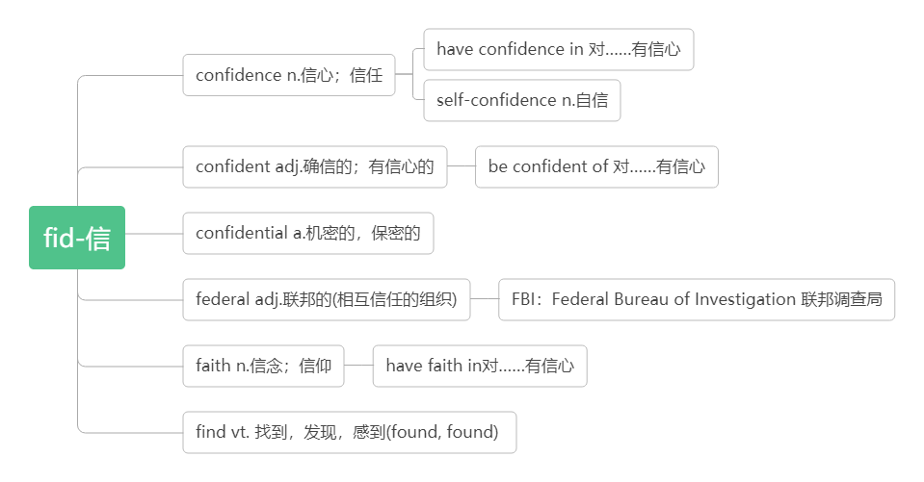

1. **forward /ˈfɔ:wəd /**

**adv.（also forwards）向前**

He took two steps forward.他向前走了两步。

They ran forward to welcome her. 他们跑向前去欢迎她。

**adj. 向前的；前进的 (只用于名词前)**

the forward movement of history 历史的向前发展

the plane's forward door 飞机前舱门

**look forward to (doing) sth. 盼望/期待(做某事)**

Tom is looking forward to meeting the new exchange student.汤姆期待着见到新来的交换生。（P6）

We are looking forward to the coming of spring.我们正盼望着春天的到来。

I look forward to your reply我期待你的答复。

I look forward to hearing from you in the near future. 我盼望着不久收到你的信。

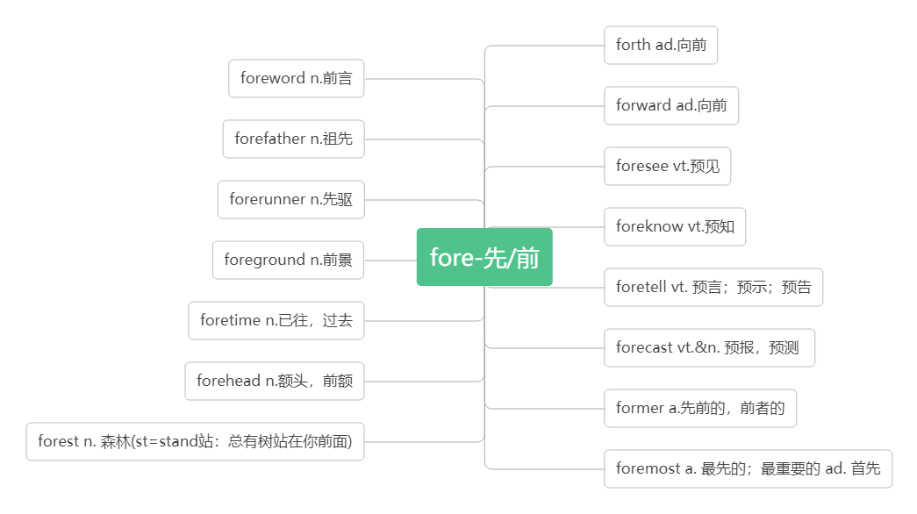

1. **take notes 记笔记**

Listen to the teacher and take notes.听老师讲课并做记笔记。（P7）

I take notes while listening and reading. 我边听边读边做笔记。（P7）

Students should take notes in class.学生在课堂上应该记笔记。

She took out her notebook and began to take notes. 她掏出笔记本,开始记笔记 。

Please take notes of the important words while you read. 请边读边把重要的单词记下来。

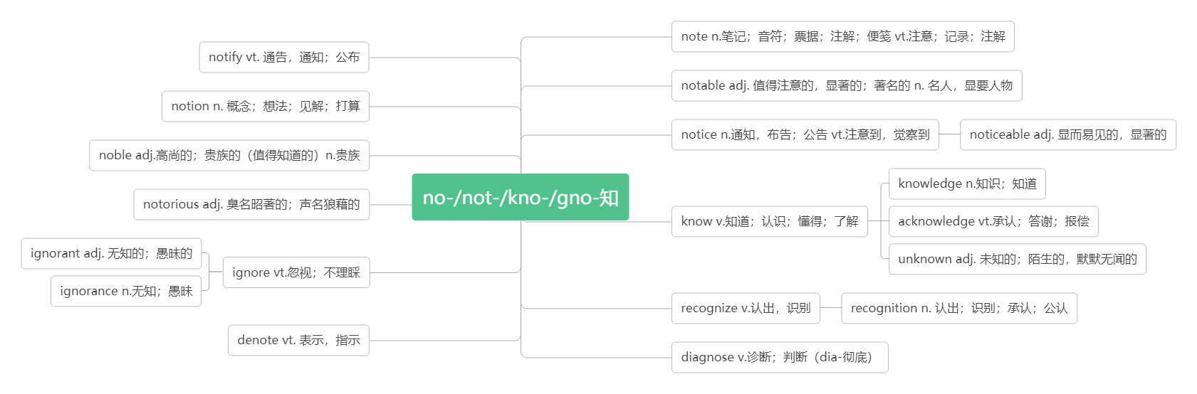

1. **flash/[flæʃ/**

**n. 闪光; 信号**

a flash of lightning 一道闪电

flash cards识字卡

Children can use flash cards to learn English. 小孩可以使用识字卡来学英语。

Flash card is very useful to students. 教学卡片对学生很有用。

The flash sent the foxes running away. 闪光惊得狐狸逃窜。

**in a flash 一瞬间**

The answer had come to him in a flash. 他一下子就有了答案。

It was done in a flash. 一眨眼的工夫就完成了。

**vi. 闪光；发出信号**

Lightning flashed in the distance. 远处电光闪闪。

There is something wrong with the traffic light because only the red light flashes on and off.

交通灯出故障了，只有红灯一直在闪。

**vt. 使闪光；发出（信号）**

Why is that driver flashing his lights at us? 为什么那个司机向我们闪着车灯？

1. **organize (BrE- ise) /'ɔ:(r)gənaɪz/ vt.&vi. 组织,筹备,安排,组建**

How does Li Ming organise his thoughts? 李明是如何组织他的想法的？（P7）

to organize a meeting /party /trip /competition /club组织筹备会议/聚会/旅行/比赛/俱乐部

We'll organize some students into the basketball team. 我们将组织一些学生参加篮球队。

Workers have the right to organize trade unions according to law. 劳动者有权依法组织工会。

His speech is well organized. 他的演讲很有条理。

It's the first time farmers have decided to organize. 这是农场主首次决定组织起来。

He has the ability to organize. 他很有组织才能。

**organization (BrE- isation)/ɔ:gənaɪˈzeɪʃn/ n.组织; 团体; 机构**

a business/political organization 一个商业/政治机构

the World Health Organization 世界卫生组织

the International Labour Organization 国际劳工组织

They set up a charity organization last year. 去年他们建立了一个慈善机构。

No organization or individual are allowed to use the logo in advertisement or any other business activities.

任何团体或个人不得将标识用于广告或其他商业性活动。

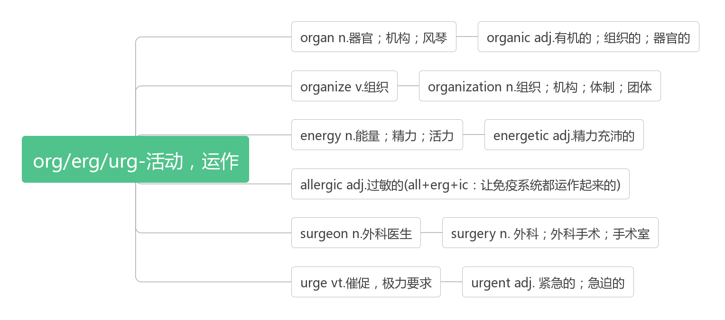

1. **goal /gəʊl / n. 目标;球门;射门**

I have learning goals and make plans for my English studies. 我有学习目标，并为我的英语学习制定计划。（P7）

Our goal is to raise as much money as possible for the project.我们的目的是为这个项目筹集到尽可能多的资金。

He scored the winning goal.他踢进了制胜的一球。

Liverpool won by three goals to one.利物浦队以三比一获胜。

1. **strategy /ˈstrætədʒi/n.策略；战略**

词根词缀：strat-(伸展)+-ety(名词后缀)：展开的计划——策略

What learning strategies do you and your partner share ?你与你的搭档分享什么学习策略？（P7）

What is the best strategy for you to learn new words?对你来说学习生词的最佳策略是什么？（P7）

the government's economic strategy 政府的经济策略

We need to discuss our new strategy. 我们需要商讨一下我们的新策略。

We have reduced air pollution through many strategies.我们通过许多策略减少了空气污染。

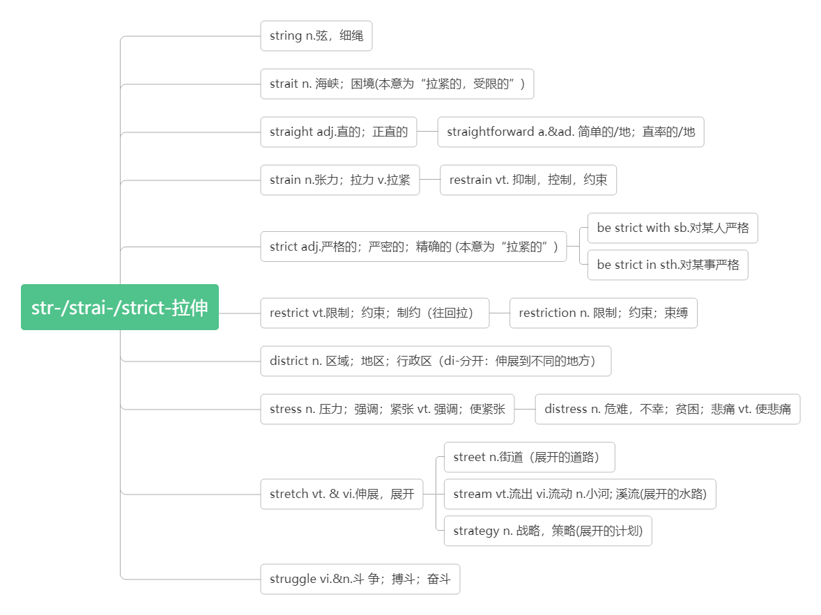

1. **partner /ˈpɑ:tnə(r)/ n.同伴; 配偶；搭档**

a marriage partner 配偶

I have a good partner to practice English with.我有一个好搭档一起练英语。

China and America are now economic partners.中国和美国目前是真正的经济合作伙伴。

"Changing Partners" , a pop song in the 1950s, is now still loved by many people.

“交换舞伴”是二十世纪五十年代的一首流行歌曲，现在仍然被人们所喜爱。

1. **curious /ˈkjʊəriəs/adj.好奇的; 奇怪的**

词根词缀：cur-(心)+-ious(形容词后缀)：用心去探寻的——好奇的

Children are naturally curious. 孩子天生好奇。

A curious child is a teacher's delight. 老师喜欢有求知欲的孩子。

It's the most curious thing I ever saw in my life! 这是我一生中看到的最奇怪的事情！

**be curious about 对……好奇**

I'm curious about everything. 我对一切都很好奇。（P8）

Always be curious about new things and keep learning.永远对新事物抱有好奇心，让学习持续不断。

She seemed to be curious about what he was doing. 她似乎对他正在做的感到很好奇。

**be curious to do sth 好奇于做某事**

You must be curious to find out how to decorate the Christmas tree. 你一定很好奇想弄清楚如何装饰你的圣诞树。

**curiously /'kjʊərɪəslɪ/ adv.好奇地；奇怪的是**

He looked curiously at the people. 他好奇地看着那些人。

Curiously enough, he had never seen the little girl.说也奇怪,他竟从未见过那个小女孩。

**curiosity/kjʊəriˈɒsəti/ n.好奇心**

It is good to be curious about the world around you because I think curiosity is the best teacher.

对你周围的世界感到新奇是件好事，因为我认为好奇心是最好的老师。

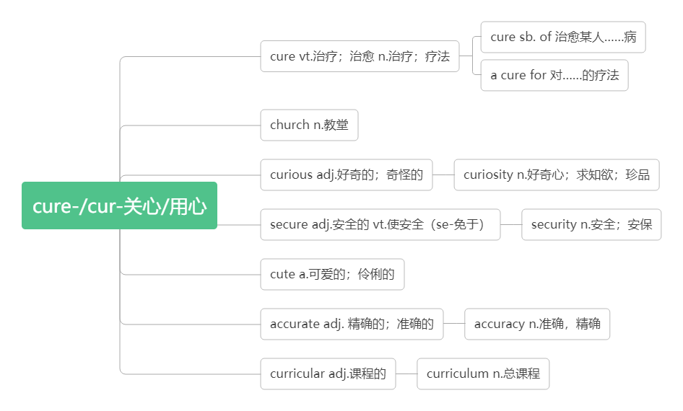

1. **company/ˈkʌmpəni/ n.公司；陪伴**

**破拆法：com-(come来)+pany(陪你)：来陪你**

My dream is to start my own IT company!我的梦想是成立自己的IT公司！（P8）

What are your plans for the development of your company?你打算怎样来发展壮大自己的公司？

I enjoy her company. 我喜欢和她在一起。

**for company 作为陪伴**

He went with us to the airport for company. 他陪同我们去机场了。

**keep company with与某人交往**

No one wants to keep company with someone who always looks upset. 没有人喜欢和经常很沮丧的人交往。

**accompany/ə'kʌmpəni/vt.&vi. 陪伴，伴随；伴奏**

strong winds accompanied by heavy rain 狂风夹着暴雨

His wife accompanied him on the trip. 那次旅行他由妻子陪同。

The singer was accompanied on the piano by her sister. 女歌手由她姐姐钢琴伴奏。

**companion /kəmˈpænjən/n.同伴，伙伴**

He was a good friend, a dependable companion. 他是个好朋友，一个可以信赖的同伴。

She was a charming dinner companion. 与她同桌进餐使人感到十分高兴。

His younger brother is not much of a companion for him. 他的弟弟和他志趣不太相投。

1. **person/ˈpɜ:sn/ n.人**

词根词缀：per-(每个)+son(儿子)：每个人都是上帝的子民。

He's just the person we need for the job. 他正是我们需要的适合这项工作的人。

At least four persons died in the accident. 至少四个人在事故中死亡。

**in person亲自**

I first considered writing to him, but then decided to go and speak to him in person.

起初我想写信给他，但后来我决定亲自过去和他谈

**personal /ˈpɜ:sənl/ adj. 个人的; 私人的**

Of course, this is just a personal opinion. 当然了，这只是个人意见。

The novel is written from personal experience . 这部小说是根据个人亲身经历写成的。

She's a personal friend of mine . 她是我的私人朋友。

He is always curious about my personal life .他对我的私生活很好奇。

**personally /ˈpɜ:sənəli / adv.亲自地; 就个人而言**

I handed the letter to him personally. 我亲自把这封信交给了他。

Personally, I am very satisfied with his work. 就个人而言，我对他的工作很满意。

**personality /ˌpɜ:səˈnæ ləti / n.性格；个性**

How would you describe Yuan Longping’s personality? 你如何描述袁隆平的个性呢？

His wife has a strong personality. 他妻子的个性很强。

The children all have very different personalities. 孩子们的性格各不相同。

1. **style /staɪl/ n.方式; 作风；样式；款式**

learning style 学习方式（P9）

a management style 管理方式

Now on-line shopping has changed people's life style.现在网上购物改变了人们的生活方式。

The story was written in a lively and interesting style.这个故事以一个生动有趣的风格来写作的。

The building was built in the style of a Chinese palace. 这座建筑是仿照中国宫殿形式而建的。

Caution was not her style. 谨小慎微不是她的作风。

**in style 时髦；气派**

She always celebrates her birthday in style. 她的生日总是过得很排场。

1. **revise / rɪˈvaɪz/ vt.& vi. 修改, 修订；复习**

Get your draft back and revise it. 把草稿拿回来修改一下。（P9）

It is necessary to revise the original plan. 原计划须加以修改。

We have to revise the dictionary. 我们必须修订这部字典。

I can't come out tonight. I have to revise. 我今晚不能出去。我得复习。

I'm revising Geography today. 我今天要复习地理。

# **revision /rɪˈvɪʒn/n.修订；复习**

# Have you started your revision yet? 你开始复习了吗？

# The phase of writing that is actually most important is revision. 写作中真正最重要的阶段是修改。

