**高考英语语法填空解题技巧**

**Step 1 高考试题考查分析**

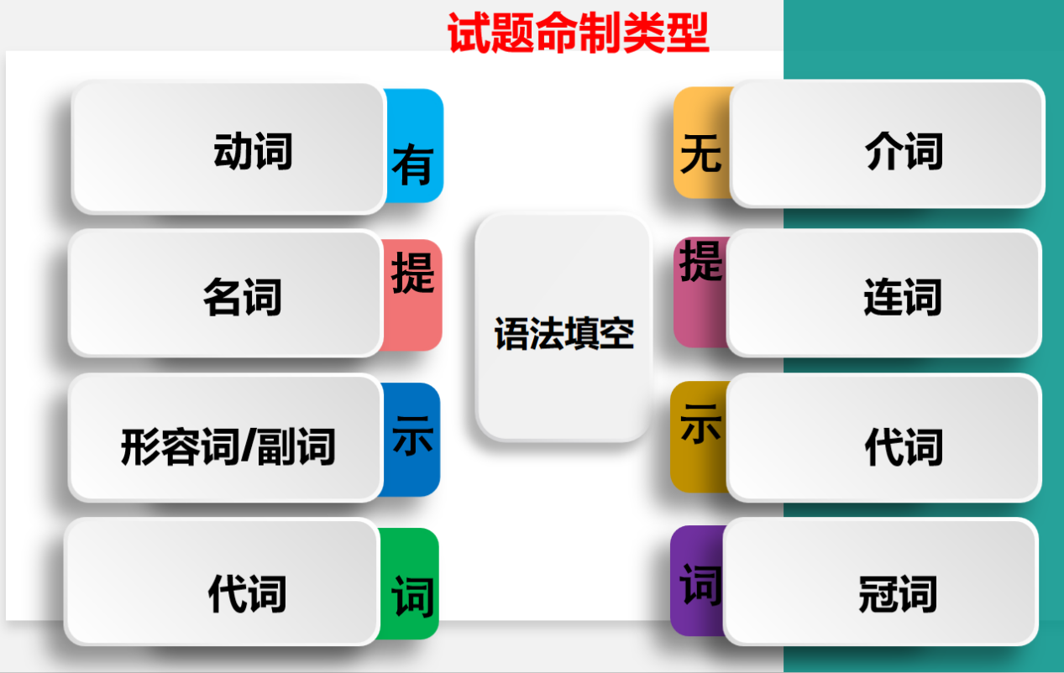

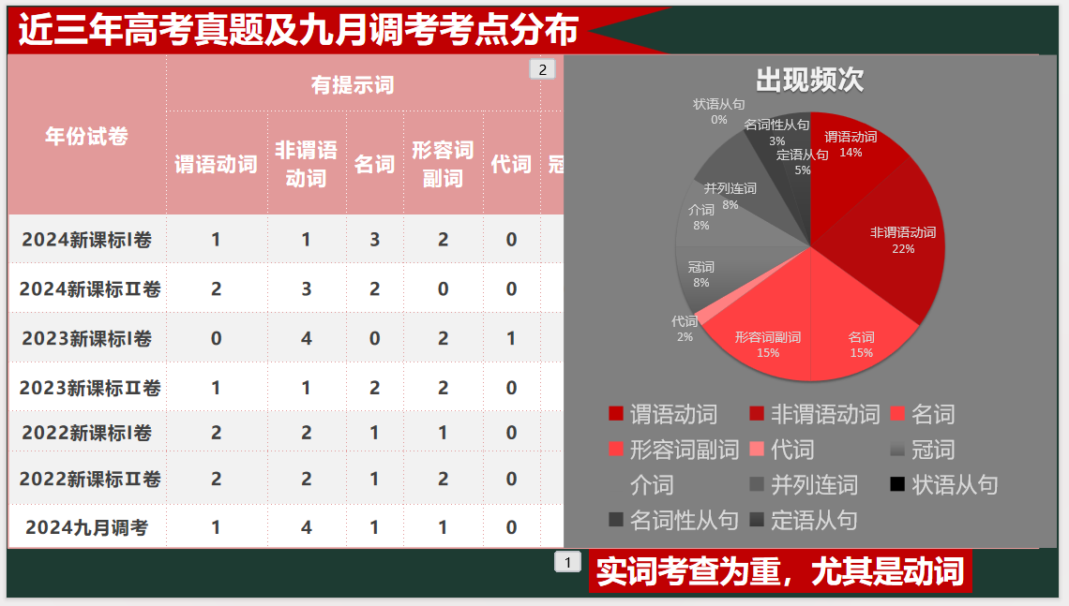

**Step 2 2024年11月浙江杭州一模题**

第二节(共10小题;每小题1.5分,满分15分)

阅读下面短文,在空白处填入1个适当的单词或括号内单词的正确形式。

“Nice” to Meet You, Hangzhou

Nice, France and Hangzhou, China have been developing a unique bond since their official declaration 56 sister cities in 1998, connecting the two vibrant cultures separated by 9, 300 kilometers through numerous 57 ( mitiative). To Rudy Salles, deputy chairman of the Nice Tourist Office,the sister-city rerationship between the two is a perfect match.

Having visited Hangzhou several times, Salles describes it as “a very well- organized and 58 (welcome) city”. He recalls a Nice food festival at the Dragon Hotel Hangzhou, where traditional food, such as salade nicoise 59 (make) from tomatoes, hard-boiled eggs and olives and dressed with olive oil, and pan bagnat,60 sandwich made from whole wheat bread enclosing the classic salade nicoise, was served.

The cultural exchange between the two cities reached a new 61 (high) in 2017 when Hangzhou Opera and Dance Drama Theater 62 ( stage)the show To Meet the Grand Canal in Nice, at the invitation of the Nice government. In addition to the formal show, Chinese performers organized flash events on the streets of Nice 63 ( engage) more people.

In 2014 the Grand Canal was listed as a UNESCO World Heritage Site. At the news, the Nice government approached Hangzhou, keen to learn from its experience, as Nice was seeking a similar status. In 2021，UNESCO added the city of Nice to its World Heritage List.“Our candidacy for UNESCO 64 (support) by China, for 65 we are so grateful, ” says Salles.

**Step 3 语法填空技巧总结**

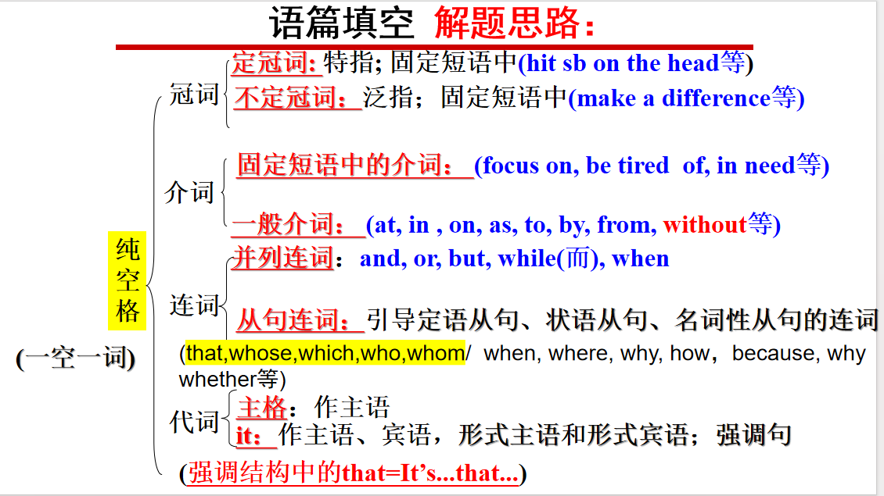

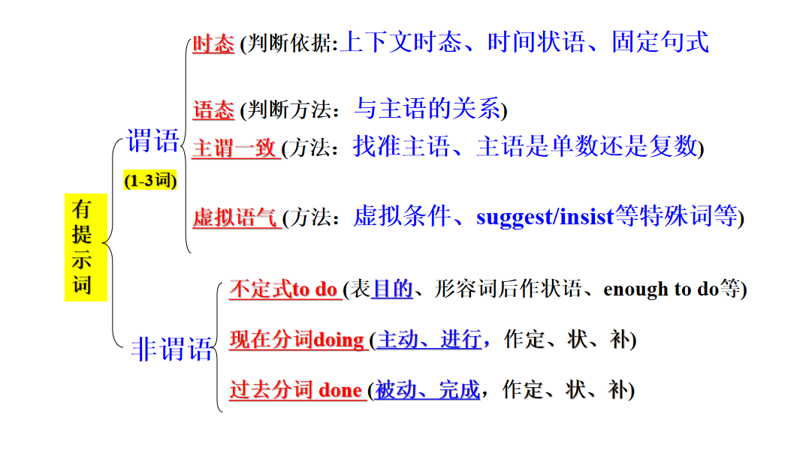

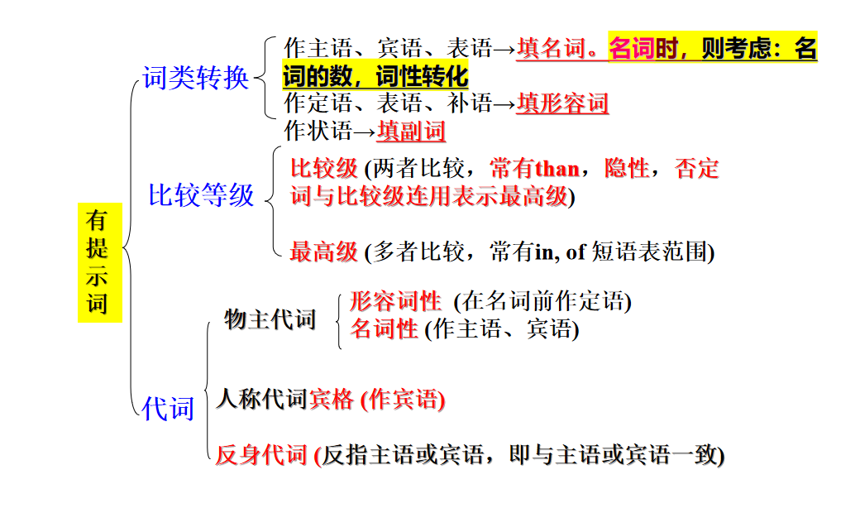

**Step 4 高考真题练习**

一、谓语动词--时态

**1.根据时间状语判断时态**

（1）(2024浙江卷) Over the last two years, some supermarkets____________(start) selling chicken or salad in packs _____________(design) with two halves containing separate portions (份).

**技巧点拨：**

现在完成时标志词：since+时间点, recently, lately, already, for/during/over/ in the last/past+时间段, so far= up to now, ever since等时间状语。

（2）（2022全国高考新高考I卷）The plan will extend protection to a significant number of areas that ___________ (be) previously unprotected, bringing many of the existing protected areas for giant pandas under one authority to increase effectiveness and reduce inconsistencies in management.

**技巧点拨：**

过去完成时标志词：by then , by/before/till the end of+过去的时间点等时间状语。

**2.根据上下文语境推测时态**

(2024年新课标II) “Some of the things that Tang was writing about____________(be) also Shakespeare’s concerns…... ”

技巧点拨：

根据空格前后的动词的形式以及整篇文章的语境来判断时态

**3.固定搭配/句式**

（1）( 2022新高考I卷 ) Henry______________(fix)his car when he heard the screams.

**技巧点拨：**

**be doing sth when sb did...**

**be about to do sth when…**

**had just done sth…when…**

（2）It was the first time in a year and a half that she____________ (see) it.

**技巧点拨：**

**It is the first/second…time that sb have/has done sth**

**It was the first/second…time that sb had done sth**

**二、谓语动词--语态**

1. (2023全国甲卷)Carson proves that a simple lyric form that has been passed down through the ages can still ________________ (employ) today to draw attention to important truths.

2. (2023新课标全国I 卷)Nanxiang aside, the best Xiao long bao have a fine skin, allowing them _________________ (lift) out of the steamer basket without allowing them tearing or spilling any of their contents.

3. (2024年新课标II) A statue commemorating Shakespeare and Tang was put up at Shakespeare’s Birthplace Garden in 2017. Two years later, a six-meter-tall pavilion, ______________(inspire) by The Peony Pavilion, ______________(build) at the Firs Garden, just ten minutes’ walk from Shakespeare’s birthplace.

4. (2024年浙江) However, though it’s nice to get a few cents off a pack of sausages, it would help even more if they could sometimes _____________(offer) in smaller packs.

**三、非谓语动词---状语（高频考点）**

1. (2023全国乙卷)___________________(visit) several times over the last 10 years, I was amazed by the co-existence of old and new, and how a city was able to keep such a rich heritage (遗产) while constantly growing.

2. (2023全国甲卷) …..,her fable begins, _______________ (borrow) some familiar words from many age-old fables.

3. (2023浙江1月) In the Ming Dynasty, the center was the Forbidden City, ______________(surround)in concentric(同心的)circles by the Inner City and Outer City.

**四、非谓语动词---定语（高频考点）**

1. (2024全国新课标II) Two years later, a six-meter-tall pavilion, ________________(inspire) by The Peony Pavilion, ________________(build) at the First Garden, just ten minutes’ walk from Shakespeare’s birthplace.

2.(2024浙江) Over the last two years, some supermarkets_______________ (start) selling chicken or salad in packs_______________(design) with two halves containing separate portions (份).

3. (2022全国甲卷) A visually-challenged man from Beijing recently hiked (徒步) 40 days to Xi’an, as a first step ___________ (journey) the Belt and Road route (路线) by foot.

4. (2023新课标全国I 卷)Shanghai may be the ____________ (recognize) home of the soup dumplings but food historians will actually point you to the neighboring canal town of Nanxiang as Xiao long Bao’s birthplace.

**五、非谓语动词---宾语（高频考点）**

1.(2023新课标全国I 卷) The dumplings arrive steaming and dangerously hot. To eat one, you have to decide whether __________ (bite) a small hole in it first, releasing the stream and risking a spill (溢出), or to put the whole dumpling in your mouth, letting the hot soup explode on your tongue.

2. (2021全国甲卷) After _______________ (spend) some time looking at all the defensive equipment at the wall, we decided it was time for some action and what better than to ride on a piece of history!

**六、动词---词性转换**

1. (2021浙江6月)In 1844, they bought it with $1,200 and some land from Charles Dresser, who performed their ______________(marry) ceremony in 1842.

2. (2022新高考全国II卷) They both fell ___________ (sleep) while watching TV.

3. (2023新课标全国2)Since June 2017, right before the __________ (arrive) of the two new pandas, Meng Meng and Jiao Qing, I have been helping the panda keepers at the zoo to feel more comfortable and confident speaking English.

4. (2024浙江) Many supermarkets are no longer doing “buy one get one free” promotions because of the ______________(criticize) that they lead to waste.

**七、形容词/副词---词性转换**

1. (2021年北京卷)Sam walked her to a nearby convenience store so that she could __________(safe)wait for the police to take her home．

2. (2023浙1月)The term “hutong”, ____________ (original)meaning “water well” in Mongolian, appeared first during the Yuan Dynasty.

3. (2023新课标全国I卷) No matter where I buy them, one steamer is _______ (rare) enough, yet two seems greedy, so I am always left wanting more next time.

4. (2023新课标全国2卷) So, what are they learning? _____________ (basic), how to describe a panda’s life.

5.(2022全国甲卷) In the last five years, Cao has walked through 34 countries in six continents, and in 2016, he reached the top of Kilimanjaro, Africa’s ___________ (high) mountain.

6. (2024全国甲)Yellowstone was the______________ (large) United States national park — 2.2 million acres — until Wrangell-Saint Elias in southern Alaska,

**技巧点拨：**

1. 最高级前: 定冠词the

2. 最高级句子中: 一个范围。

**八、名词单复数**

1. (2023新课标全国2)They also need to be ready to give_____________(interview) in English with international journalists.

2. (2021新高考全国1卷)The rolling sea of clouds you see once you are at the top will remind you how tiny we ___________ (human) are.

3. (2021全国甲卷) Supposedly you can do it in two hours, but we stopped at the different gates and ________________ (watchtower) to fake pictures or just to watch the local people going about their daily routines.

1. **代词**

1. (2021新高考卷) As the song goes, this long and winding road “will never disappear”, and it will always stick in the visitor’s memory. It sure does in ____________ (I).

2. (2021全国乙卷) Ecotourism has ______ (it) origin with the environmental movement of the 1970s.

3. (2023新课标全国I卷)Nanxiang aside, the best Xiao long bao have a fine skin, allowing them to be lifted out of the steamer basket without allowing them tearing or spilling any of_________(they) contents.

**十、连词---定语从句**

1.(2022全国甲卷语法填空)On the 1,100. Kilometer journey, the man Cao Shengkang, _______________ lost his eyesight at the age of eight in a car accident, crossed 40 cities and counties in three province.

2.(2022北京卷)That includes cups, bottles, and bags, most of ________ are only good for one use.

**十一、连词---名词性从句**

1. (2022年浙江) Cobb, for her party, started to ask conference organizers who invited her to speak __________ she could do so remotely; about three-quarters of the time, they agreed.
2. (2024全国甲) On a cool, starry night in mid-September 1870, four men relaxed before a campfire along the Firehole River in___________ is now northwestern Wyoming.

3. (2019 全国I)While they are rare north of 88°, there is evidence_______ they range all the way across the Arctic, and as far south as James Bay in Canada.

4. (2024浙江) If most of their customers are happy to buy larger quantities, that’s _________they’ll promote. But that leaves the solo (单独) customers out of pocket and disappointed.

5. (2021新高考全国1卷)_________ is so breathtaking about the experience is the out-of-this-world scenes.

**十二、连词---并列句**

1. (2021新高考卷)Though it is the only unnatural thing on your way up the mountain, still it highlights the whole adventure ____________offers a place where you can sit down to rest your aching legs.

2.(2021年1月浙江)In a study of 33 years of trends in Body Mass Index（体重指数）across 200 countries the scientists found that people worldwide are getting heavier ____________ that most of the rise is due to gains in BMT in rural areas.

3.(2020年1月浙江)It’s also that they are on average healthier ____________ more productive for longer. Therefore, they can work for longer, consume more and in general be a boost to the economy.

4.(2023全国乙卷)It is a distinct visual contrast (反差) that shouldn’t work, ____________ somehow these two very different worlds make a good combination.

5.(2023新课标全国I卷) The dumplings arrive steaming and dangerously hot. To eat one, you have to decide whether to bite a small hole in it first, releasing the stream and risking a spill (溢出), __________to put the whole dumpling in your mouth, letting the hot soup explode on your tongue.

6. (2021浙江) Although Mary loved flowers, _________ she nor her husband was known as a gardener.

7. (2019全国II) I work not because I have to, _________because I want to.”

**十三、连词---状语从句**

1. (2015安徽卷)_______________________________scientists have learned a lot about the universe, there is much we still don’t know.

2.(2016天津卷)____________the average age of the population increases, there are more and more old people to care for.

3. If you don’t understand something，you may research，study，and talk to other people ___________ you figure it out.

4.(2019·全国Ⅲ)On our way to the house，it was raining _______ hard that we couldn’t help wondering how long it would take to get there.

**状语从句固定句型有：**

so/such...that...; so that….

not...until...

It will/won’t be＋...＋before... ;

It was＋...＋before...

It is some time＋since... ;

no sooner...than...;

hardly...when...

As….As …..

**十四、冠词**

1.(2022全国甲卷)______ friend of his, Wu Fan, volunteered to be his companion during the trip.

2. (2022新高考全国II卷) _________ Brown family live in an apartment building outside Toronto. On the day of the accident, Mrs. Brown was at work and Eric was at home with his father.

3. (2022新高考全国1卷) Covering an area about three times _________ size of Yellowstone National Park, the GPNP will be one of the first national parks in the country.

4. (2022浙江) The tactile(可触知的)paintings work as a way to show art to ________ blind because we don’t see with just Our eyes: We see with our brains.

5. (2021新高考全国卷1)As the song goes, this long and winding road “will never disappear”, and it will always stick in the visitor’s memory. It sure does in mine. While you’re in China, Mount Huangshan is________ must to visit!

6.(2023新课标全国1卷) The meat should be fresh with ________ touch of sweetness and the soup hot, clear and delicious.

7.(2023浙江1月) In contrast to the court life and upper-class culture represented by the Forbidden City, the Summer Palace, and the Temple of Heaven, the hutongs reflect __________ culture of grassroots Beijingers.

**技巧点拨：**

1.a+辅音音素；an+元音音素;

a/an+单数可数名词

2.如果空格后是序数词、最高级或上文提到过的人或物等时，考虑空格处是否需要填the；

3.固定搭配: in a word, a touch of,倍数+the size of, a range of等

**Step 5 Homework**

**九省联考第二节(共10小题;每小题1.5分，满分15分)**

阅读下面短文，在空白处填入1个适当的单词或括号内单词的正确形式。

The 21- year- old Olympic champion Zheng Qinwen made history as the first Asian player to win an Olympic singles title by 56 (defeat)Croatia’s Donna Vekic in the final match in Paris on Saturday. It was the first singles medal for China in tennis since the sport returned to the Olympics in 1988.

Zheng expressed her thanks to her two coaches, Xia Xiyao and Yu Liqiao, both of 57 previously coached LiNa. 58 (Zheng)first coach was Xia Xiyao. After training under Xia for a year, she 59 (send) to Yu Liqiao. Known for her strict and tough coaching style, Yu was famously demanding. Zheng remarked that during her stay in Wuhan, Yu was the coach who contributed most significantly 60 her progress.

Zheng also revealed the lengths her supportive parents went to during her early 61 (year) to prepare for the victory. “My parents sacrificed a lot for me," Zheng said. “When I was 12, my mum quit her job to support my tennis journey. When I was 14 62 15, my father sold our house to help me to 63 (real) my tennis dream. My success is not just 64 (I) ; it’s also my parents’. They taught me how to stay 65 (focus) on my dream. They always believed in me.”