**The World**（**1016-1031**）材料分析和教学目标：

本次选用的材料：①*T**he Wall Street Journal* 的*World Watch*（世界观察）、②*BBC Science Focus*的*The botanists studying plants from the sky*（植物学家从空中研究植物）、③*Unprocess Your Diet*的*HOW MUCH SUGAR IS TOO MUCH?*（摄入多少糖算多？）、④*The Times*的 *Smoking leaves a trace in bones for centuries*（吸烟会在骨头上留下的痕迹会持续几个世纪）和⑤BBC的新闻报道。通过语法填空、阅读理解、分析长难句、翻译句子、听力填空和词汇拓展等方式，让学生从多角度提升学习兴趣，提高分析句子、运用词块和听力能力。外媒英语新闻可以让学生体验真实语境下的语言运用，拓展学生的国际视野，了解时事，逐步提升跨文化沟通能力，形成正确的世界观、人生观和价值观。

**教学思路：**

**Part 1: News Report 1 *The Wall Street Journal* (October 18, 2024 A8)**

**World Watch 世界观察**

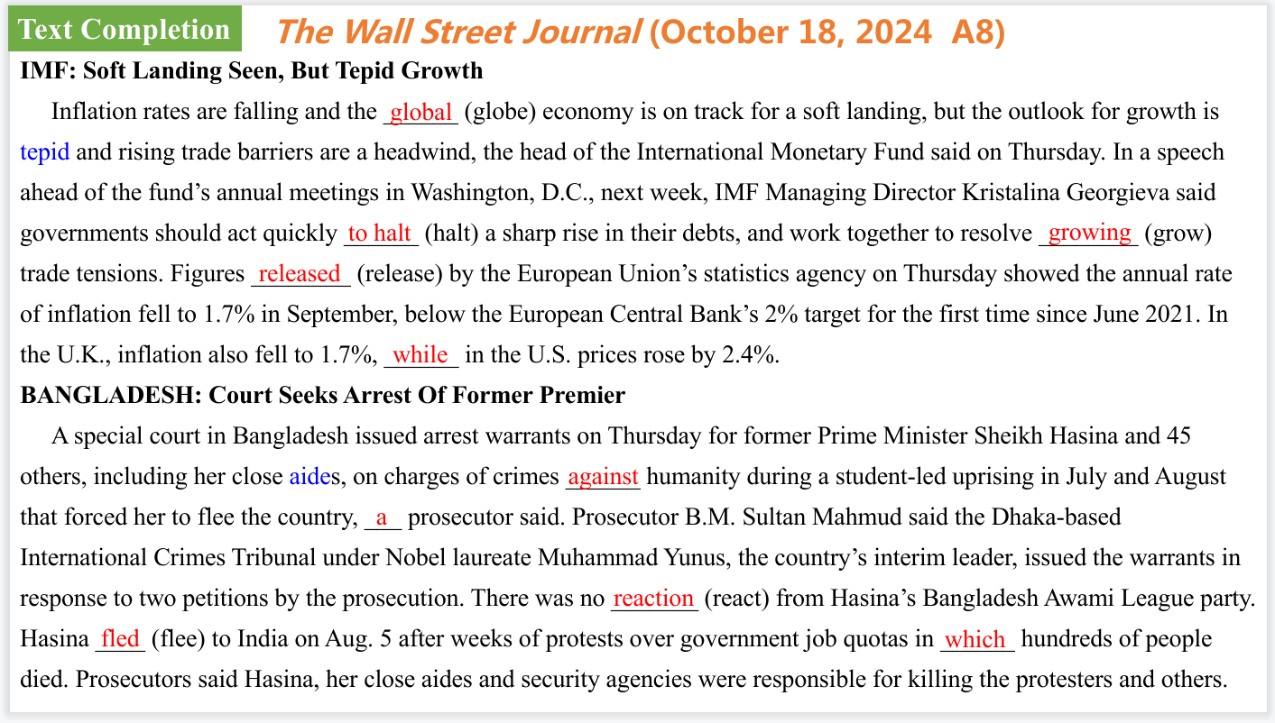

【设计意图】通过语篇填空的形式帮助学生理解新闻的主要内容，同时训练语言语法的运用能力：在语篇的视角下如何正确使用所给词汇，根据语法规则确定词汇的正确形式，使得文章通顺，激活学生的思维和语言。该新闻主题语境是关于“人与社会”中“社会热点问题”这一子主题，通过学习让学生了解实事两则。

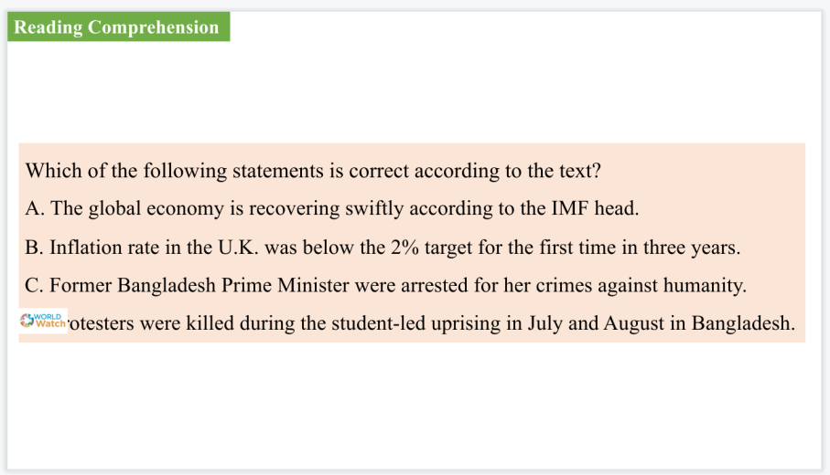

【设计意图】通过阅读理解的形式帮助学生理解新闻的主要内容。

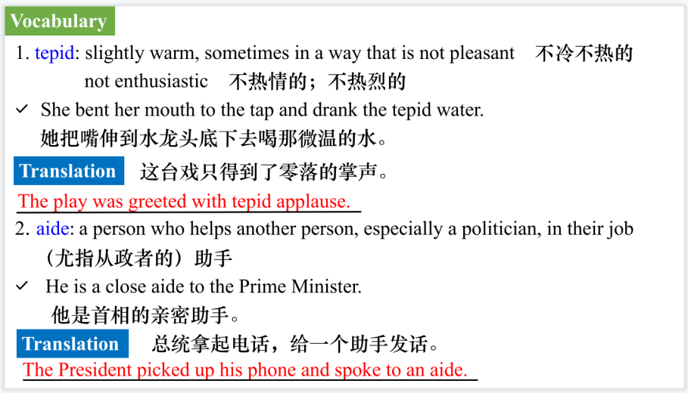

【设计意图】对文本中的词汇进行解读，并通过翻译句子对其进行巩固。

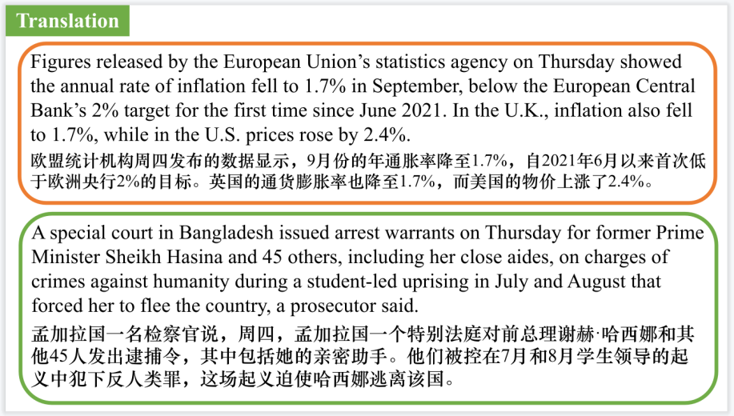

【设计意图】对文中的两个句子进行翻译练习，对其中单词、词组、句法进行巩固并关注句子结构。

**Part 2: News Report 2 BBC Science Focus（October, 2024 P25)**

**The botanists studying plants from the sky**

**植物学家从空中研究植物**

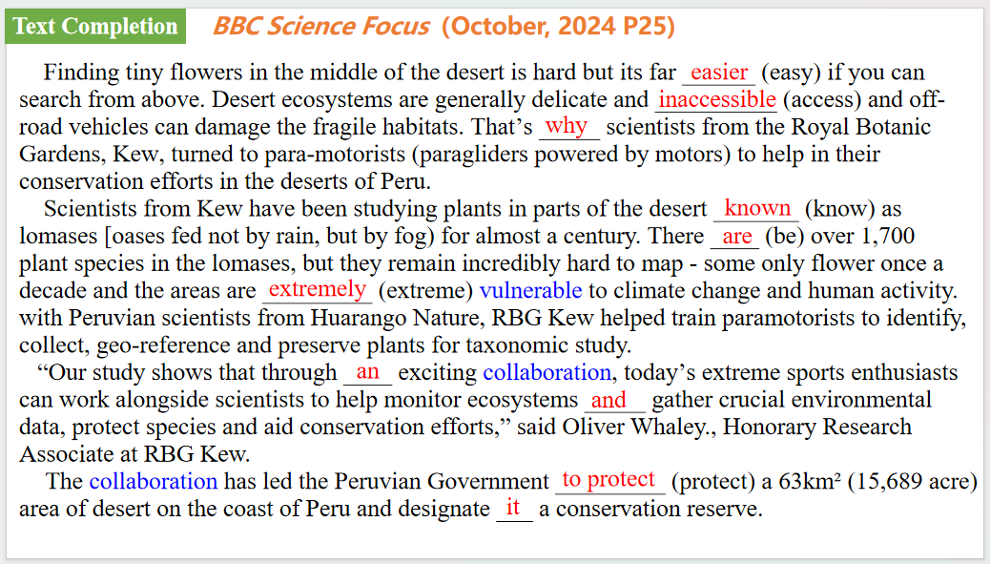

【设计意图】通过语篇填空的形式帮助学生理解新闻的主要内容，同时训练语言语法的运用能力：在语篇的视角下如何正确使用所给词汇，根据语法规则确定词汇的正确形式，使得文章通顺，激活学生的思维和语言。该新闻主题语境是关于“人与自然”中“自然科学研究成果”这一子主题，通过学习让学生了解植物学家从空中研究植物的新研究方法。

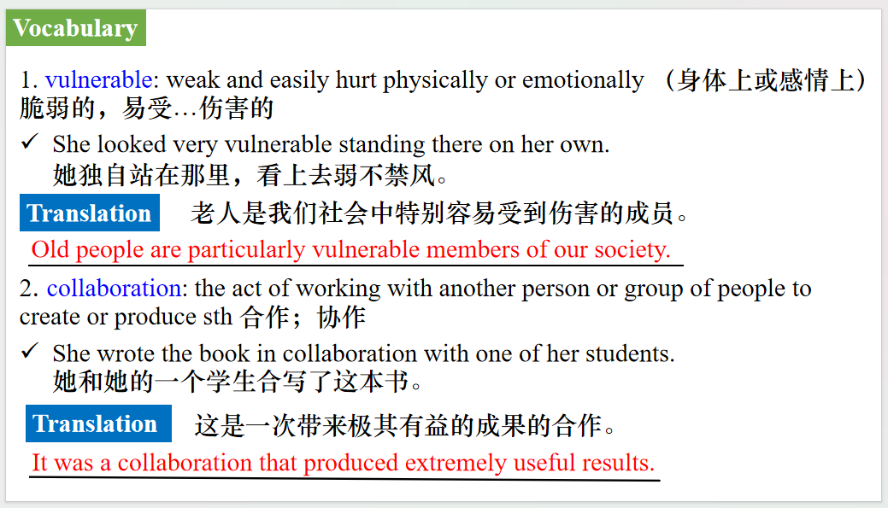

【设计意图】对文本中的词汇进行解读，并通过翻译句子对其进行巩固。

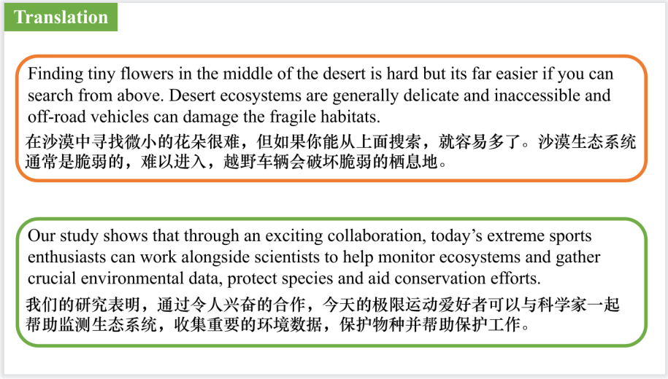

【设计意图】对文中的两个句子进行翻译练习，对其中单词、词组、句法进行巩固并关注句子结构。

**Part 3: News Report 3 Unprocess Your Diet（October 9, 2024 P39)**

**HOW MUCH SUGAR IS TOO MUCH?**

**摄入多少糖算多？**

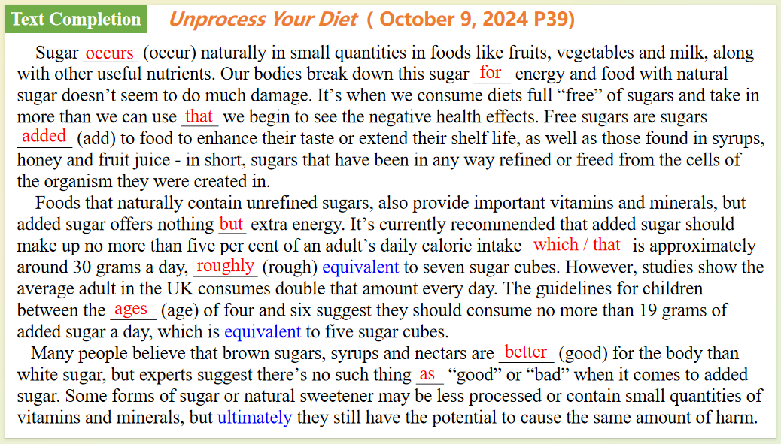

【设计意图】通过语篇填空的形式帮助学生理解新闻的主要内容，同时训练语言语法的运用能力：在语篇的视角下如何正确使用所给词汇，根据语法规则确定词汇的正确形式，使得文章通顺，激活学生的思维和语言。该新闻主题语境是关于“人与社会”中“社会热点问题”这一子主题，通过学习让学生了解人类最佳的摄糖量。

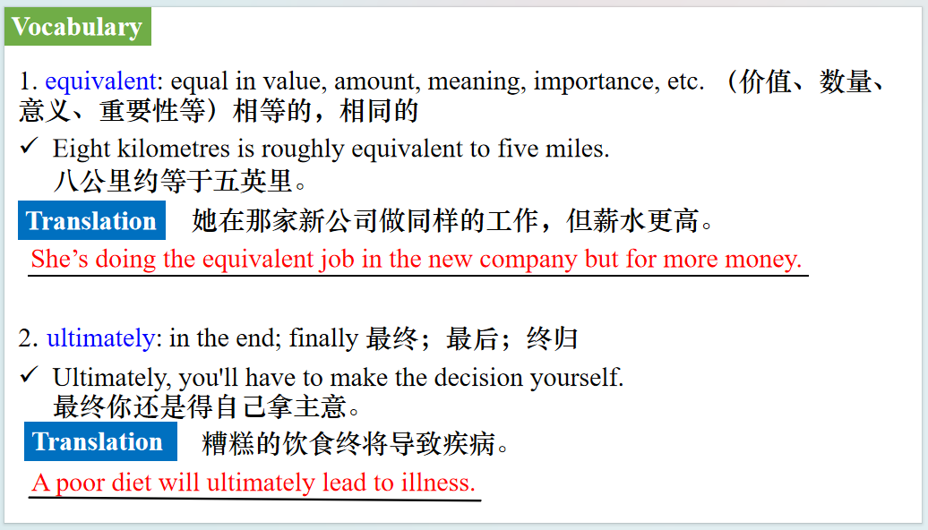

【设计意图】对文本中的词汇进行解读，并通过翻译句子对其进行巩固。

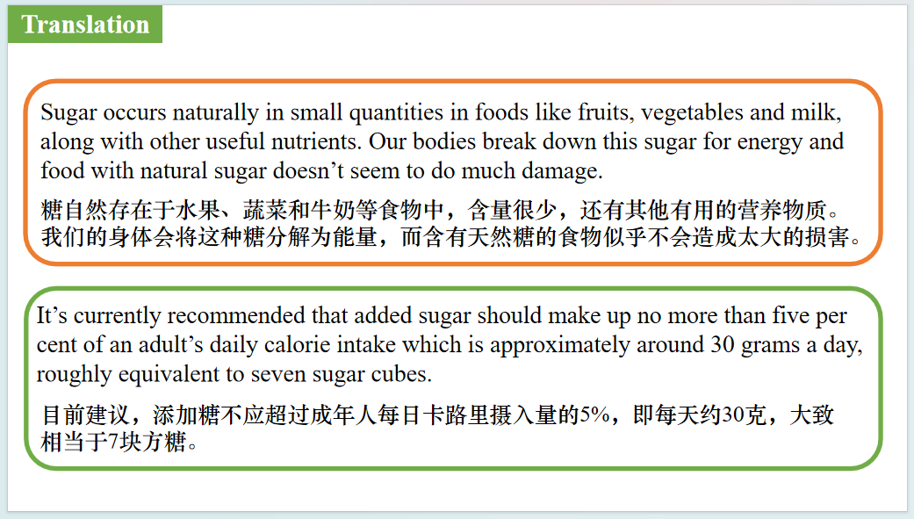

【设计意图】对文中的两个句子进行翻译练习，对其中单词、词组、句法进行巩固并关注句子结构。

**Part 4: News Report 4** ***The Times*(October 16, 2024 P14)**

**Smoking leaves a trace in bones for centuries**

**吸烟会在骨头上留下的痕迹会持续几个世纪**

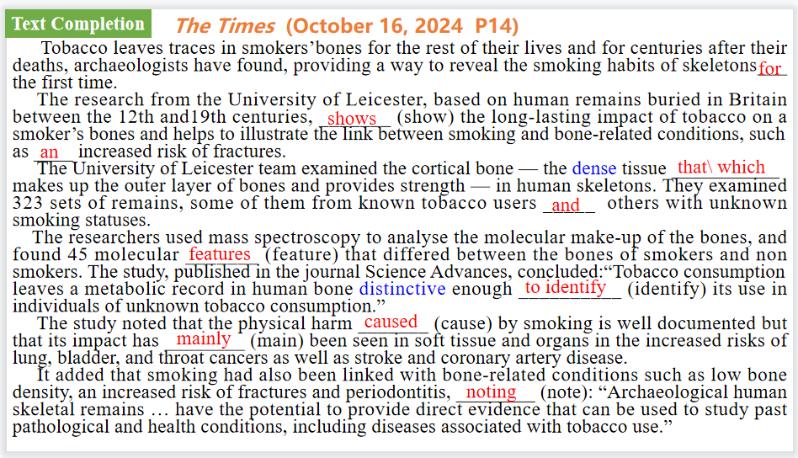

【设计意图】通过语篇填空的形式帮助学生理解新闻的主要内容，同时训练语言语法的运用能力：在语篇的视角下如何正确使用所给词汇，根据语法规则确定词汇的正确形式，使得文章通顺，激活学生的思维和语言。该新闻主题语境是关于“人与社会”中“社会热点问题”这一子主题，通过学习让学生了解吸烟的有害性可以持续很久，养成不吸烟的习惯。

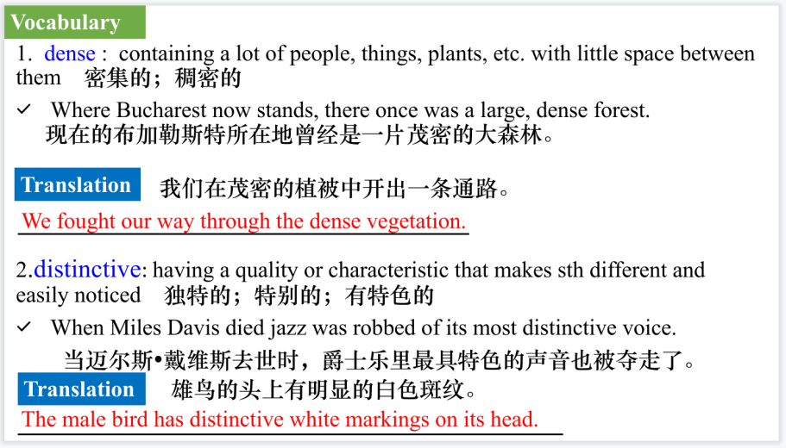

【设计意图】对文本中的词汇进行解读，并通过翻译句子对其进行巩固。

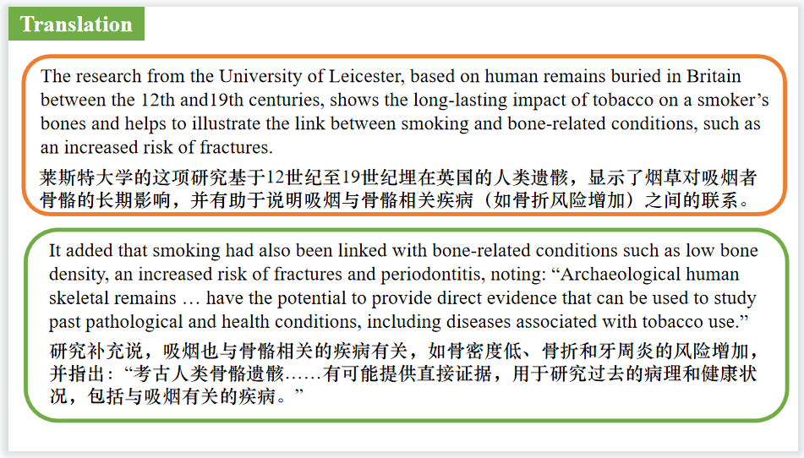

【设计意图】对文中的两个句子进行翻译练习，对其中单词、词组、句法进行巩固并关注句子结构。

**Part 5: BBC News 10/21/2024**

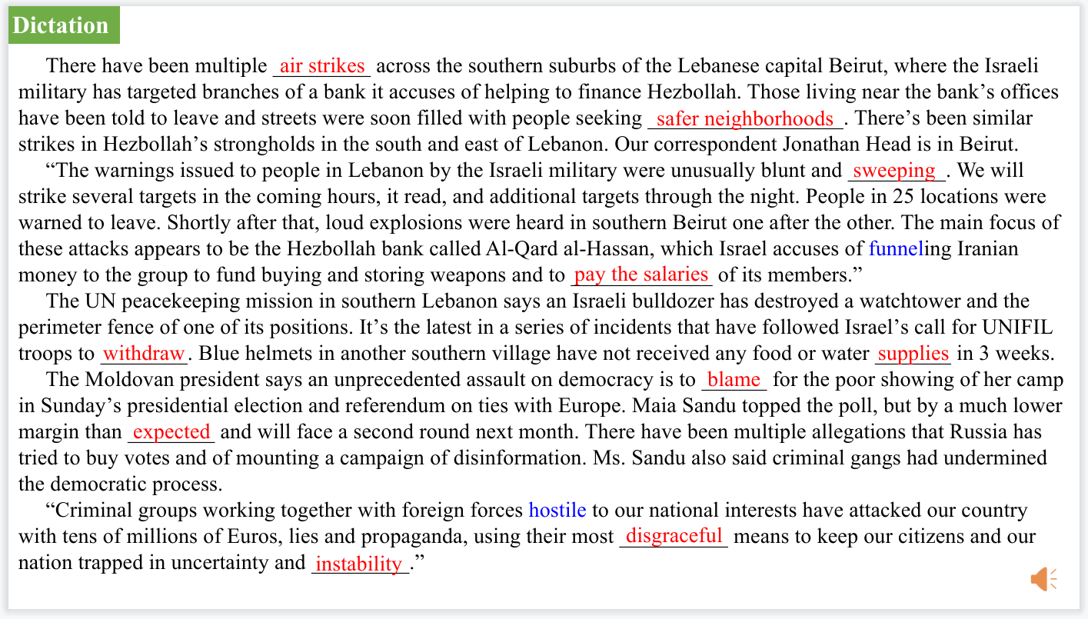

【设计意图】听一则材料，通过听力填空的方式理解文本，考察听力辨识词汇的能力。

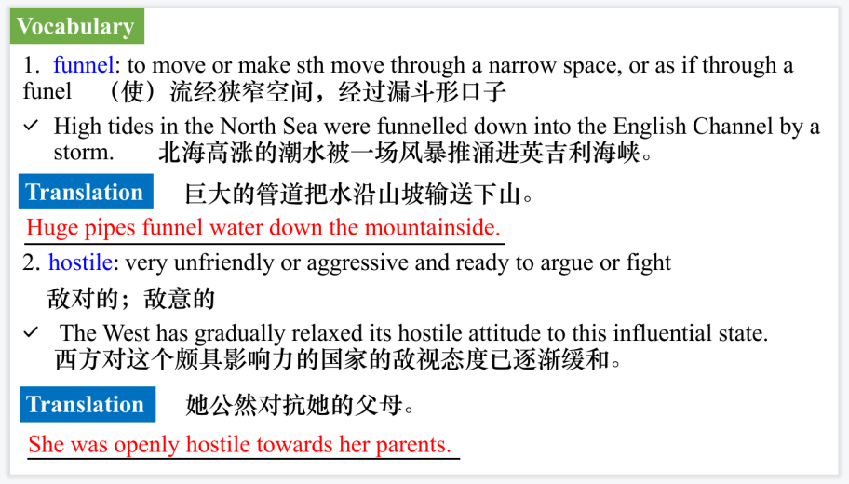

【设计意图】对文本中的词汇进行解读，并通过翻译句子对其进行巩固。

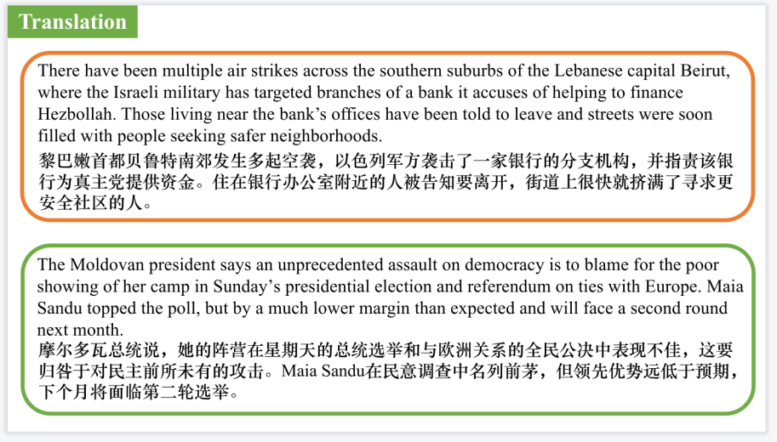

【设计意图】对文中的两个句子进行翻译练习，对其中单词、词组、句法进行巩固并关注句子结构。

附：外刊原文

**Part 1: News Report 1 *The Wall Street Journal* (October 18, 2024 A8)**

**World Watch 世界观察**

**IMF: Soft Landing Seen, But Tepid Growth**

Inflation rates are falling and the global economy is on track for a soft landing, but the outlook for growth is tepid and rising trade barriers are a headwind, the head of the International Monetary Fund said on Thursday. In a speech ahead of the fund’s annual meetings in Washington, D.C., next week, IMF Managing Director Kristalina Georgieva said governments should act quickly to halt a sharp rise in their debts, and work together to resolve growing trade tensions. Figures released by the European Union’s statistics agency on Thursday showed the annual rate of inflation fell to 1.7% in September, below the European Central Bank’s 2% target for the first time since June 2021. In the U.K., inflation also fell to 1.7%, while in the U.S. prices rose by 2.4%.

**BANGLADESH: Court Seeks Arrest Of Former Premier**

A special court in Bangladesh issued arrest warrants on Thursday for former Prime Minister Sheikh Hasina and 45 others, including her close aides, on charges of crimes against humanity during a student-led uprising in July and August that forced her to flee the country, a prosecutor said. Prosecutor B.M. Sultan Mahmud said the Dhaka-based International Crimes Tribunal under Nobel laureate Muhammad Yunus, the country’s interim leader, issued the warrants in response to two petitions by the prosecution. There was no reaction from Hasina’s Bangladesh Awami League party. Hasina fled to India on Aug. 5 after weeks of protests over government job quotas in which hundreds of people died. Prosecutors said Hasina, her close aides and security agencies were responsible for killing the protesters and others.

**Part 2: News Report 2 *BBC Science Focus*（October, 2024 P25)**

**The botanists studying plants from the sky**

植物学家从空中研究植物

Finding tiny flowers in the middle of the desert is hard but its far easier if you can search from above. Desert ecosystems are generally delicate and inaccessible and off-road vehicles can damage the fragile habitats.That’s why scientists from the Royal Botanic Gardens, Kew.turned to para-motorists (paragliders powered by motors) to help in their conservation efforts in the deserts of Peru.

Scientists from Kew have been studying plants in parts of the desert known as lomases [oases fed not by rain, but by fog) for almost a century.There are over 1,700 plant species in the lomases, but they remain incredibly hard to map-some only flower once a decade and the areas are extremely vulnerable to climate change and human activity.

Working with Peruvian scientists from Huarango Nature, RBG Kew helped train paramotorists to identify, collect, geo-reference and preserve plants for taxonomic study.

“Our study shows that through an exciting collaboration, today’s extreme sports enthusiasts can work alongside scientists to help monitor ecosystems and gather crucial environmental data, protect species and aid conservation efforts,"said Oliver Whaley., Honorary Research Associate at RBG Kew.

The collaboration has led the Peruvian Government to protect a 63km² (15,689 acre) area of desert on the coast of Peru and designate it a conservation reserve.

**Part 3: News Report 3 *Unprocess Your Diet*（October 9, 2024 P39)**

**HOW MUCH SUGAR IS TOO MUCH?**

**摄入多少糖算多？**

Sugar occurs naturally in small quantities in foods like fruits,vegetables and milk, along with other useful nutrients. Our bodies break down this sugar for energy and food with natural sugar doesn’t seem to do much damage. It’s when we consume diets full “free” of sugars and take in more than we can use that we begin to see the negative health effects. Free sugars are sugars added to food to enhance their taste or extend their shelf life, as well as those found in syrups, honey and fruit juice - in short, sugars that have been in any way refined or freed from the cells of the organism they were created in.

Foods that naturally contain unrefined sugars, also provide important vitamins and minerals, but added sugar offers nothing but extra energy. It’s currently recommended that added sugar should make up no more than five per cent of an adult’s daily calorie intake which is approximately around 30 grams a day, roughly equivalent to seven sugar cubes.However studies show the average adult in the UK consumes double that amount every day. The guidelines for children between the ages of four and six suggest they should consume no more than 19 grams of added sugar a day, which is equivalent to five sugar cubes.

Many people believe that brown sugars,syrups and nectars are better for the body than white sugar, but experts suggest there’s no such thing as “good” or “bad” when it comes to added sugar. Some forms of sugar or natural sweetener may be less processed or contain small quantities of vitamins and minerals, but ultimately they still have the potential to cause the same amount of harm.

**Part 4: News Report 4** ***The Times* (October 16, 2024 P14)**

**Smoking leaves a trace in bones for centuries**

**吸烟会在骨头上留下的痕迹会持续几个世纪**

Tobacco leaves traces in smokers’bones for the rest of their lives and for centuries after their deaths, archaeologists have found, providing a way to reveal the smoking habits of skeletons for the first time.

The research from the University of Leicester, based on human remains buried in Britain between the 12th and19th centuries, shows the long-lasting impact of tobacco on a smoker’s bones and helps to illustrate the link between smoking and bone-related conditions, such as an increased risk of fractures.

The introduction of tobacco to western Europe about 500 years ago led to “changes in human bone”, the researchers discovered after comparing remains from earlier and later than the 16th century.

In the past, archaeologists have relied on teeth to ascertain whether a skeleton belonged to a smoker, looking for stains or for signs of wear caused by a pipe being held in the mouth. However, in many cases “dental remains have not survived or teeth were lost prior to death”, rendering this method useless.

The University of Leicester team examined the cortical bone — the dense tissue that makes up the outer layer of bones and provides strength — in human skeletons. They examined 323 sets of remains, some of them from known tobacco users and others with unknown smoking statuses.

More than 140 of the sets of remains were taken from a rural church cemetery in Barton-upon-Humber in North Lincolnshire, where remains date from 1150 to 1855. Another 177

came from the St James’s Gardens Smoking leaves a trace in bones for centuries burial ground in Euston, London, dating from the 18th and 19th centuries.

The researchers used mass spectroscopy to analyse the molecular make-up of the bones, and found 45 molecular features that differed between the bones of smokers and non smokers.

The study, published in the journal Science Advances, concluded:“Tobacco consumption leaves a metabolic record in human bone distinctive enough to identify its use in individuals of unknown tobacco consumption.”

Dr Sarah Inskip, an author of the study, said: “Our research shows that there are significant differences in the molecular features contained in [the] bone of past tobacco users and nonusers. This potentially shows that we can see the impact that tobacco use has on the structure of our skeletons.

“Our ongoing research aims to ascertain how these differences emerge as this may have significance for understanding why tobacco use is a risk factor for some musculoskeletal and dental disorders.”

The study noted that the physical harm caused by smoking is well documented but that its impact has mainly been seen in soft tissue and organs in the increased risks of lung, bladder, and throat cancers as well as stroke and coronary artery disease.

It added that smoking had also been linked with bone-related conditions such as low bone density, an increased risk of fractures and periodontitis, noting: “Archaeological human skeletal

remains … have the potential to provide direct evidence that can be used to study past pathological and health conditions, including diseases associated with tobacco use.”